# Amazon Web Services

Cloud computing offers dynamic provisioning of resources based on demand, on a **pay-as-you-use** pricing. Instead of physical servers, cloud computing helps to spin out virtual servers. With dynamic scaling and load balancing features of cloud, long term planning is not necessary.

## Why Cloud?

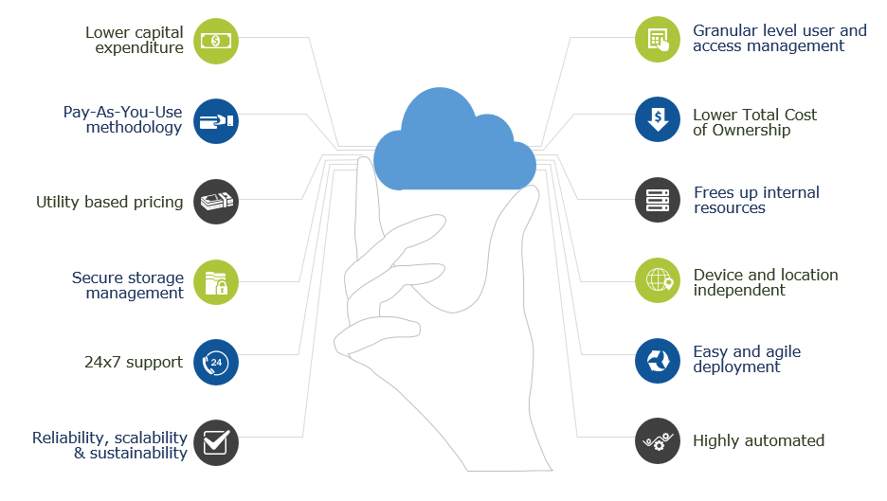

Amazon.com's Great Indian Festival or Flipkart's Big Billion Day, they also declare intermittent offer days. 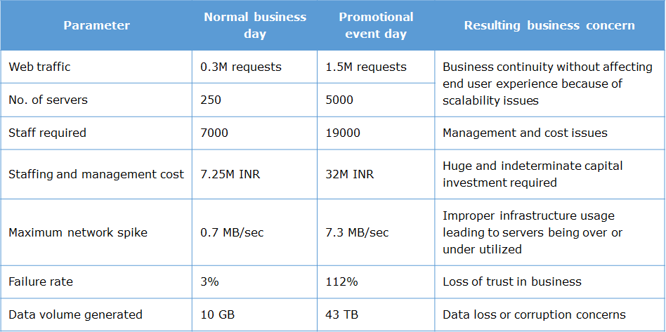

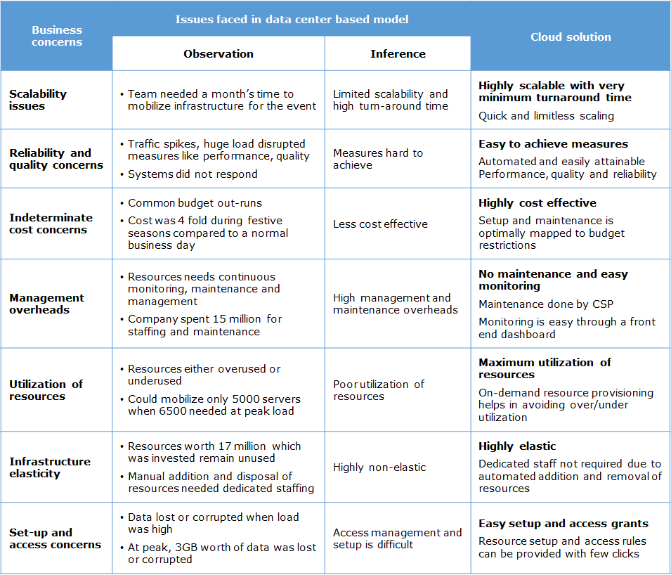

## Types of Cloud Infrastructure

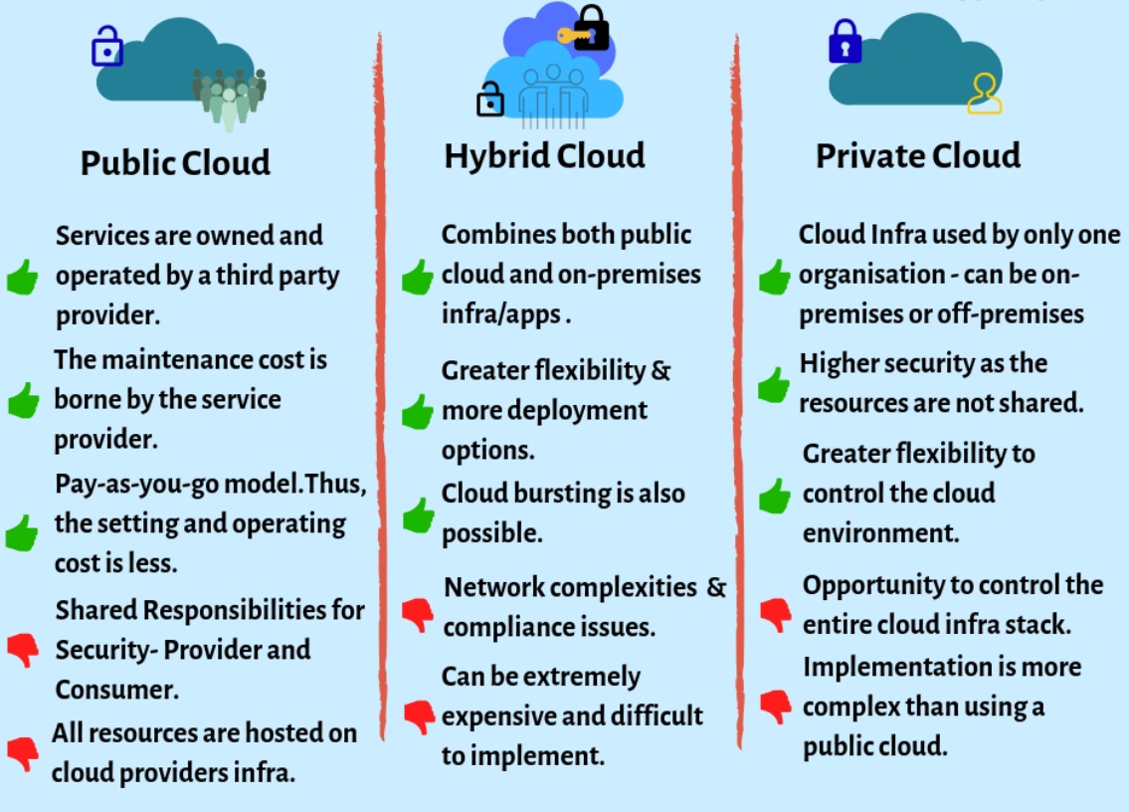

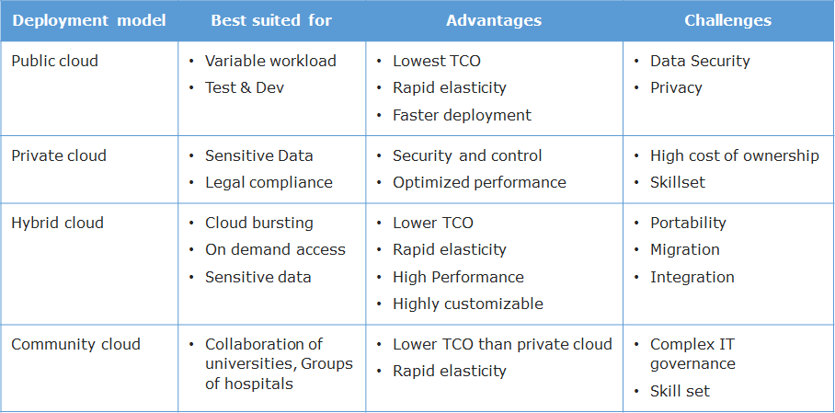

## Types of Cloud Services

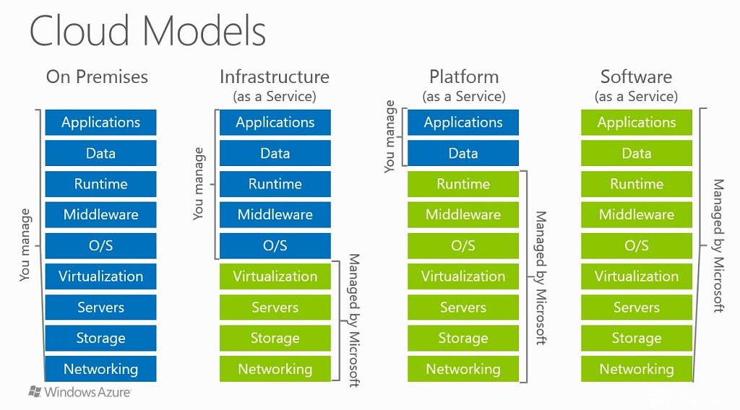

## Learning Path

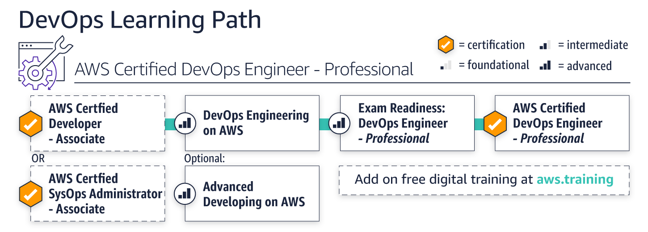

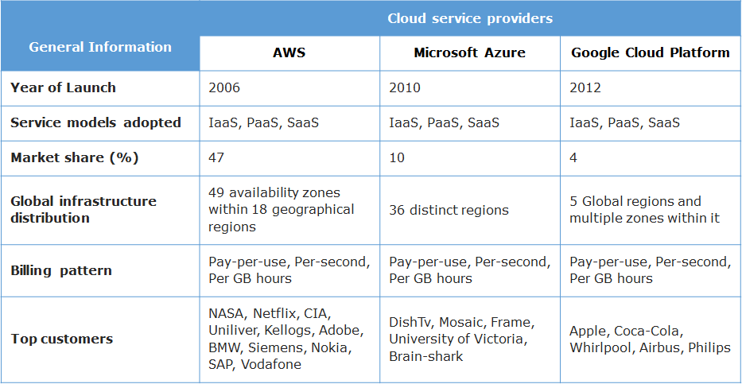

## AWS History

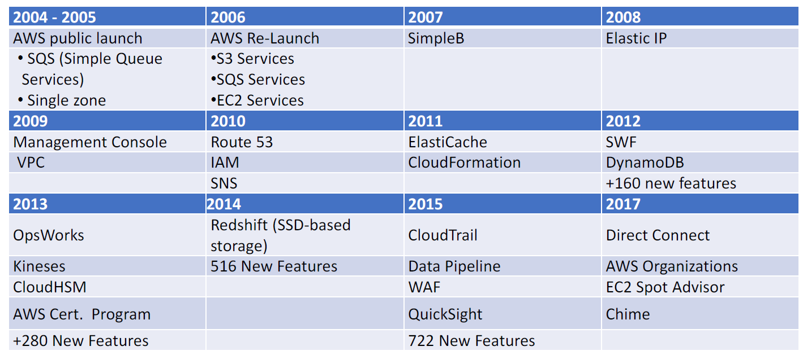

* Launched in 2006 as we know it today
* Included three services: S3, SQS and EC2
* SQS launched as a single service in 2004
* Simple DB launched in 2007
* More than 10 new services in 2008 (including Elastic IP)
* 2009 introduced the AWS management console
* 2010 gave us Route 53
* 2011 ElastiCache was introduced
* Dynamo DB was introduced in 2012
* AWS certifications launched in 2013
* 2014 added Redshift (SSD‐based storage)
* Amazon QuickSight launched in 2015

**Amazon Web Services**(AWS) is a low cost cloud service platform from Amazon, which provides services such as compute, storage, networking, CDN services etc to users. All AWS services are exposed as web services accessible from any where, any time, on a pay per use pricing model.

AWS services can be managed through a web based management console, command line interface (CLI) or software development kits (SDK). With AWS, you can provision resources in seconds and build applications without upfront capital investment.

Choosing Region

**Region**

* is a physical location spread across globe to host your data
* In each region, there will be atleast two availability zones for fault tolerance
* Regions are completely separate from one another
* Enterprises can choose to have their data in a specific region

**Availability zones**

* Availability zones are analogous to clusters of datacenters
* Availability zones are connected through redundant low-latency links
* These AZs offer scalable, fault tolerant and highly-available architecture

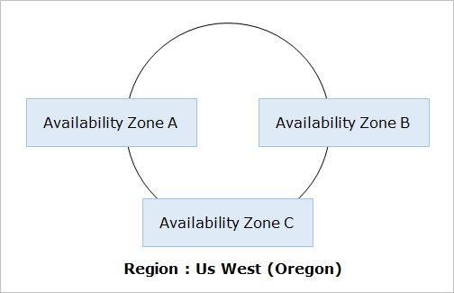

Most of the AWS services are region dependent and only a few are region independent. Few services may not be available in all the regions. So, while determining a region to push the workloads, the following parameters to be considered.

* Availability of required services
* Cost
* Latency
* Security & Compliance
* Service Level Agreements(SLAs)

# AWS Services

55 services currently available from AWS. The following are the various categories of services offered by Amazon Web Services (AWS). 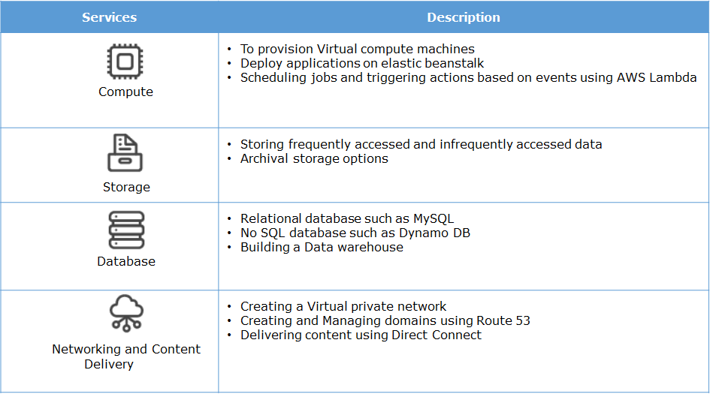

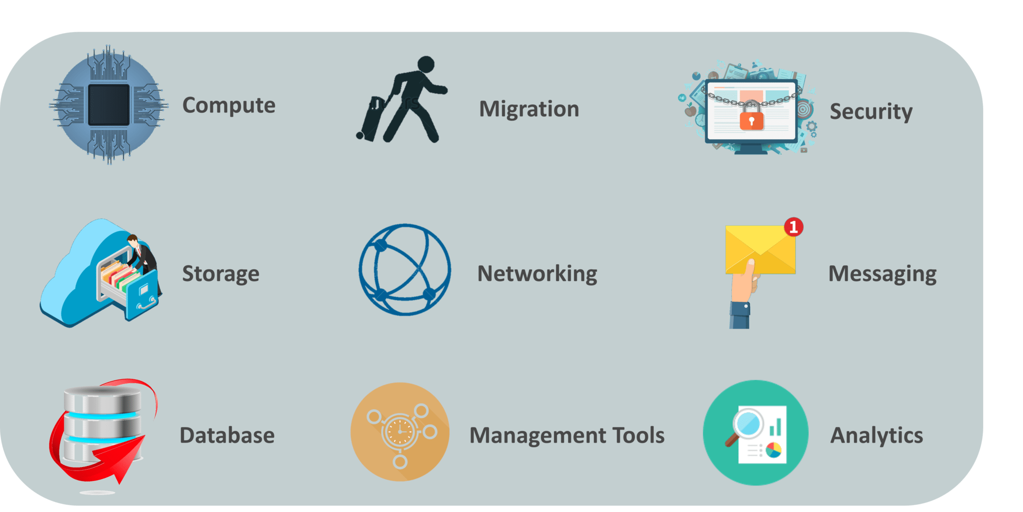

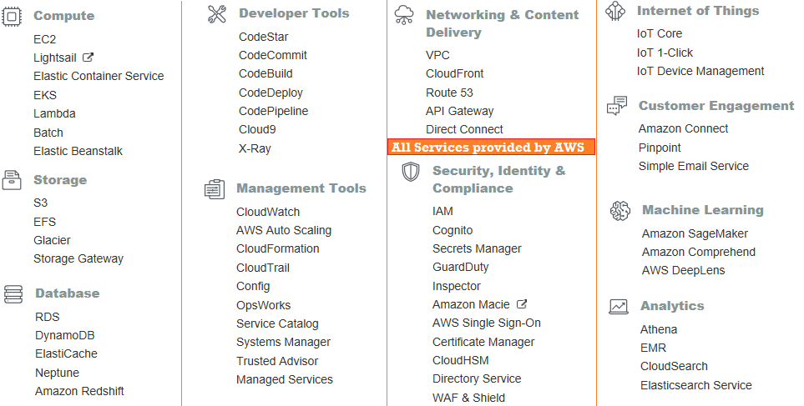

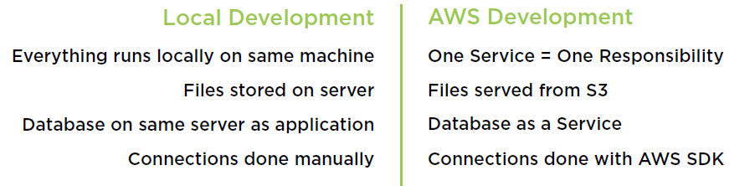

### Security, Identity, & Compliance

* [**IAM**](https://console.aws.amazon.com/iam/home?region=us-east-2)
* [**Resource Access Manager**](https://us-east-2.console.aws.amazon.com/ram/home?region=us-east-2)
* [**Cognito**](https://us-east-2.console.aws.amazon.com/cognito/home?region=us-east-2)
* [**Secrets Manager**](https://us-east-2.console.aws.amazon.com/secretsmanager/home?region=us-east-2)
* [**GuardDuty**](https://us-east-2.console.aws.amazon.com/guardduty/home?region=us-east-2)
* [**Inspector**](https://us-east-2.console.aws.amazon.com/inspector/home?region=us-east-2)
* [**Amazon Macie**](https://us-east-1.redirection.macie.aws.amazon.com/)
* [**AWS Single Sign-On**](https://us-east-2.console.aws.amazon.com/singlesignon/home?region=us-east-2)
* [**Certificate Manager**](https://us-east-2.console.aws.amazon.com/acm/home?region=us-east-2)
* [**Key Management Service**](https://us-east-2.console.aws.amazon.com/kms/home?region=us-east-2)
* [**CloudHSM**](https://us-east-2.console.aws.amazon.com/cloudhsm/home?region=us-east-2)
* [**Directory Service**](https://us-east-2.console.aws.amazon.com/directoryservicev2/home?region=us-east-2)
* [**WAF & Shield**](https://console.aws.amazon.com/wafv2/home?region=us-east-2)
* [**Artifact**](https://console.aws.amazon.com/artifact/home?region=us-east-2)
* [**Security Hub**](https://us-east-2.console.aws.amazon.com/securityhub/home?region=us-east-2)

### Compute

* [**EC2**](https://us-east-2.console.aws.amazon.com/ec2/v2/home?region=us-east-2)
* [**Lightsail**](https://lightsail.aws.amazon.com/ls/webapp/home)
* [**ECR**](https://us-east-2.console.aws.amazon.com/ecr/home?region=us-east-2)
* [**ECS**](https://us-east-2.console.aws.amazon.com/ecs/home?region=us-east-2)
* [**EKS**](https://us-east-2.console.aws.amazon.com/eks/home?region=us-east-2)
* [**Lambda**](https://us-east-2.console.aws.amazon.com/lambda/home?region=us-east-2)
* [**Batch**](https://us-east-2.console.aws.amazon.com/batch/home?region=us-east-2)
* [**Elastic Beanstalk**](https://us-east-2.console.aws.amazon.com/elasticbeanstalk/home?region=us-east-2)
* [**Serverless Application Repository**](https://us-east-2.console.aws.amazon.com/serverlessrepo/home?region=us-east-2)
* [**EC2 Image Builder**](https://us-east-2.console.aws.amazon.com/imagebuilder/home?region=us-east-2)

### Storage

* [**S3**](https://s3.console.aws.amazon.com/s3/home?region=us-east-2)
* [**EFS**](https://us-east-2.console.aws.amazon.com/efs/home?region=us-east-2)
* [**FSx**](https://us-east-2.console.aws.amazon.com/fsx/home?region=us-east-2)
* [**S3 Glacier**](https://us-east-2.console.aws.amazon.com/glacier/home?region=us-east-2)
* [**Storage Gateway**](https://us-east-2.console.aws.amazon.com/storagegateway/home?region=us-east-2)
* [**AWS Backup**](https://us-east-2.console.aws.amazon.com/backup/home?region=us-east-2)

### Database

* [**RDS**](https://us-east-2.console.aws.amazon.com/rds/home?region=us-east-2)
* [**DynamoDB**](https://us-east-2.console.aws.amazon.com/dynamodb/home?region=us-east-2)
* [**ElastiCache**](https://us-east-2.console.aws.amazon.com/elasticache/home?region=us-east-2)
* [**Neptune**](https://us-east-2.console.aws.amazon.com/neptune/home?region=us-east-2)
* [**Amazon Redshift**](https://us-east-2.console.aws.amazon.com/redshift/home?region=us-east-2)
* [**Amazon QLDB**](https://us-east-2.console.aws.amazon.com/qldb/home?region=us-east-2)
* [**Amazon DocumentDB**](https://us-east-2.console.aws.amazon.com/docdb/home?region=us-east-2)

### Networking & Content Delivery

* [**VPC**](https://us-east-2.console.aws.amazon.com/vpc/home?region=us-east-2)
* [**CloudFront**](https://console.aws.amazon.com/cloudfront/home?region=us-east-2)
* [**Route 53**](https://console.aws.amazon.com/route53/home?region=us-east-2)
* [**API Gateway**](https://us-east-2.console.aws.amazon.com/apigateway/home?region=us-east-2)
* [**Direct Connect**](https://console.aws.amazon.com/directconnect/v2/home?region=us-east-2)
* [**AWS App Mesh**](https://us-east-2.console.aws.amazon.com/appmesh/home?region=us-east-2)
* [**AWS Cloud Map**](https://us-east-2.console.aws.amazon.com/cloudmap/home?region=us-east-2)
* [**Global Accelerator**](https://us-west-2.console.aws.amazon.com/ec2/GlobalAccelerator/home?region=us-west-2)

### Developer Tools

* [**CodeStar**](https://us-east-2.console.aws.amazon.com/codestar/home?region=us-east-2)
* [**CodeCommit**](https://us-east-2.console.aws.amazon.com/codesuite/codecommit/home?region=us-east-2)
* [**CodeBuild**](https://us-east-2.console.aws.amazon.com/codesuite/codebuild/home?region=us-east-2)
* [**CodeDeploy**](https://us-east-2.console.aws.amazon.com/codesuite/codedeploy/home?region=us-east-2)
* [**CodePipeline**](https://us-east-2.console.aws.amazon.com/codesuite/codepipeline/home?region=us-east-2)
* [**Cloud9**](https://us-east-2.console.aws.amazon.com/cloud9/home?region=us-east-2)
* [**X-Ray**](https://us-east-2.console.aws.amazon.com/xray/home?region=us-east-2)

### Management & Governance

* [**AWS Organizations**](https://console.aws.amazon.com/organizations/home?region=us-east-2)
* [**CloudWatch**](https://us-east-2.console.aws.amazon.com/cloudwatch/home?region=us-east-2)
* [**AWS Auto Scaling**](https://us-east-2.console.aws.amazon.com/awsautoscaling/home?region=us-east-2)
* [**CloudFormation**](https://us-east-2.console.aws.amazon.com/cloudformation/home?region=us-east-2)
* [**CloudTrail**](https://us-east-2.console.aws.amazon.com/cloudtrail/home?region=us-east-2)
* [**Config**](https://us-east-2.console.aws.amazon.com/config/home?region=us-east-2)
* [**OpsWorks**](https://console.aws.amazon.com/opsworks/landing/home?region=us-east-2)
* [**Service Catalog**](https://us-east-2.console.aws.amazon.com/servicecatalog/home?region=us-east-2)
* [**Systems Manager**](https://us-east-2.console.aws.amazon.com/systems-manager/home?region=us-east-2)
* [**Trusted Advisor**](https://console.aws.amazon.com/trustedadvisor/home?region=us-east-2)
* [**Control Tower**](https://us-east-2.console.aws.amazon.com/controltower/home?region=us-east-2)
* [**AWS License Manager**](https://us-east-2.console.aws.amazon.com/license-manager/home?region=us-east-2)
* [**AWS Well-Architected Tool**](https://us-east-2.console.aws.amazon.com/wellarchitected/home?region=us-east-2)
* [**Personal Health Dashboard**](https://phd.aws.amazon.com/phd/home)
* [**AWS Chatbot**](https://console.aws.amazon.com/chatbot/home?region=us-east-2)
* [**Launch Wizard**](https://us-east-2.console.aws.amazon.com/launchwizard/home?region=us-east-2)

### Analytics

* [**Athena**](https://us-east-2.console.aws.amazon.com/athena/home?region=us-east-2)
* [**EMR**](https://us-east-2.console.aws.amazon.com/elasticmapreduce/home?region=us-east-2)
* [**CloudSearch**](https://console.aws.amazon.com/cloudsearch/home?region=us-east-2)
* [**Elasticsearch Service**](https://us-east-2.console.aws.amazon.com/es/home?region=us-east-2)
* [**Kinesis**](https://us-east-2.console.aws.amazon.com/kinesis/home?region=us-east-2)
* [**QuickSight**](https://quicksight.aws.amazon.com/)
* [**Data Pipeline**](https://console.aws.amazon.com/datapipeline/home?region=us-east-2)
* [**AWS Data Exchange**](https://us-east-2.console.aws.amazon.com/dataexchange/home?region=us-east-2)
* [**AWS Glue**](https://us-east-2.console.aws.amazon.com/glue/home?region=us-east-2)
* [**AWS Lake Formation**](https://us-east-2.console.aws.amazon.com/lakeformation/home?region=us-east-2)
* [**MSK**](https://us-east-2.console.aws.amazon.com/msk/home?region=us-east-2)

### Application Integration

* [**Step Functions**](https://us-east-2.console.aws.amazon.com/states/home?region=us-east-2)
* [**Amazon EventBridge**](https://us-east-2.console.aws.amazon.com/events/home?region=us-east-2)
* [**Amazon MQ**](https://us-east-2.console.aws.amazon.com/amazon-mq/home?region=us-east-2)
* [**Simple Notification Service**](https://us-east-2.console.aws.amazon.com/sns/home?region=us-east-2)
* [**Simple Queue Service**](https://us-east-2.console.aws.amazon.com/sqs/home?region=us-east-2)
* [**SWF**](https://us-east-2.console.aws.amazon.com/swf/home?region=us-east-2)

## Exam Topics

#### 1.Security & Identity

* IAM
* Cagnito
* Inspector
* AWS Organization
* CloudHSM
* Directory Service

#### 2.Storage

* S3
* EFS - Elastic File System
* Glacier - Large chunk of frozen water(Archive)
* Storage Gateway - Local <-> Cloud

#### 3.Compute

* EC2
* Elastic Beanstalk
* Elastic Container Service
* Lambda

#### 4.Netorking

* VPC
* CloudFront
* Route 53
* API Gateway
* Direct Connect

#### 5.Databases

* RDS
* DynamoDB
* ElasticCache
* Amazon RedShift

#### 6.Migartion (from Local/VM to AWS)

* Database Migration
* Server Migration
* Snowball

#### 7.Management Tools

* CloudWatch
* AWS Auto scaling
* CloudFormation
* CloudTrail
* Trusted Adviser

#### 8.Application Integration

* Simple Notification Service
* Simple Queue Service

# AWS – Account creation

Go to <https://aws.amazon.com/free>

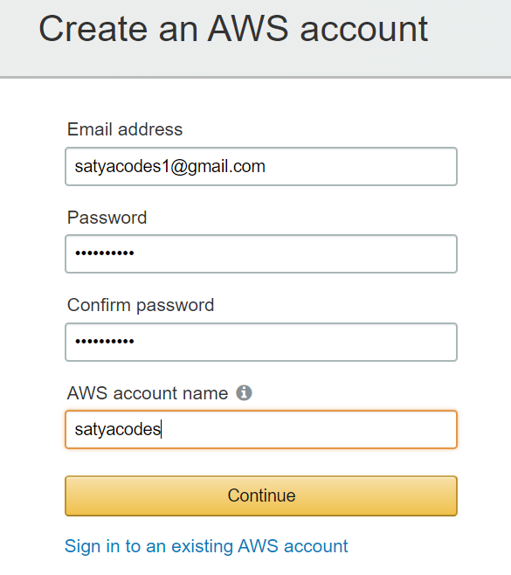

2. Once sign up login to your console.

[https://us-east-2.console.aws.amazon.com/console/home?region=us-east-2#](https://us-east-2.console.aws.amazon.com/console/home?region=us-east-2)

**AWS assigns two types of unique ID to each user's account:**

* An AWS account ID
  + Click on **"My Account"** in the dropdown menu of account name to view your **account ID**.
* A canonical user ID
  + My account > My Security Credentials > Account identifiers

# 1. Security, Identity, & Compliance

* IAM
* Cagnito
* Inspector
* AWS Organization
* CloudHSM
* Directory Service

## 1.Identity and Access Management (IAM)

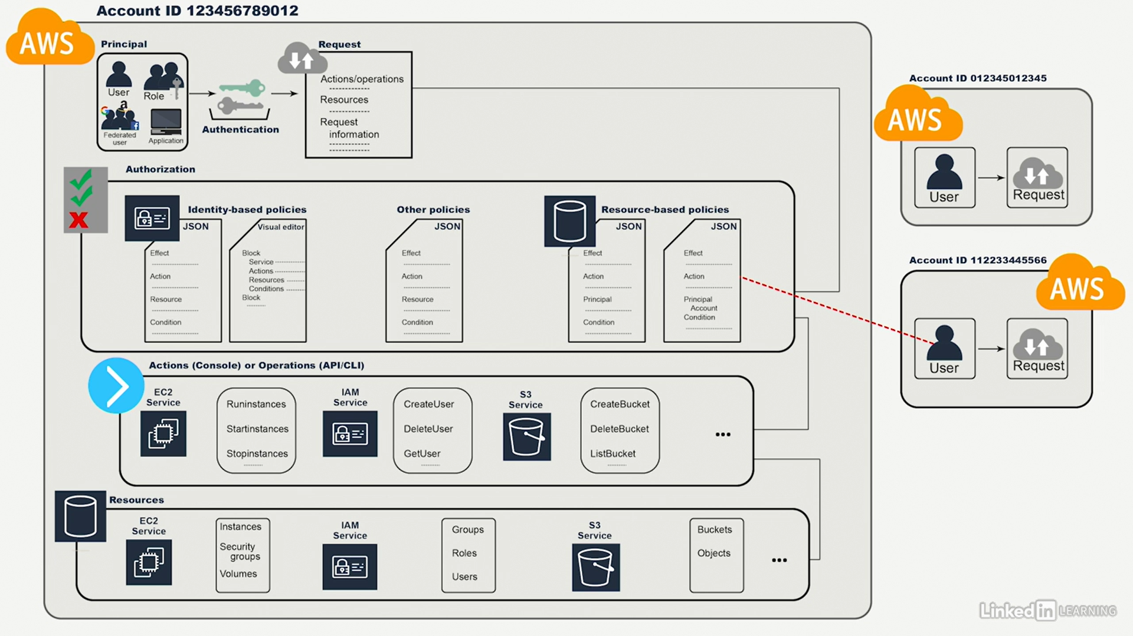

**AWS Identity and Access Management (IAM)** is a web service that enables Amazon Web Services (AWS) customers to manage users and user permissions in AWS.

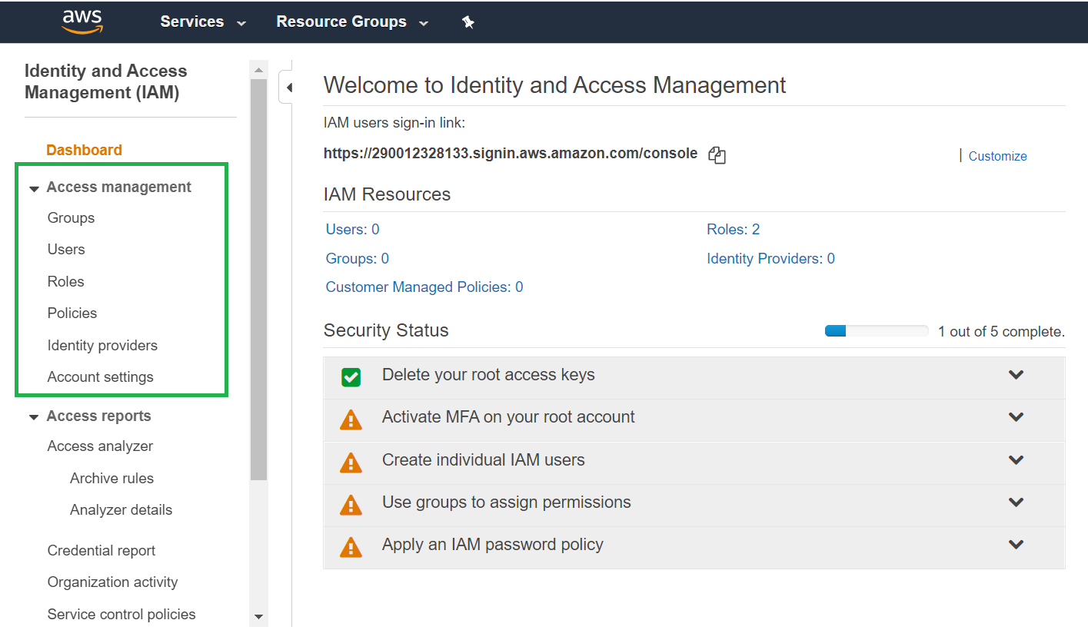

AWS Identity and Access Management (IAM) can be used to:

* **Manage IAM Users and their access:** You can create Users and assign them individual security credentials (access keys, passwords, and multi-factor authentication devices). You can manage permissions to control which operations a User can perform.
* **Manage IAM Roles and their permissions:** An IAM Role is similar to a User, in that it is an AWS identity with permission policies that determine what the identity can and cannot do in AWS. However, instead of being uniquely associated with one person, a Role is intended to be *assumable* by anyone who needs it.
* **Manage federated users and their permissions:** You can enable *identity federation* to allow existing users in your enterprise to access the AWS Management Console, to call AWS APIs and to access resources, without the need to create an IAM User for each identity.

### Authentication

* authentication is really the validation of credentials
* Authentication in AWS
* WEBUI - User name and password
* API, CLI - Access key and secret key

When connecting to AWS programmatically with APIs, an access key and secret key are used. Additionally, these keys can be used for CLI access.

### Lab 1 - Create New Root user

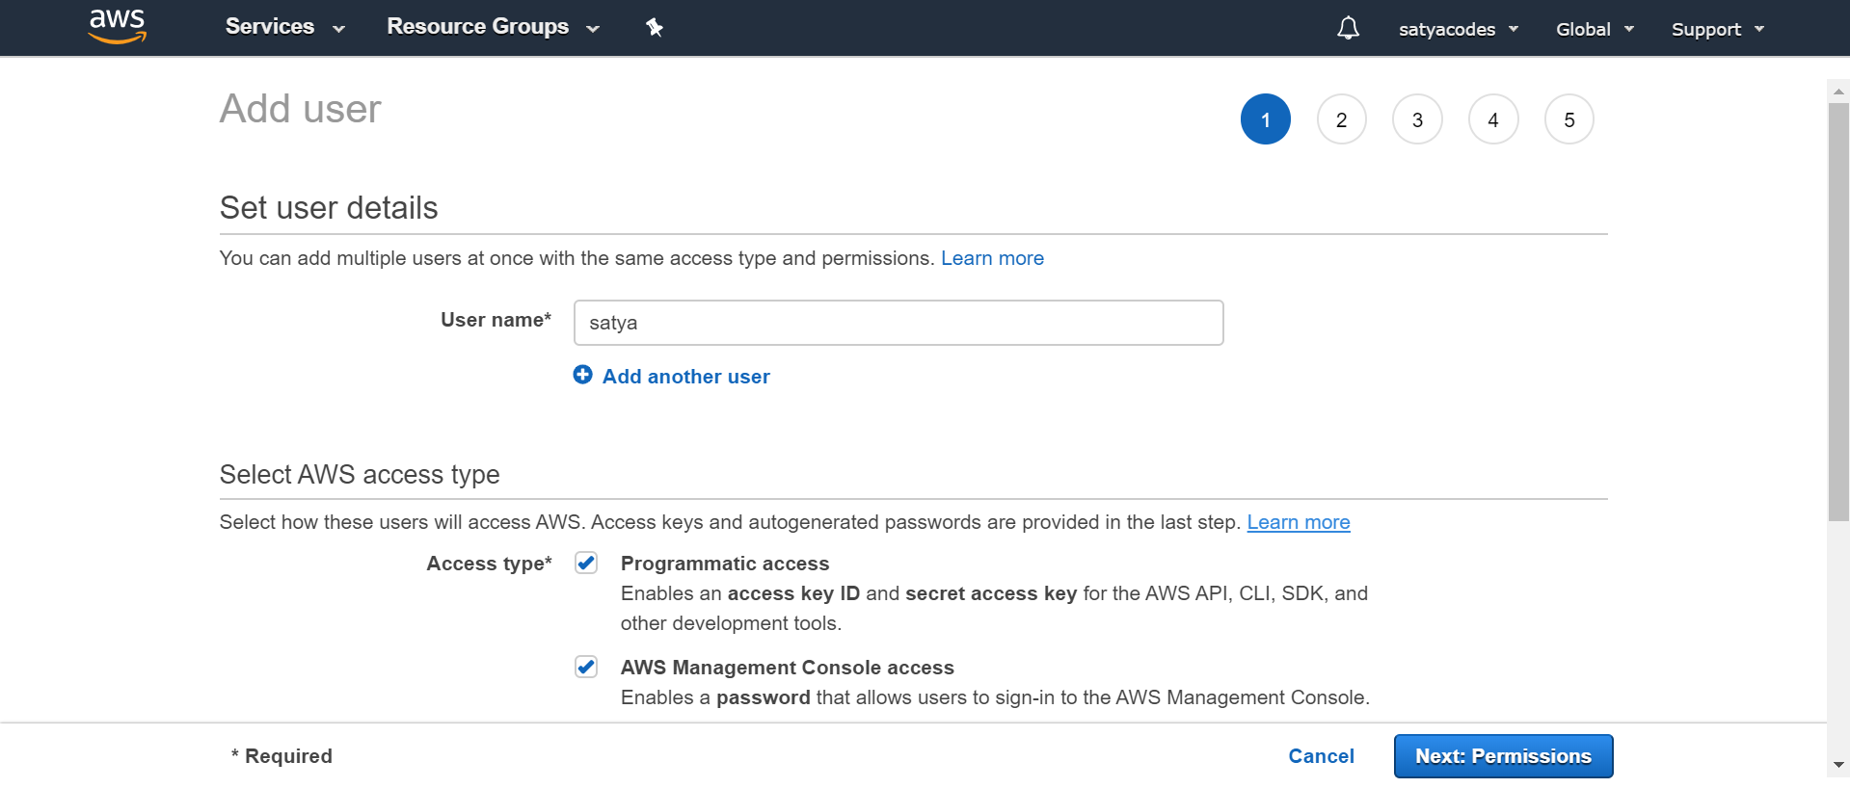

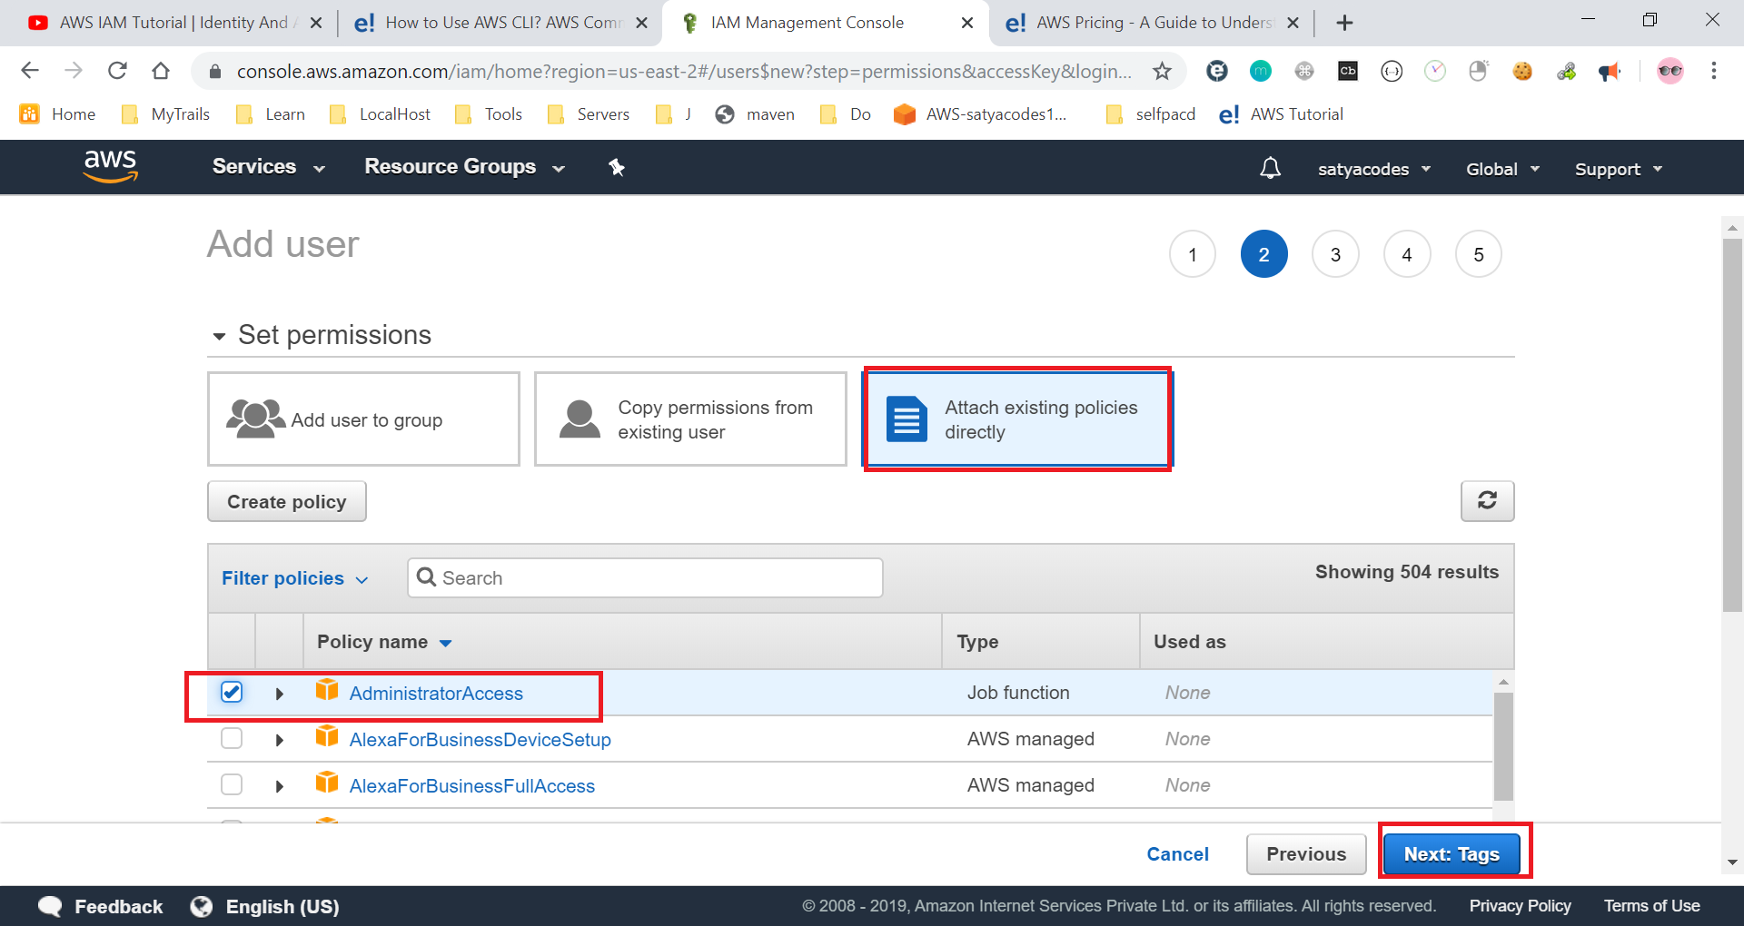

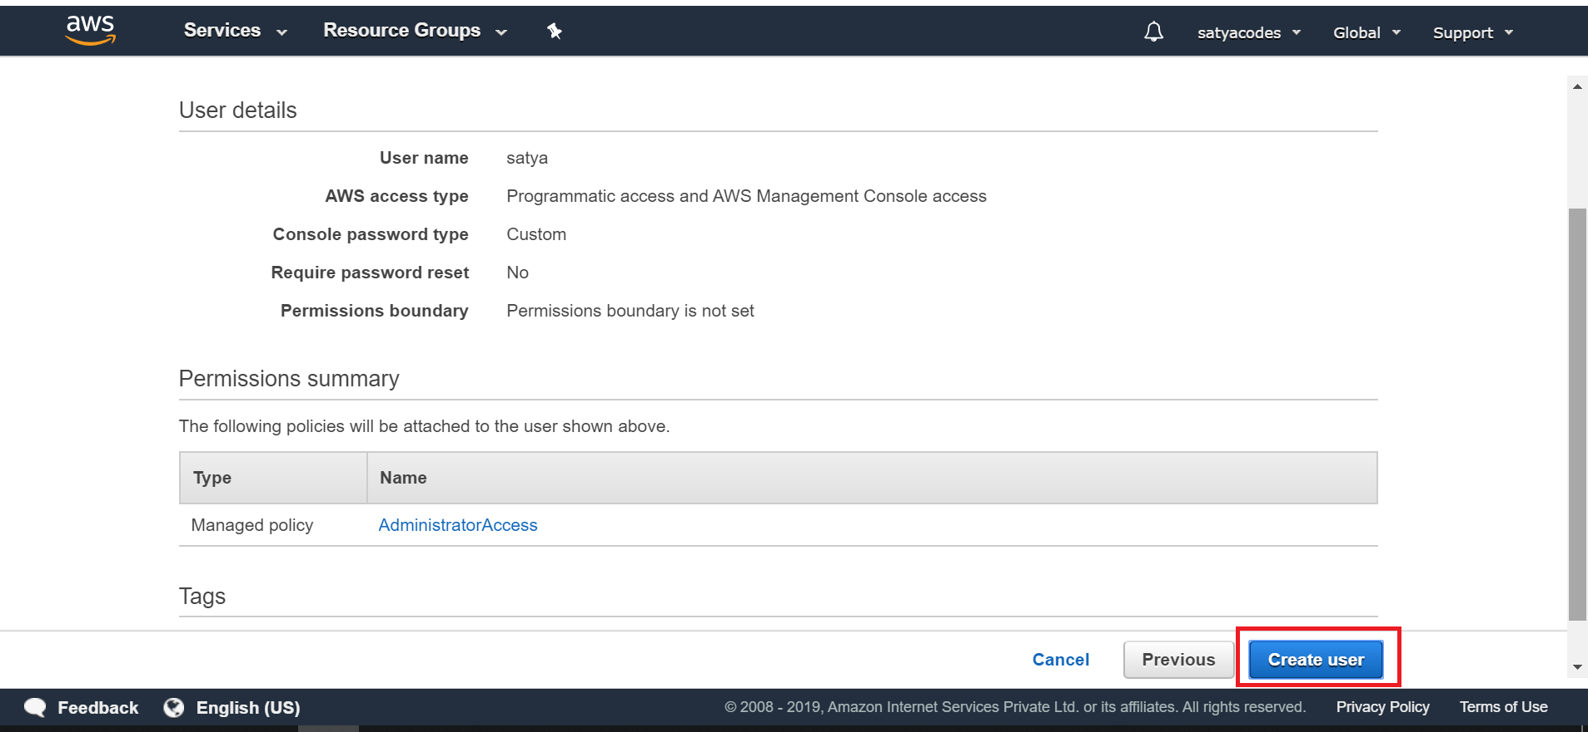

Download CSV

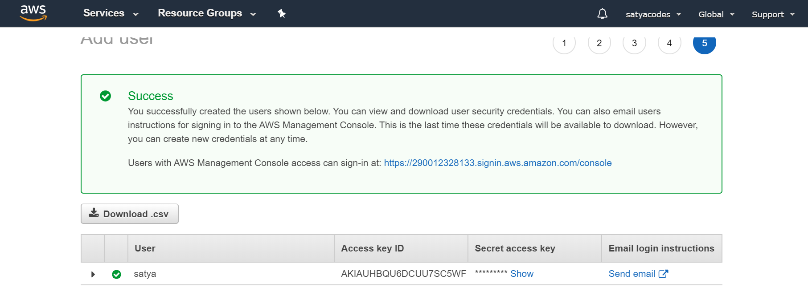

Login with new url from mail

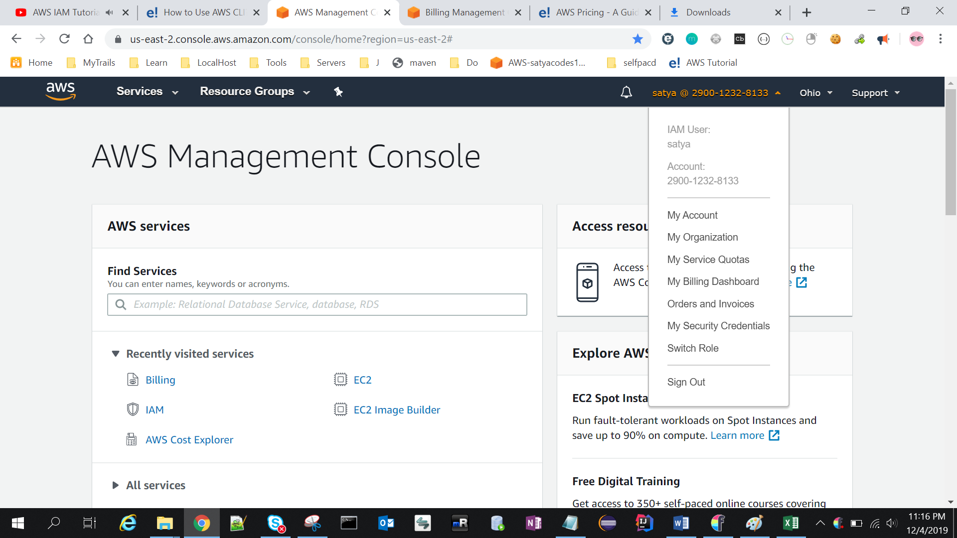

### Lab 2 – Create Users & Groups and apply policies

Scenario : I have newly Started an IT Company called "SatyaCodes", newly recruited below Users

**Users - [dev1, dev2, dev3], [dba1, dba2], [ops1, ops2]**

Create All above users

**Groups - [DEV_GROUP, DBA_GROUP, OPS_GROUP]**

Each User should be part of their resepective Groups

Each Group/User should have respective Policy

|  |  |  |  |
| --- | --- | --- | --- |
| **Policies** | **S3** | **DynamoDB** | **VPC** |
| DEV_Policy | Full | Read | NO |
| DBA_Policy | READ | FULL | NO |
| OPS_Policy | READ | READ | FULL |

#### Users Creation

**Users - [dev1, dev2, dev3], [dba1, dba2], [ops1, ops2]**

1. In the **AWS Management Console**, on the **Services** menu, click **IAM**.
2. on the left, click **Users**.
3. Add user – - [dev1, dev2, dev3], & it will gives access keys as well
4. Login with created users

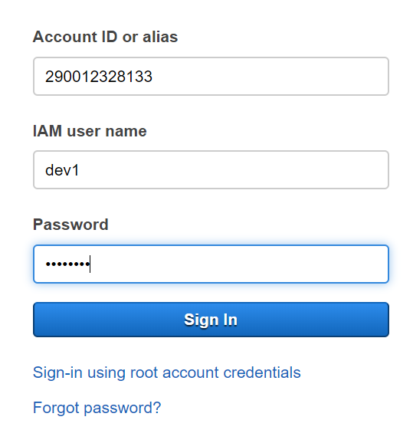

1. It will redirect to change password page

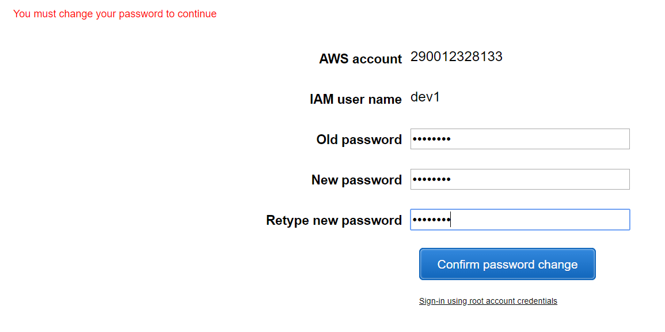

1. It will show the newly created User dashboard & if we try to access anything it will show error message , because you were not part of any Group/Policy

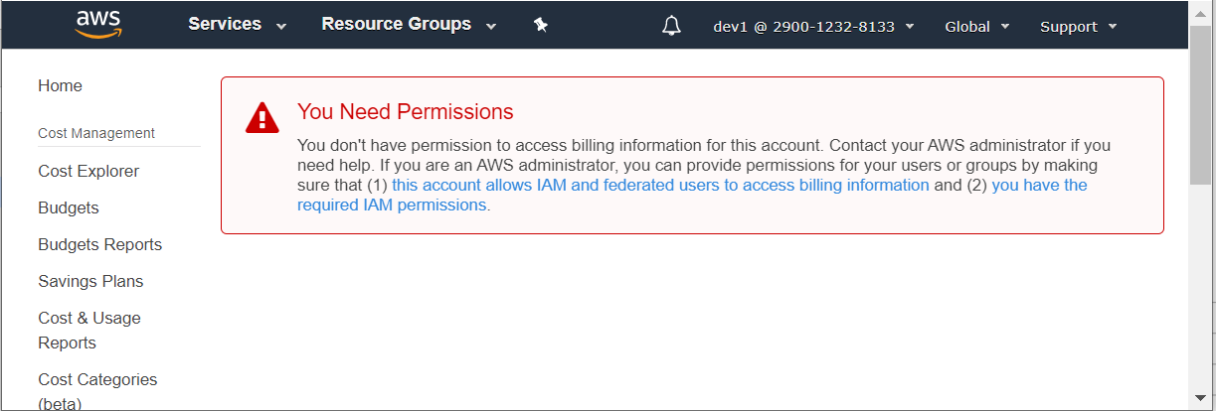

#### Groups Creation

Click On Groups from left > Add Group ([DEV_GROUP, DBA_GROUP, OPS_GROUP]) > Skip policy for Now

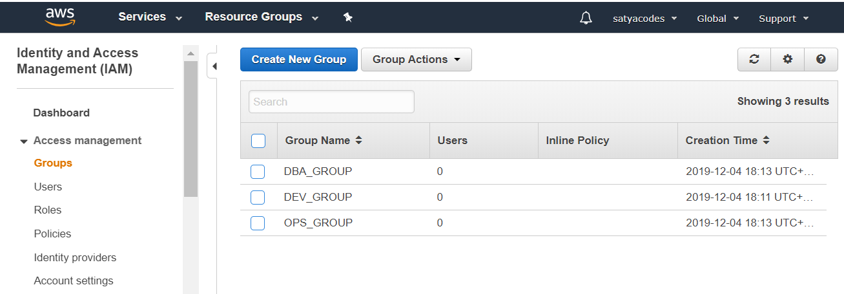

Select Each group & add Users to It

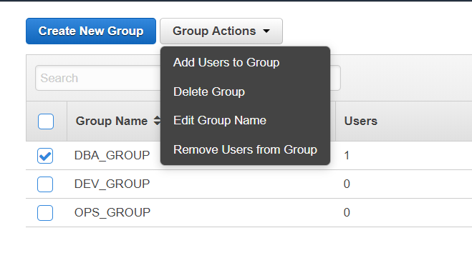

Now Click on Users Tab – Groups will be updated.

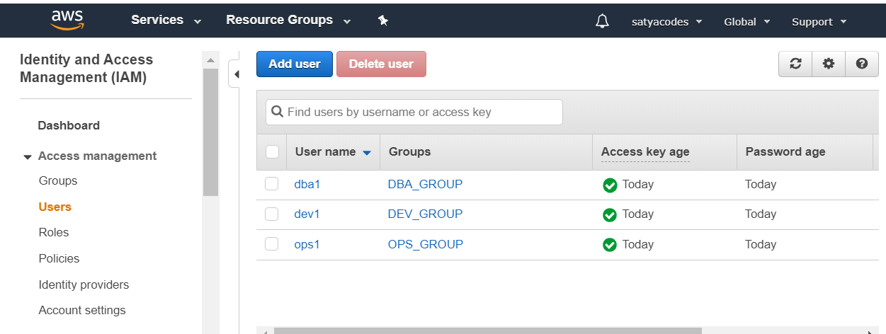

#### Policies

Policies nothing but permissions – what type of permissions user have for the particular service.

Each Group/User should have respective Policy

|  |  |  |  |
| --- | --- | --- | --- |
| **Policies** | **S3** | **DynamoDB** | **VPC** |
| DEV_Policy | Full | Read | NO |
| DBA_Policy | READ | FULL | NO |
| OPS_Policy | READ | READ | FULL |

By default all Users have **IAMUserChangePassword** policy, that’s why users are navigating to change password page after first login.

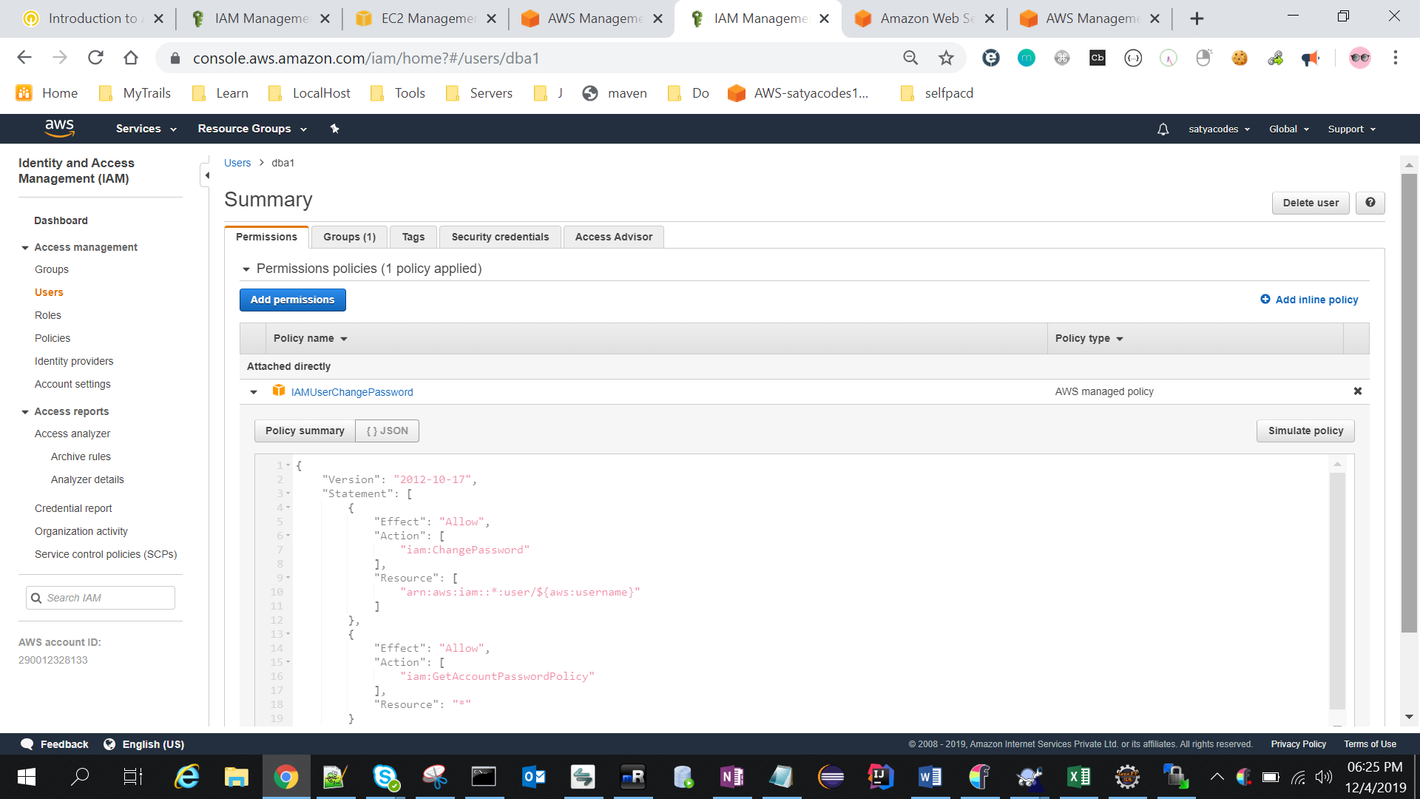

### Lab 3 – Create Role : Application Deployed in EC2 can access S3 Service

Roles assign to Applications but not Users

Create Role : Any Application Deployed in my EC2 Instance can access S3 Service

Go to IAM > Roles > Create Role

Choose the service that will use this role : S3

Add Policy : AmazonS3FullAccess 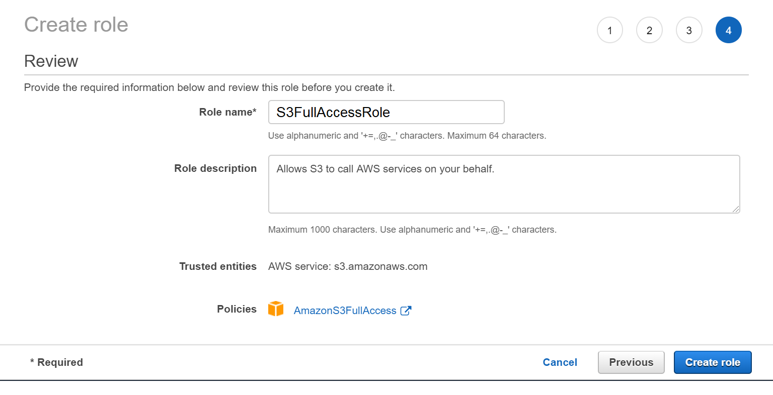

Create Role

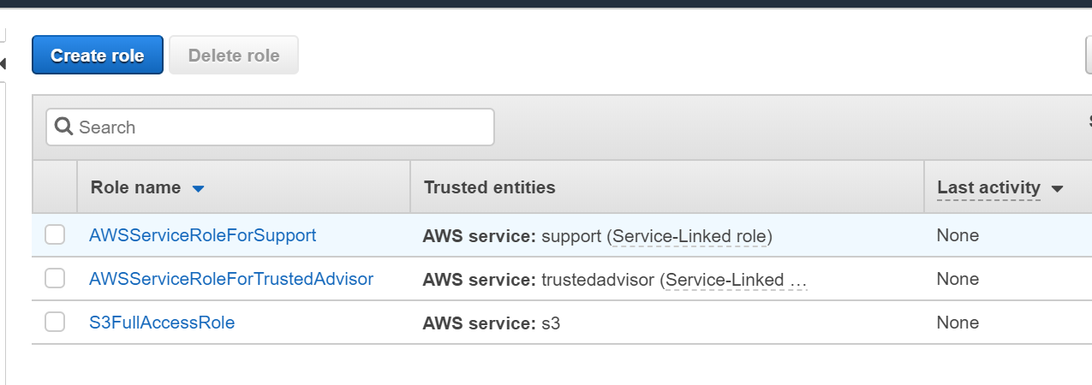

Add Role to EC2 Instace

Services > Compute > EC2

Select Instance > Actions

Add Role : S3FullAccessRole

### Lab 4 – MFA : Multifactor Authentication

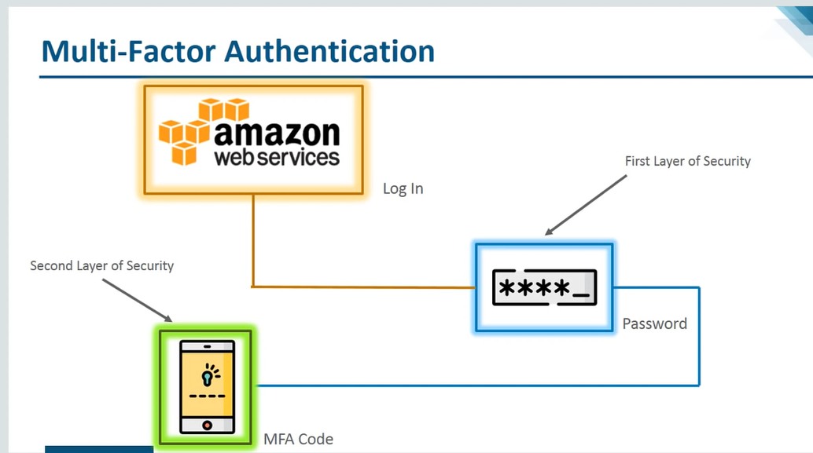

I want assign Multifactor authentication to user “satya”

Install [Google Authenticator](https://play.google.com/store/apps/details?id=com.google.android.apps.authenticator2) on your mobile.

1.Go to Users : Select User> Security > Assign MFA – Manage

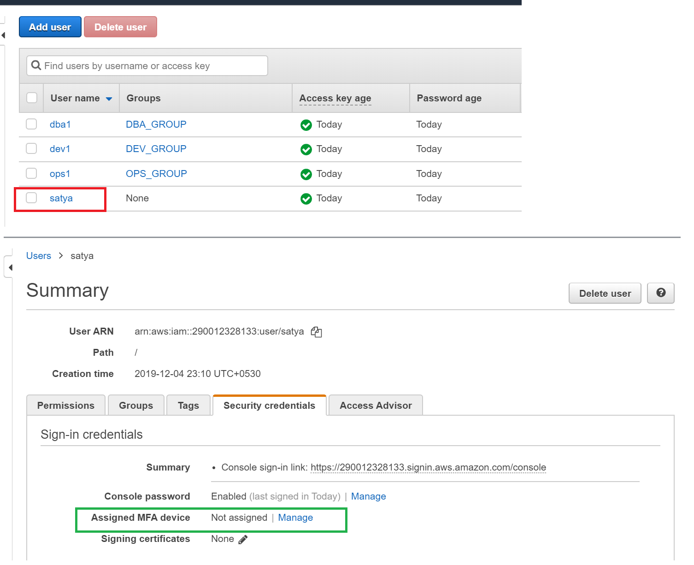

2.Select Virtual MFA Device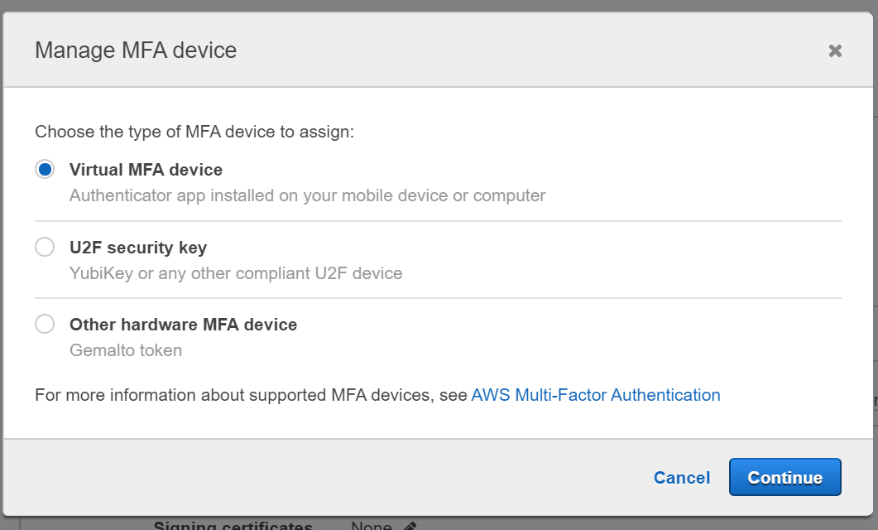

3.Select – Show QR code

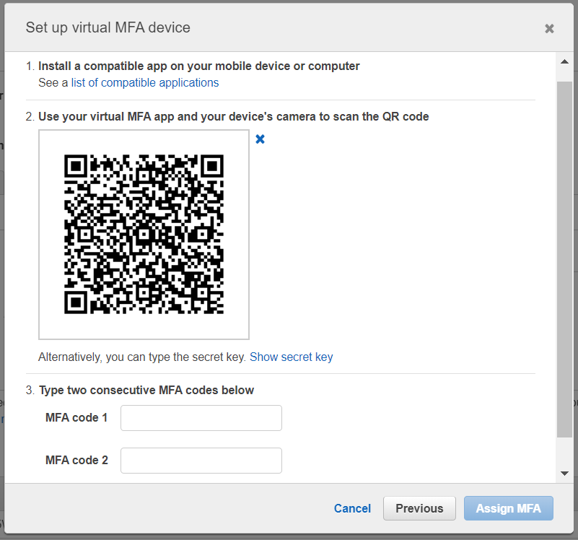

4.open Google Authenticator App > Scan a bar Code > Scan AWS bar code > Enter Codes 1,2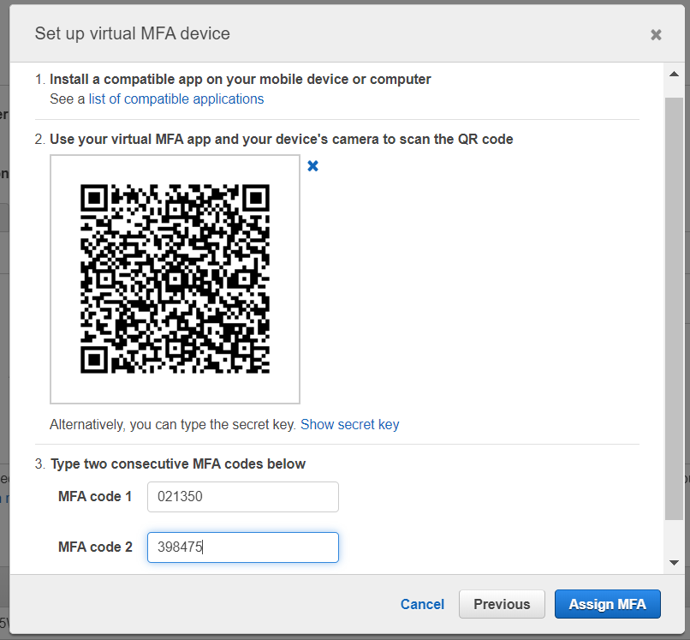

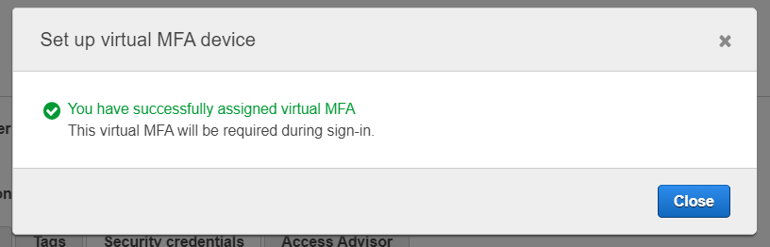

5.Now Logout, and try to Login again 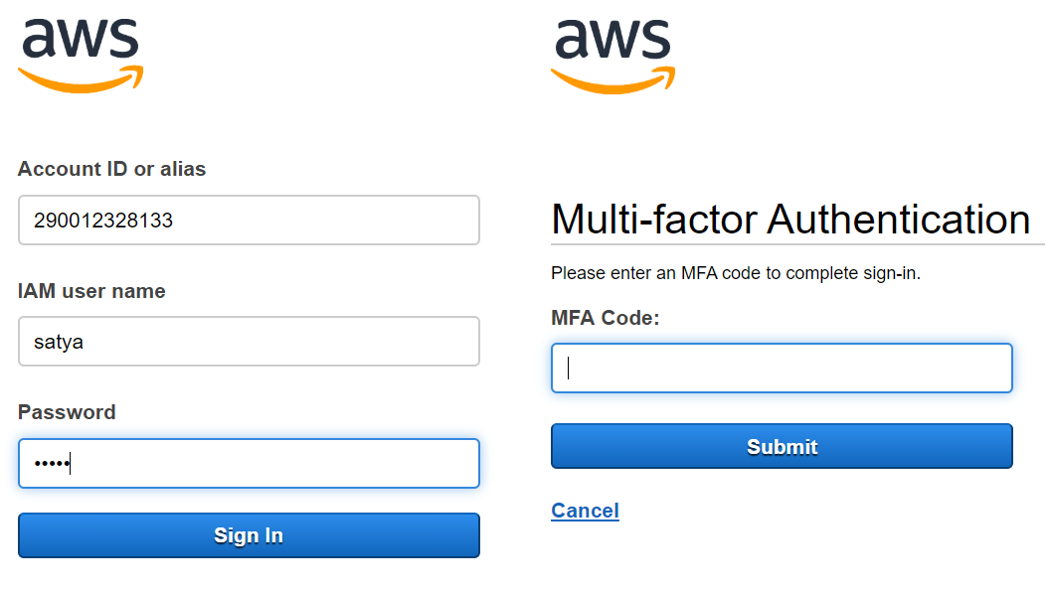

6.it will ask for MFA & enter code from Google Authenticator app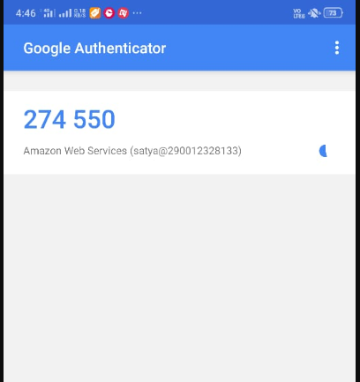

7.Now it will navigate to your dashboard.

## CloudTrail

With CloudTrail, you can log, continuously monitor, and retain account activity related to actions across your AWS infrastructure. CloudTrail provides event history of your AWS account activity, including actions taken through the AWS Management Console, AWS SDKs, command line tools, and other AWS services. This event history simplifies security analysis, resource change tracking, and troubleshooting. In addition, you can use CloudTrail to detect unusual activity in your AWS accounts.

# 2. Storage*

* Simple Storage Service (S3) - First Storage Service
* Glacier - For archive data, not frequent data
* CloudFront - Frequent access data place near to customer
* Elastic Block Store (EBS) - Instance level storage
* Storage Gateway - Access your local storage via VPN
* Snow family - Migrating Local Data
* Block Storage - Local Network, Data stored in Block
* File Storage - Data stored in Object format

Block Storage VS File Storage

Block Storage

* Data Stored in Blocks
* Used on local networks(iSCSI, Fiber Channel, local hard drives)
* AWS can use block storage with virtual machines within the AWS cloud using EBS

File Storage

* Data Stored in Objects
* AWS uses similar, called object storage in S3
* Used with NAS devices locally

## Simple Storage Service (S3)

* S3 is **Object Storage**
* Object can be a file, chunk any thing
* Data saved in S3 bucket, data will Distributes across at least three Availability Zones automatically(Except: 1A (1 zone, least expensive))
* Supports encryption and automatic data classification(S3 to Glacier if data not using for 3 months)

### S3 Concepts

* **Buckets - Container for storing files**
* **Regions** - if we create bucket, we must put it in a region where users can frequently access
* **Objects** - Just Files
* **Keys** - Each Object has a Key. Kind of file name.
* **Object URLs** - Share Object publicly via URL
* **consistency** - It data modified in one region automatically updated in other regions

***Very Good example use of S3 is "static website hosting”, it will have a Object URL***

### How S3 Storage Works

Before adding any data in S3 the user has to create a bucket which will be used to store objects.

* A Bucket is a logical unit of storage in S3(like Folder).
* A Bucket contains objects which contain the **data** and **metadata(Key+version+etc)**.

When you are creating a Bucket keep note about below factors

* Pricing
* User/Customer Location - make sure bucket is near to user access location
* Latency - less distance – good latency
* Service Availability

### S3 Features

#### Prefixes and delimiters

* Making files in S3 is Organized
* When you create a folder in an S3 bucket, It is actually creates “Prefix(/)”

#### Storage classes

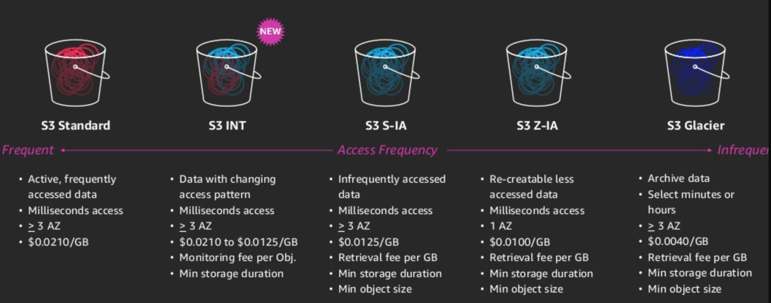

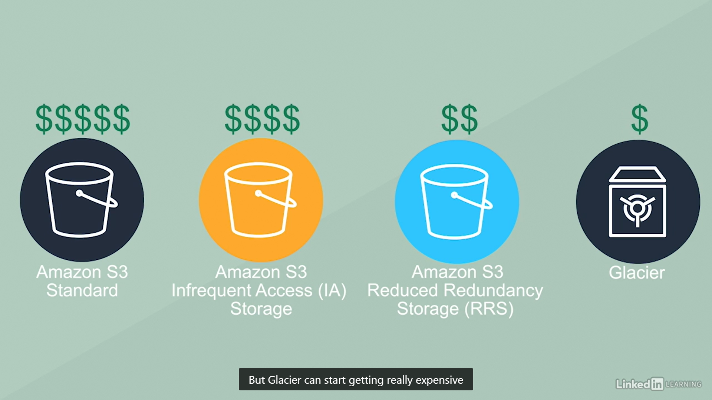

#### Object lifecycle management

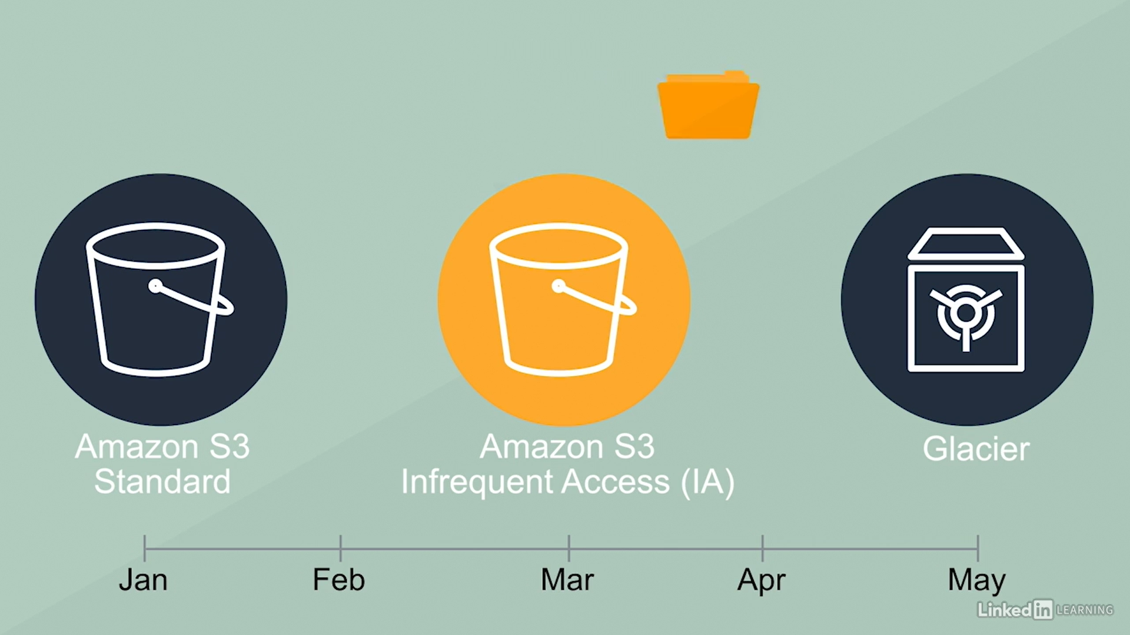

#### Encryption

* Server-side Encryption
* Client-Side Encryption

#### versioning

Versioning automatically keeps up with different versions of the same object. For example, say that you have an object (object1) currently stored in a bucket. With default settings, if you upload a new version of object1 to that bucket, object1 will be replaced by the new version.

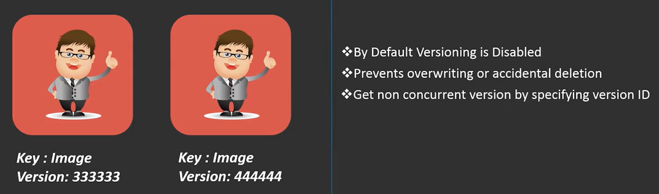

#### Cross region Replication

Cross-region Replicationenables user to either replicate or transfer data to some other location securely and at a faster rate.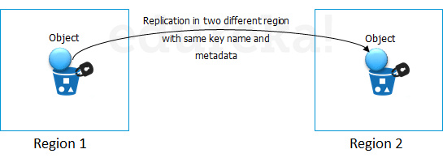

AWS has 2 ways to provide data transfer securely and at a faster rate:

* CloudFront Transfer Acceleration
* Snowball

**CloudFront** is a caching service by AWS, in which the data from client site gets transferred to the nearest edge location and from there the data is routed to your AWS S3 bucket over an optimised network path.

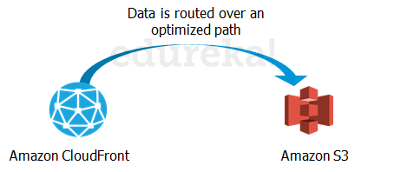

**Snowball** is a way of transferring your data physically. In this Amazon sends an equipment to your premises, on which you can load the data. It has a kindle attached to it which has your shipping address when it is shipped from Amazon. When data transfer is complete on the Snowball, kindle changes the shipping address back to the AWS headquarters where the Snowball has to be sent.

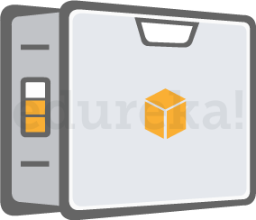

### Lab 1 – Create a New Bucket

1.Services > Storage > S3 – Create a New Bucket

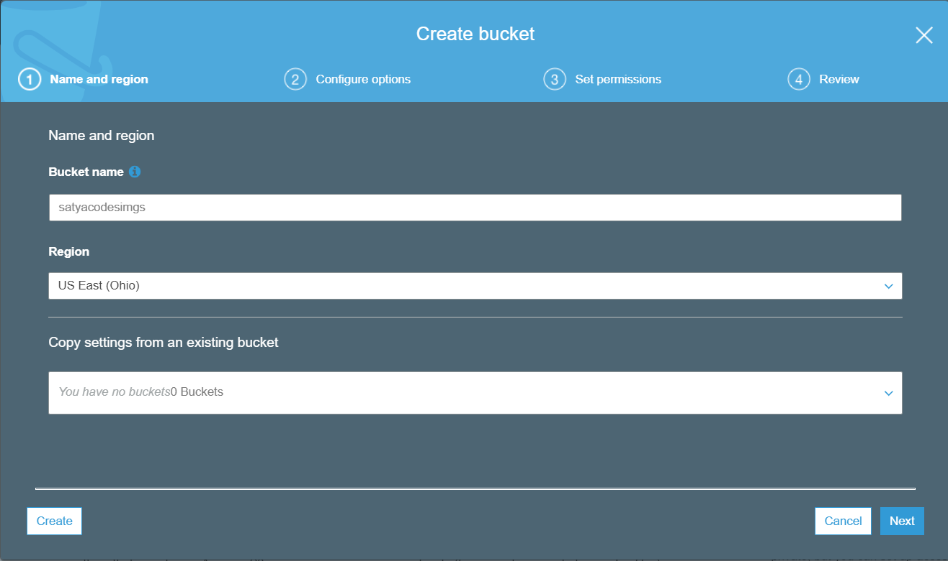

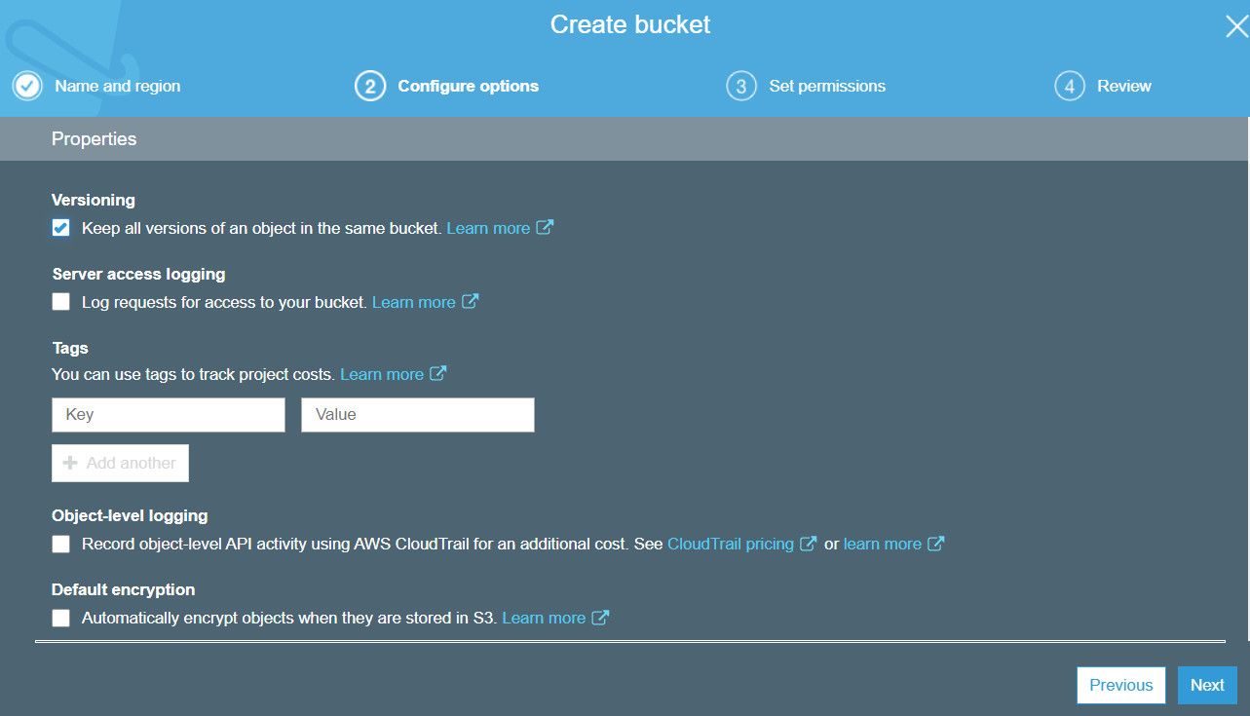

Finally – Create Bucket.

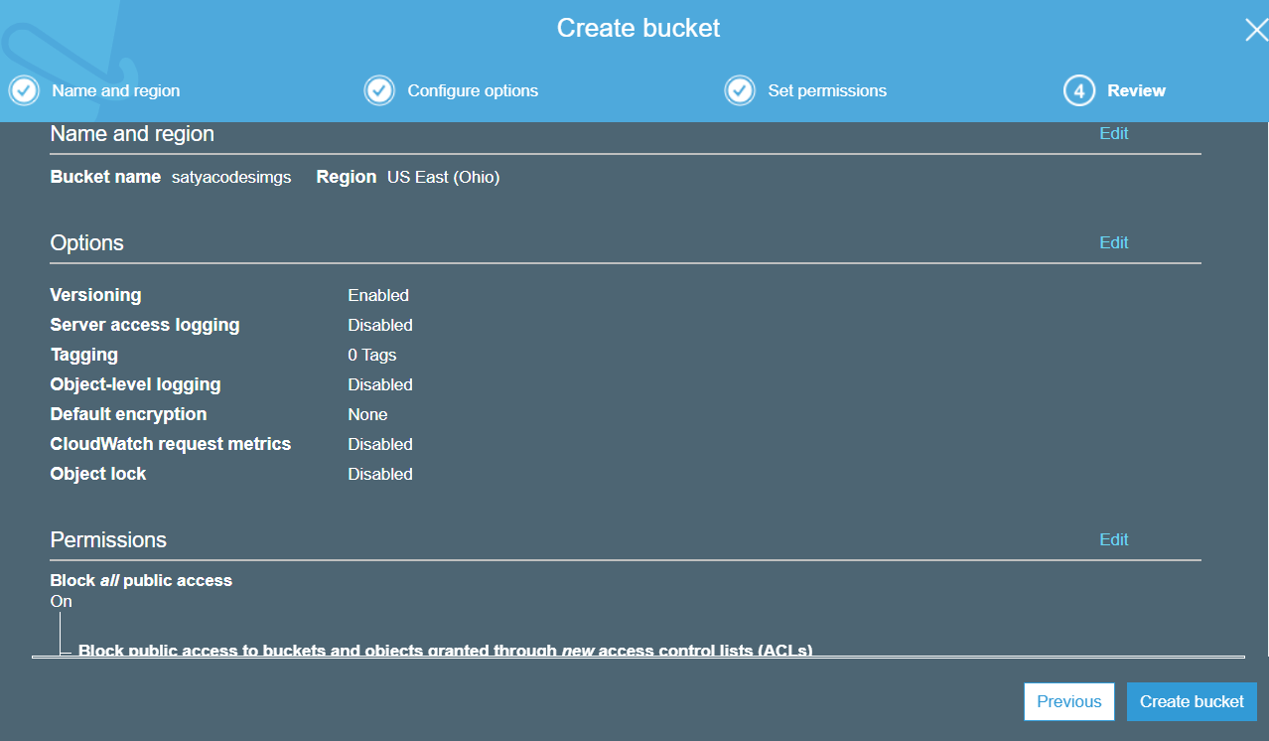

Bucket Created

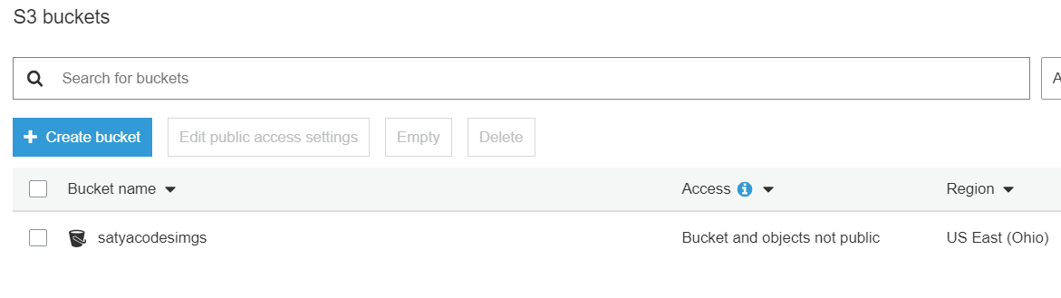

#### Add image to Bucket

Select Bucket > Upload > Add Files

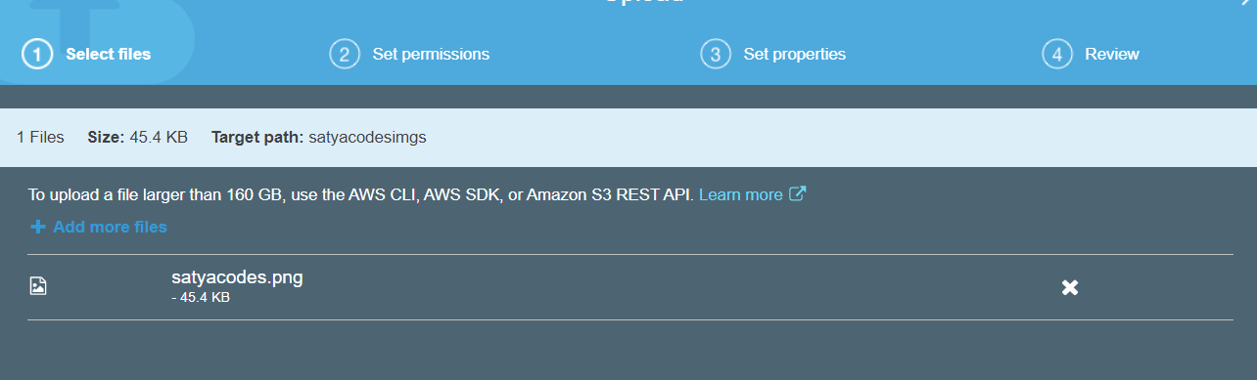

Select Storage class Type – Standard

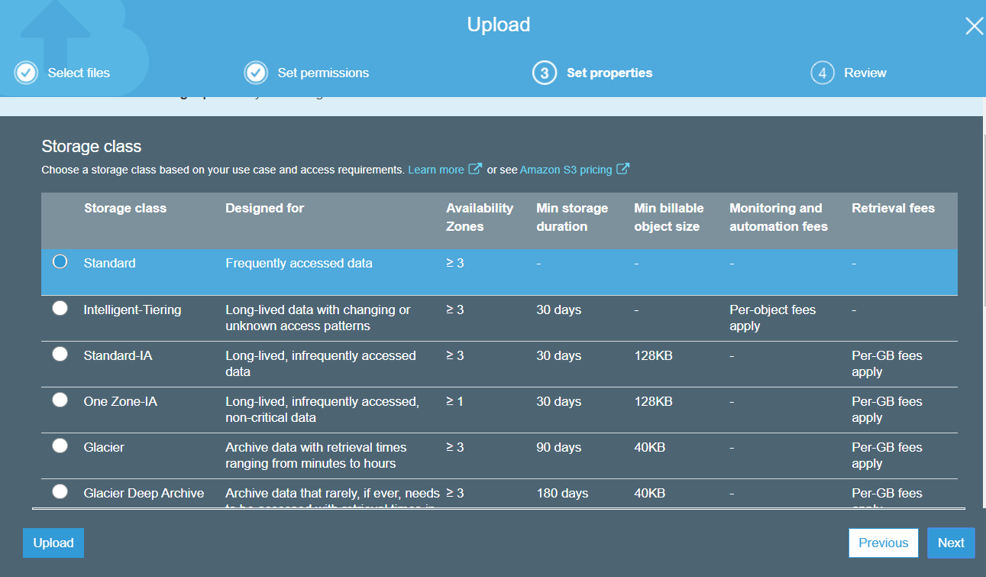

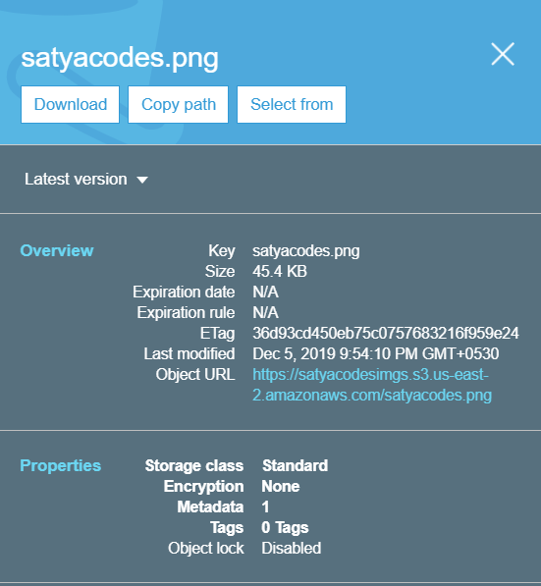

### Lab 2 – Move Data from one Bucket to another Bucket

Select Bucket > Management > Replicastion

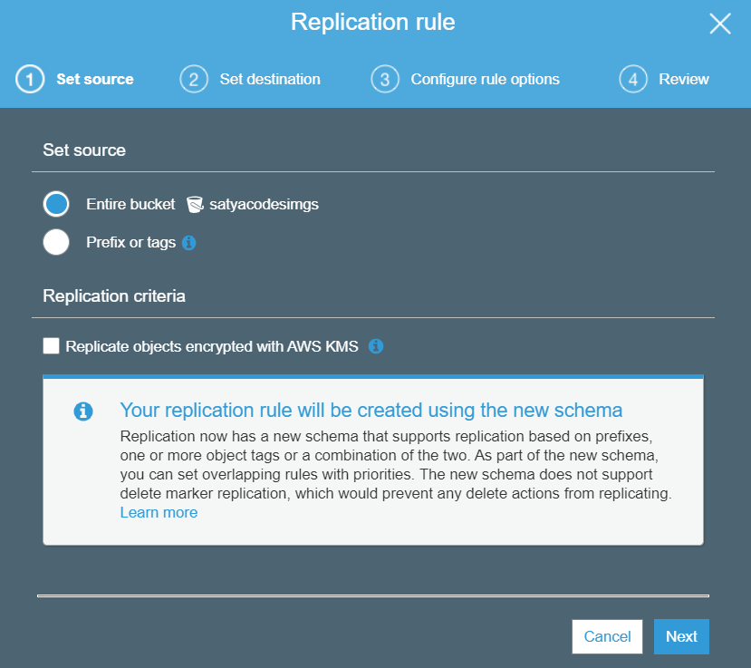

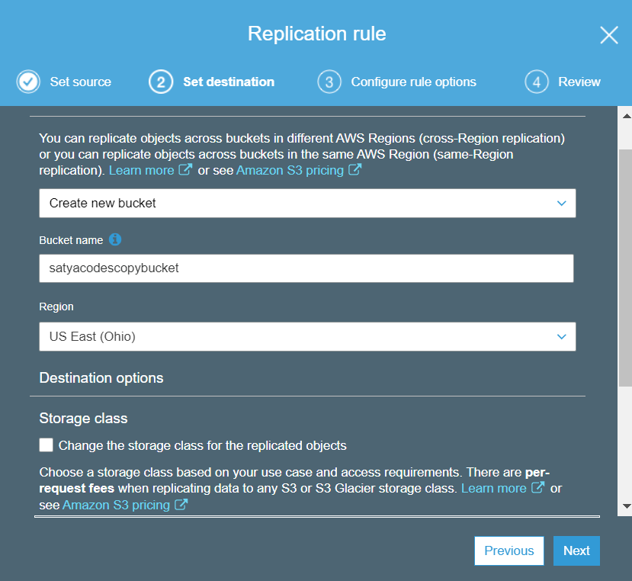

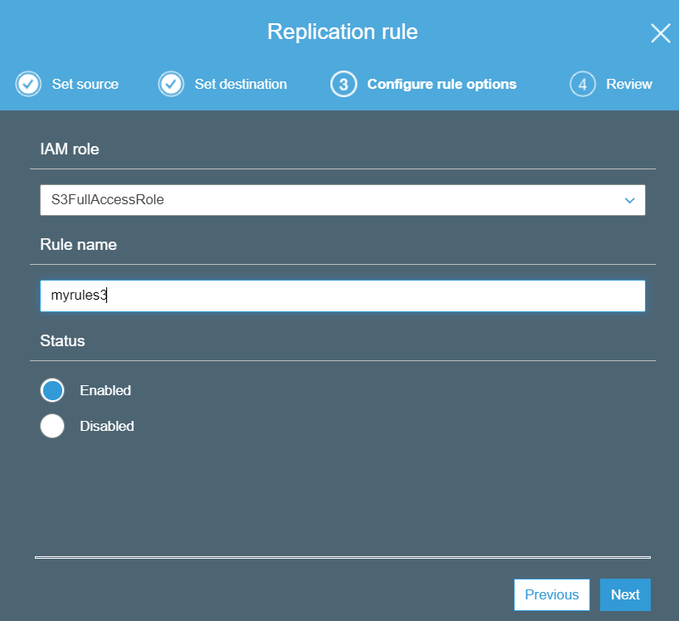

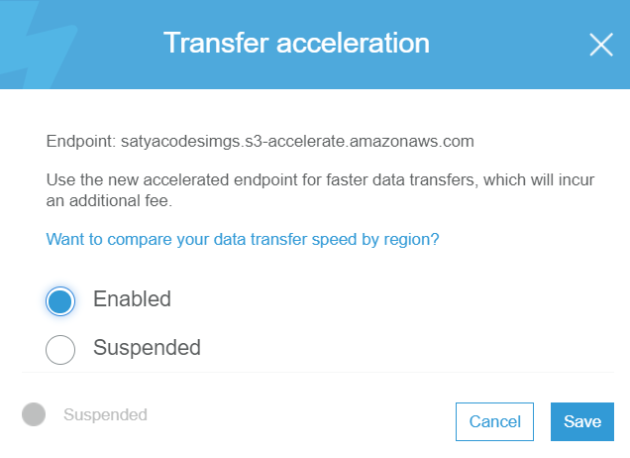

### Lab 3 – Hosting a Static Website on Amazon S3

1.Create a bucket with domain name recommended.

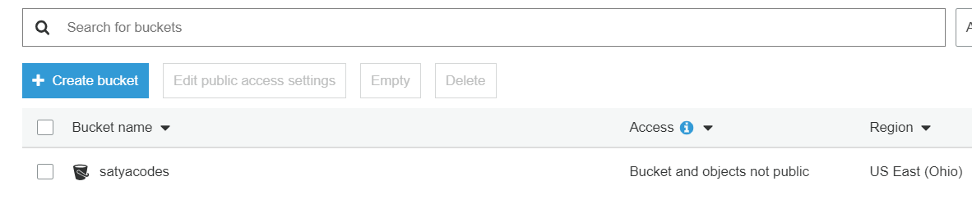

2. Enable Static Website Hosting from the properties panel on the right.

- set index.html & save

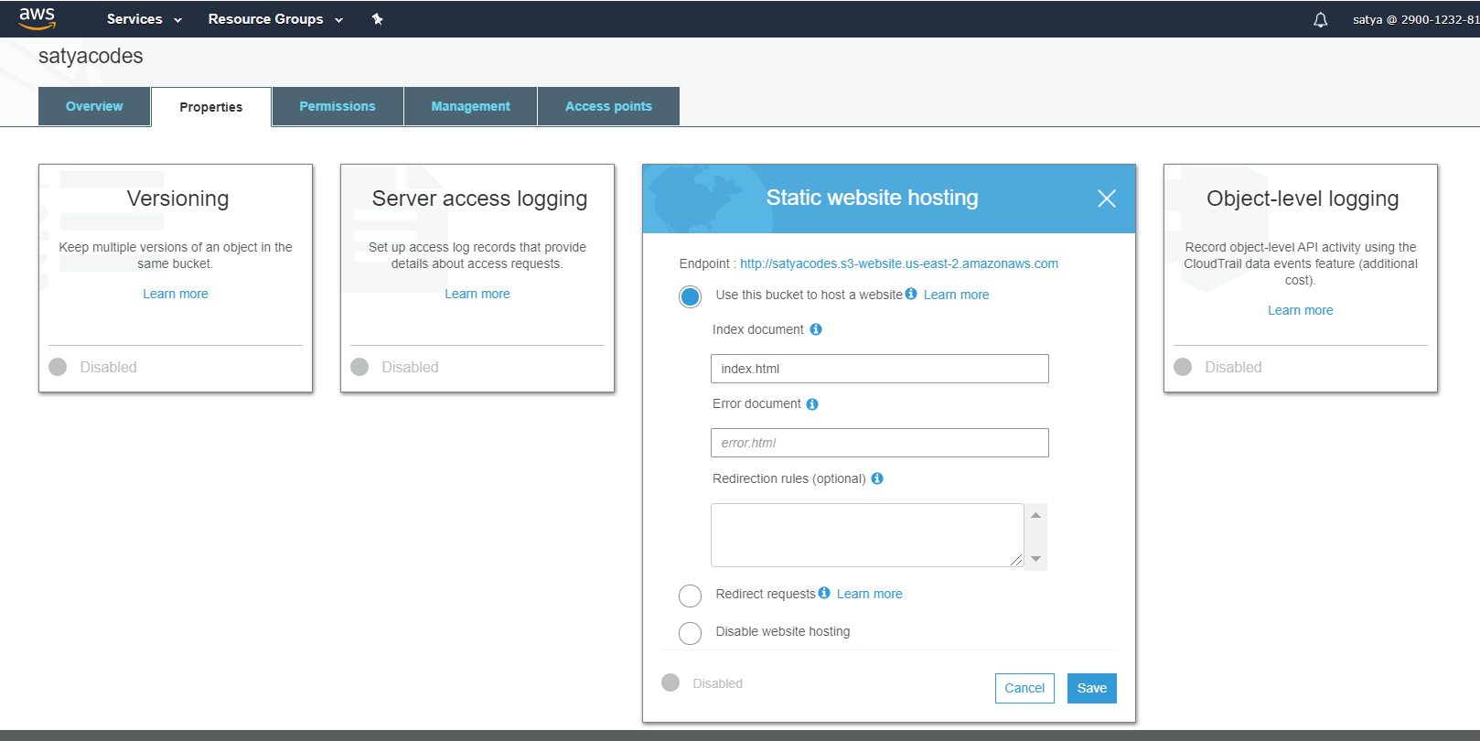

3. Upload the Files in a Bucket

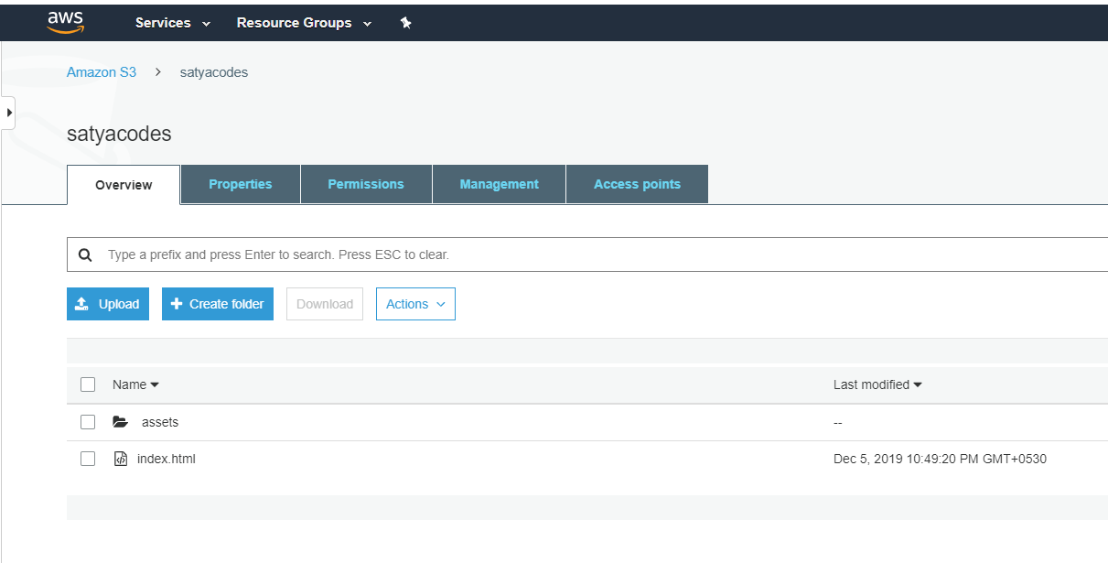

4. Make the Html File Public

- unselect Block public access

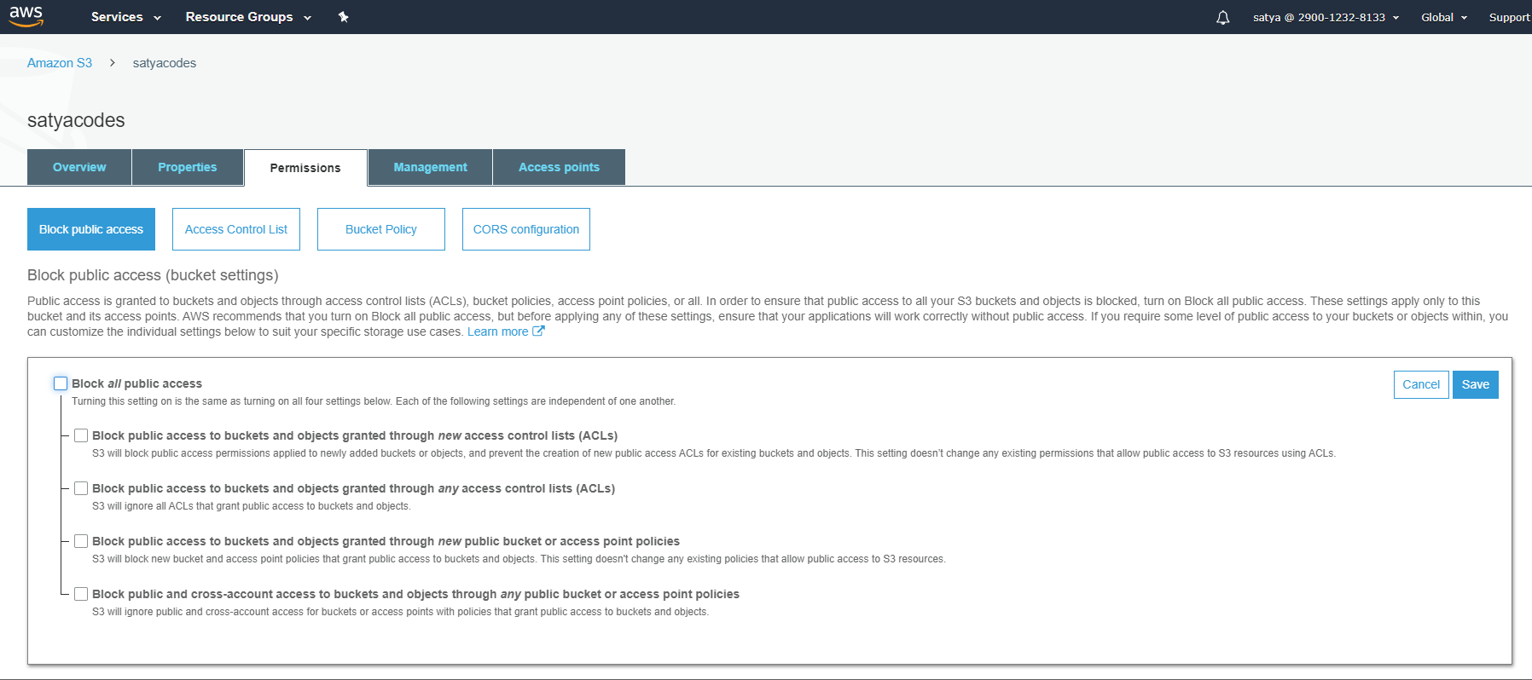

Select files > Actions > Make files public

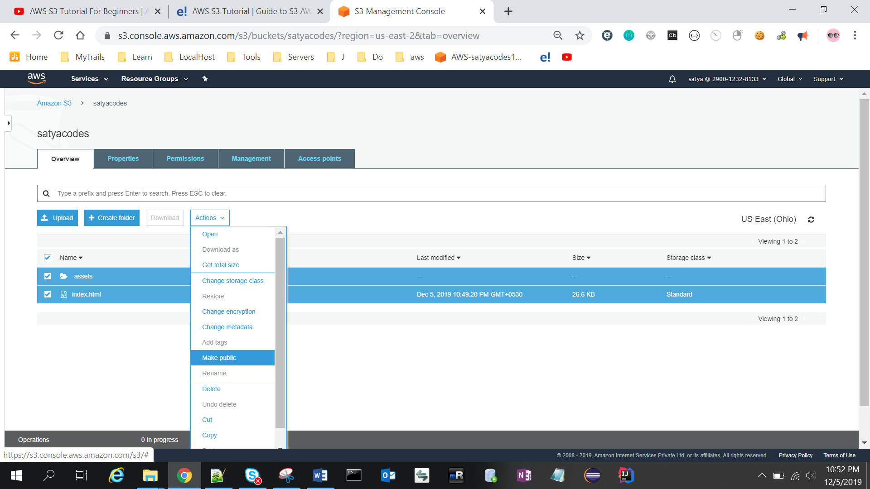

5. Now, select index.html in the console and go to the Properties tab

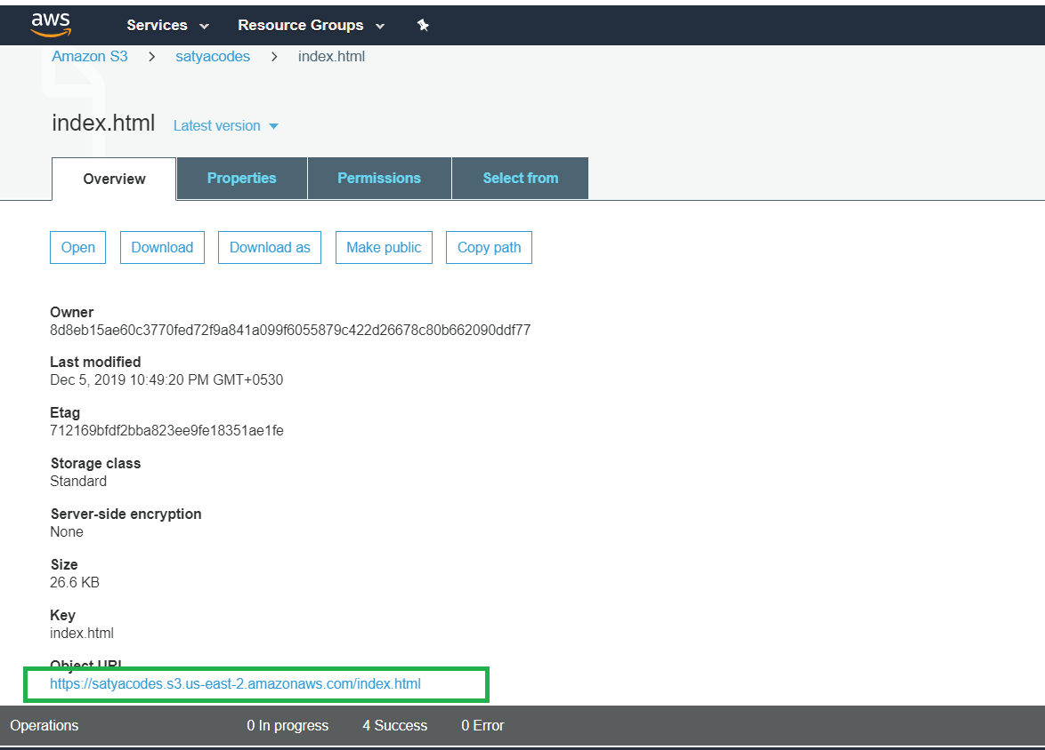

6. Clicking the link will take you to your new homepage

<https://satyacodes.s3.us-east-2.amazonaws.com/index.html>

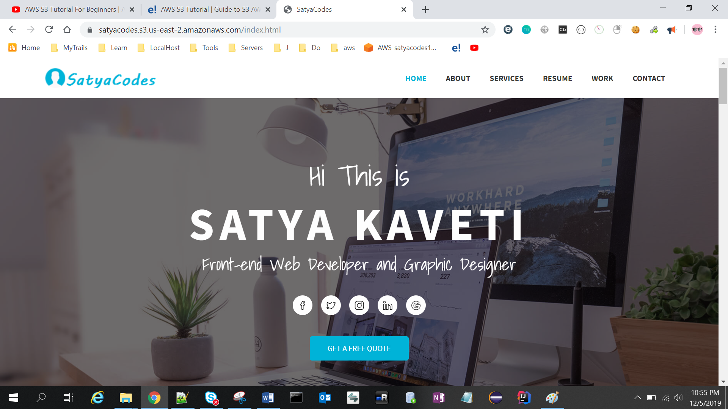

### Use Case – IMDB Media

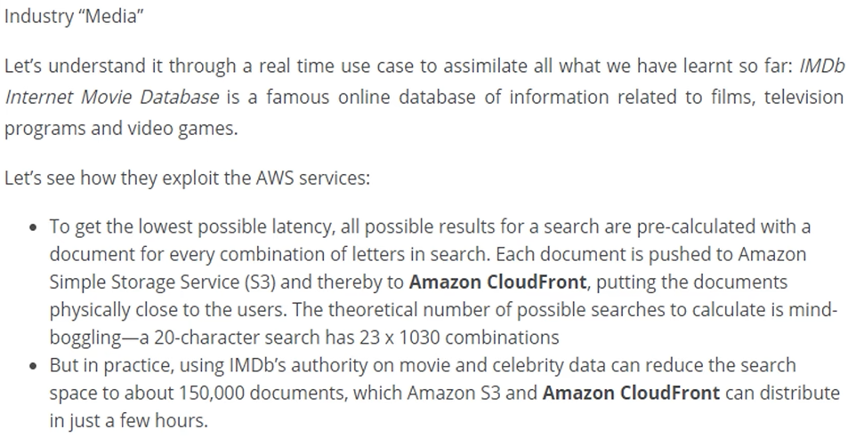

### Lab – Hosting WordPress Using Amazon S3

## Glacier

* Archival data storage
* Less Cost
* takes Hours to retrieve data
* Three access methods
  + Expedited (3‐5 minutes)
  + Standard (3‐5 hours)
  + Bulk (5‐12 hours)
* You define the Region for data storage
* Data stored with AES 256‐bit encryption default

### Save Data in Glacier

* S3 older data can be automatically moved into Glacier
* Snow devices(USB, Hard Disks) can be used to import data to Glacier
* Storage Gateway(Local Data) can connect to Glacier

### Glacier Concepts

* Archives - In S3 we call as Object(files), here file is an "archive"
* Vaults - Same as Bucket in S3
* Vault locks - Securing Vaults
* Data retrieval Cost
  + Up to 5% retrieved at no charge, no rollover
  + Vault can be configured to limit costs

### Lab – C

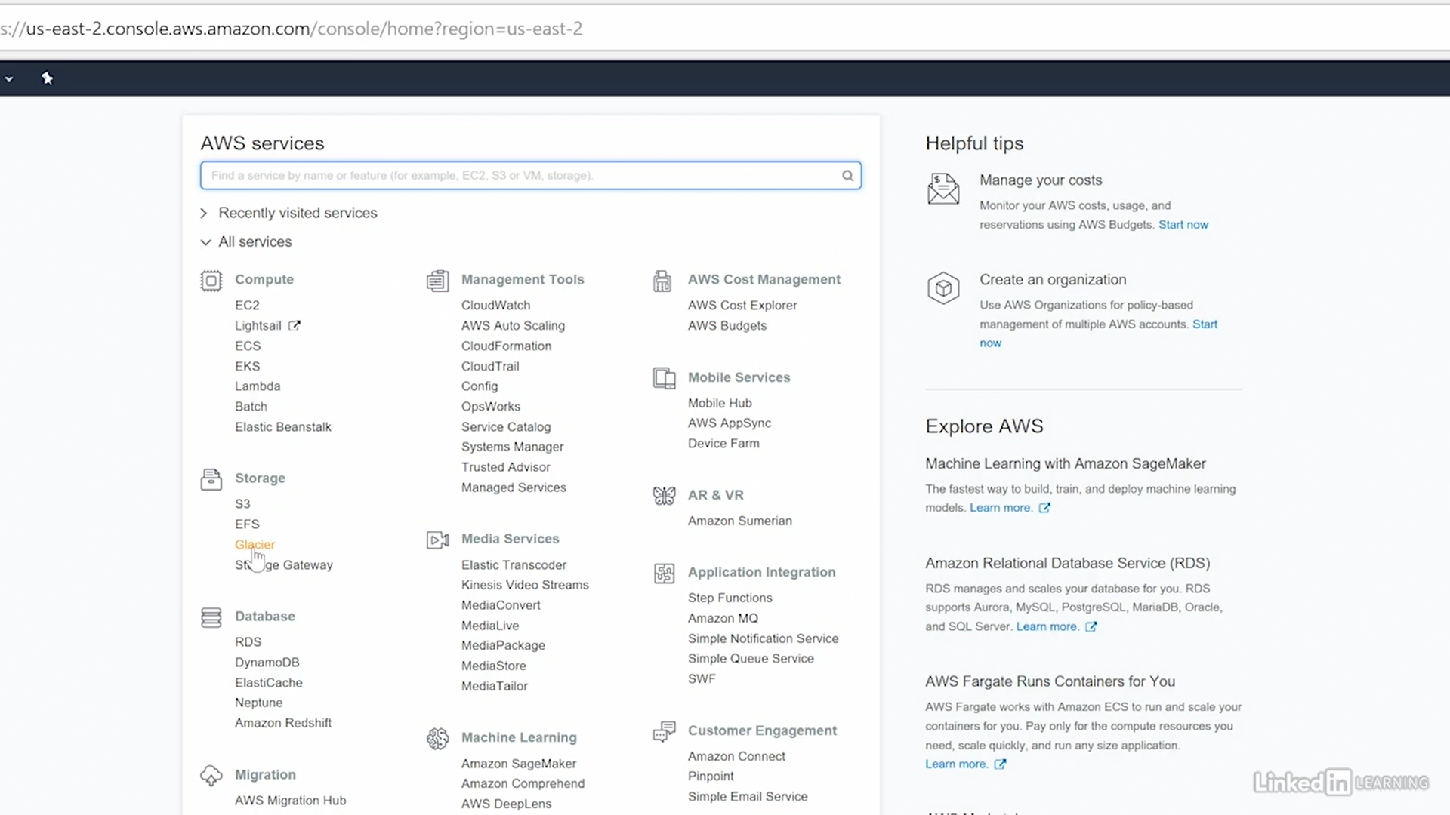

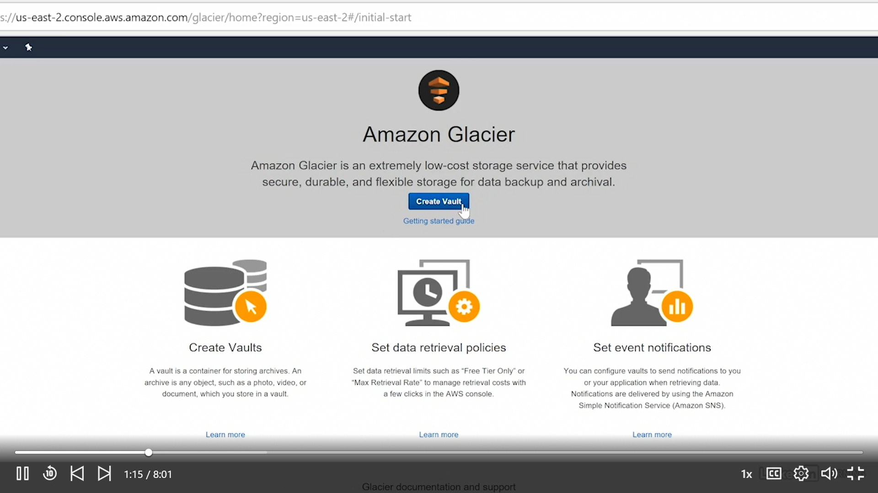

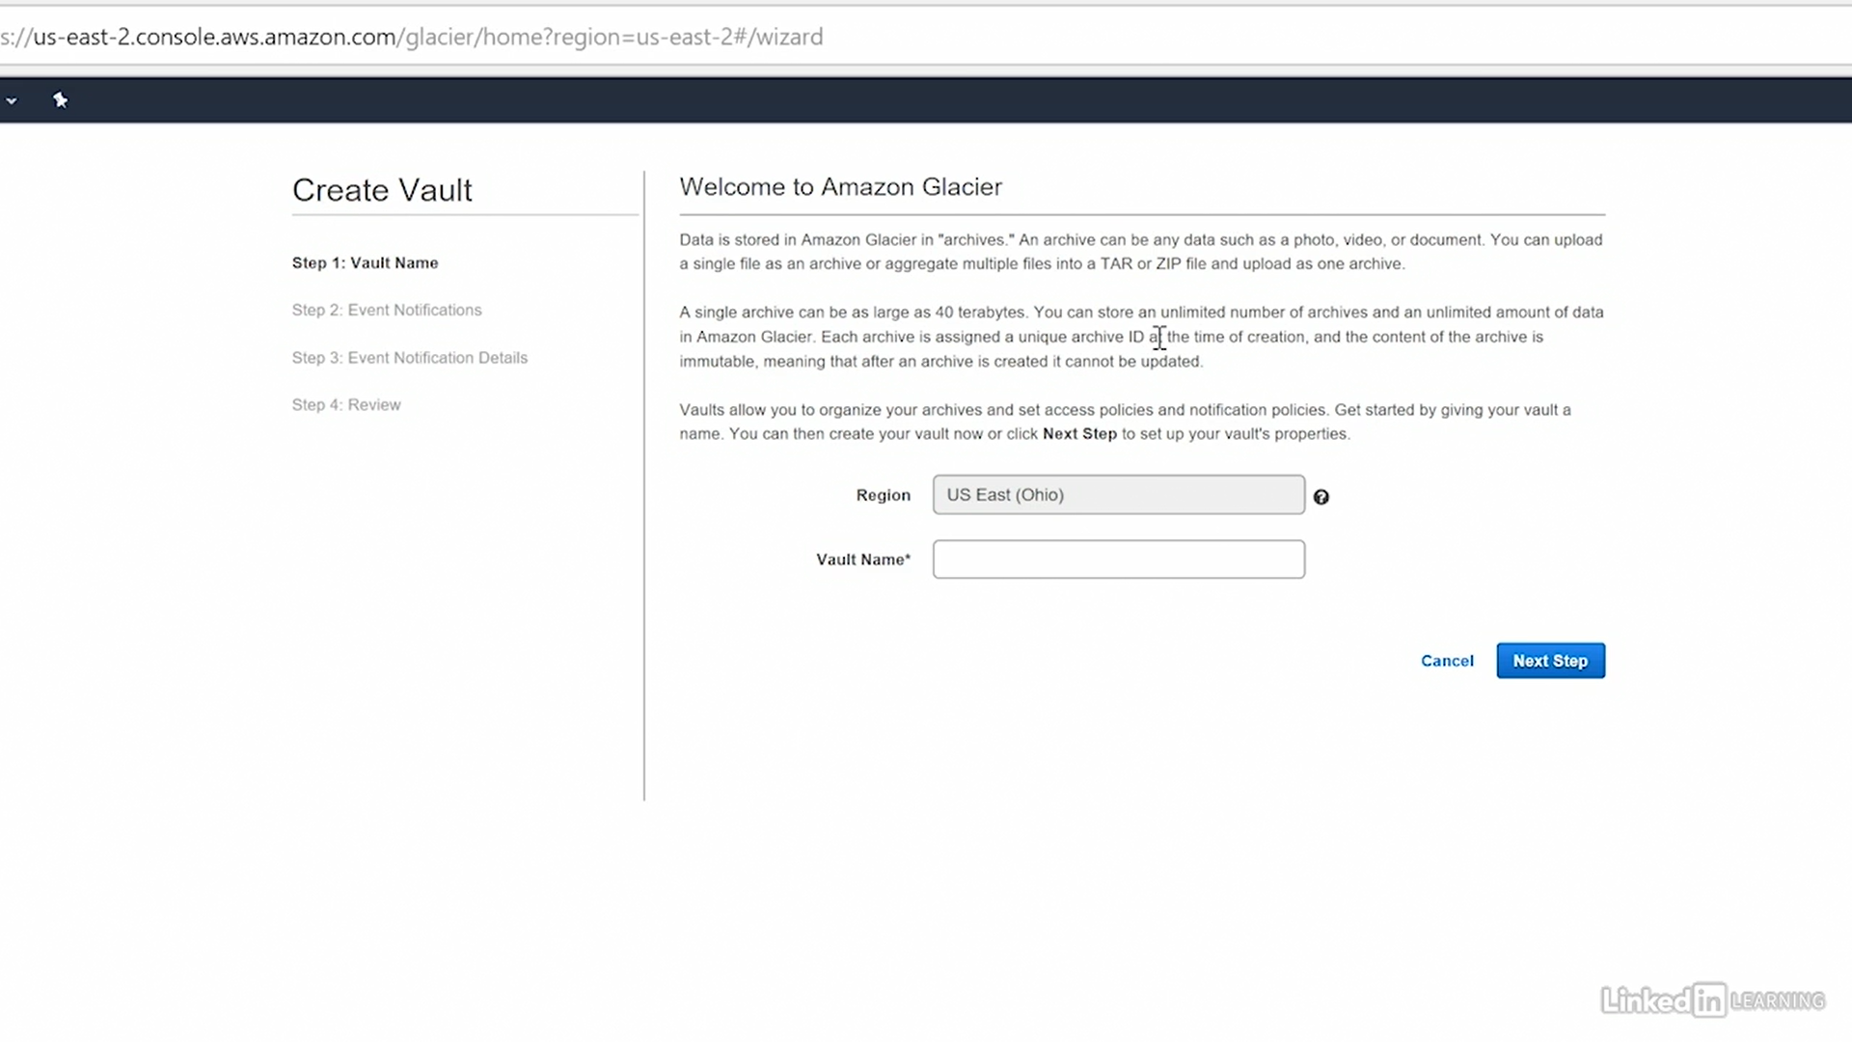 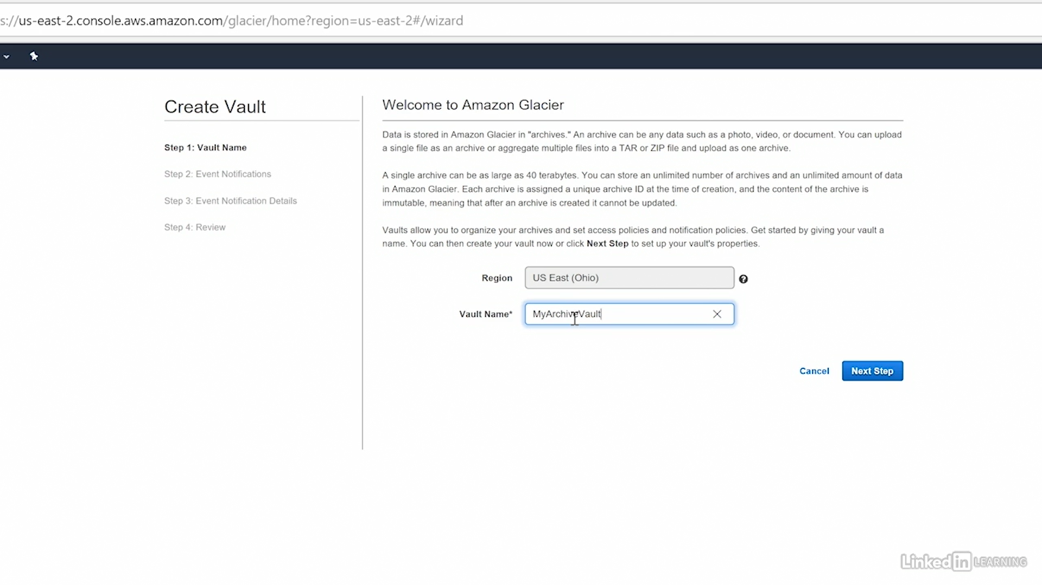

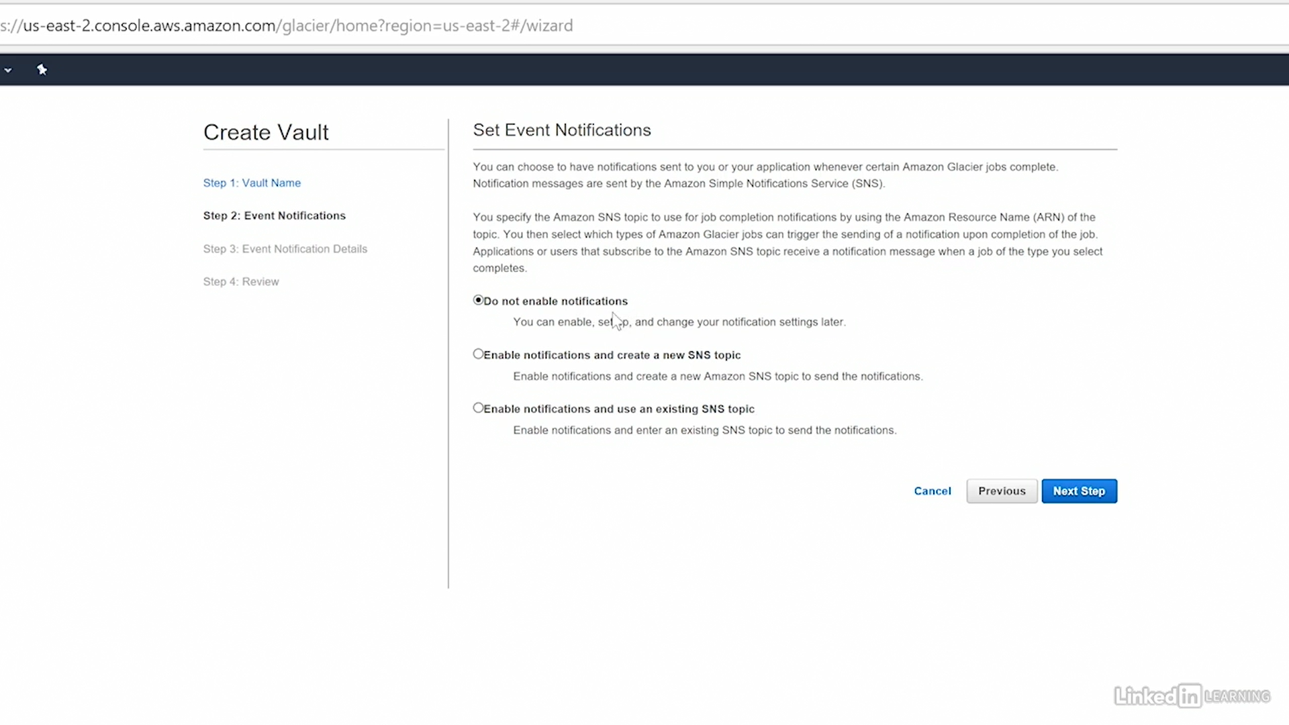 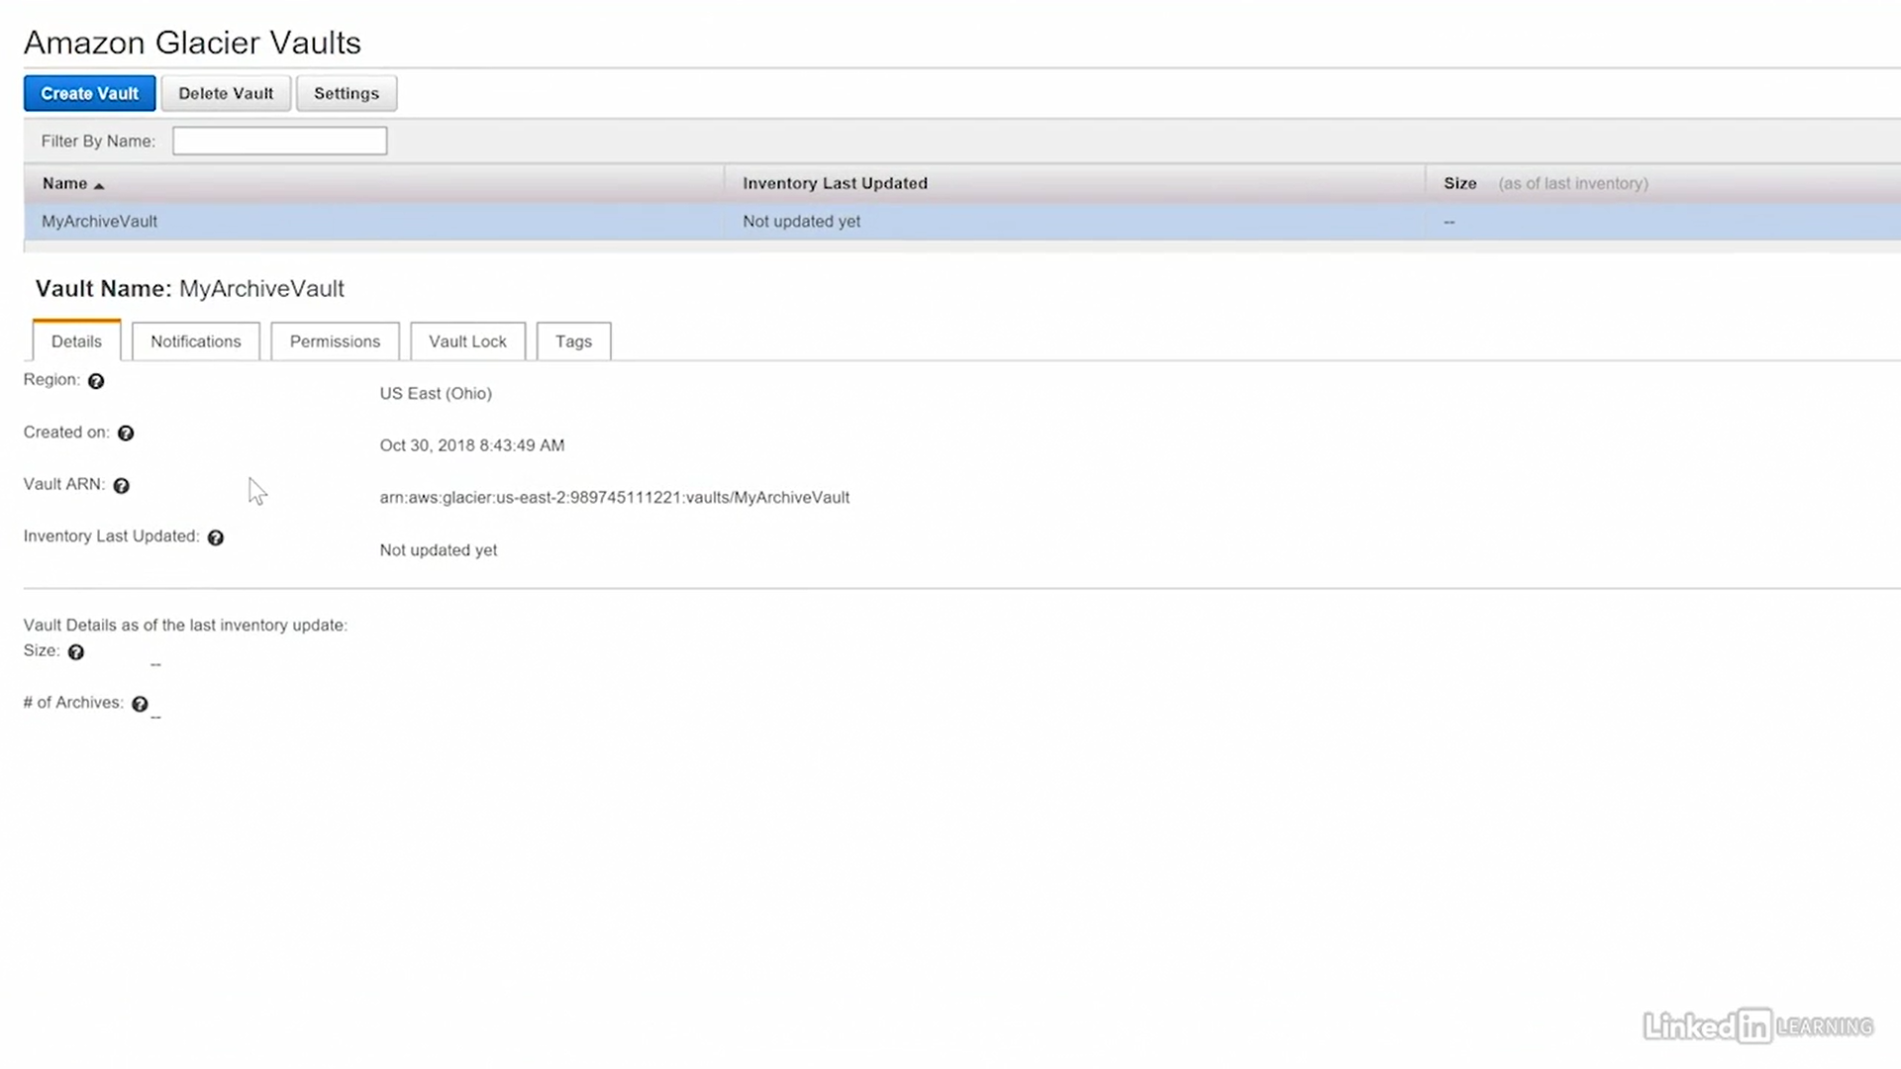

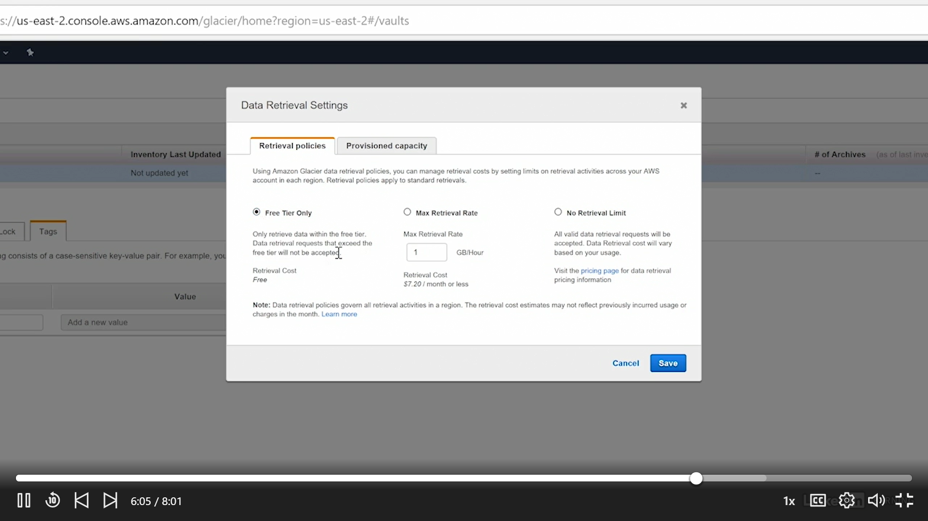

## Elastic Block Store (EBS)

We use USB's, Hard Disks to save/retrieve data in our Laptops& computers. Similarly AWS instances uses EBS for that purpose, Block by Block

* Used for durable(saving state) storage in EC2 instances
* Block level storage from one AWS service to another

EBS comes under “Compute”, because we use along with instances

### EBS Volume Types

* Magnetic -Lowest cost & slowest
* SSD (solid state drive) - Fast, below are various types
  + General purpose
  + Provisioned IOPS(input/output operations per second )
  + PIOPS (provisioned input/output operations per second)

### EBS Data Recovery

* Snapshots - Creating Image with Current State.
* Volume recovery - Attaching volumes from one instance to another

### Lab

EBS comes under “Compute”, because we use along with instances

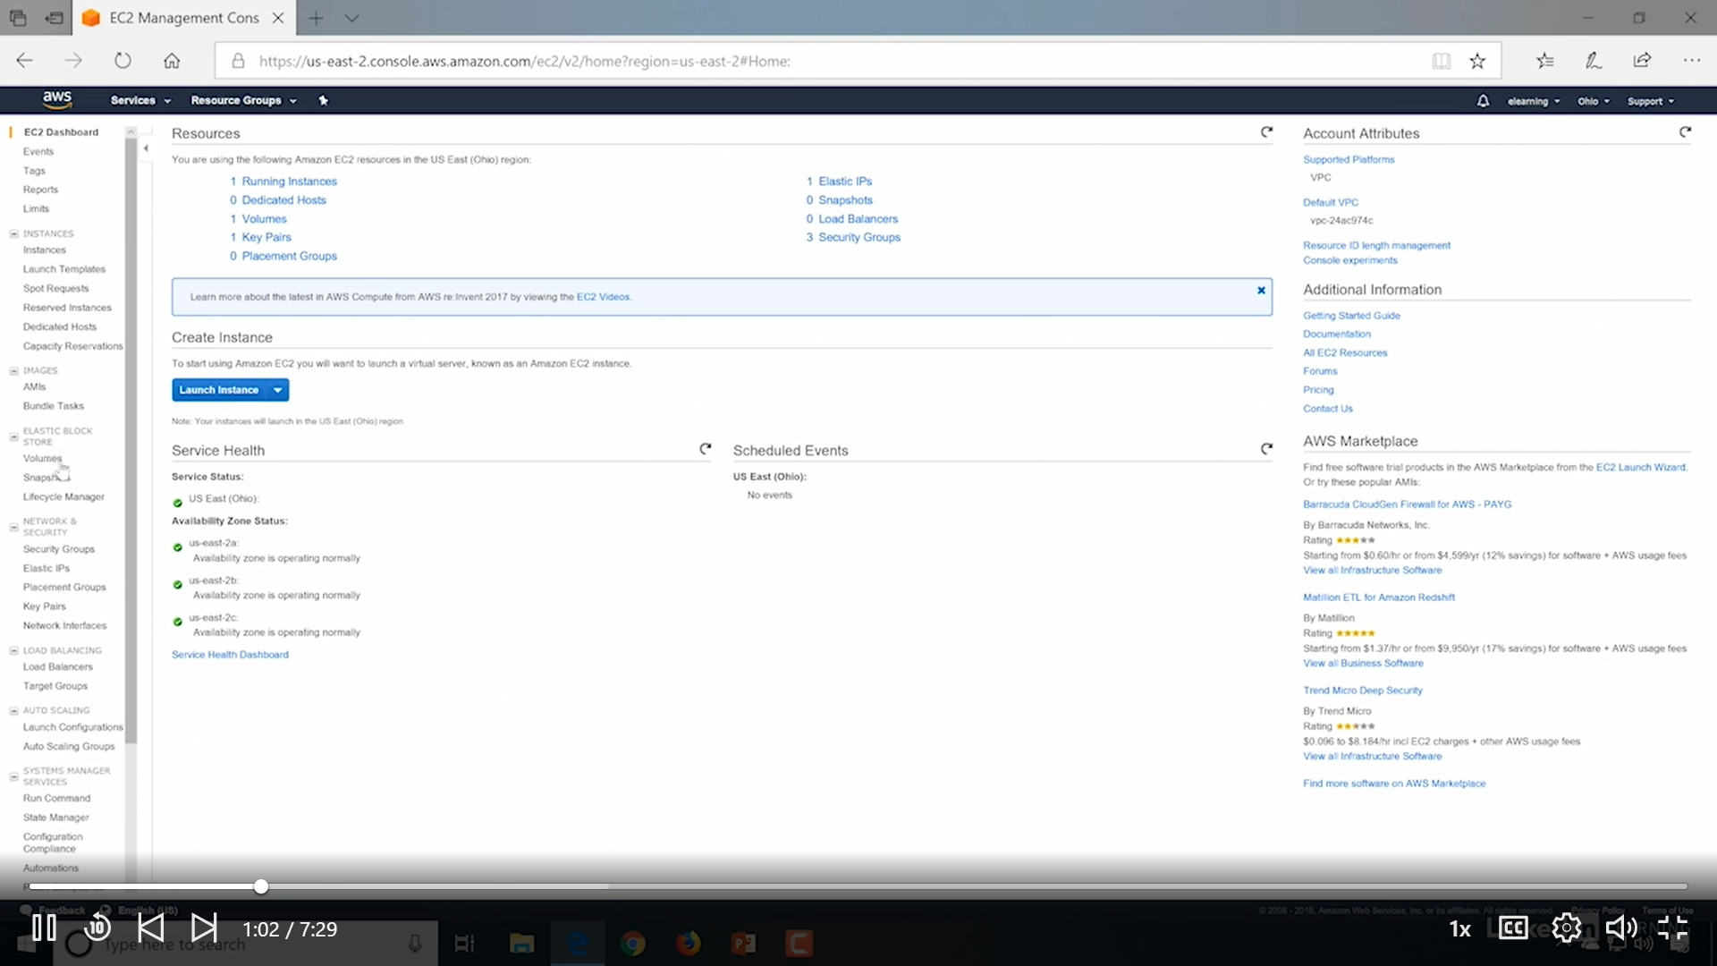

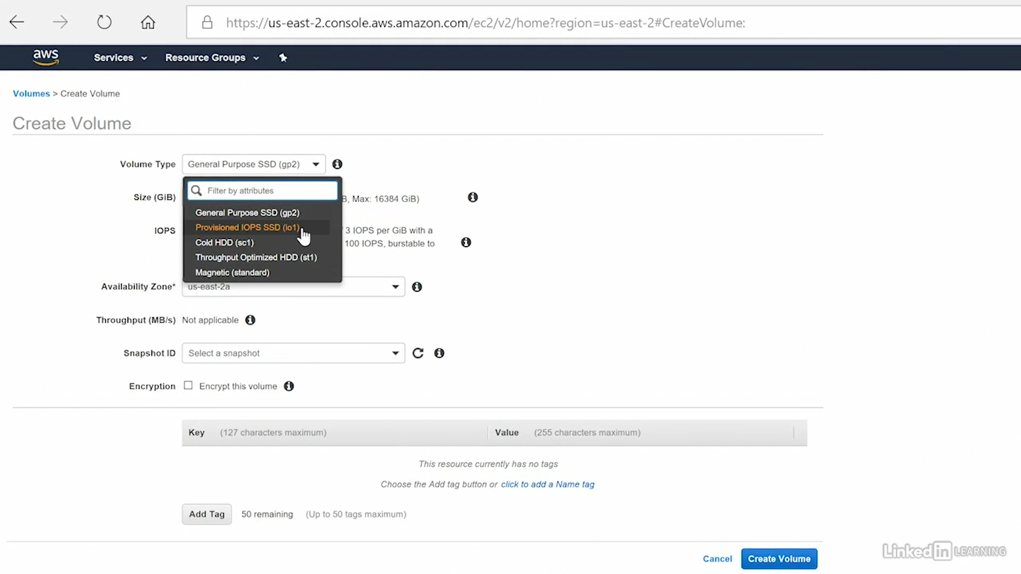

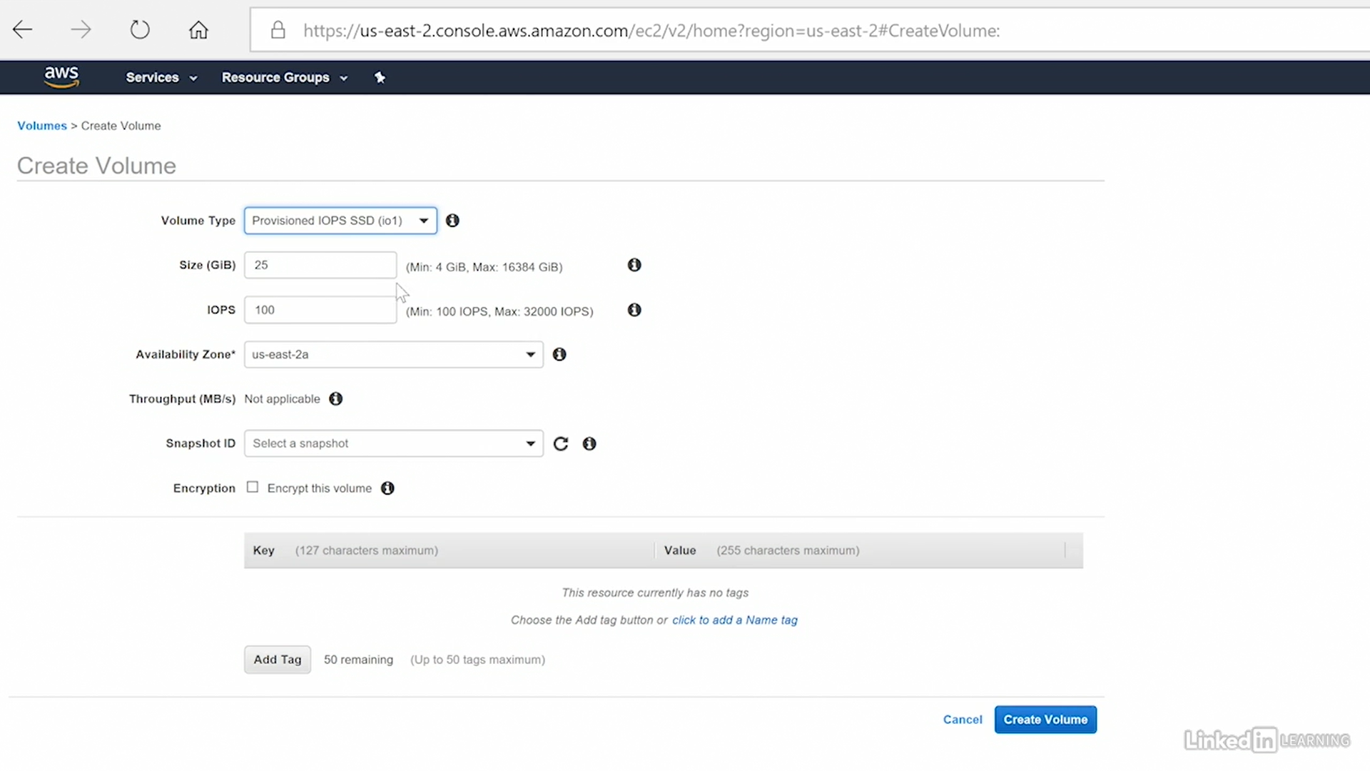

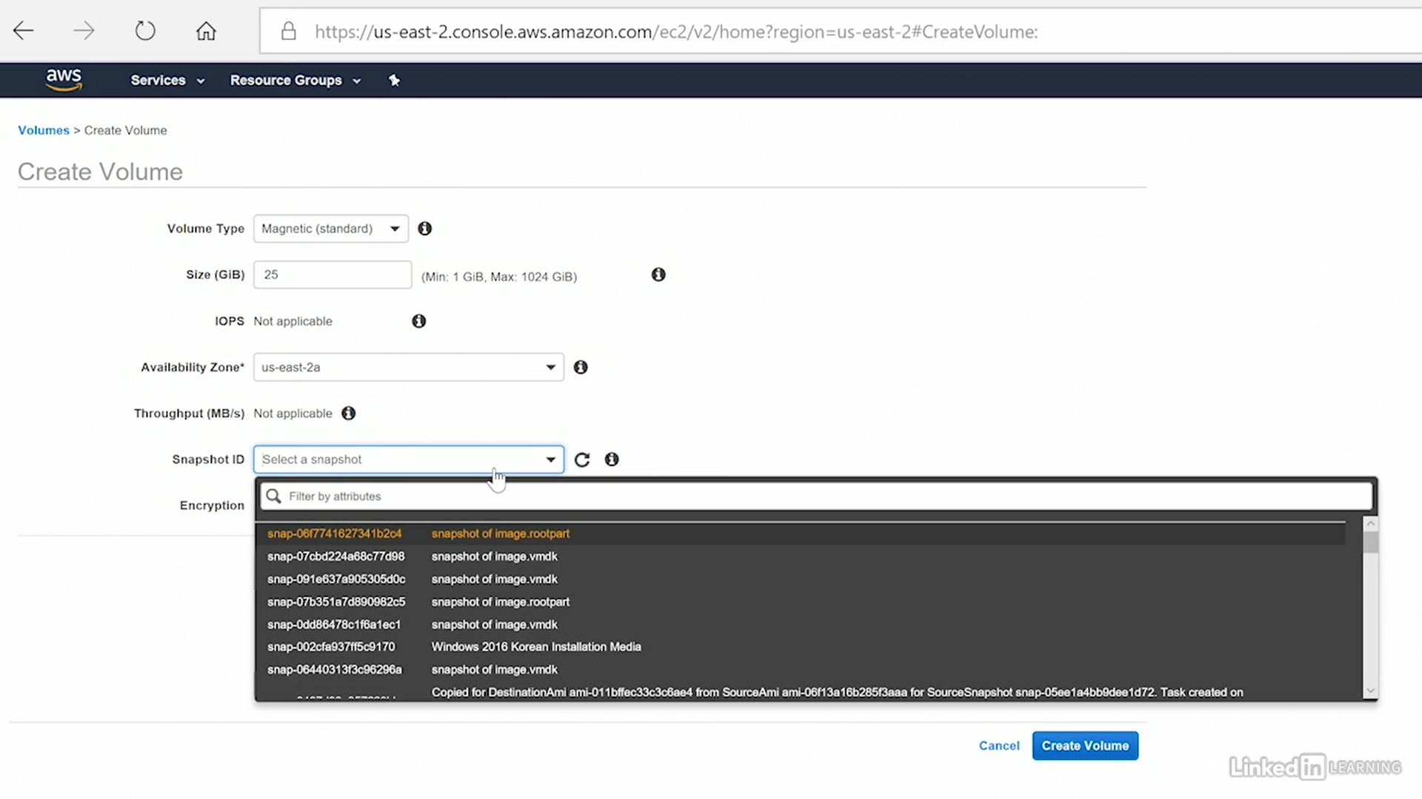

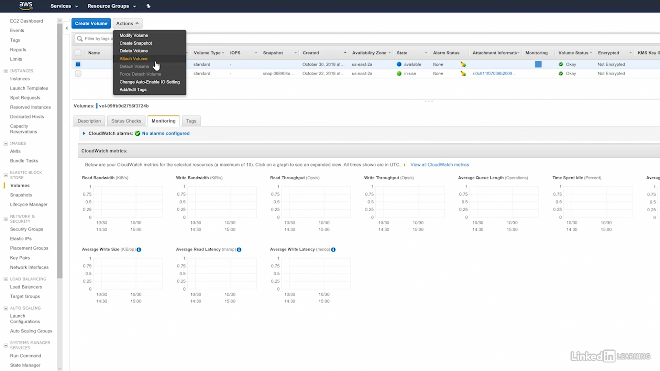

## Elastic File System (EFS)

* **Shareable** - multiple instances can access same time, but EBS only single instance can access at a time
* **Hierarchical** - Folder hierarchy is there
* EC2 instances can use EFS shares
* EFS is **not supported on Windows instances**

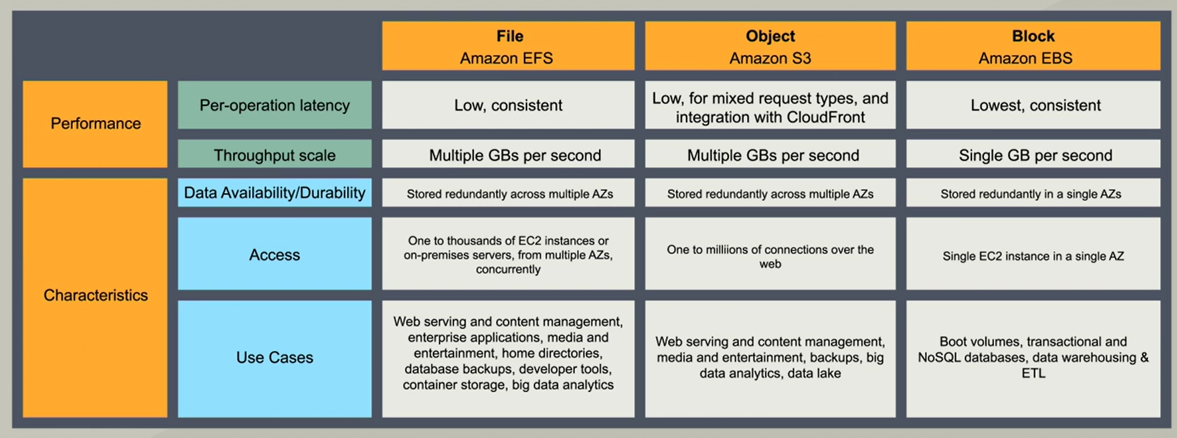

### Lab

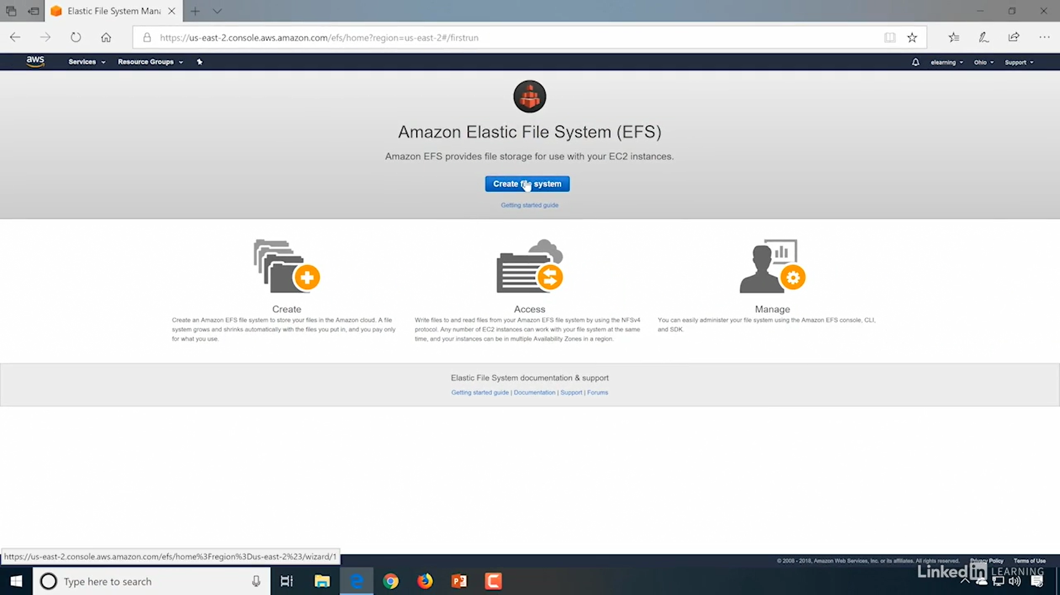

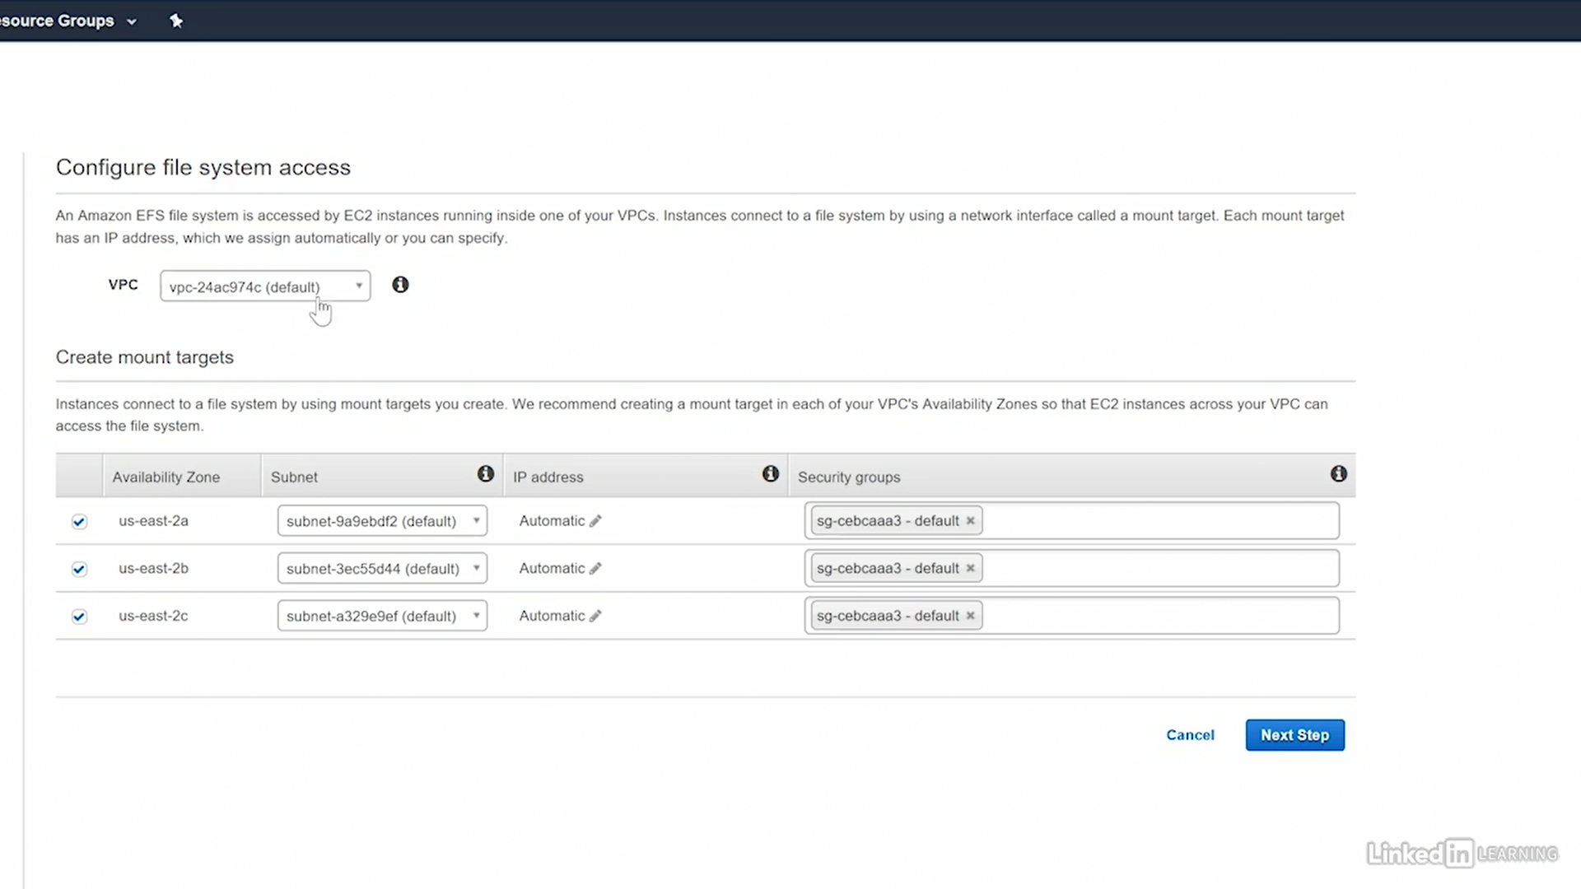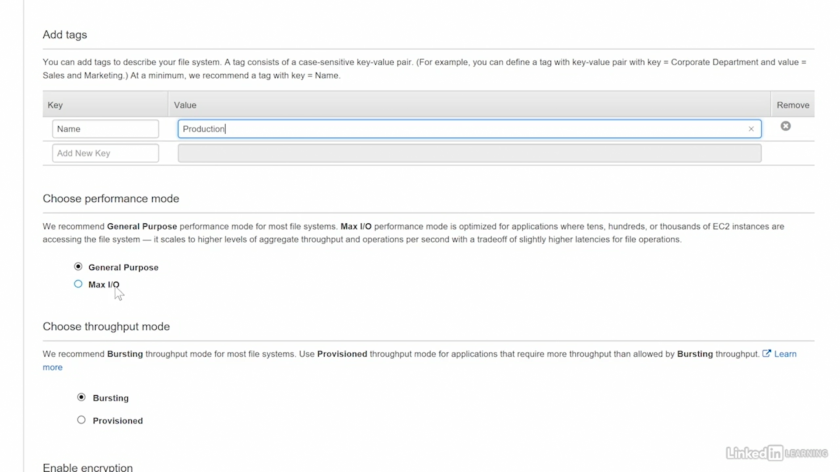

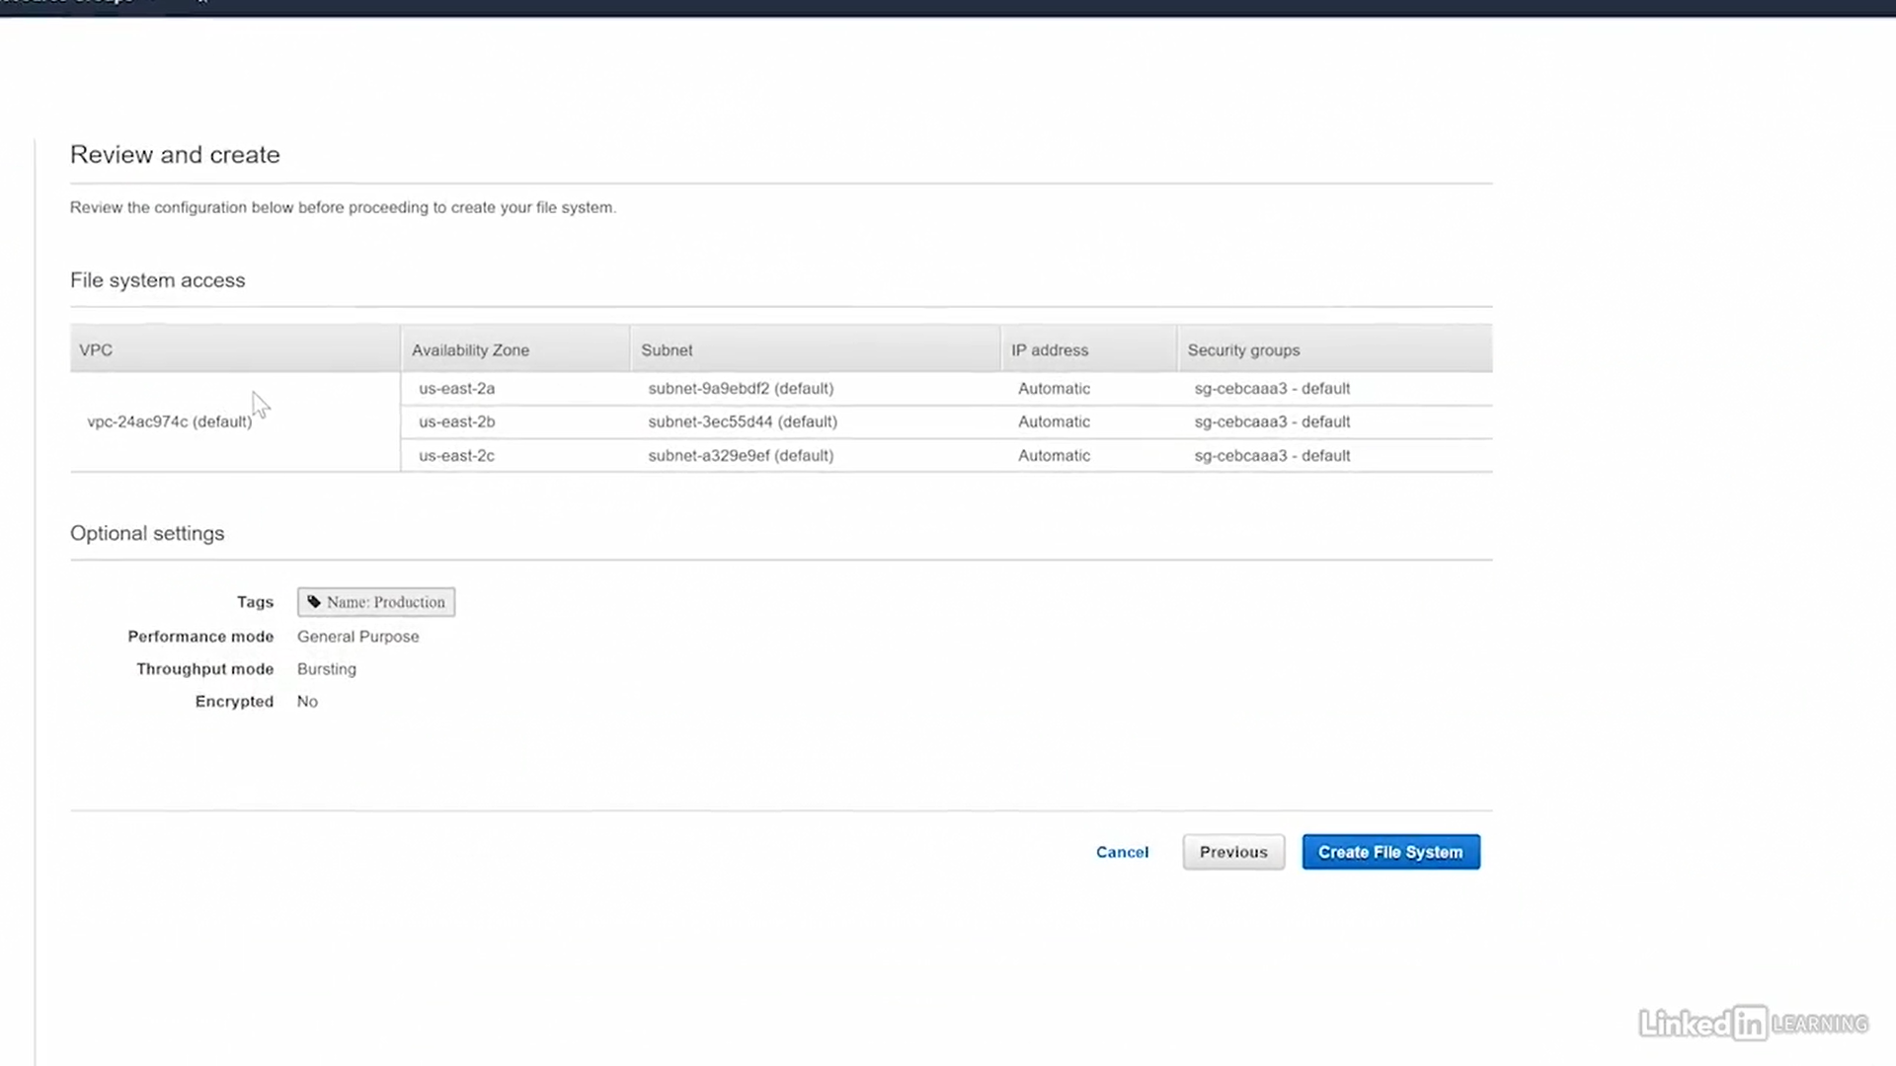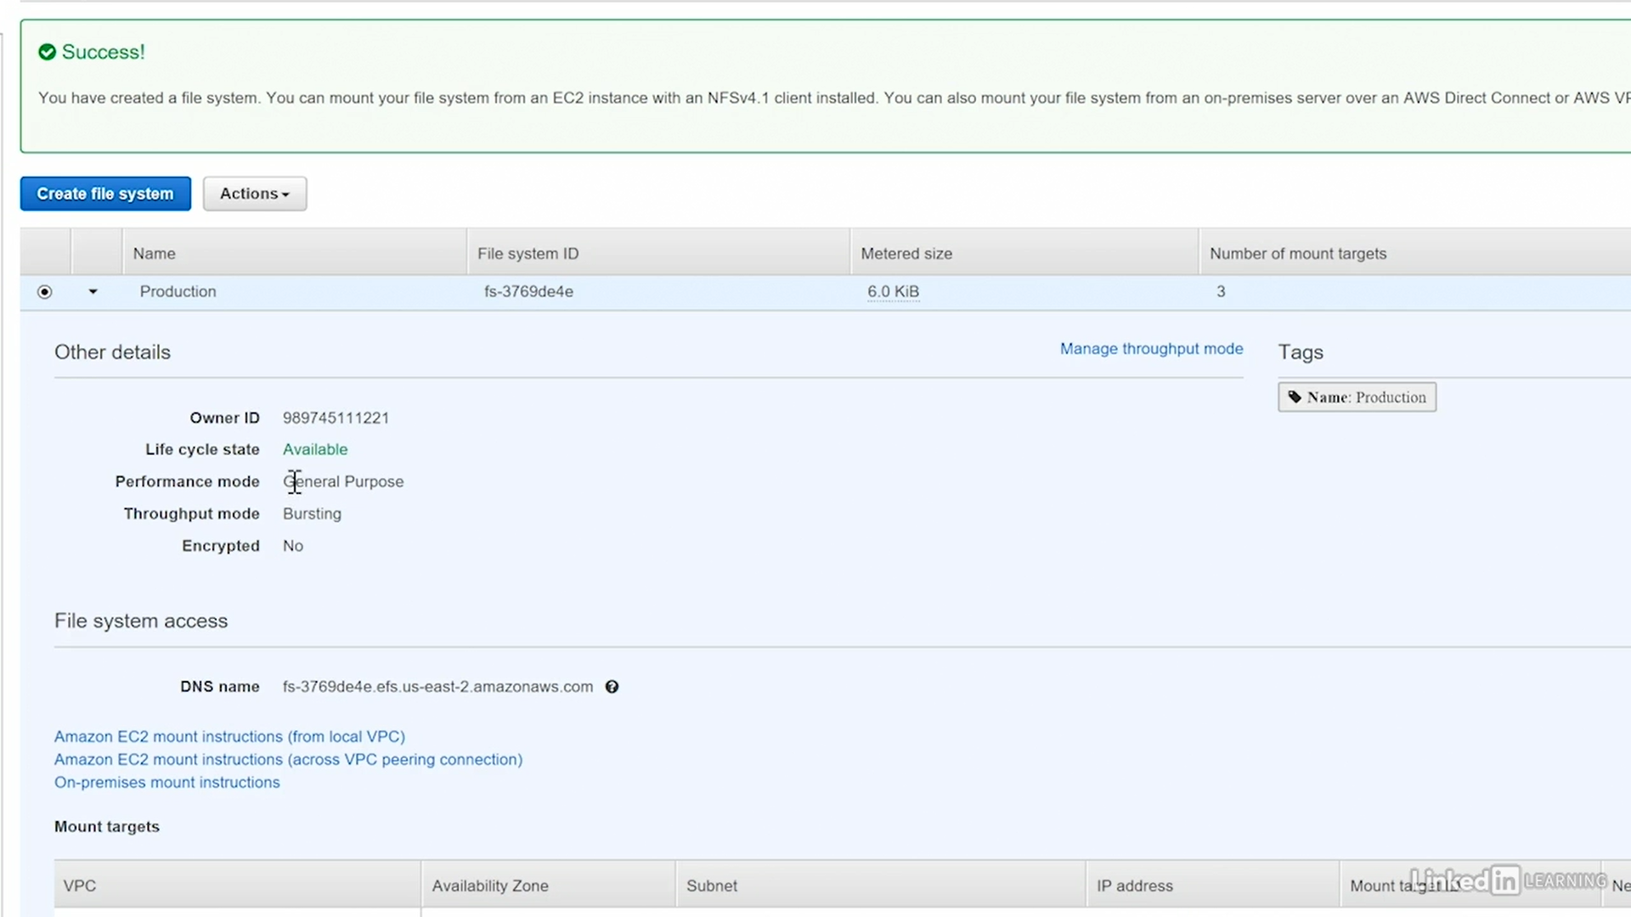

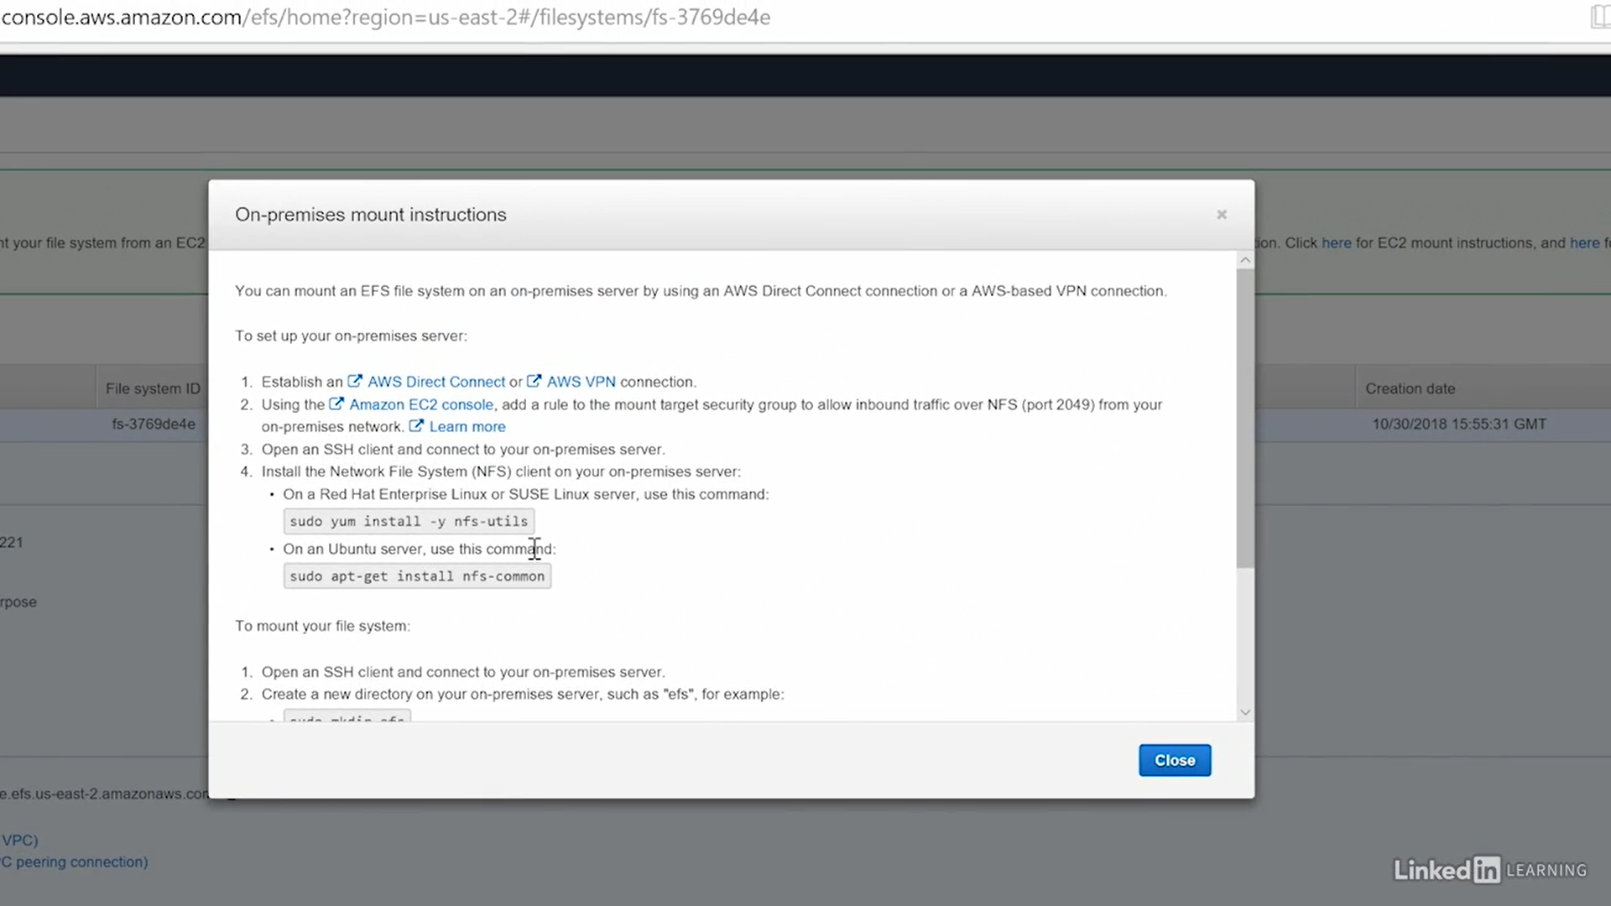

## AWS Storage Gateway

How to move our local data to Cloud (or) Cloud to local.

Ex: OneDrive now

•Its a VM image , need to install Local System

## Q’s

What language is used to create policies within AWS?

JSON

## References

<https://www.linkedin.com/learning/aws-certified-solutions-architect-associate-2-storage-design/storage-services?u=2057244>

<https://www.edureka.co/blog/s3-aws-amazon-simple-storage-service/>

<https://www.youtube.com/watch?v=9HsEMyKrlnw>

<https://www.qwiklabs.com/focuses/8582?catalog_rank=%7B%22rank%22%3A1%2C%22num_filters%22%3A1%2C%22has_search%22%3Atrue%7D&parent=catalog&search_id=3982783>

<https://www.qwiklabs.com/focuses/8595?catalog_rank=%7B%22rank%22%3A2%2C%22num_filters%22%3A1%2C%22has_search%22%3Atrue%7D&parent=catalog&search_id=3982783>

# 3. Networking & Content Delivery

* VPC
* CloudFront
* Route 53
* API Gateway
* Direct Connect

### Networking Terms

Private IP adress

Public IP adress

Subnets

- Public

- Private

- Dynamic private IP

- Dynamic public IP

- Private DNS names

- Public DNS names

- DHCP Pool

- Routing Tables

## Virtual Private Cloud (VPC)

Amazon Virtual Private Cloud (Amazon VPC) enables you to launch Amazon Web Services (AWS) resources into a virtual network that you've defined.

A "Virtual Private Cloud" is a sub-cloud inside the AWS public cloud. Sub-cloud means it is inside an isolated logical network. Other servers can't see instances that are inside a VPC.

* When an user register for AWS account, the VPC for that user is Created
* All the Instances launch by that user is reside inside his VPC
* So, for each User , his own VPC is there to play with aws Services

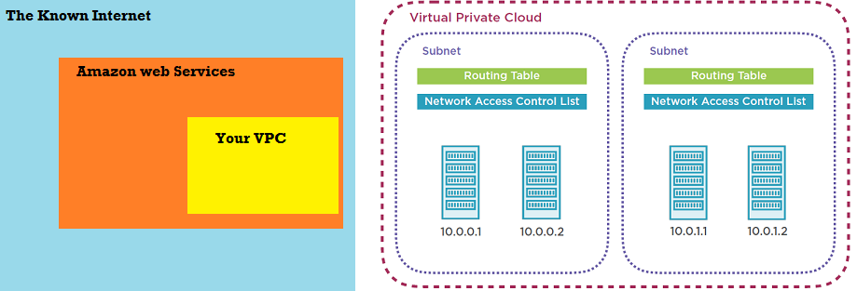

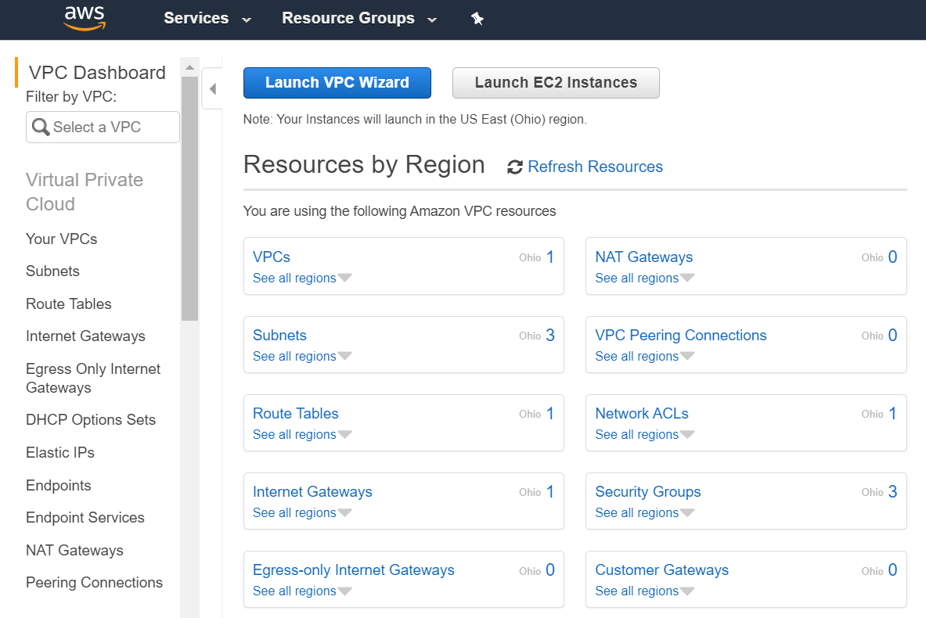

* You have complete control over your virtual networking environment, including a selection of your IP address range, the creation of subnets, and configuration of route tables and network gateways.
* Applications run in the VPC or on-premises
* Subnets can be created in the VPC
  + Public subnets - Opens to outside internet
  + Private subnets - Inside Communication
* Direct Connect provides VPN(Virtual Private Network) connections
* Multiple VPCs can be connected by VPC pairing
* VPC endpoints connect to Amazon resources which are outside the VPC

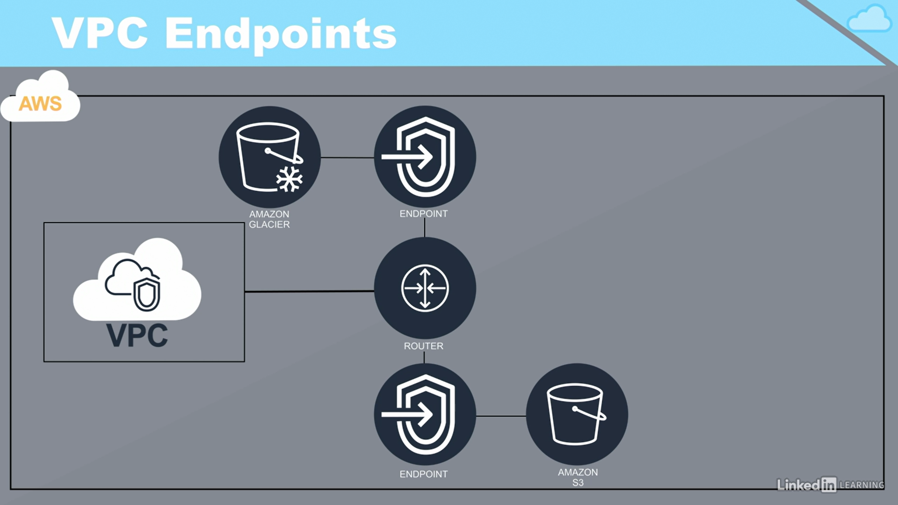

Endpoint - Kind of jump - direction of next connection

### Features:

* Dynamic private IP
* Dynamic public IP
* AWS-provisioned DNS names
* Private DNS names
* Public DNS names

### Public Network vs Private Network

Public N/w : Google, Facebook

Private N/w : portal.pxl.com, sparshv2/

After creating a VPC, what is typically the first task you will perform?

**Create one or more subnets in the VPC.**

* After creating a VPC, you will need to create one or more subnets. The instances will be configured to connect to one of these subnets.

### Lab – Creating VPC

Networking > VPC

If open VPC dashboard we alaredy have a VPC, with tenancy : Default.

That means that on creating AWS account by default one VPC is creatred

all the S3 Buckets, instances we created will be created inside Default VPC

### IP Subnet

-------------------------

172.31.0.0/16 -> 16 is bits it used = IPv4

172 - 8 bits

31 - 8 bits

0 - 8 bits

0 - 8 bits

1st 16 bits(1st two numbers) is known as "Network"

172.31 } - "Network"

2nd 16 bits is known as "Host address" on this network

0.0 } - "Host address on this network"

for more Deatils : "Private IP adress"

### 1.Create VPC

IPv4 CIDR : 10.10.0.0/16

Tenancy : Shared/Dedicated(Expensive)

#### VPC Communication

-----------------------

Think of it like there's a network in my building, where my company's headquartered,

and there's a network in your building, where your company is headquartered.

Our two networks cannot talk directly to each other. If we want to talk to each other,

we're going to have to build some routes between us and possibly use VPN or leased lines or some method that we can use to get a connection between us.

VPCs are the same way. Even though they're virtual private clouds, they're still private,

and it does mean that if we want even two of our VPCs to talk to each other, we have to facilitate those communications

### 2.Create Subnet

------------------------

### AWS Direct Connect

-------------------------

### 3.DHCP

What is an example of something you can configure as a DHCP option in AWS?

Domain Name

* You can configure the following parameters in DHCP options: Domain Name Servers, Domain Name, NTP Servers, NetBIOS name servers, and NetBIOS node types.

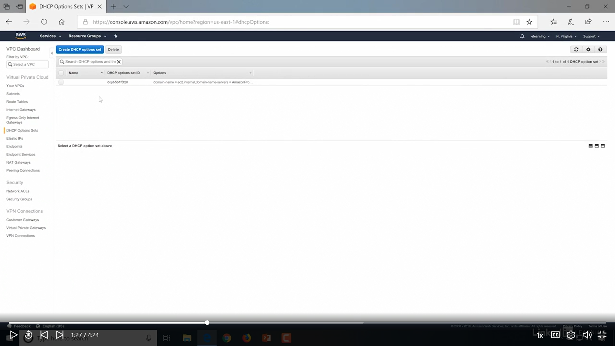

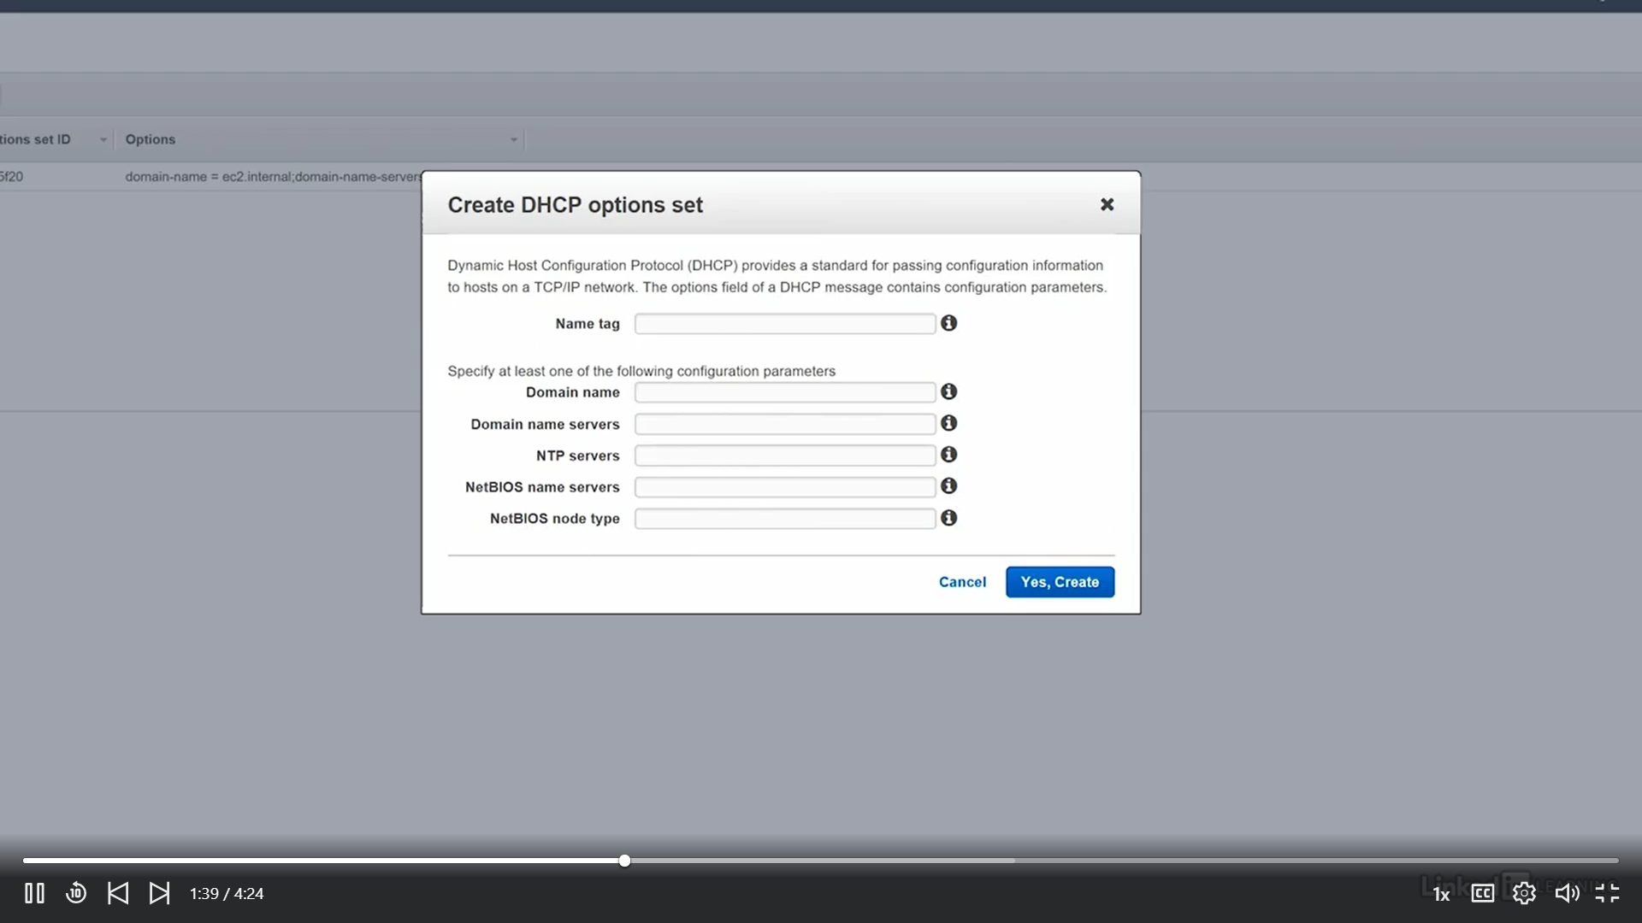

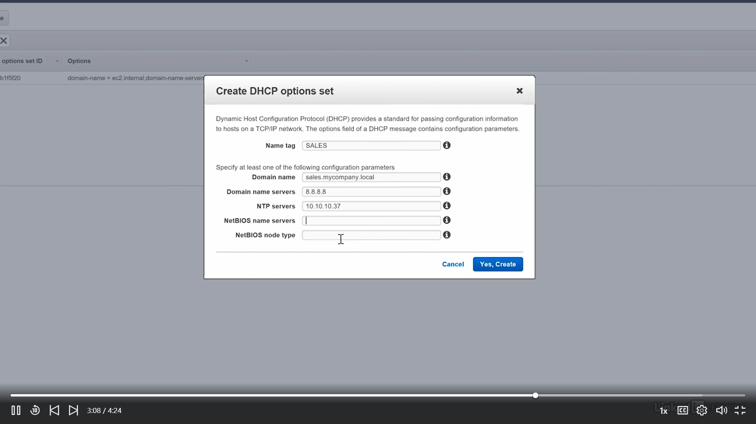

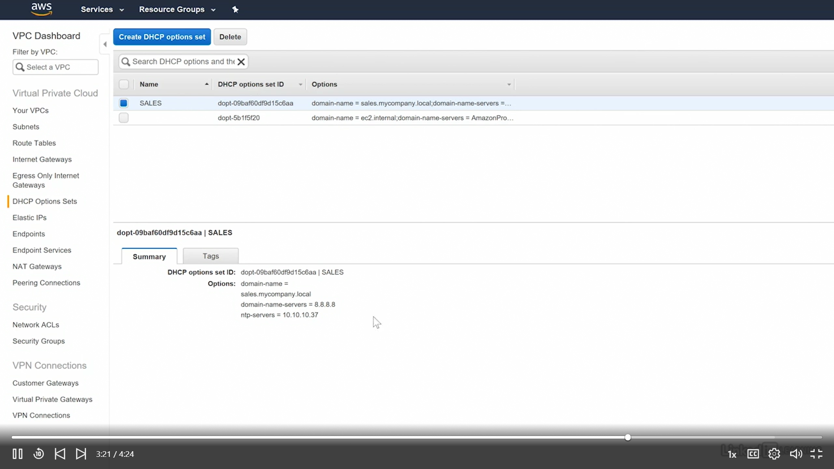

### Lab : Creating a Virtual Private Cloud

We are now going to create below architecture in AWS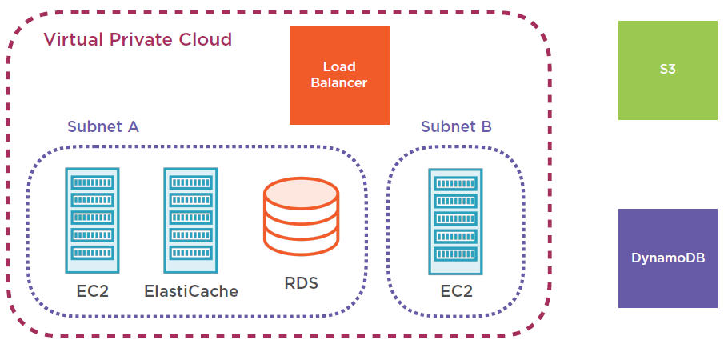

1.Go to Services > Search > VPC

2.Click on VPC > Create VPC > fill details & Create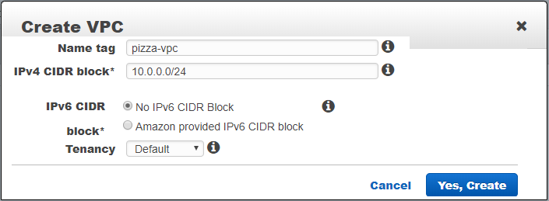

3. VPC is created Successfully.

***Now VPC is just created, but for instances of the VPC has no access with Internet by default. We need to configure Routing table for the Internet access.***

4.**To Configure VPC,** Go to VPC > Left: Your VPC’s > Select : Pizza VPC > Summary: Routetable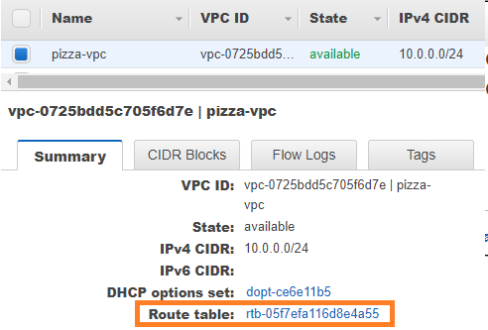

By Clicking Route Table link, it will open new tab, and select Route Table Id > Routes Tab 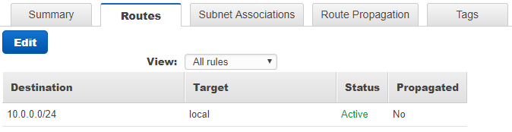

5.**Next, Create Subnet**, VPN >Left: Subnet > Create Subnet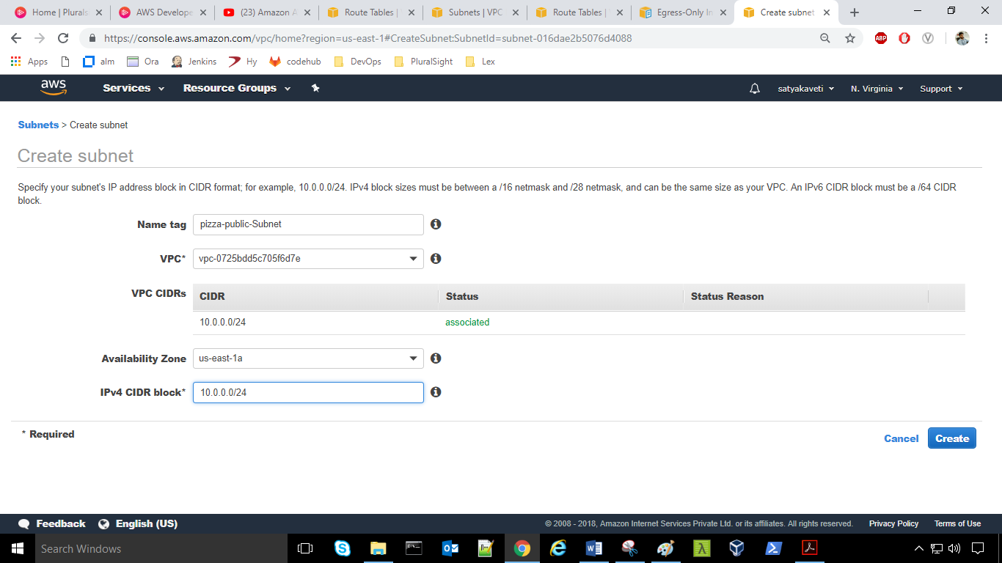

6.**Next, create Route Table**, VPN >Left: Route Table > Create Route Table 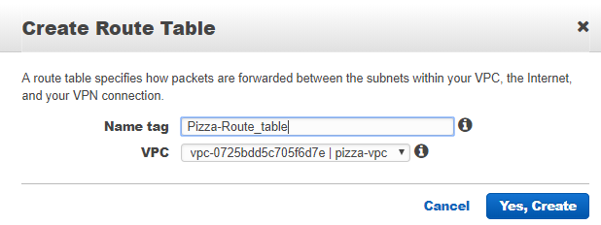

7.To access Internet, we must create Internet gateway : **Internet gateways** > Create internet gateway

8.To add Internet gateway to VPC, go to subnets > Pizza-Public-Subnet>Routing table > Edit > add another route & save details 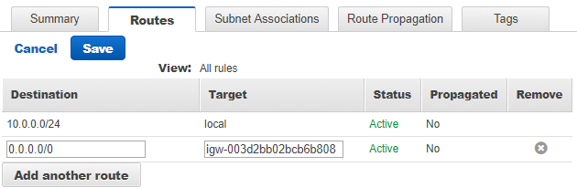

8.So now we need to create another subnet in different region for replica purpose.

* Go to **VPCs** > Edit CIDRs > **Add IPv4 CIDR > 100.64.0.0/24 > save**
* Go to VPC > **Subnets** > Create subnet > Fill Details > Save 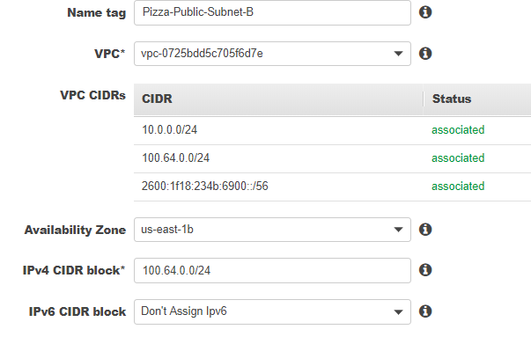

### VPC peering

* you have a virtual private cloud for **sales** and a virtual private cloud for **marketing**
* now the sales VPC need to access resources in the marketing VPC and vice versa.
* Well in order for we must open a channel for communications between them because normally VPCs can't talk directly with other VPCs as a default.
* So we've got to have some method to link them together so that they can connect. This is what we call VPC peering

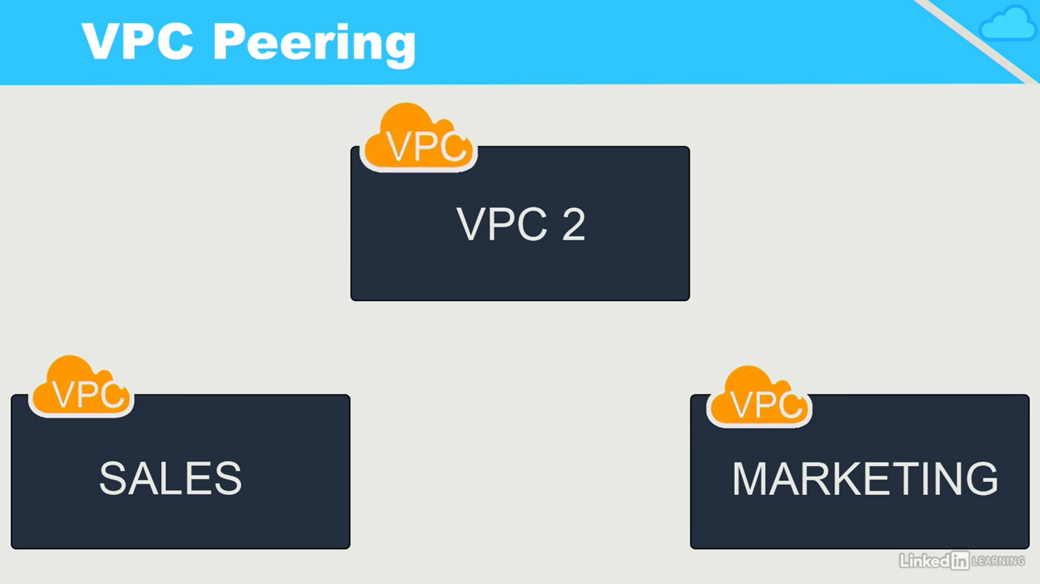

Not Transitive

VPC peering is not transitive. This simply means that peering does not pass through. For example, if VPC1 is peered with VPC2 and VPC2 is peered with VPC3, this does not mean that VPC1 is peered with VPC3. All peers must be directly configured.

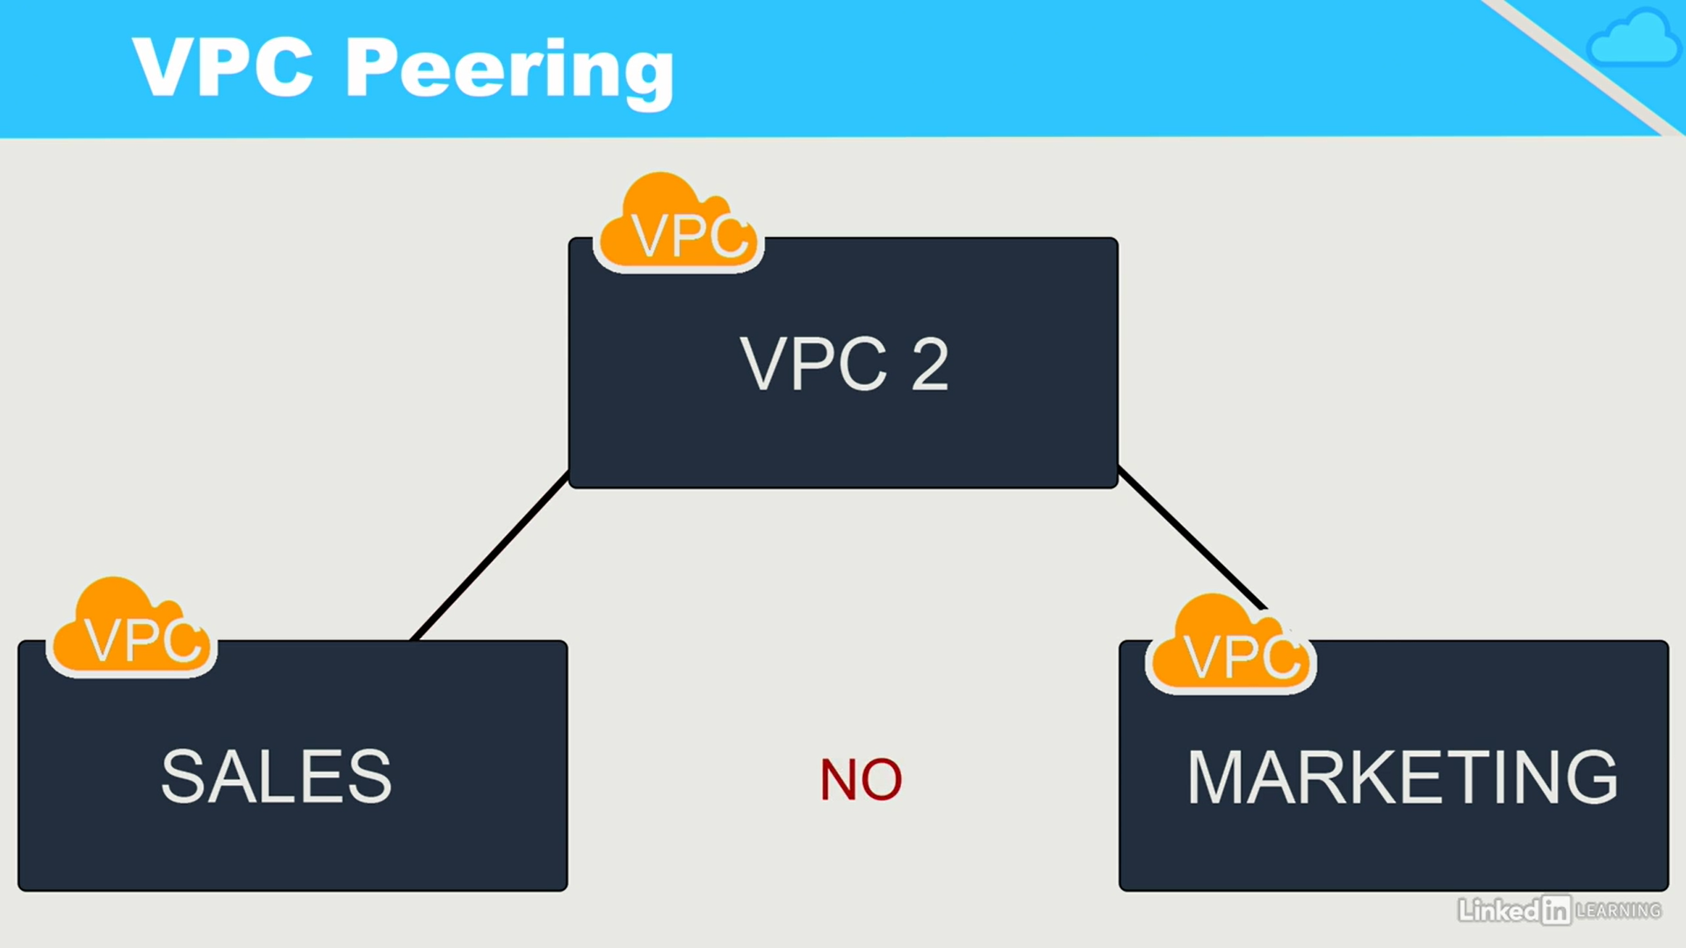

#### Lab - Creating VPC Peers

•Owner role of one VPC sends a request to the other VPC

•Owner of the other VPC accepts the request

•Each VPC needs a route to the other VPC in their route tables

•Security group rules may require updates

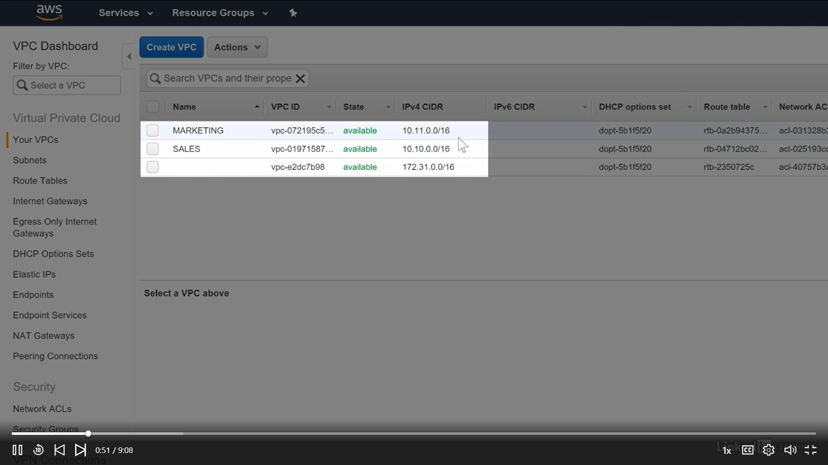

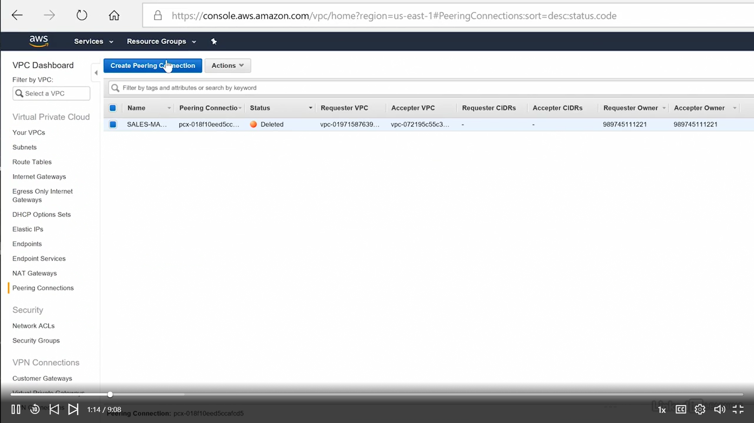

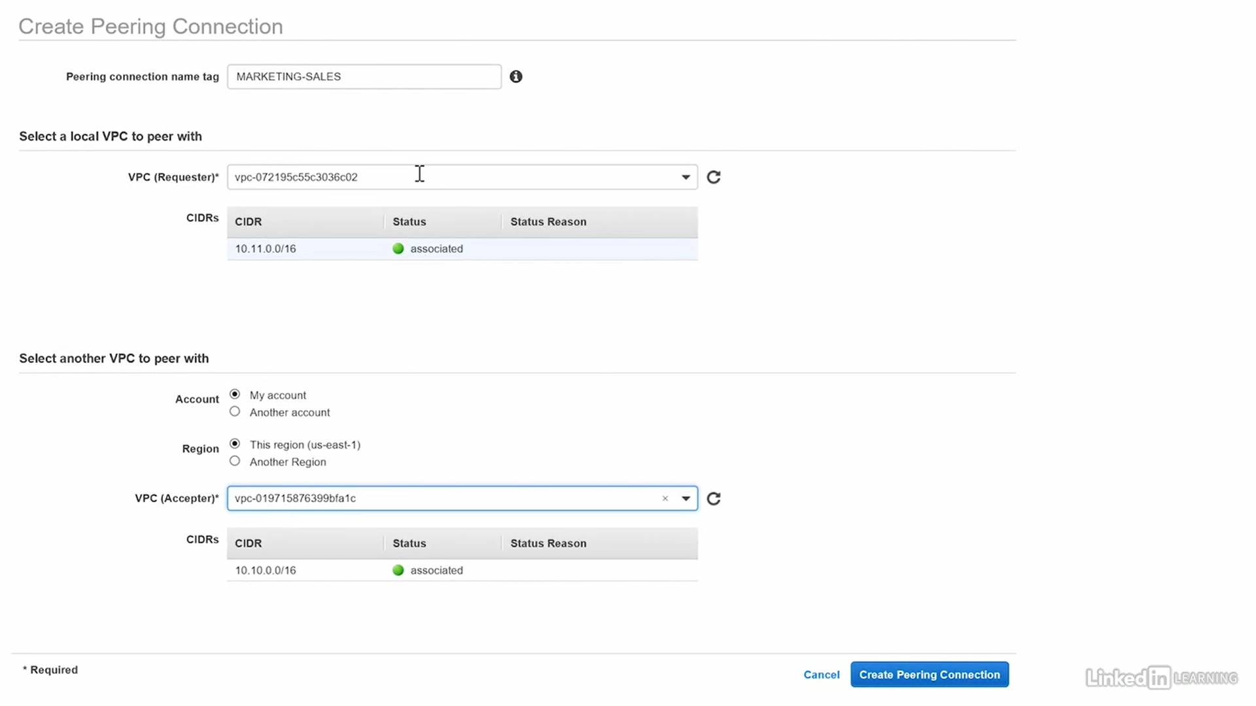

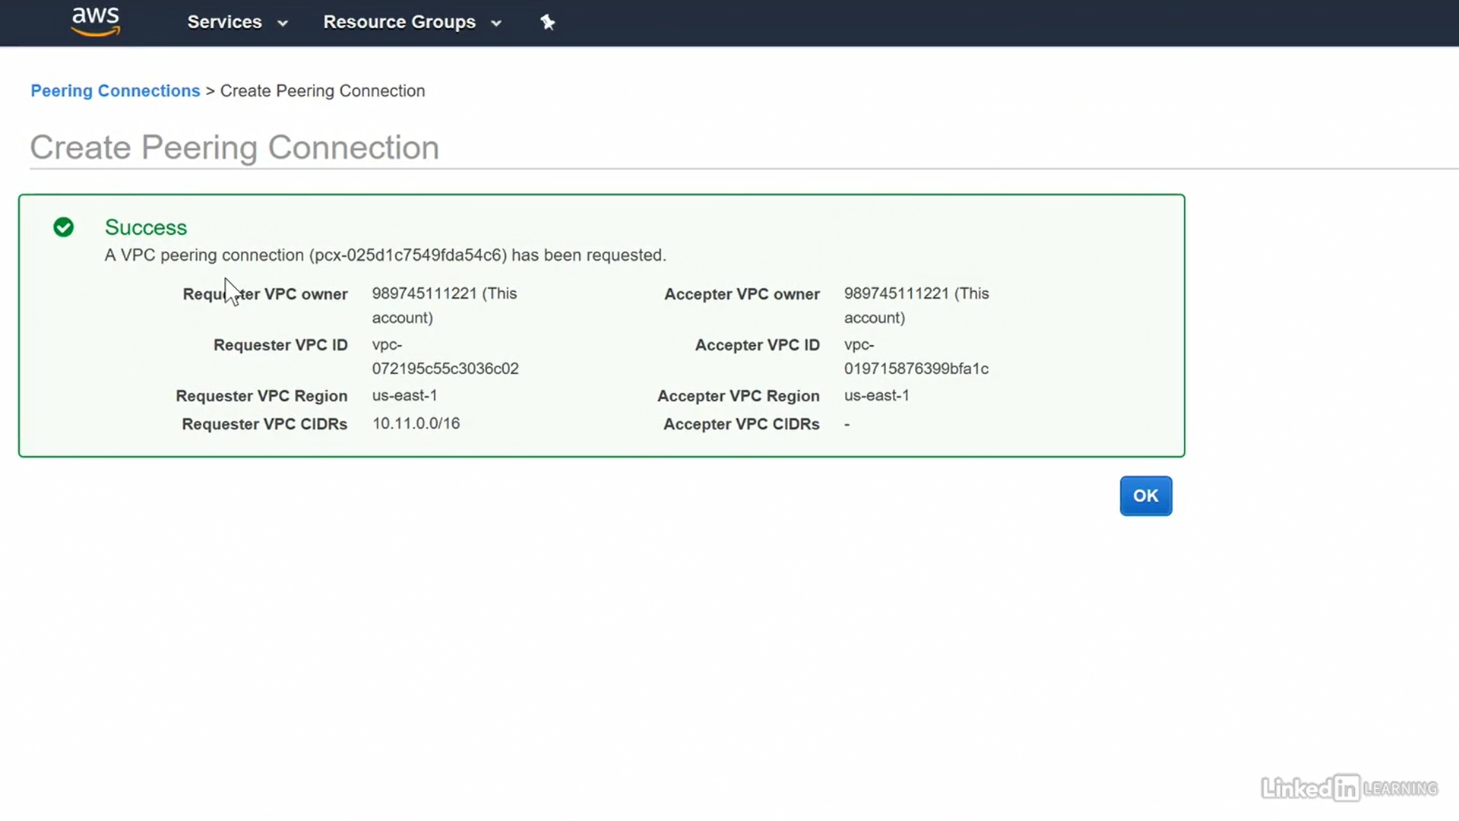 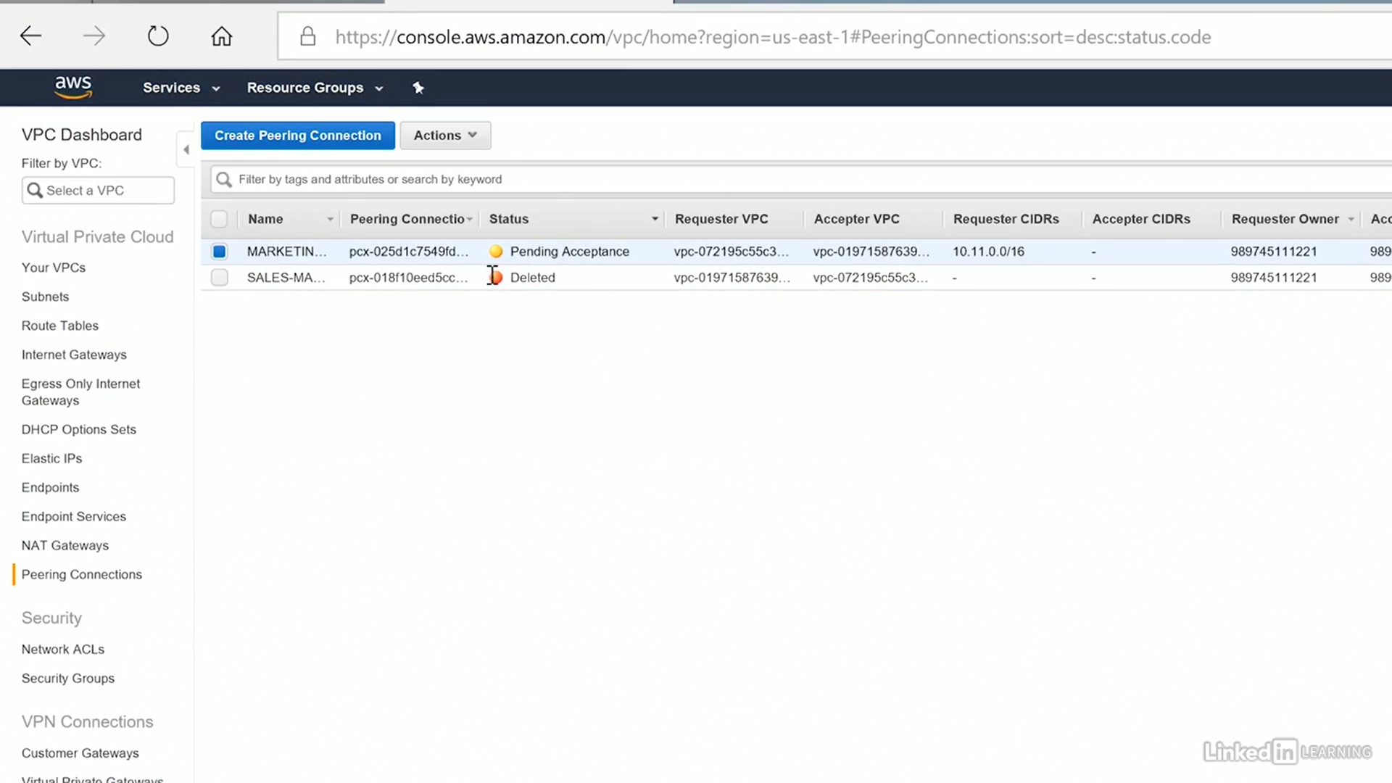

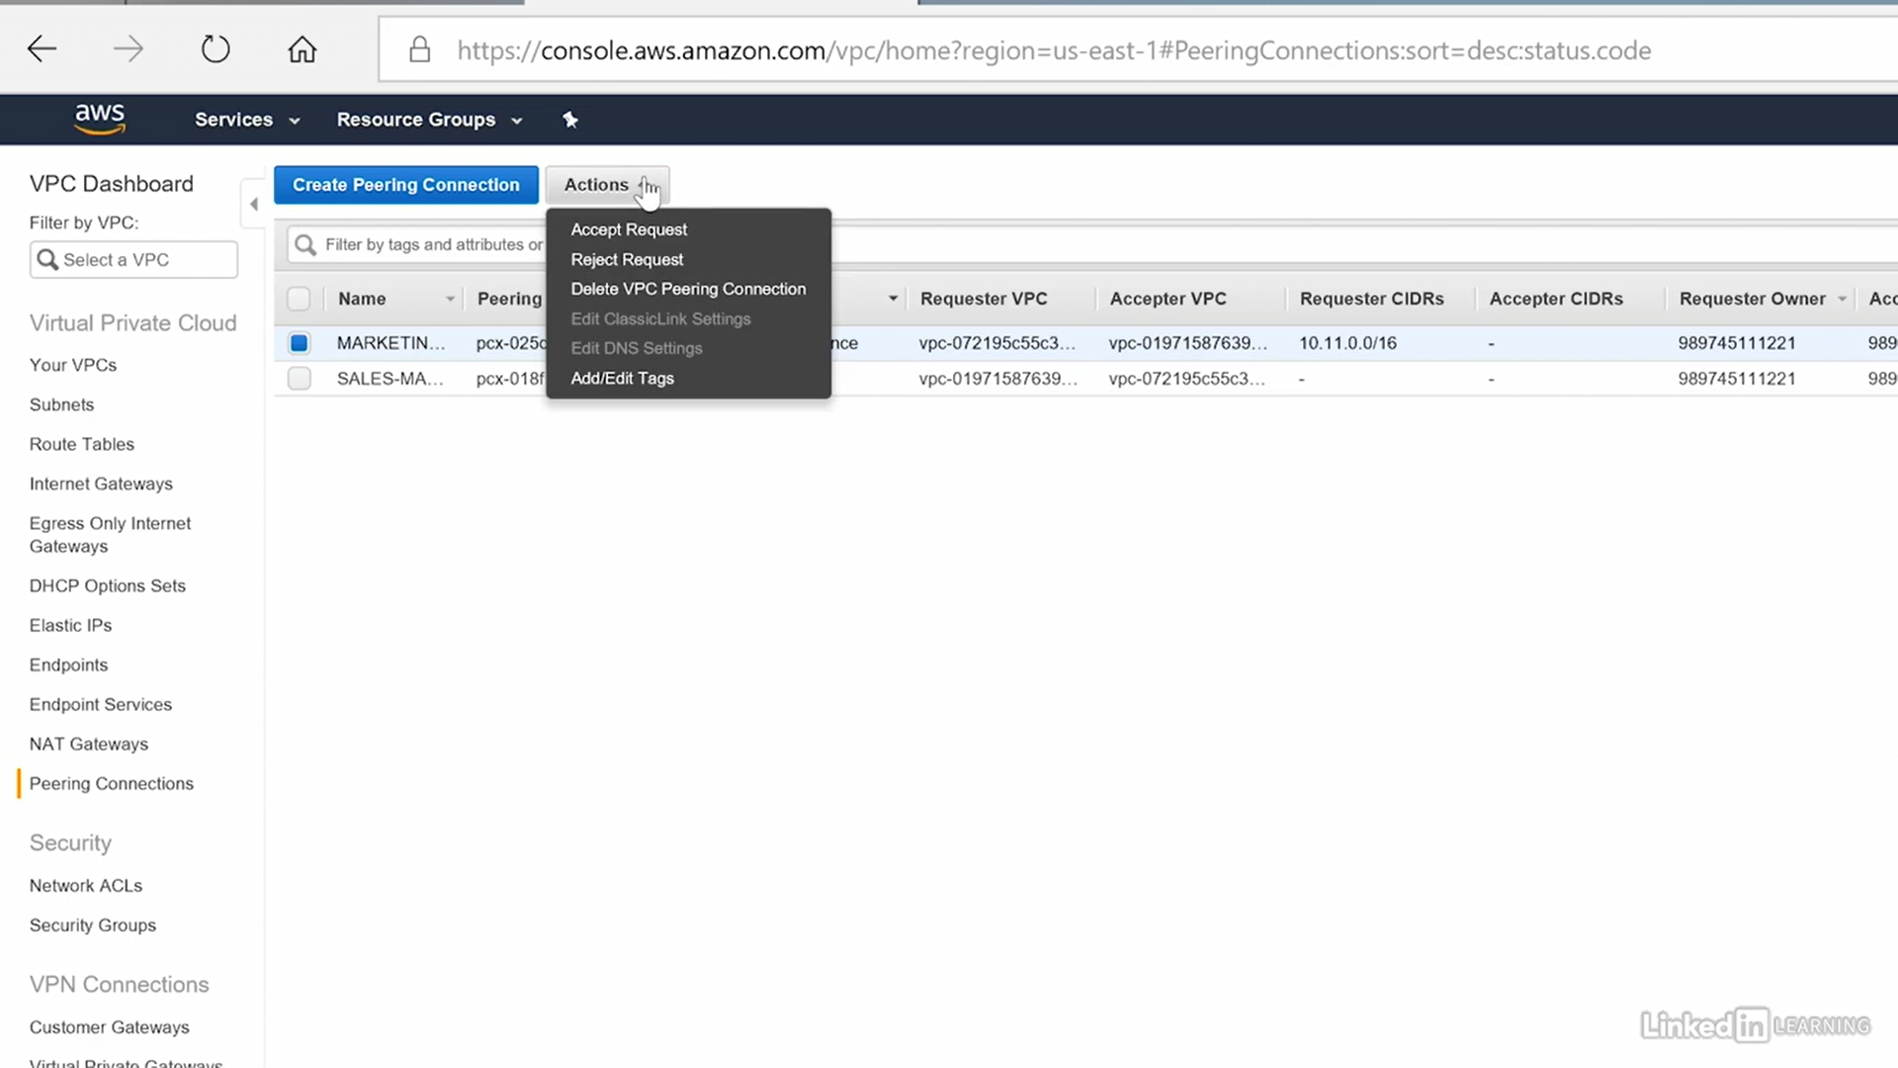 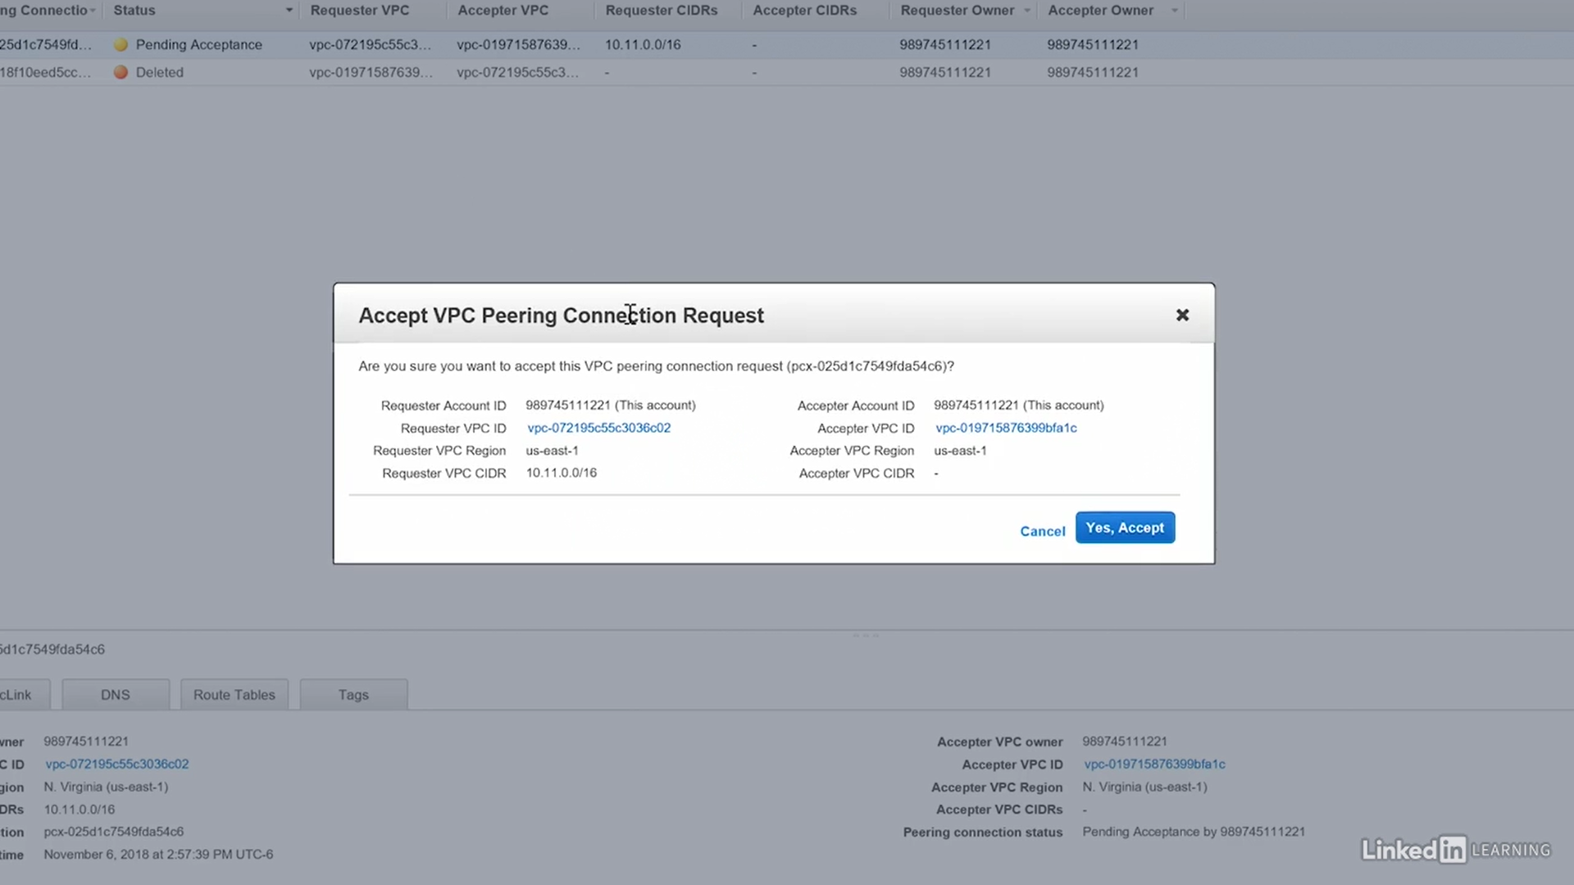

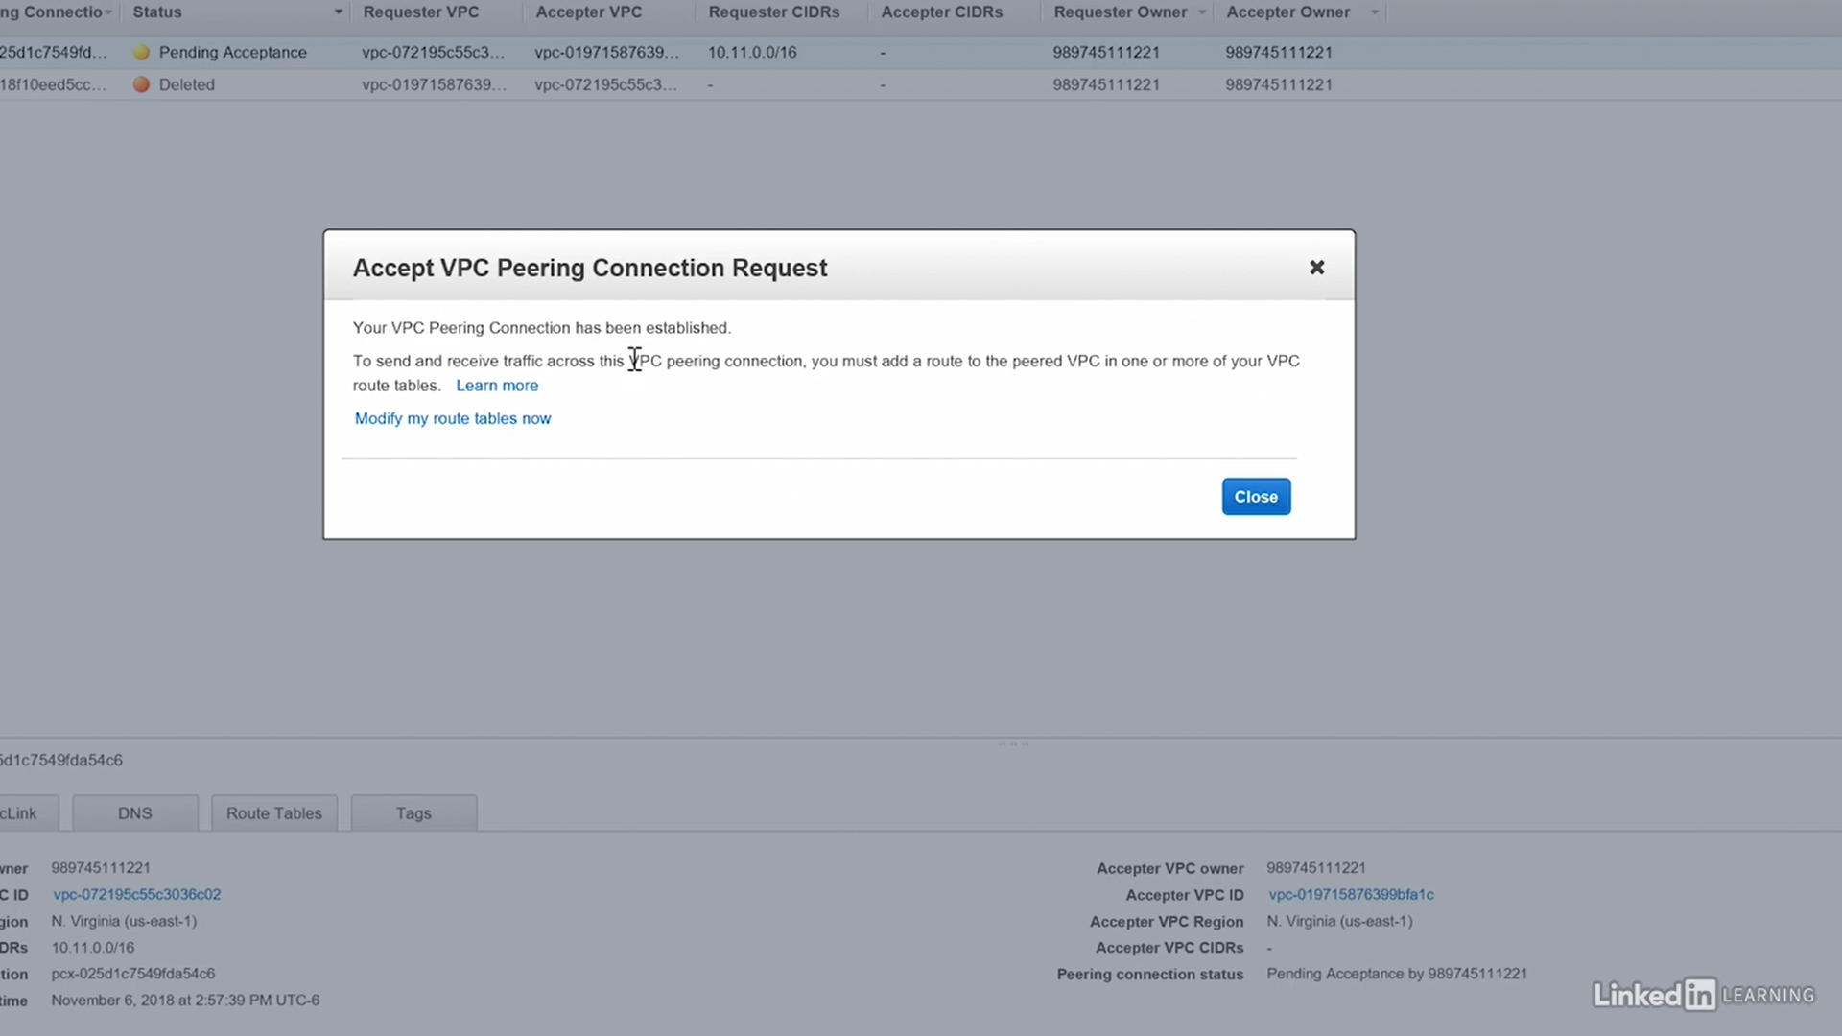

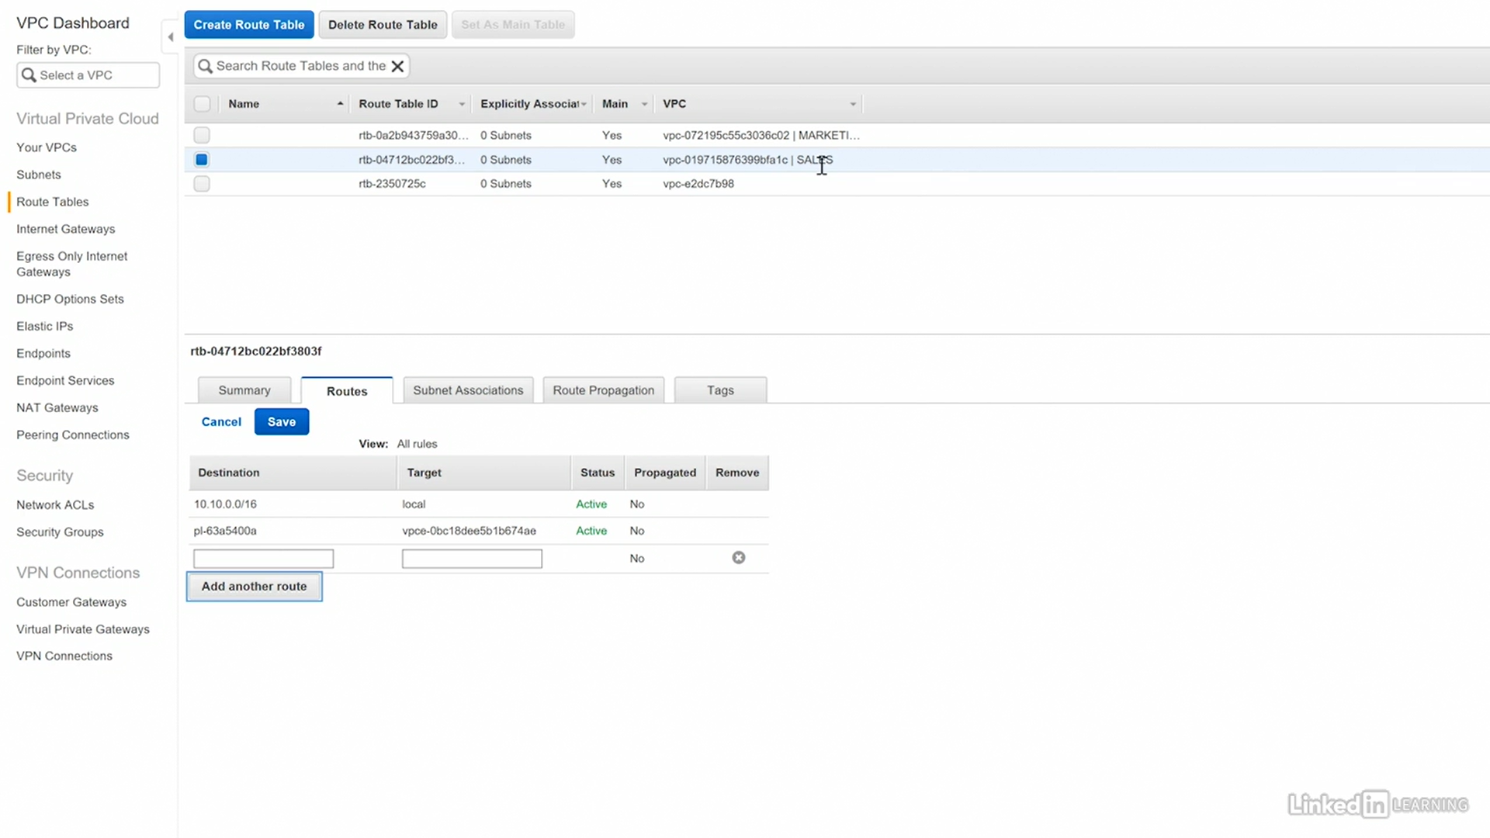

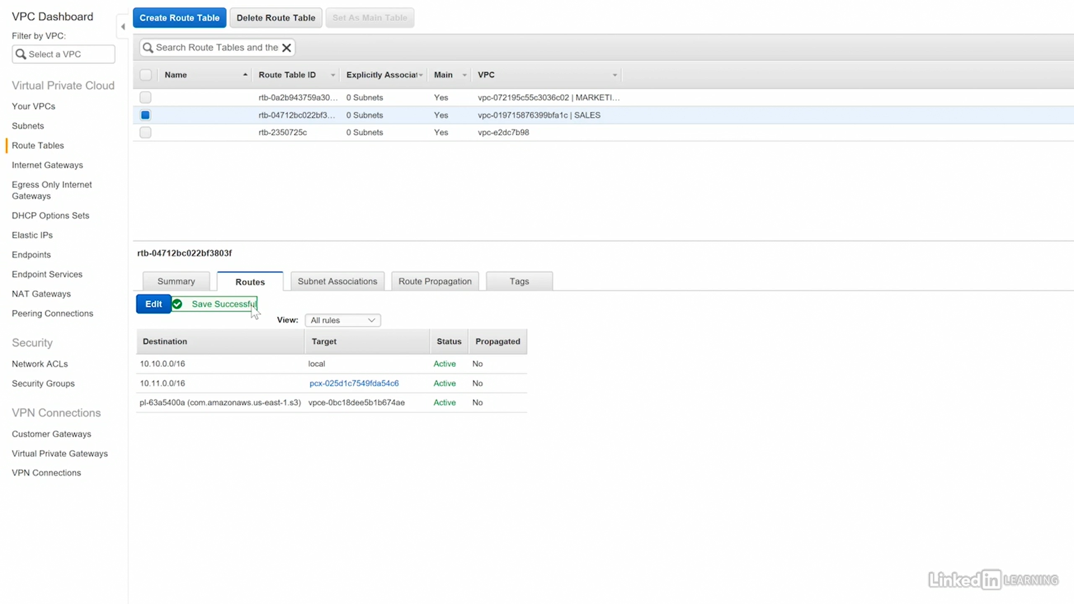

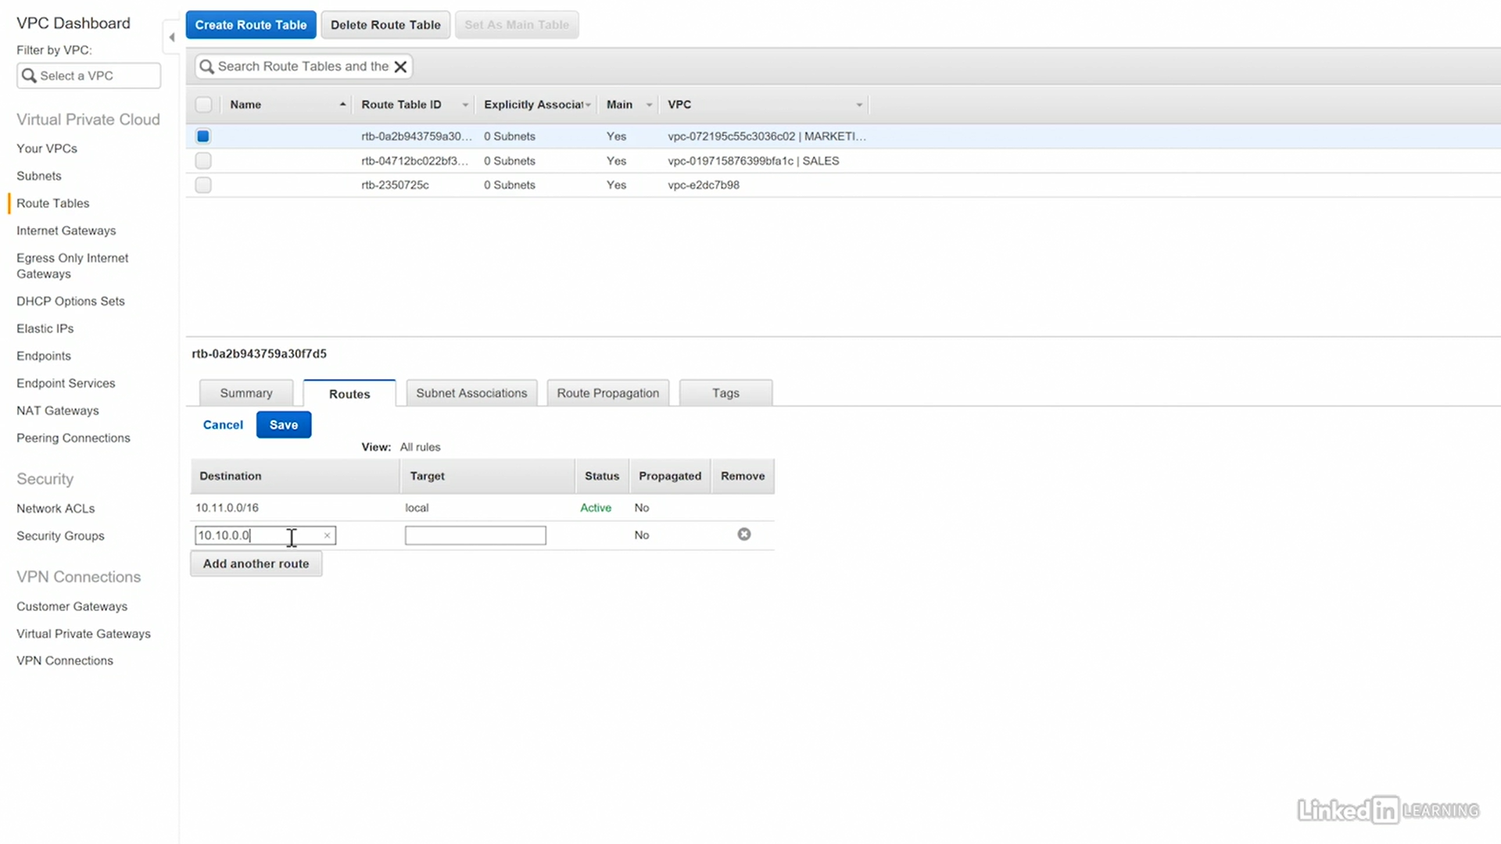

## Elastic IP Addresses (EIPs)

Public IP addresses from the VPC region

- Permanently allocated to your account until released

- Account is charged until release

- EIPs can be moved between instances in the same region only.

Network interfaces consume EIPs

you create the Elastic IP, and then you associate it with an Elastic Network Interface, and that network interface then is the point at which that public IP address can be used.

### Lab

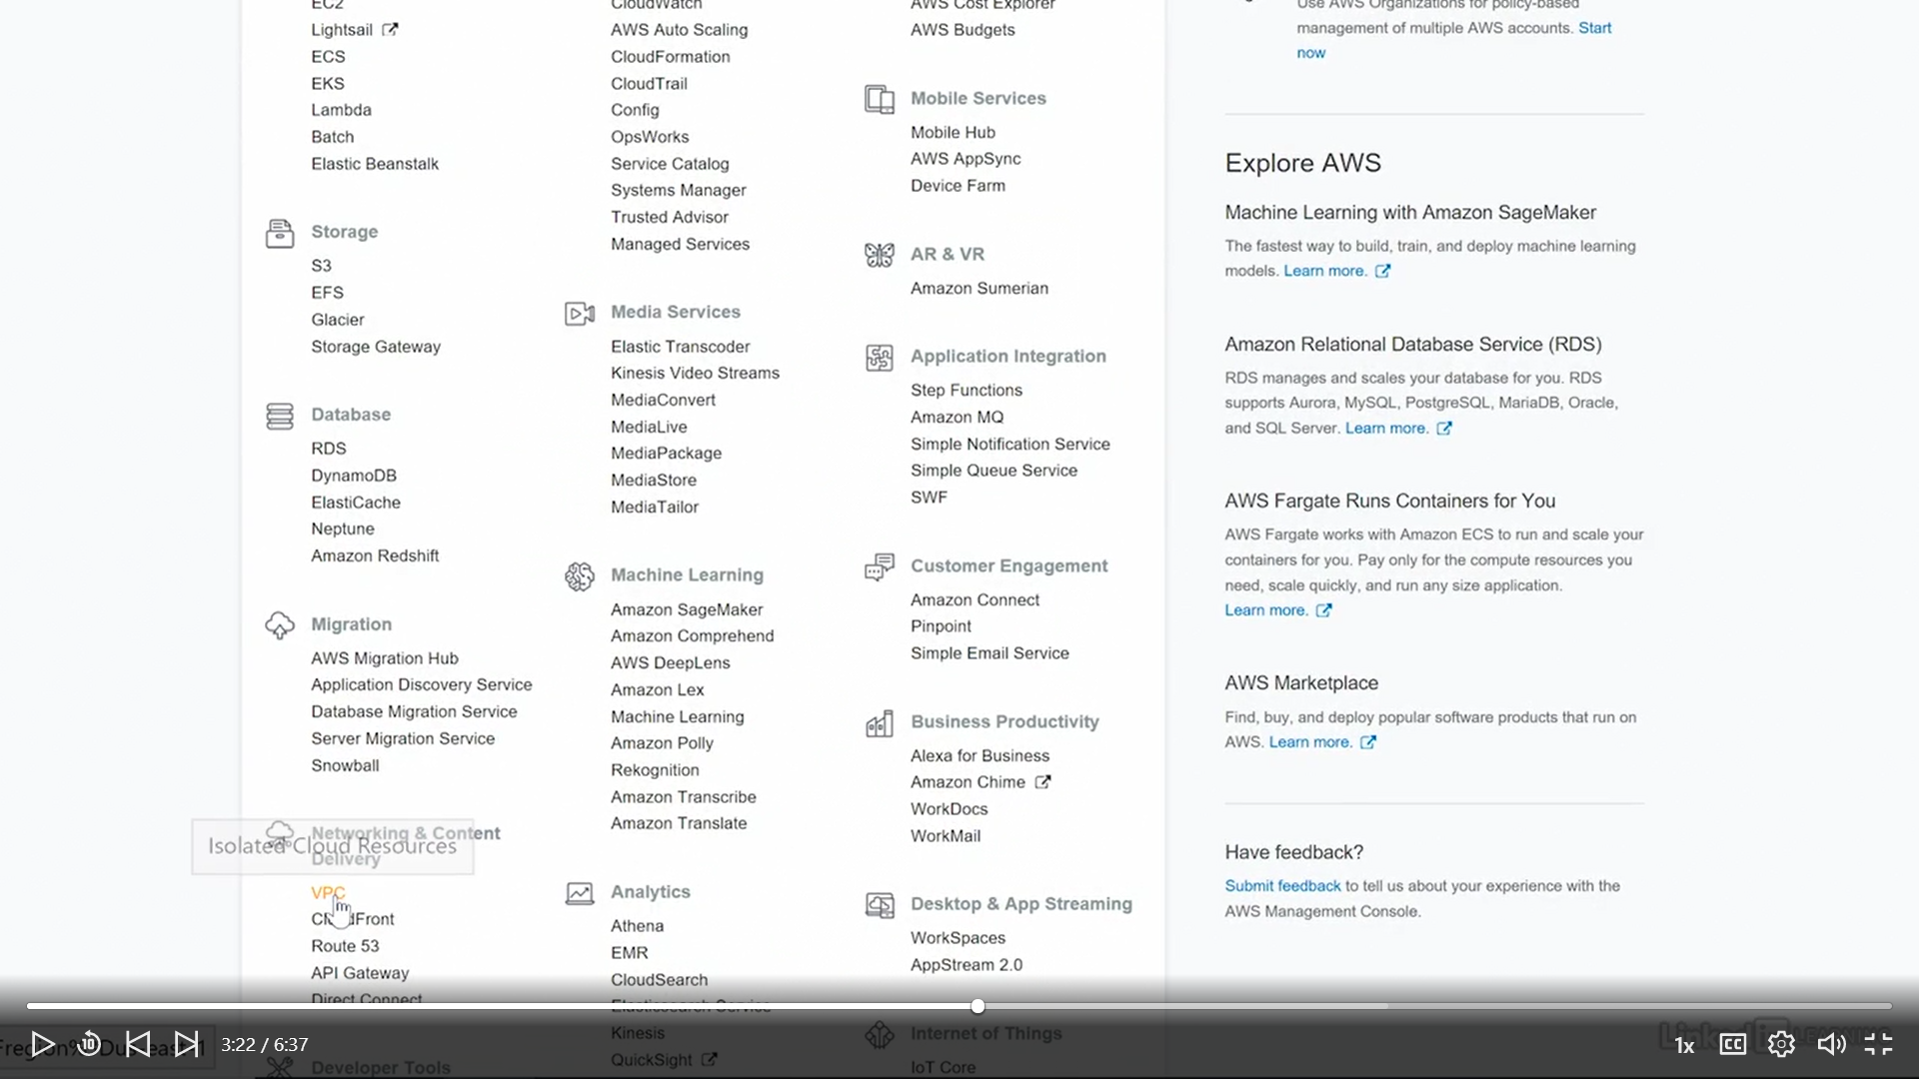

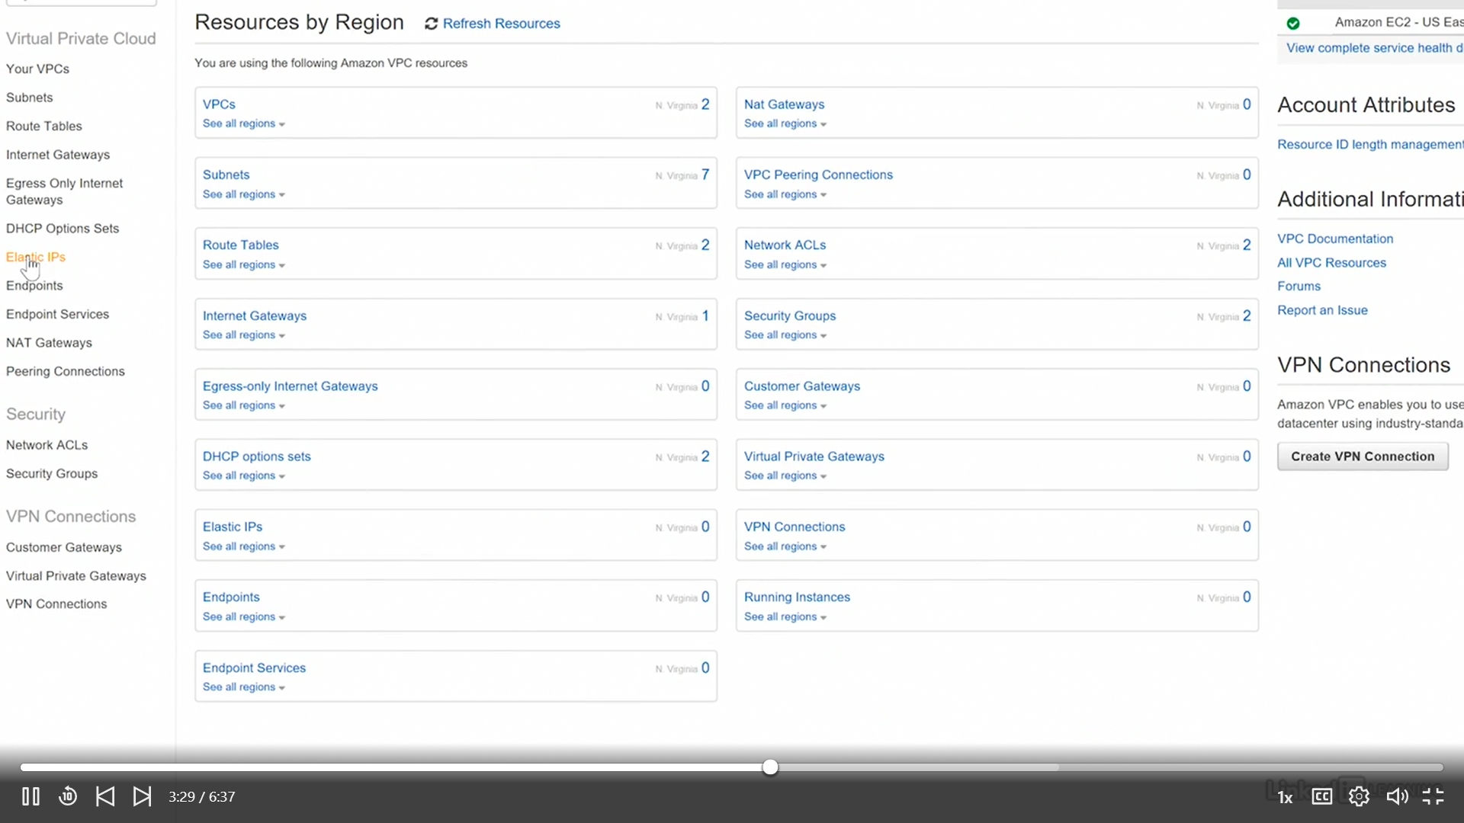

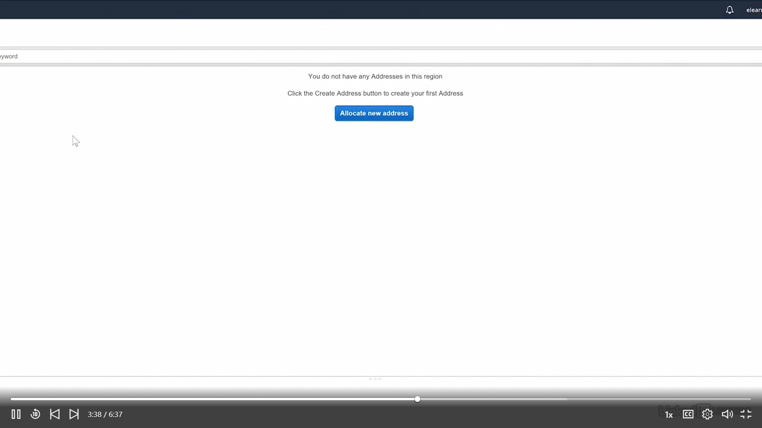

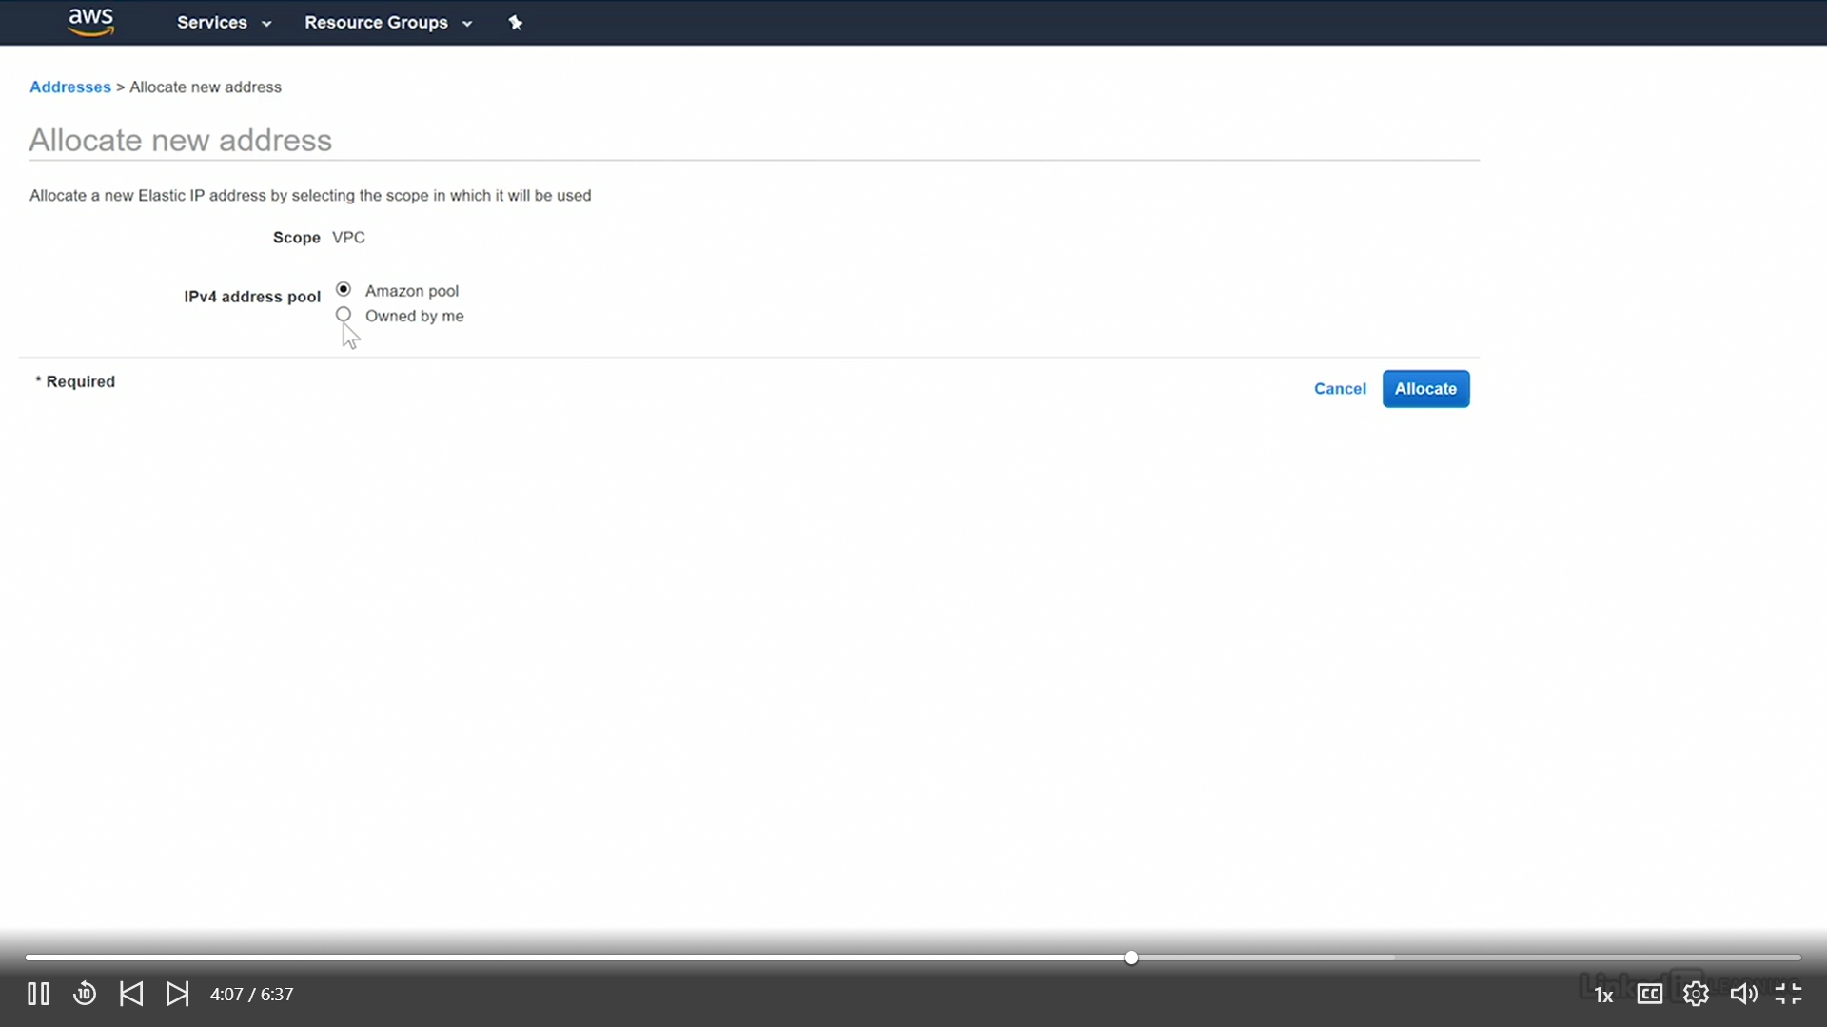

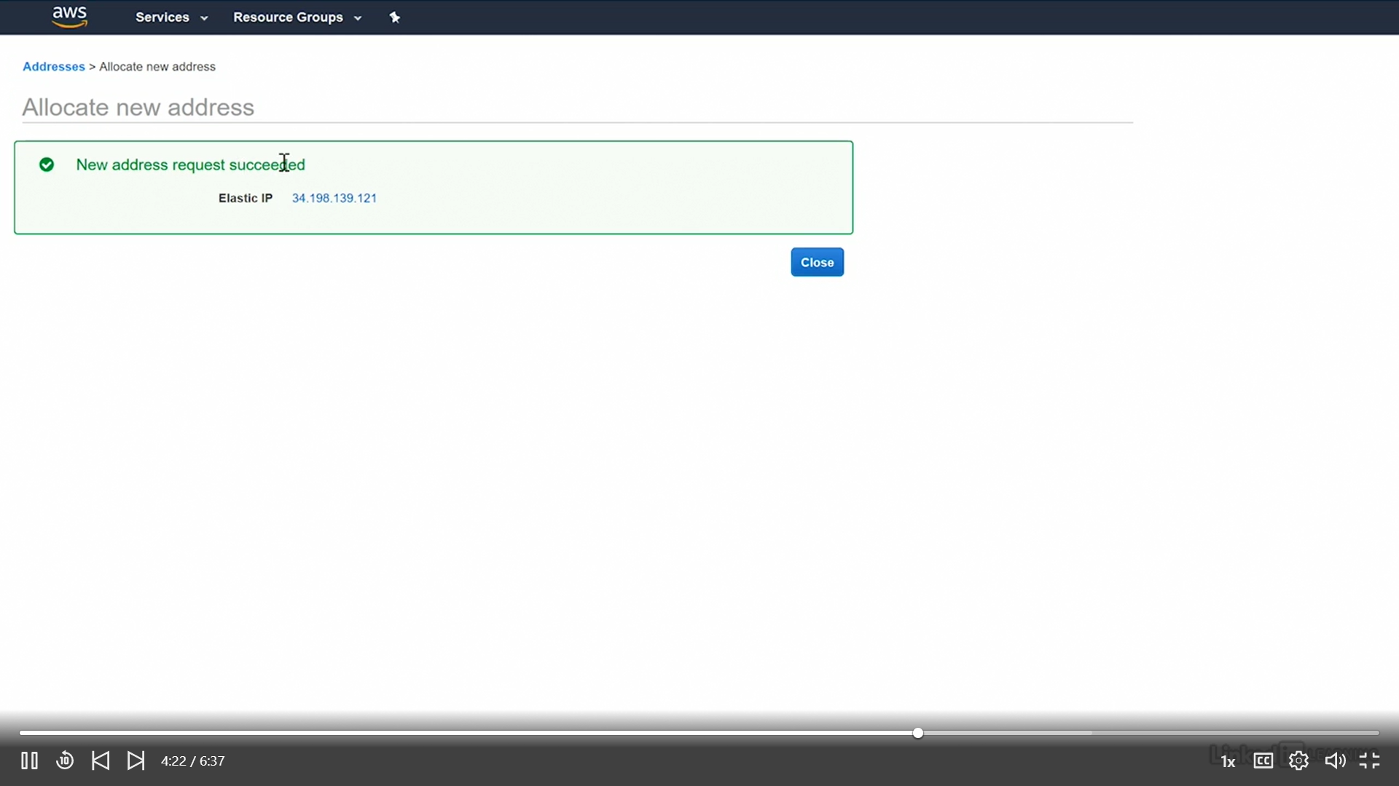

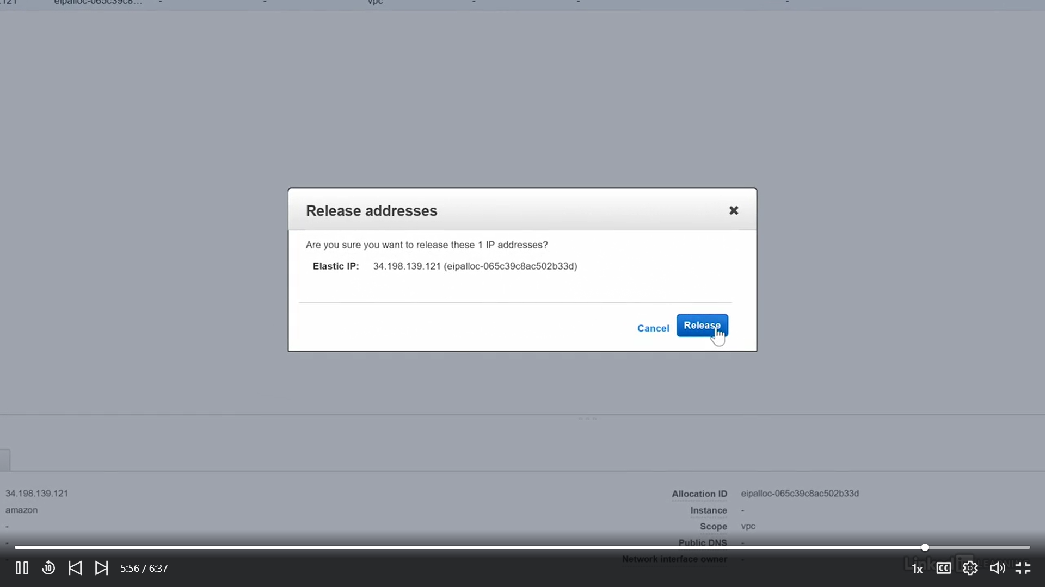

## Elastic Network Interfaces (ENIs)

Elastic Network Interfaces (ENIs)

Virtual network interface attached to an instance

Only available within a VPC

Associated with a subnet

Allows dual‐homing

an internet router is a dual-homed device. It would be a device that has one connection on the internet and one connection on your private network. A firewall would be a dual-homed device. One connection on the network that's untrusted, one connection on the network that's trusted, and then it's doing its fire-walling between those two networks because it's dual-homed.

One public address and multiple private

addresses

you are dealing with this for instances that run in a Virtual Private Cloud and it's associated with a subnet. So you have a subnet; you have an ENI, that is associated with that subnet; they all exist in a VPC; and, of course, the ENI's connected to an instance.

## EndPoints

There are many services that exist outside of the virtual private cloud that you might be taking advantage of. You want to use those with an instance that's inside the virtual private cloud. To accomplish that, you create an endpoint



### Lab

* Specify the Amazon VPC
* Specify the service

com.amazonaws. <region>.<service>

* Specify the policy
* Specify route tables

VPC >Endpoints

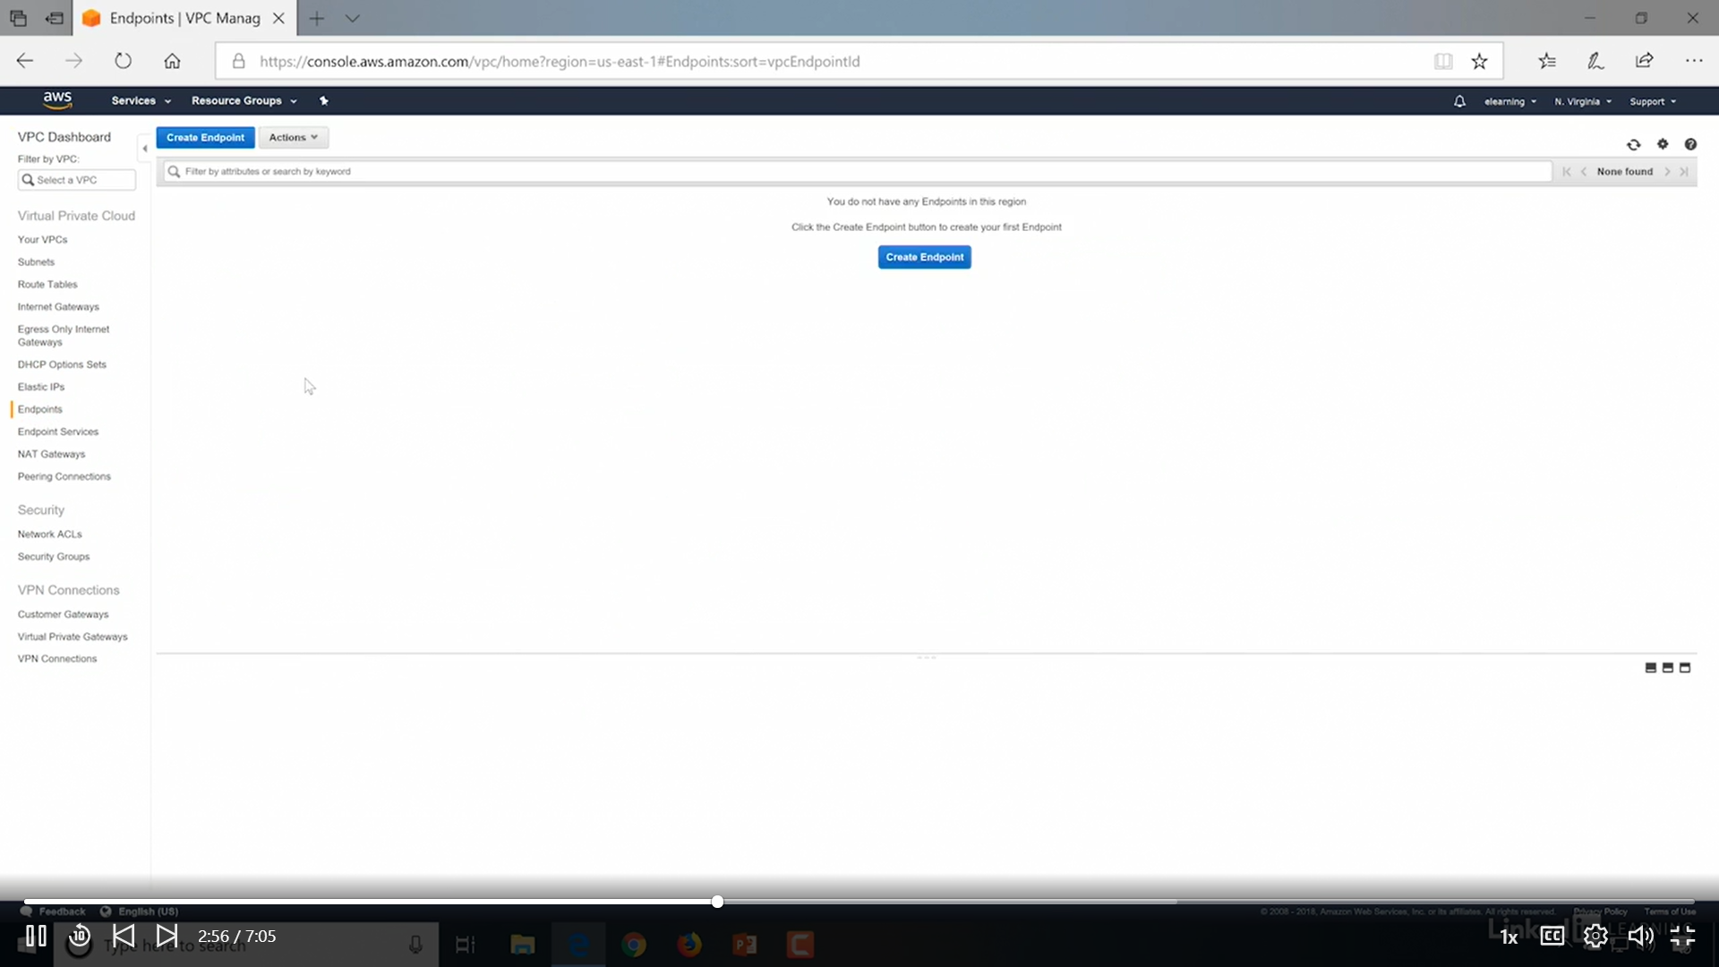

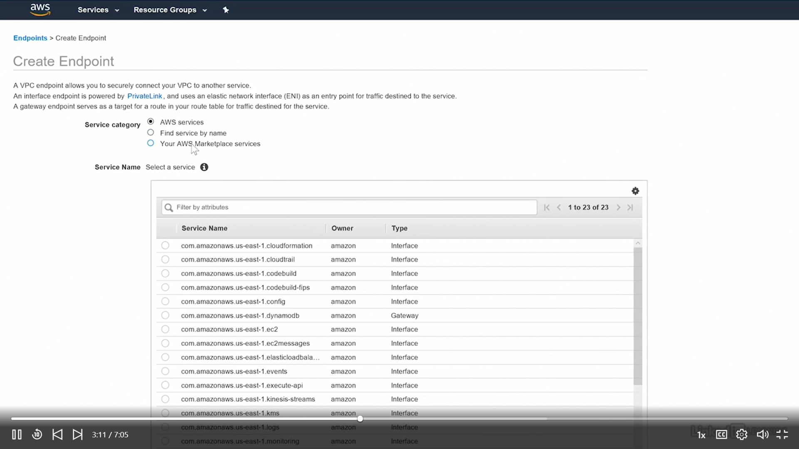

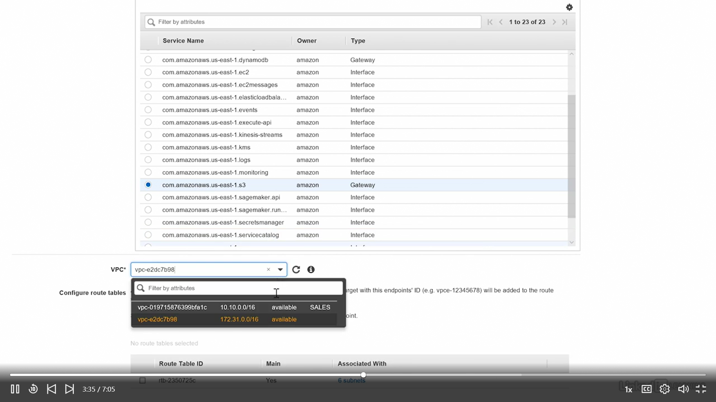

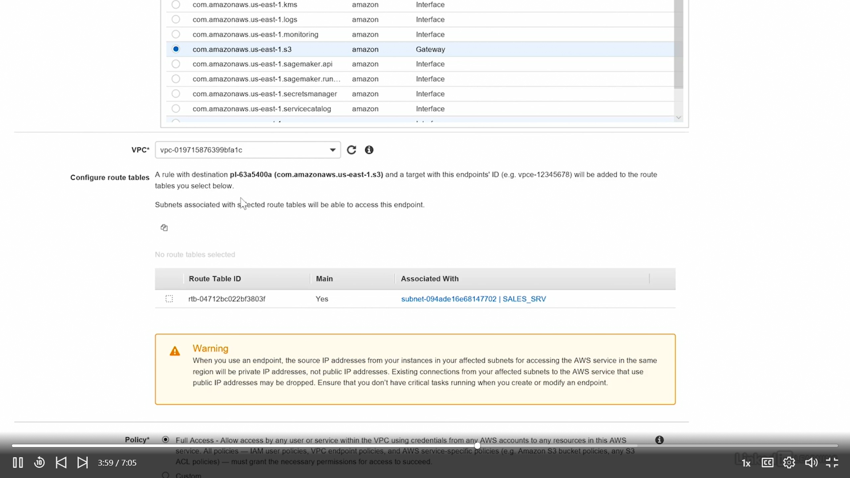

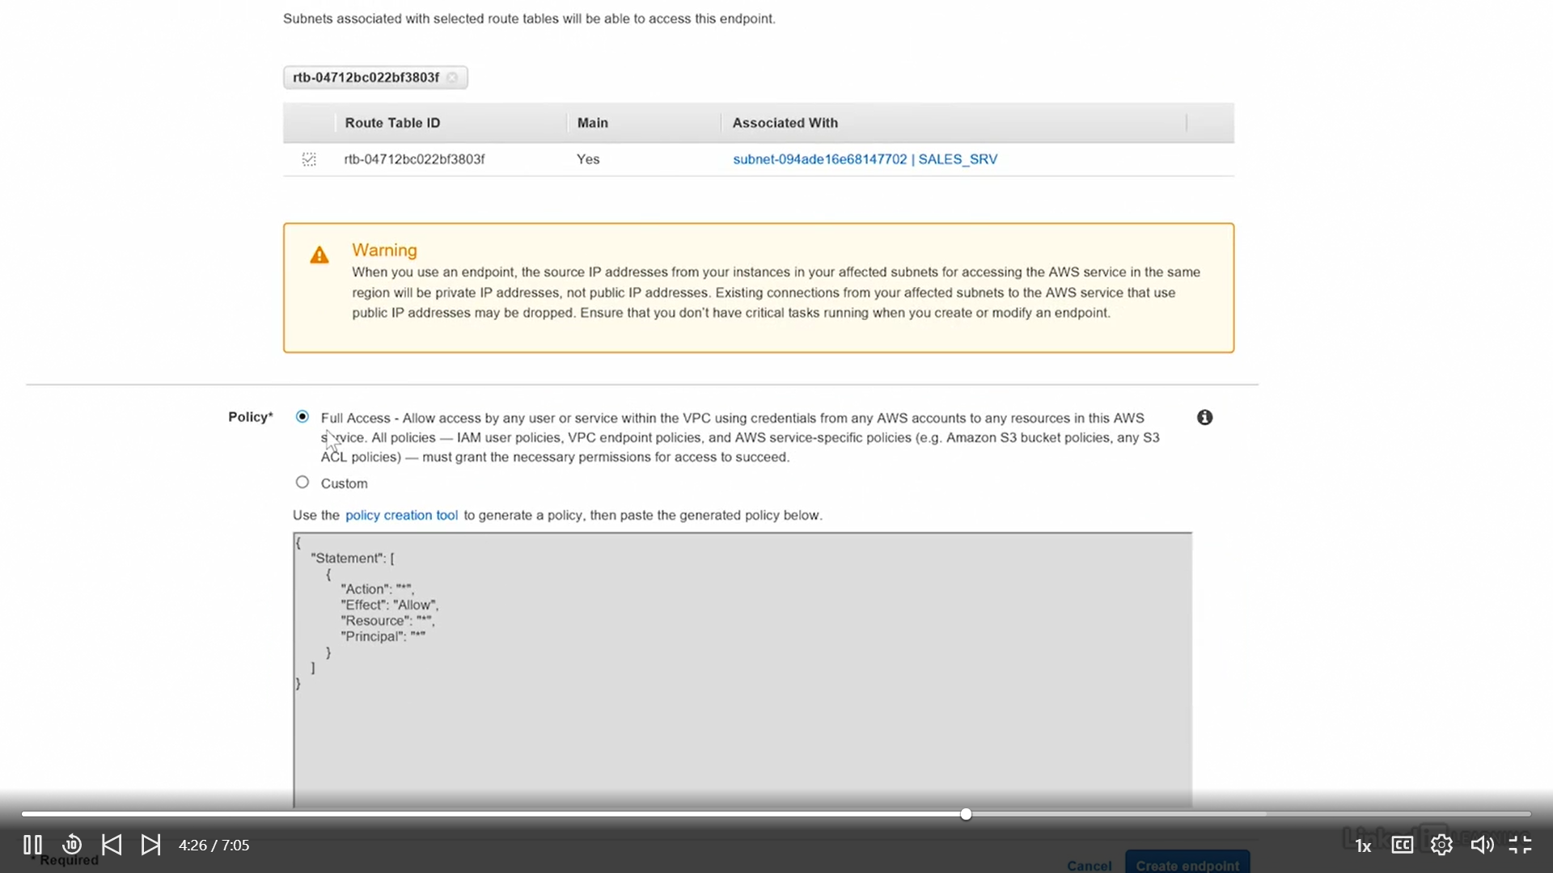

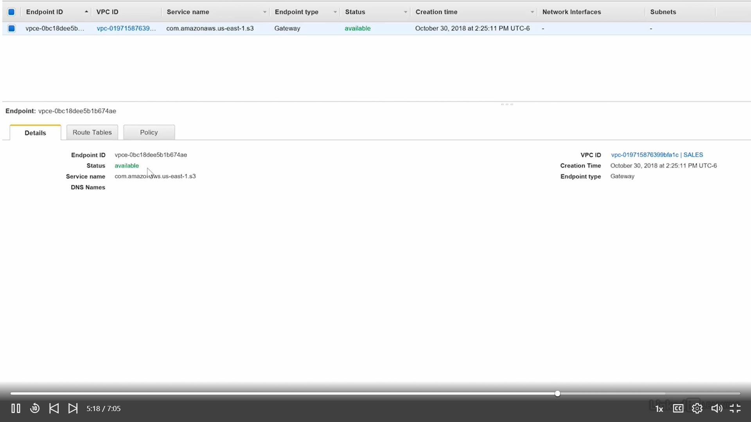

## Network Access Control Lists (NACLs)

•Applied on subnets

•Stateless processing

•Supports both allow and deny rules

Rule number defines precedence

• Lowest numbered rules first

• First match applies

## Network Address Translation (NAT)

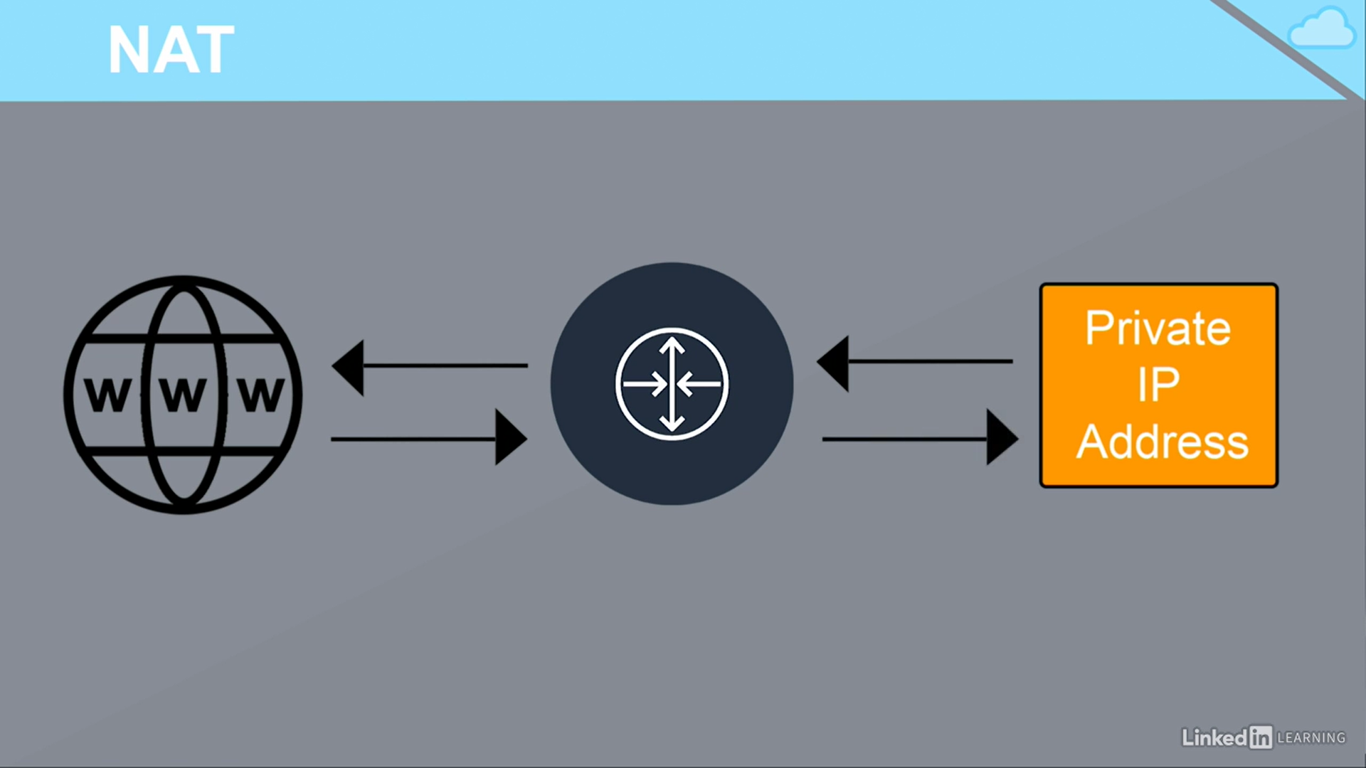

# 4. Compute*

* EC2
* Elastic Beanstalk
* Elastic Container Service
* Lambda

## Amazon Elastic Cloud Compute (EC2)

Amazon Elastic Compute Cloud, EC2 is a web service from Amazon that provides **re-sizable** compute services in the cloud.

You can use Amazon EC2 to launch as many or as few virtual servers as you need, configure security and networking, and manage storage. Amazon EC2 enables you to scale up or down to handle changes.

* Simple, EC2 – Virtual machine in the Cloud.
* Elastic – Fairly Resizable & Reusable
* Think of it like virtual machines in the cloud
* Pay as you go
* Control storage, networking and security

#### Supported Operating Systems

* Windows 2003 R2 through 2016
* Amazon Linux
* AMI (Amazon Machine Image)
* Debian
* SUSE
* CentOS
* Red Hat Enterprise Linux
* Ubuntu

## Types of Instances

EC2 is one of the oldest Service provided by AWS, it is there from Starting.

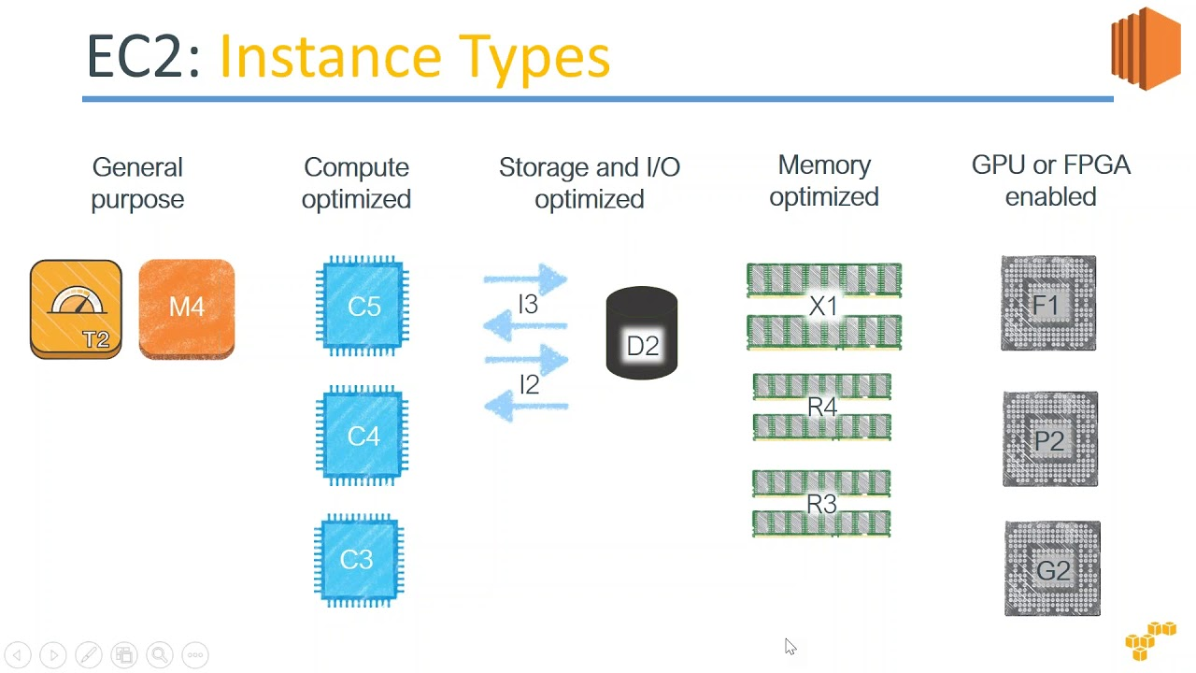

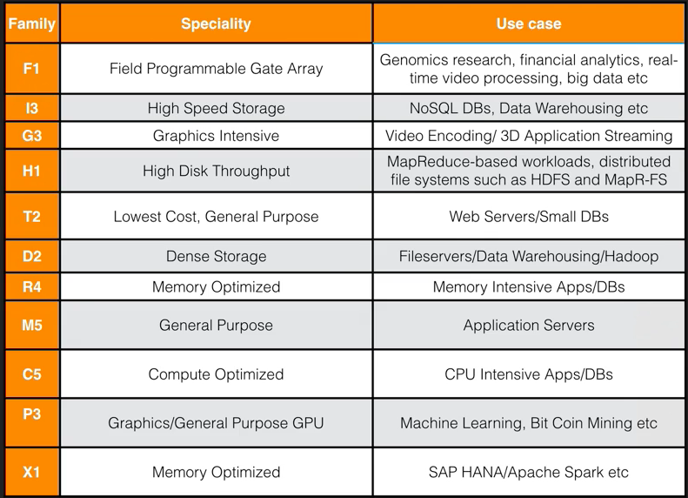

## Type of Instance Pricing Models

On‐demand

* Charged for usage time at a flat rate
* Billed in 60 second increments rounded up

Reserved

* Reserve usage for at least 1 year
* Less expensive than on‐demand when usage is known

Spot

* Bid on unused compute time
* Up to a 90% discount over on‐demand

Reserved Instance Pricing

* 1 year, no up‐front costs
* 1 year, partial up‐front costs
* 1 year, all up‐front costs
* 3 years, no up‐front costs
* 3 years, partial up‐front costs
* 3 years, all up‐front costs

|  |  |  |  |  |
| --- | --- | --- | --- | --- |
|  | **On-demand** | **Spot** | **Reserved** | **Dedicated Host** |
| **Best for** | Apps with fluctuating demand | Maximizing cost savings | Workloads with predictable, consistent demand | Workloads that benefit from bare-metal access |
| **Discounts available (compared to on-demand)** | None | Up to 90 percent off | Up to 75 percent off | None (but you can potentially save on licensing fees) |
| **Resource usage limitations** | None | None | Reserved capacity | Server maximum capacity |

## Elastic Block Store (EBS) and EC2

For each and every Instance(VM) should have a storage to store operating system & other OS related files. When you shut down the instance all the changes should save. If we re-start the instance all the changes should be there. In AWS we use EBS for this.

* Persistent block storage
* Requires an EBS‐optimized instance
* Can use magnetic or SSD (general purpose or provisioned IOPS (PIOPS))

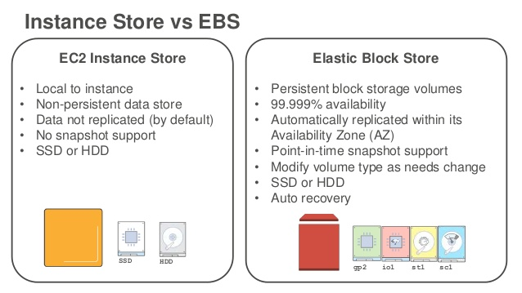

EC2 instances boot from EBS volumes and not EFS or S3, so an EBS volume must be used. Magnetic volumes are slower but less expensive than SSD volumes.

#### Amazon EBS–Optimized Instances

An Amazon EBS–optimized instance uses an optimized configuration stack and provides additional, dedicated capacity for Amazon EBS I/O. This optimization provides the best performance for your EBS volumes by minimizing contention between Amazon EBS I/O and other traffic from your instance.

When attached to an EBS–optimized instance, General Purpose SSD (gp2) volumes are designed to deliver their baseline and burst performance 99% of the time, and Provisioned IOPS SSD (io1) volumes are designed to deliver their provisioned performance 99.9% of the time. Both Throughput Optimized HDD (st1) and Cold HDD (sc1) guarantee performance consistency of 90% of burst throughput 99% of the time

T- type instances doen’t support EBS. So for EBS we should not be a Free Tier user.

[Learn how Adobe uses EBS for their enterprise products.](https://aws.amazon.com/solutions/case-studies/adobe/)

[Learn how BazaarVoice uses larger and faster EBS volumes.](https://aws.amazon.com/solutions/case-studies/bazaarvoice/)

[Learn how Infor saved 75% on their monthly backup costs.](https://aws.amazon.com/solutions/case-studies/infor-ebs/)

## Shared Tenancy

•Multiple instances on a physical machine

•Multiple organizations/applications share the time on the machine.

Multiple customers share the time and space on the physical machine

•Default behavior of an instance

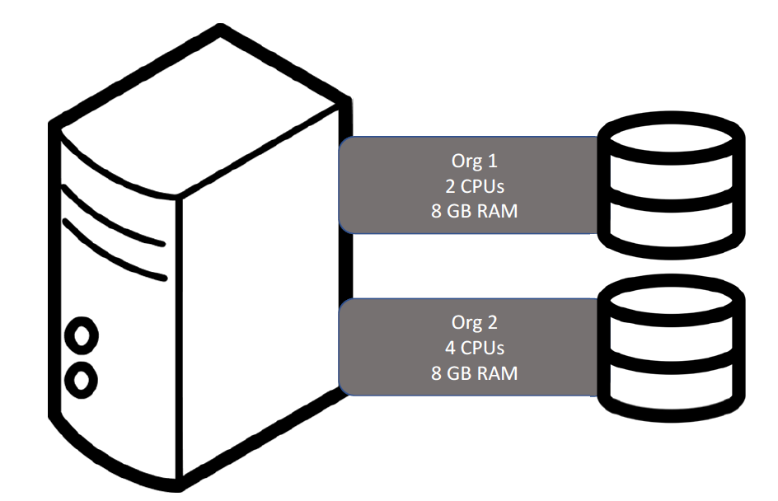

•Pros

• Reduced costs

• Simpler deployment

•Cons

• Lower performance

• Less control

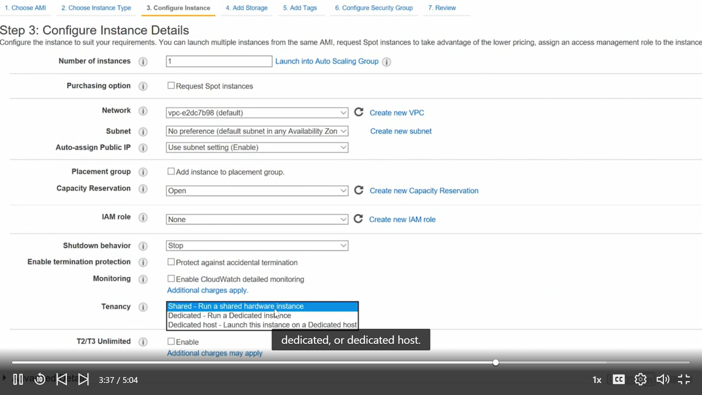

## Dedicated Hosts

One Dedicated Physical Server – run multiple VM’s

•Physical machines

• Run the virtual machines

•Used by one customer

•Must be explicitly configured

•Not available in free tier

•Pros

• More accurate licensing management

• More detailed reporting

• Compliance management

• Determine host placement during instance restarts

•Cons

• Costs more

BYOL – Bring Your Own Lincec Option is vailable (ex. Windows lince )

## Dedicated Instance

•Runs on a physical machine

• Only instance running on that machine

• On restart, may be moved

•Used by one customer

•Must be explicitly configured

•Not available in free tier

•Pros

• Runs on hardware dedicated to the customer

• Provides performance advantage of a dedicated

host

•Cons

• Less accurate licensing management

• Doesn’t allow placement determination

## AMI

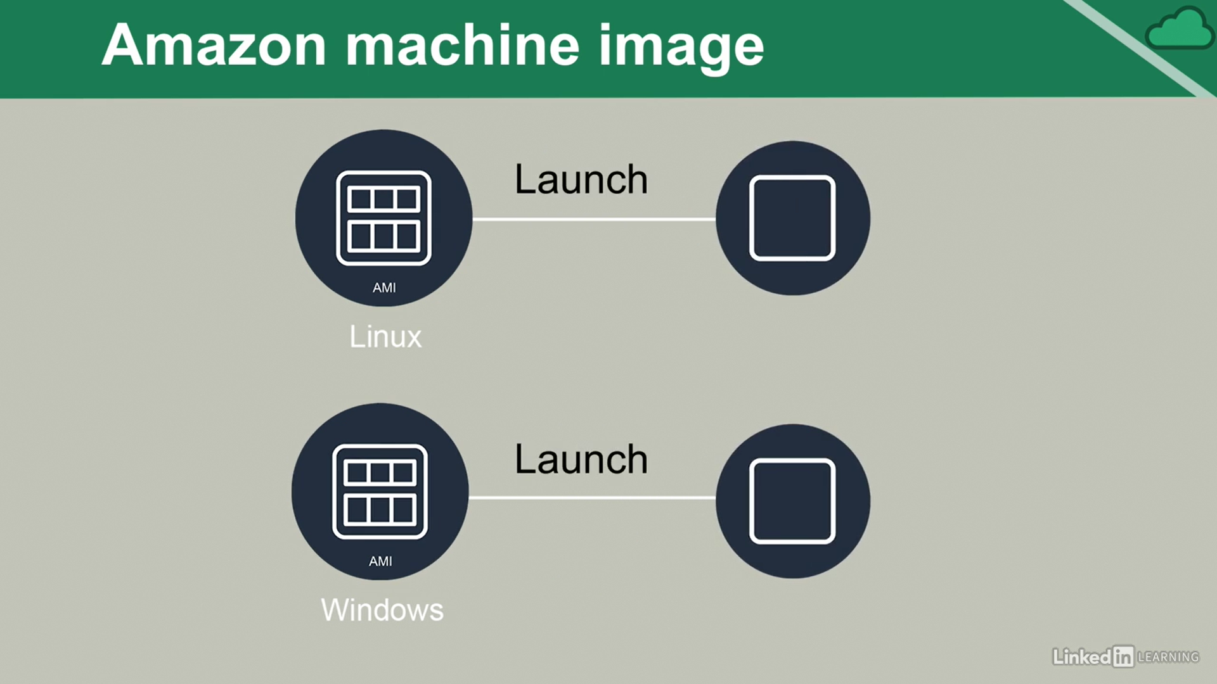

* Blueprint with server configuration details
* Similar to localized imaging solutions
* The term “instance” indicates the use of the AMI
* All instances are created from an AMI
* Sources
  + Amazon (free)
  + AWS Marketplace (free/$)

**Who can launch an instance of an AMI?**

* Public: Anyone
* Explicit: Specified
* Implicit: Owner(def.)

#### AMI Creation

* Many come with AWS
* AMIs can be created from the existing AMIs
* AMIs can be created from scratch
* AMIs can be pulled from other public sources
* They may be purchased from the AWS Marketplace

#### Instance Root Volume

* Contains the boot sector
* Boot sector initiates the boot loader
* Boot loader launches the OS

## Lab: Launching an EC2 Linux instance

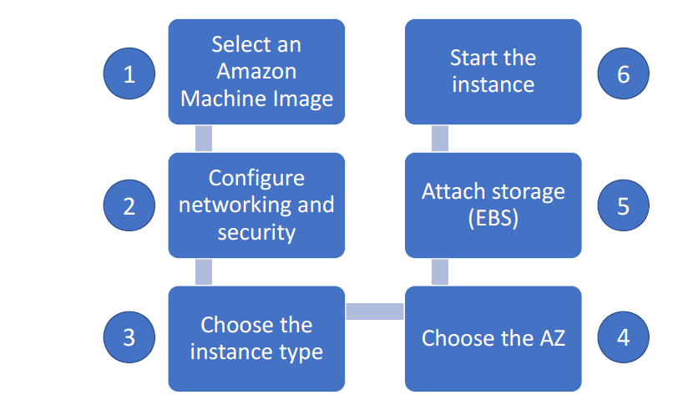

**Lab: Launching an EC2 Linux instance**

1.Go to EC2 by Services > Compute >EC2 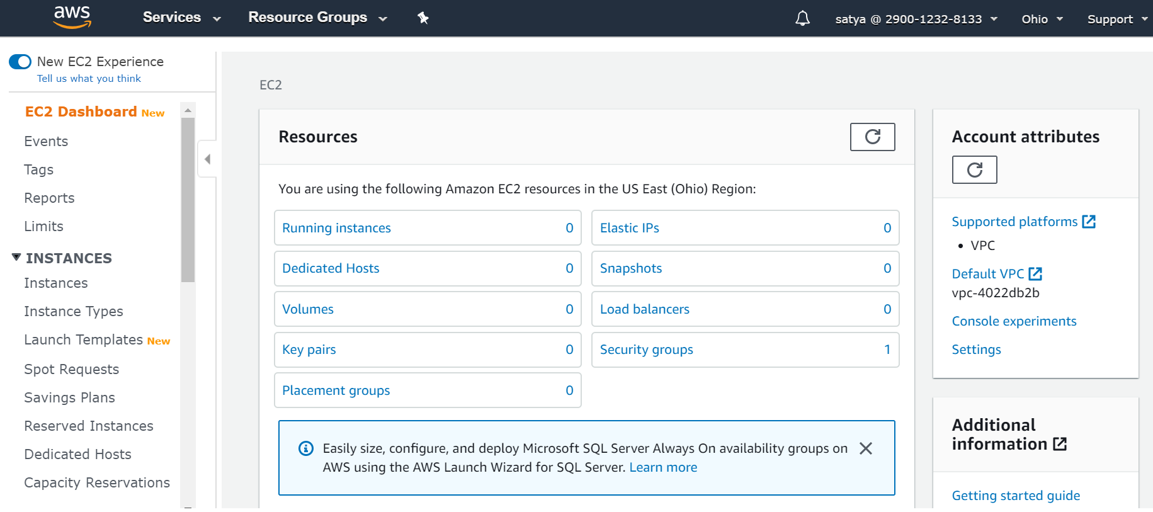

2.To create new Instance – Click on **“Launch Instance “**

1.Choose Amazon Machine Image(AMI) - [Tick] Free Tier One

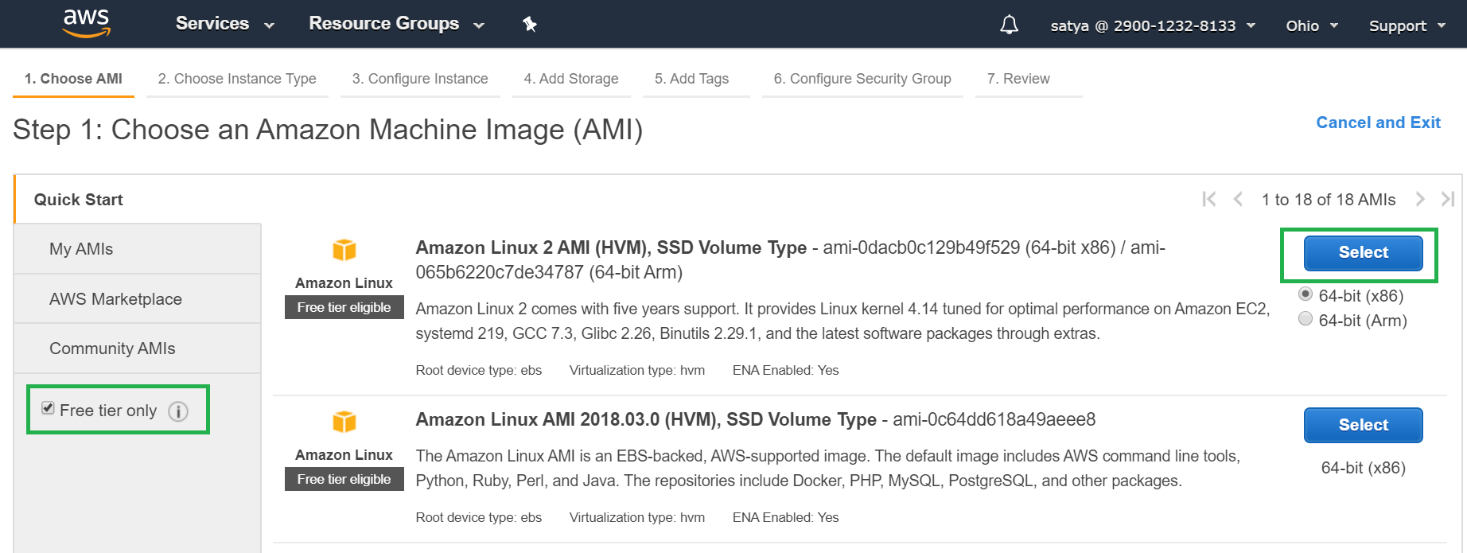

2.Choose Instance Type : (General Purpose) 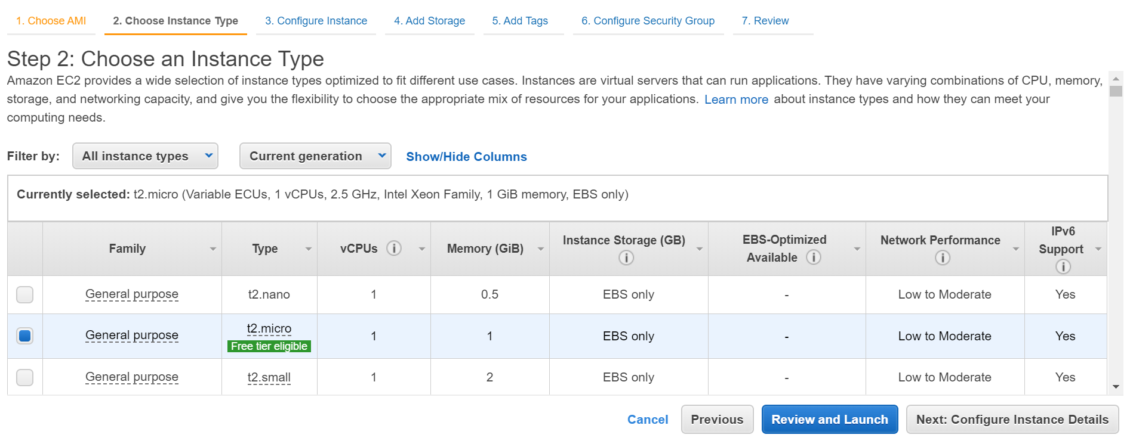

3.Configure Instance : Network / Security /IAM Roles

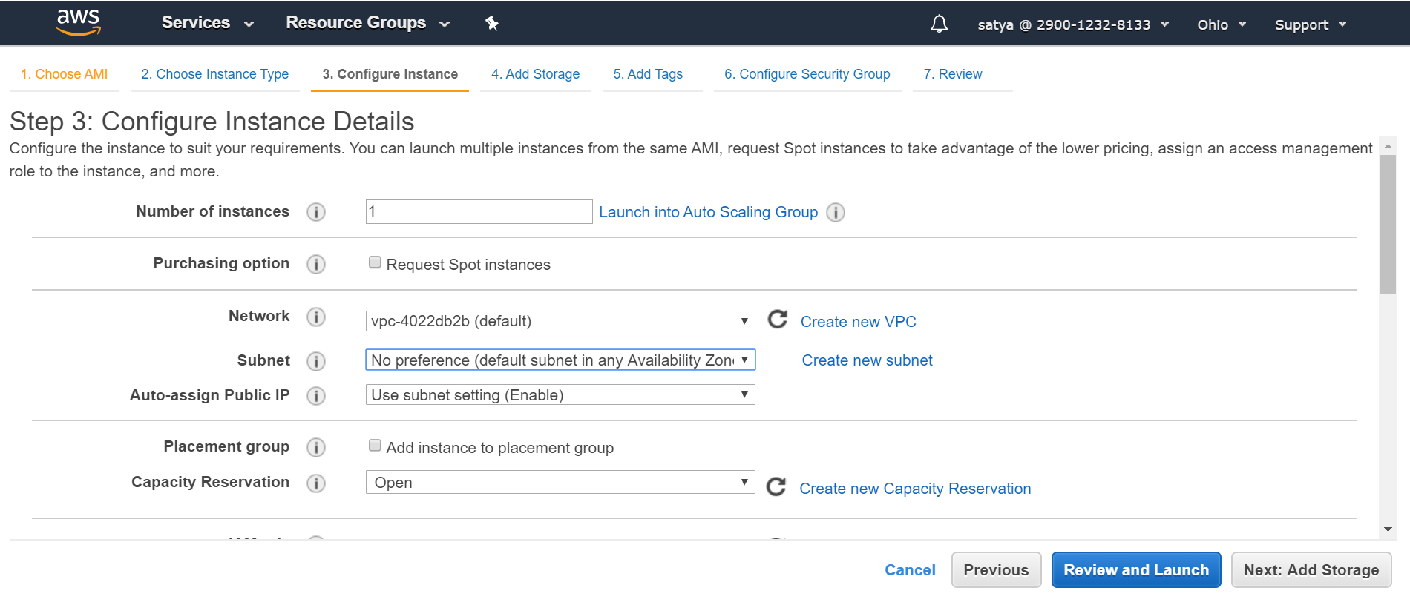

4.Add Storage : Memory Size, EBS or Not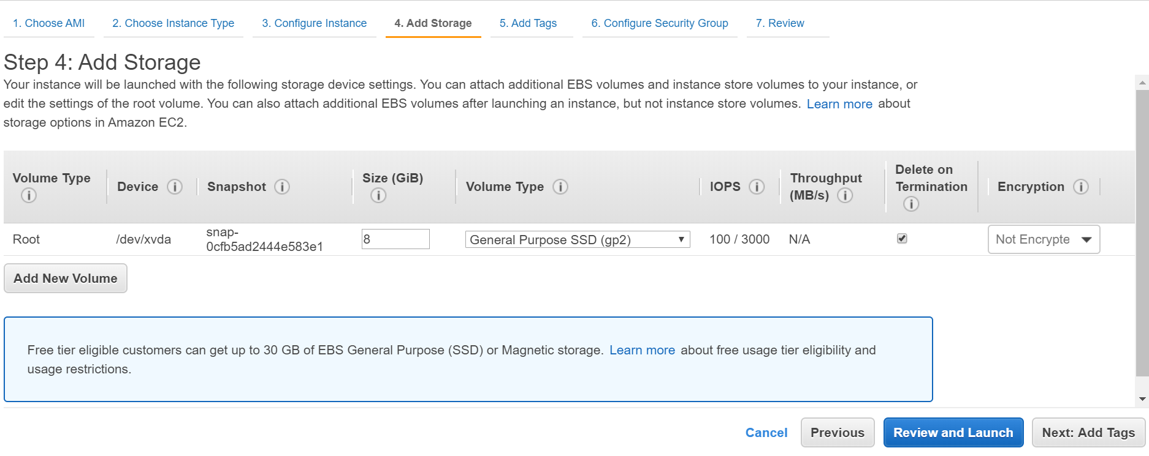

5.Add Tags: Just for using Purpose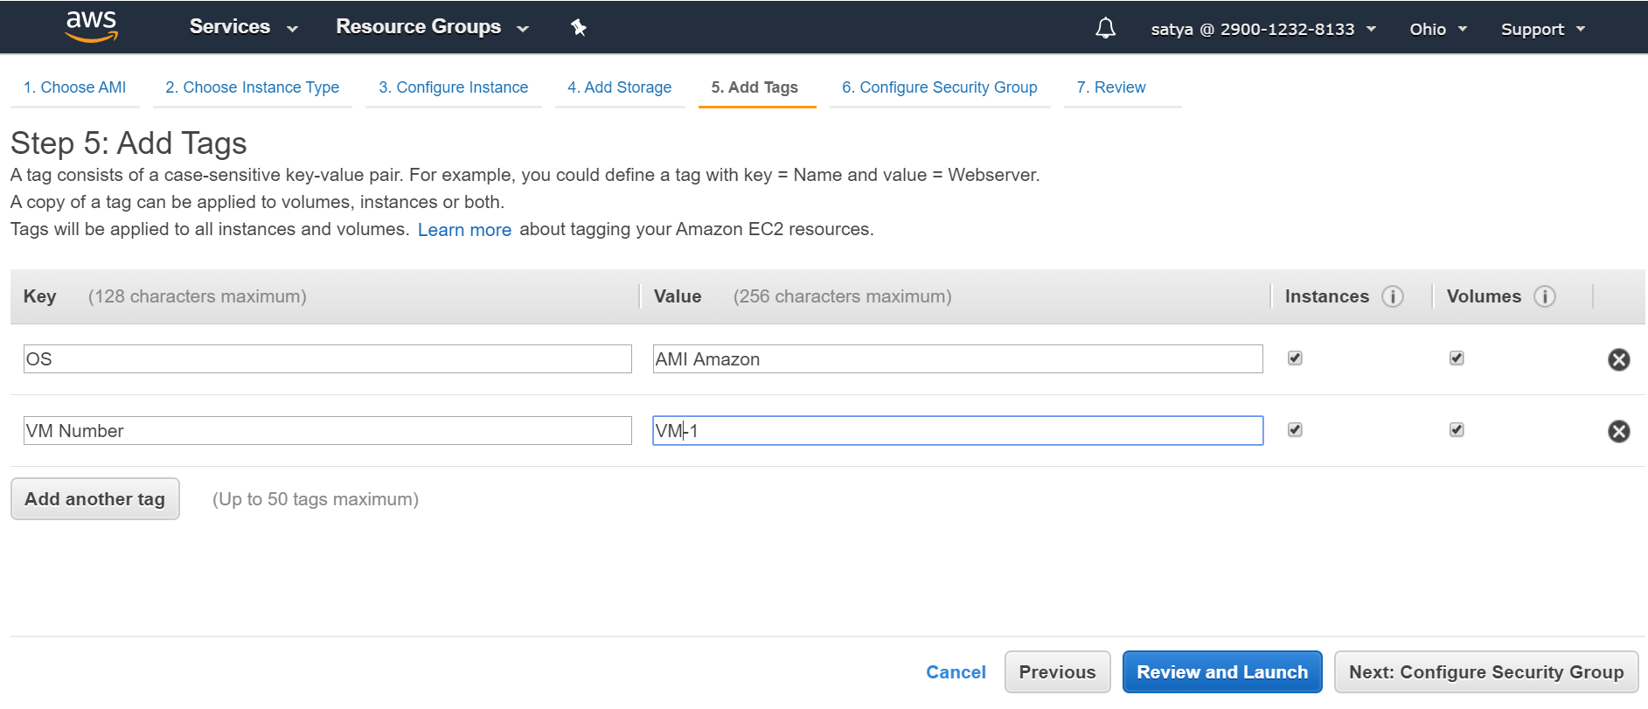

6.Security Groups : Leave it as it is or create new one with VM Name

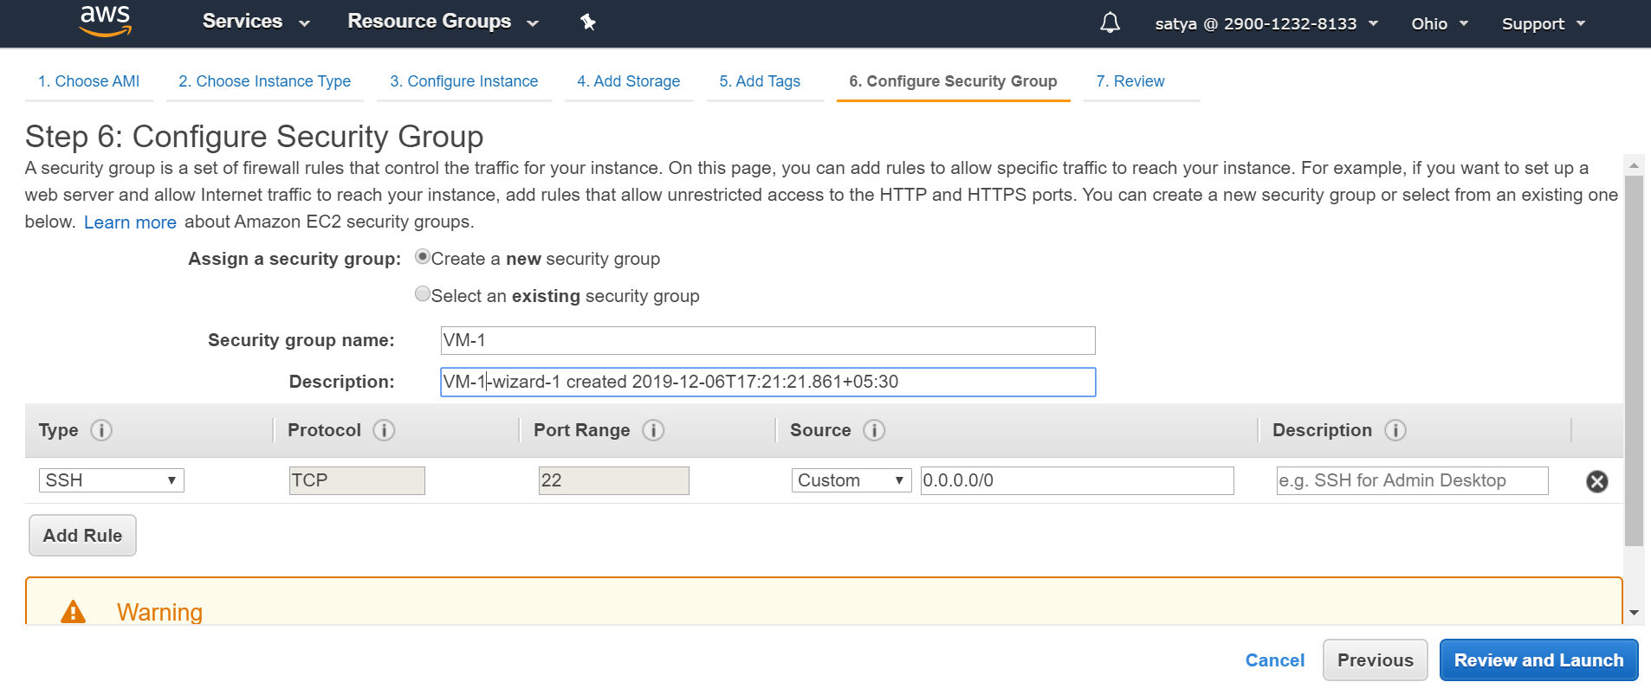

7. Review Instance Launch

8.Boot from General Purpose Warning > Select "Magnetic"

9.Generate a new Key Pair / use Existing one & Download Key pair

- used for SSH login via Putty/ any tool

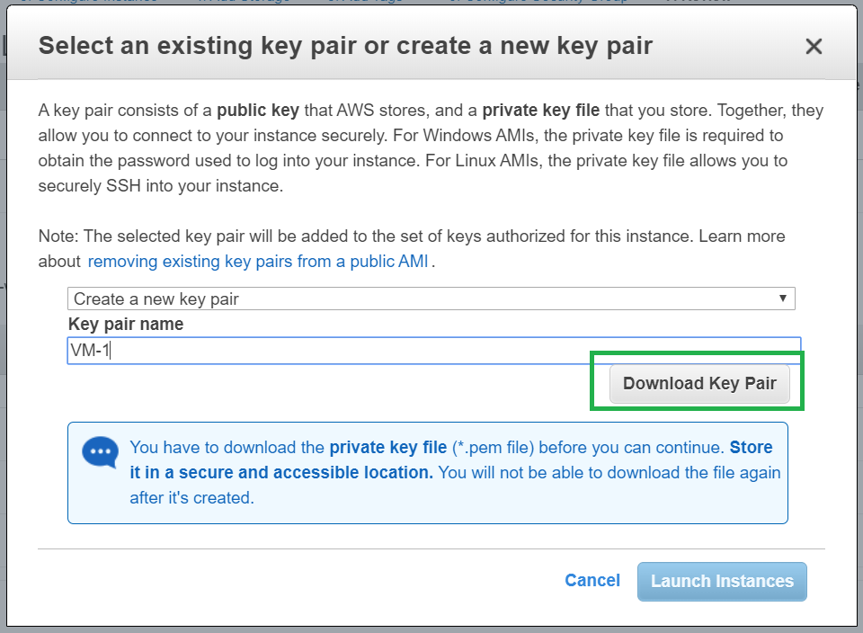

10.Launch Instance& Make Sure its State is **Running**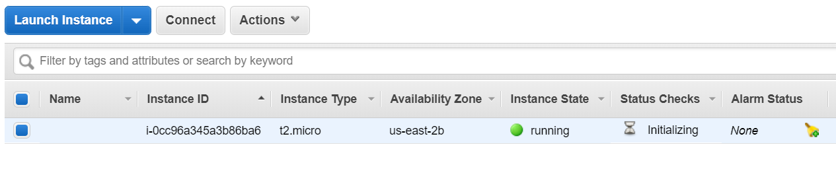

#### Connect to EC2 Instance

1.Get IPv4 Public IP from Instance Description

Public DNS(IPv4): ec2-18-216-255-66.us-east-2.compute.amazonaws.com

IPv4 Public IP : 18.216.255.66

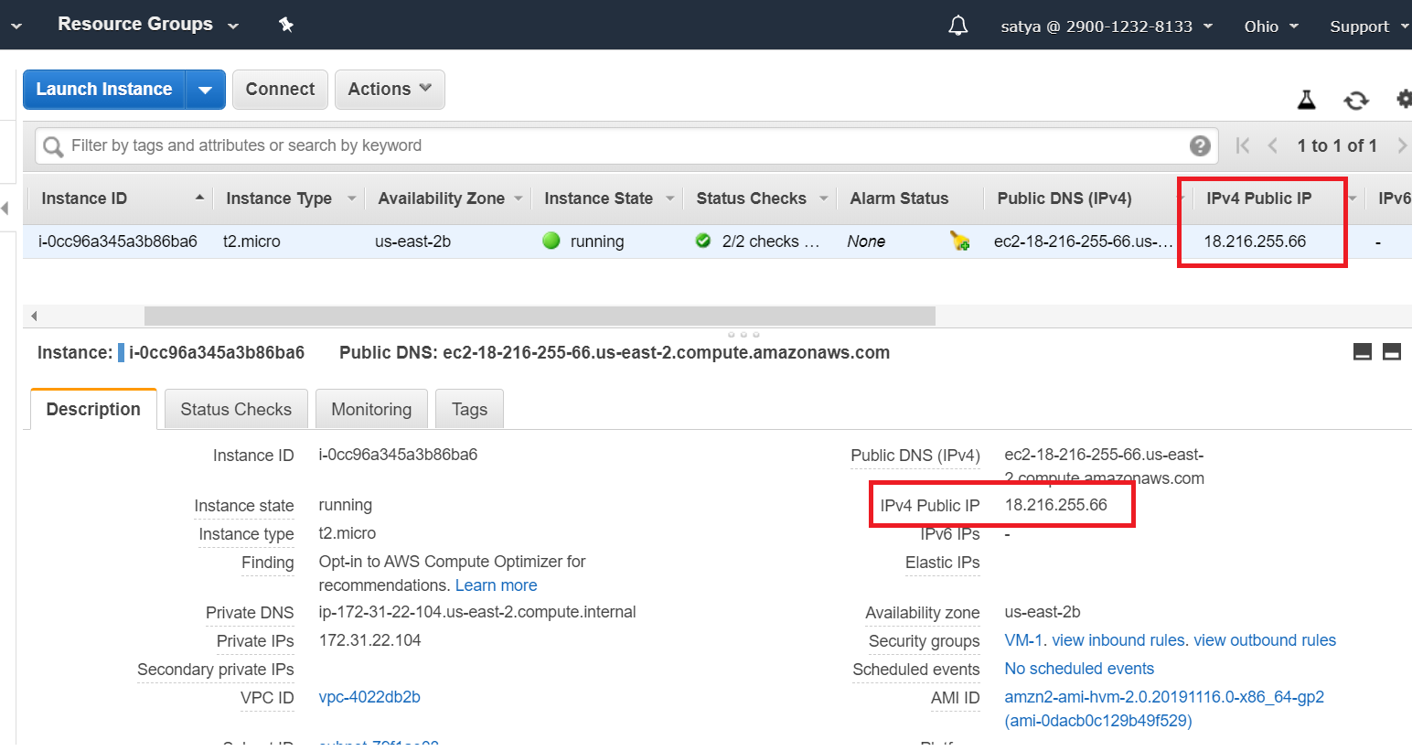

2.Open Downloaded .pem file

* If we are using Linux system we can directly use .pem file for connection.
* If we are using Windows System, we don’t have SSH directly.

we use PuttY for SSH connections. but Putty doesn't support .pem file it only supports .ppk file. for that we need to convert .pem file to .ppk file

**3.Covert .pem to .ppk using Putty**

* Launch PuttyGen
* Load .pem file
* Save Private Key: VM-1.ppk

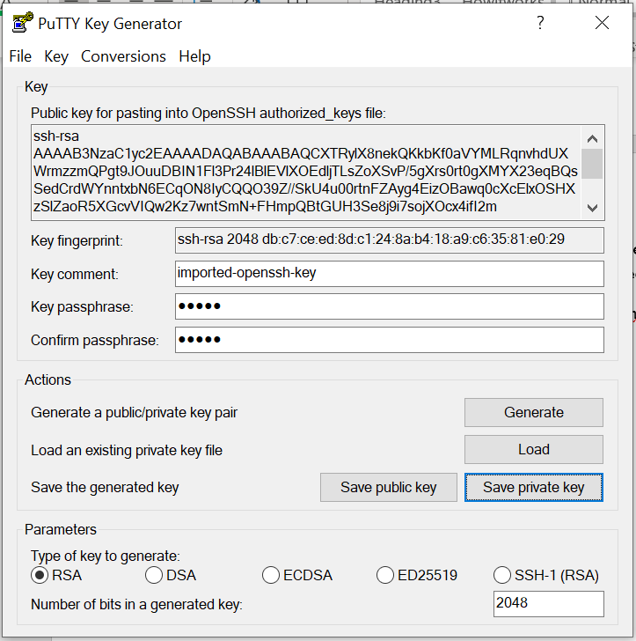

4.Open Putty

* Enter Ip : 18.216.255.66
* Connection Type : SSH
* Left Menu > SSH >+AUTH : Browse saved VM-1.ppk file

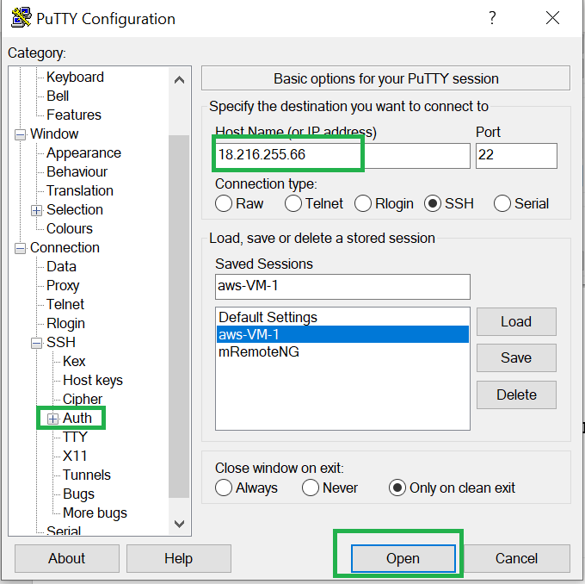

5.Remember : Default user for EC2 Instance is : "**ec2-user**"

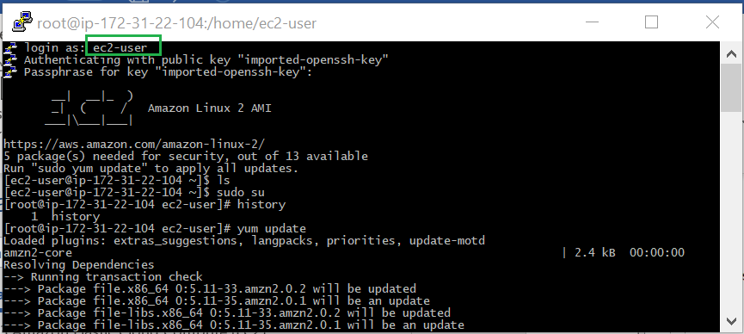

## Lab: Launching an EC2 Windows instance

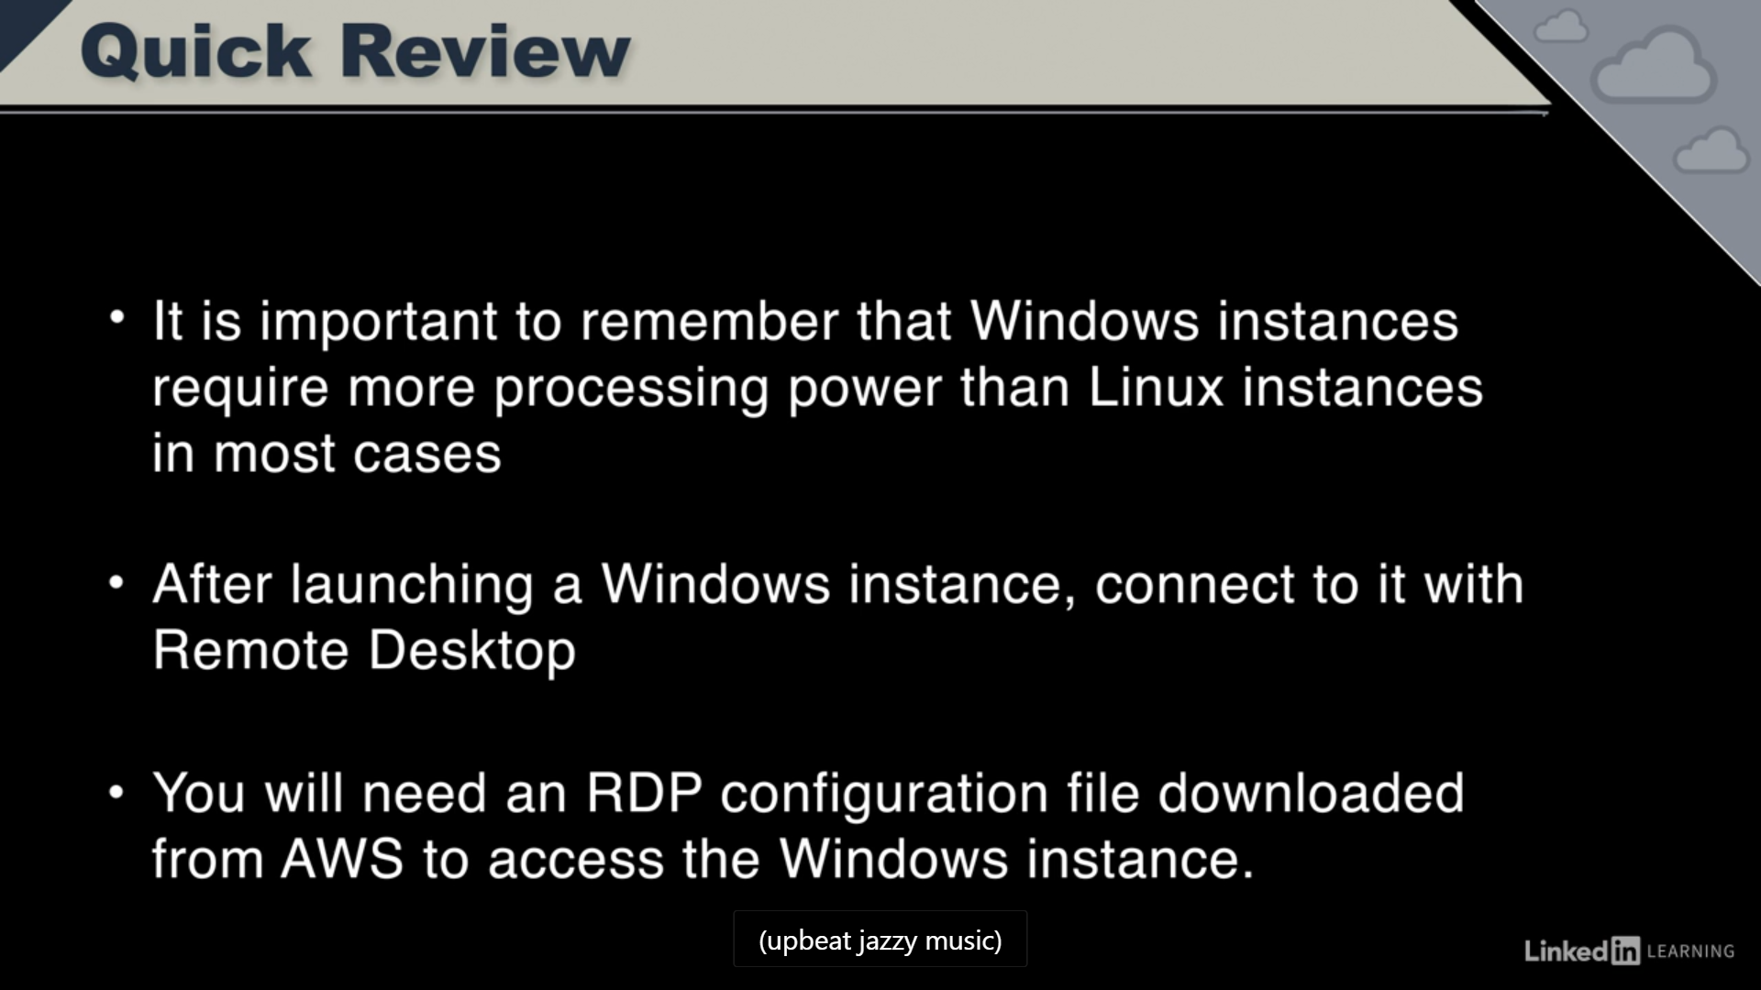

Lunch Instance : Free Tier

1.Select AMI - Windows Server 2012

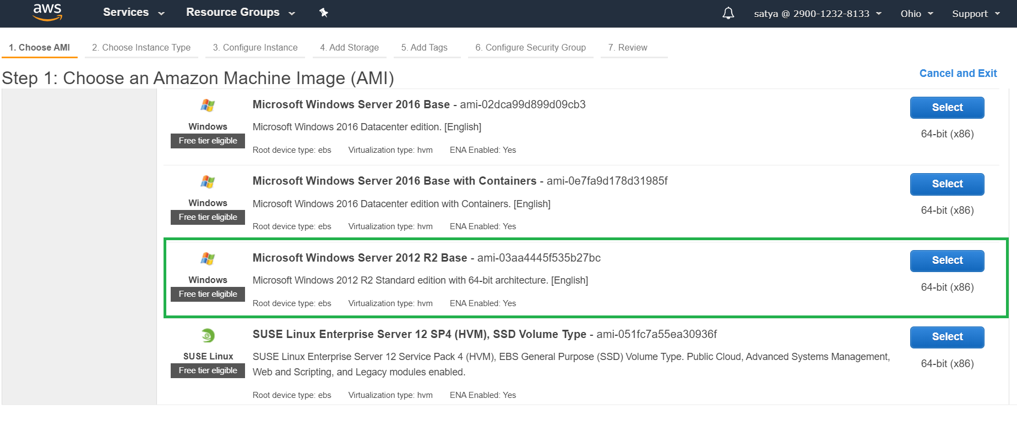

2.Instance Type : free Tier 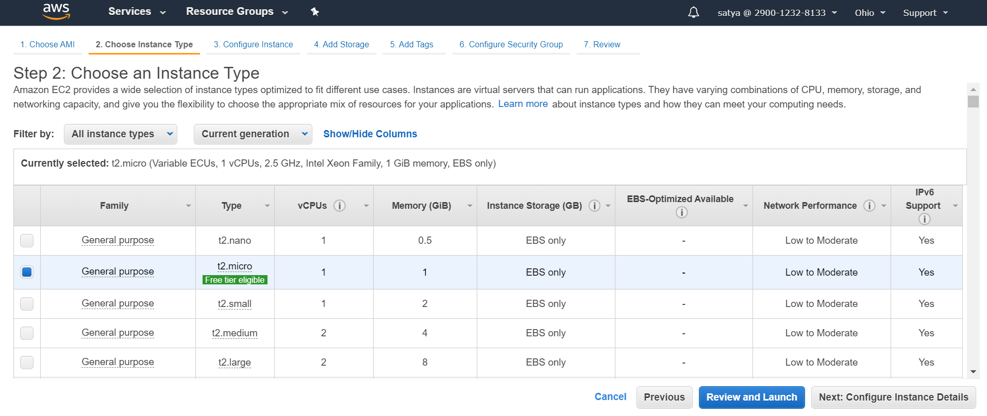

3.Network : Leave it Default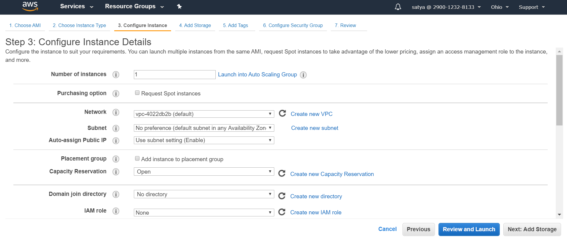

4.Storage :30GB - general purpose SSD(Linux we used magnetic Disc) 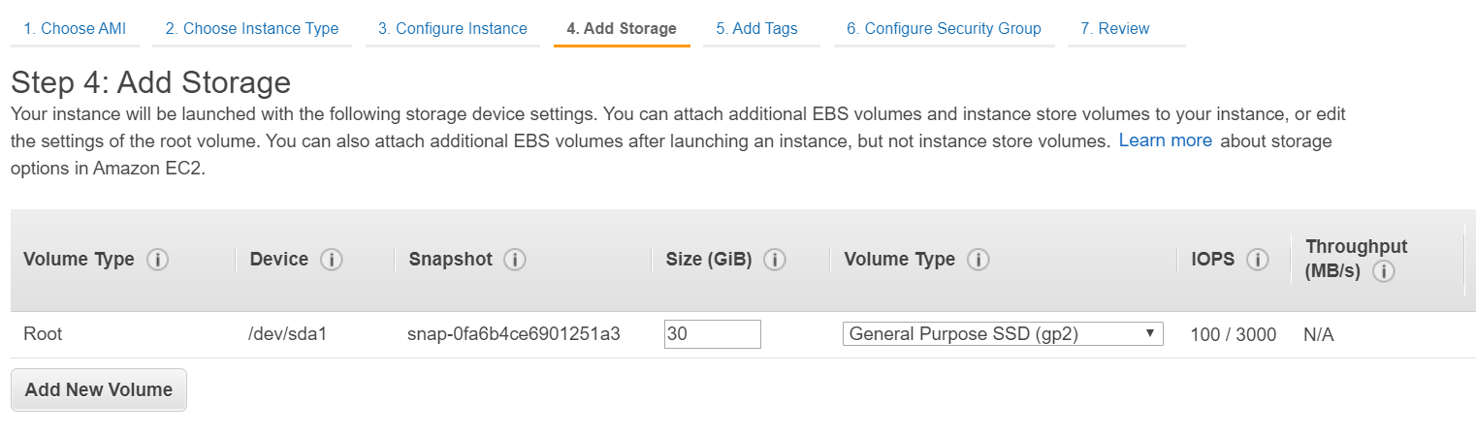

5.Add Tags if required 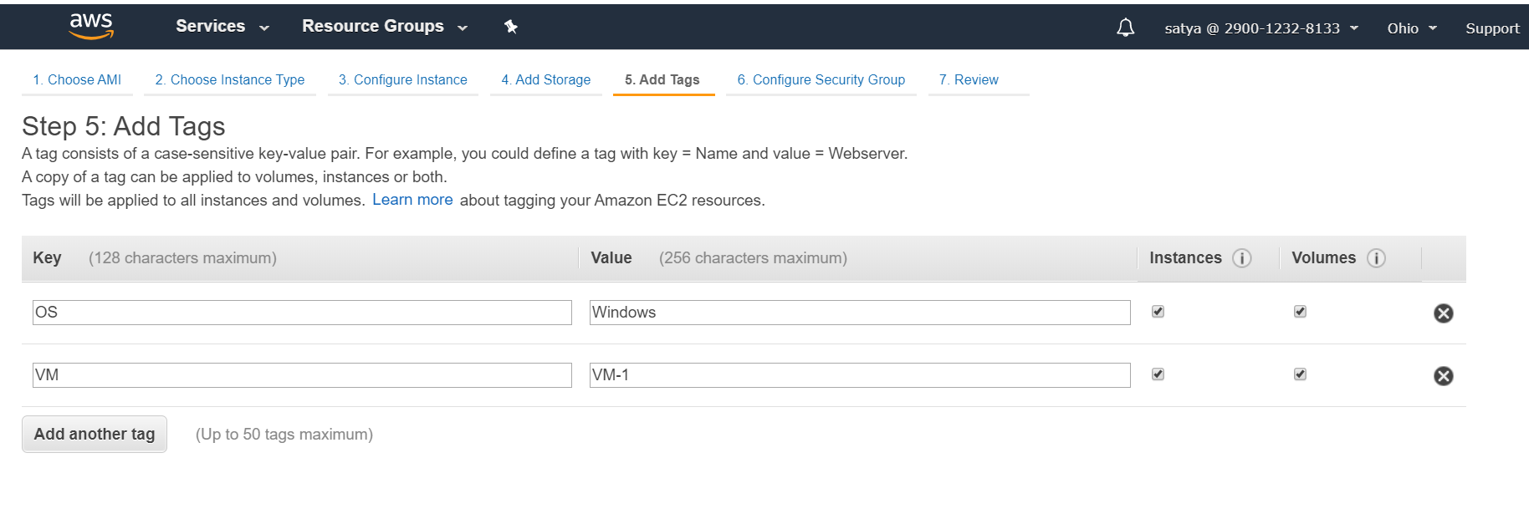

6.Security Group : RDP (Remote Desktop)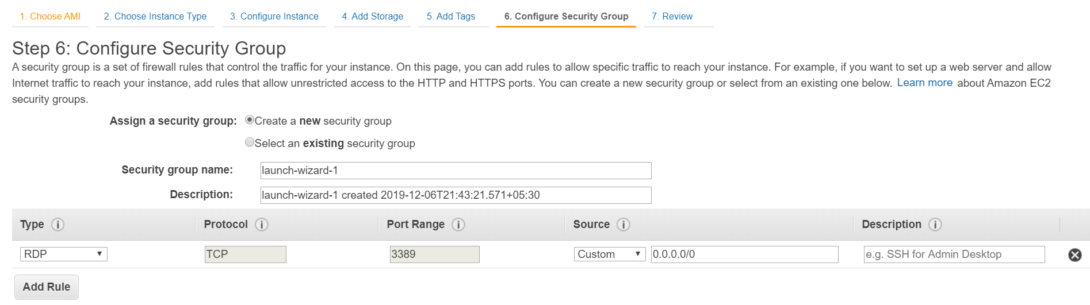

* Inbound - Only 3389 is open for Incoming Request
* OutBound Rules - All request are allowed for outside the world

7.Review & Launch

8.Choose new Key pair / Existing

we can use same Key for both Linux & Windows

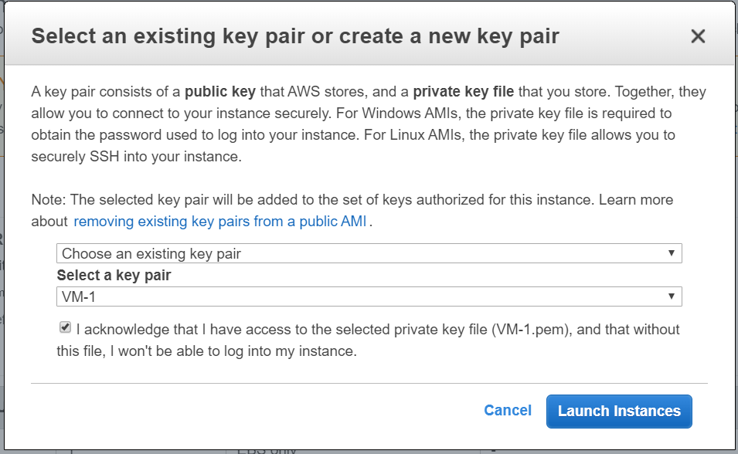

**You launched windows Server in 3 minutes** 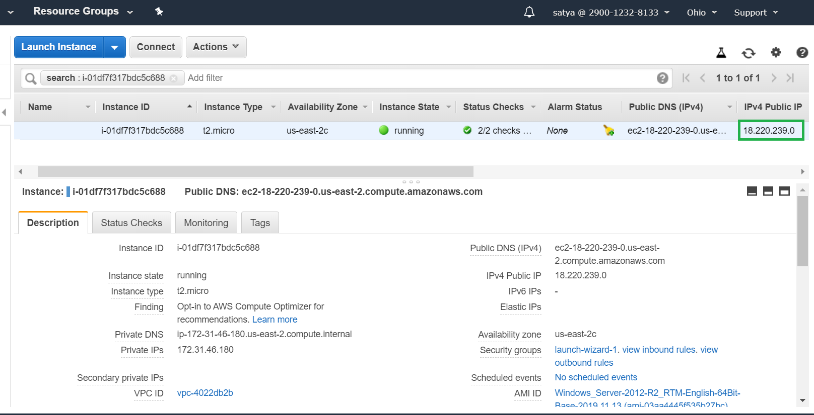

8.To connect RDP > Click on Connect beside Instance

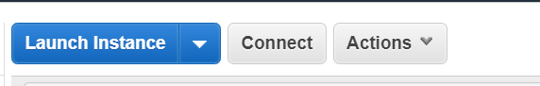

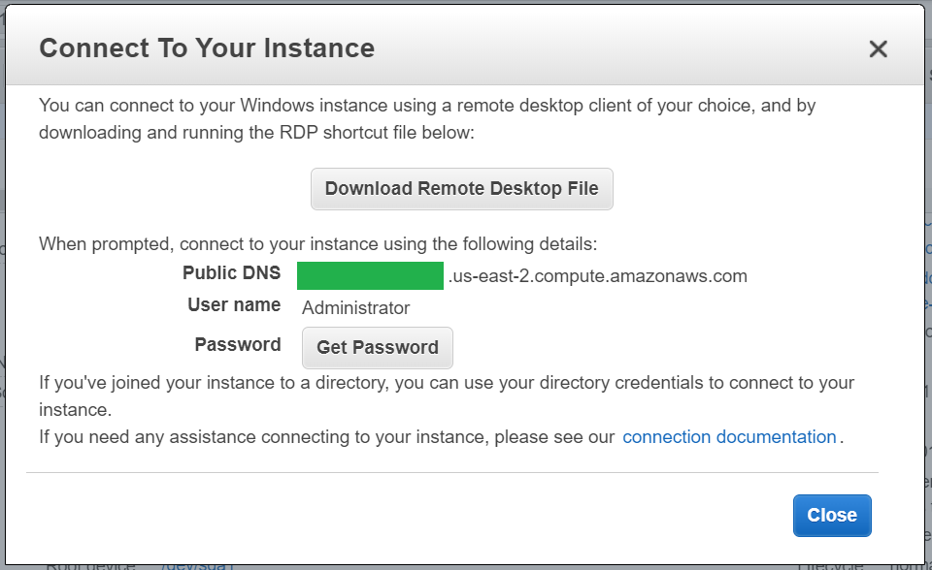

Click On Generate Password > Upload Downloaded Key file> Decrypt Password

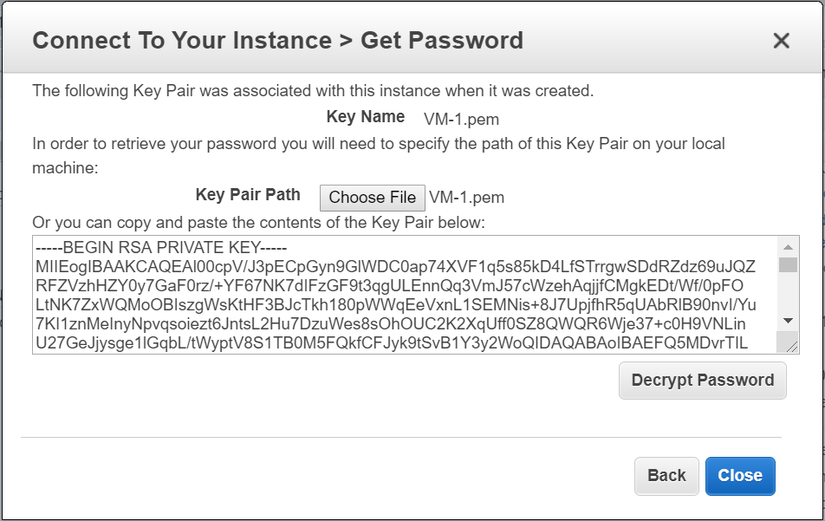

It will show the password : *************

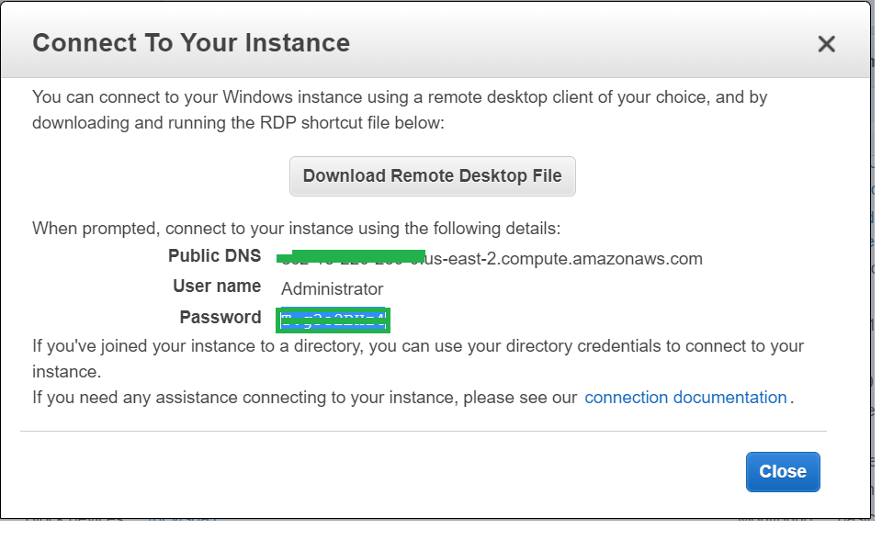

Download Remote Desktop file > Open it to RDP connection.

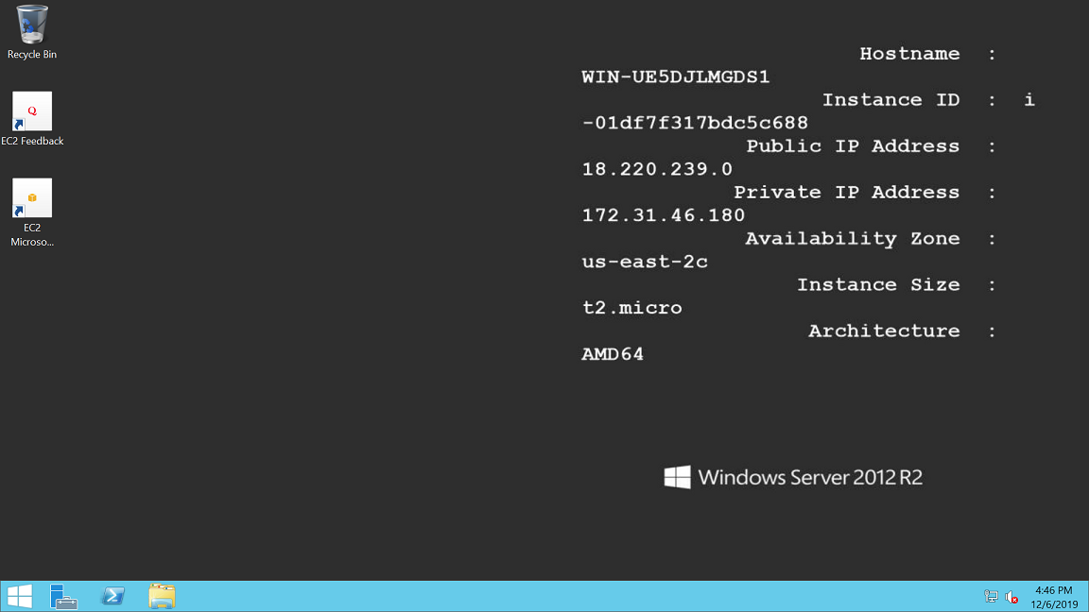

## Handson

[Launch a Linux Virtual Machine](https://aws.amazon.com/getting-started/tutorials/launch-a-virtual-machine/?trk=gs_card&e=gs&p=gsrc)

[Launch a Windows Virtual Machine](https://aws.amazon.com/getting-started/tutorials/launch-windows-vm/?trk=gs_card)

[Build a WordPress Website](https://aws.amazon.com/getting-started/projects/build-wordpress-website?trk=gs_card)

[Deploy a Python Web App](https://aws.amazon.com/getting-started/projects/deploy-python-application?trk=gs_card)

[Host a .NET Application](https://aws.amazon.com/getting-started/projects/host-net-web-app?trk=gs_card)

[Build a LAMP Stack Web App](https://aws.amazon.com/getting-started/projects/launch-lamp-web-app?trk=gs_card)

[Build a Drupal Website](https://aws.amazon.com/getting-started/projects/build-drupal-website?trk=gs_card)

[Provision Desktops in the Cloud](https://aws.amazon.com/getting-started/projects/provision-cloud-desktops?trk=gs_card)

[Linux Bastion Hosts](https://aws.amazon.com/quickstart/architecture/linux-bastion/?trk=gs_card)

[Launch and Configure a WordPress Website](https://lightsail.aws.amazon.com/ls/docs/en/articles/amazon-lightsail-tutorial-launching-and-configuring-wordpress)

[Launch and Configure a LAMP Website](https://lightsail.aws.amazon.com/ls/docs/en/articles/amazon-lightsail-tutorial-launching-and-configuring-lamp)

[Launch and Configure a Windows Server 2016 Instance](https://lightsail.aws.amazon.com/ls/docs/en/articles/amazon-lightsail-tutorial-launching-and-configuring-windows-server-2016)

## EC2 – Operations

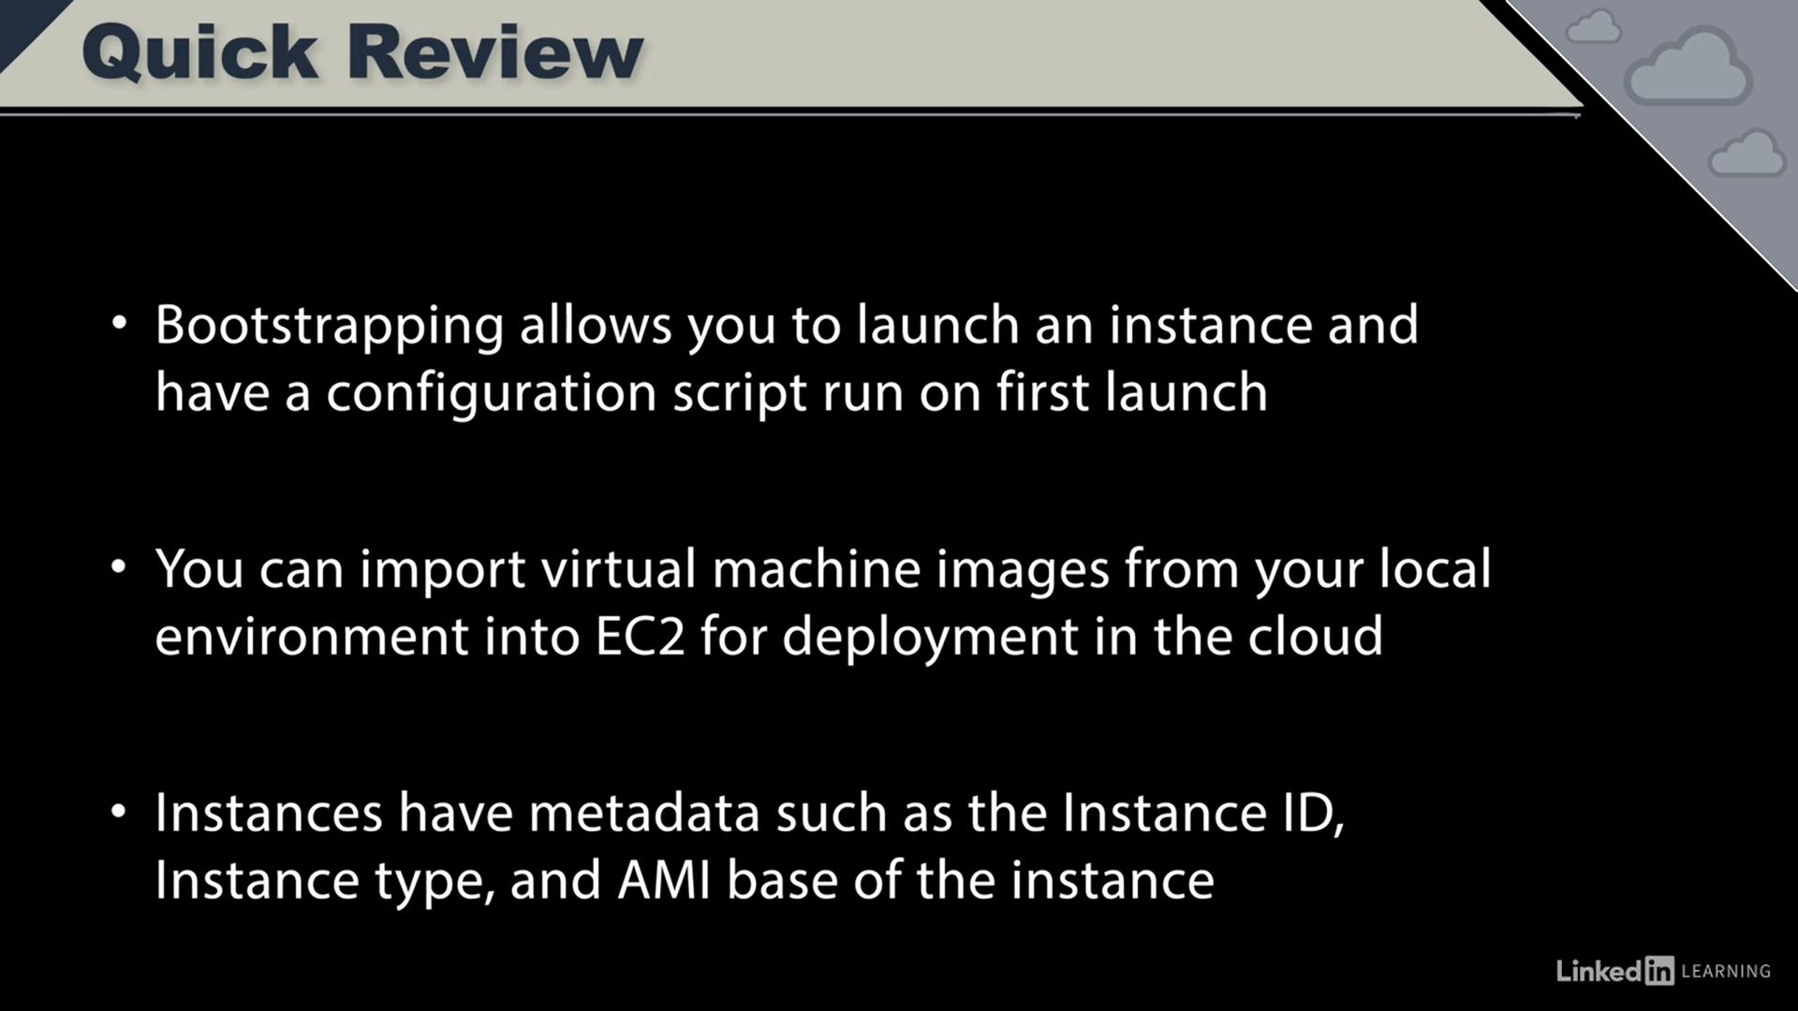

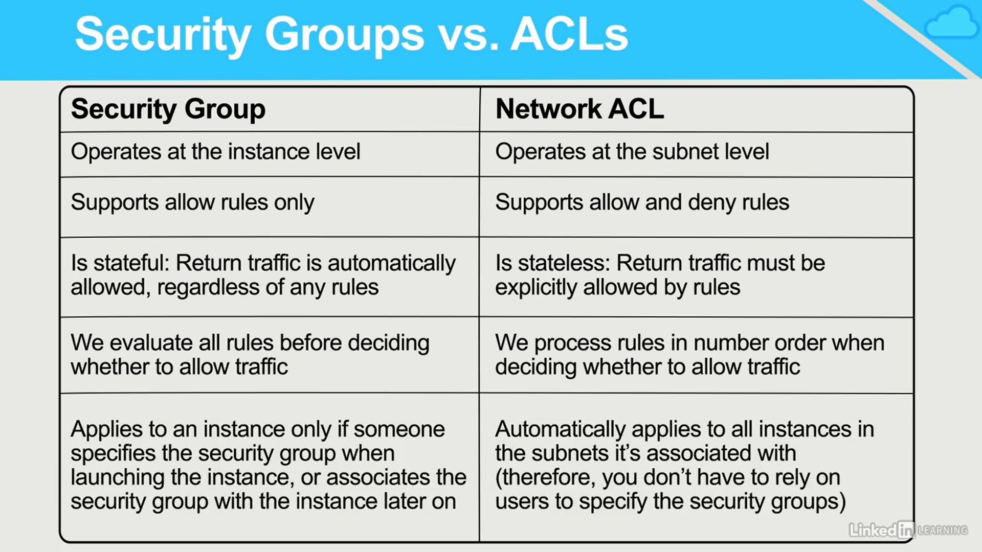

## EC2 – Security Groups

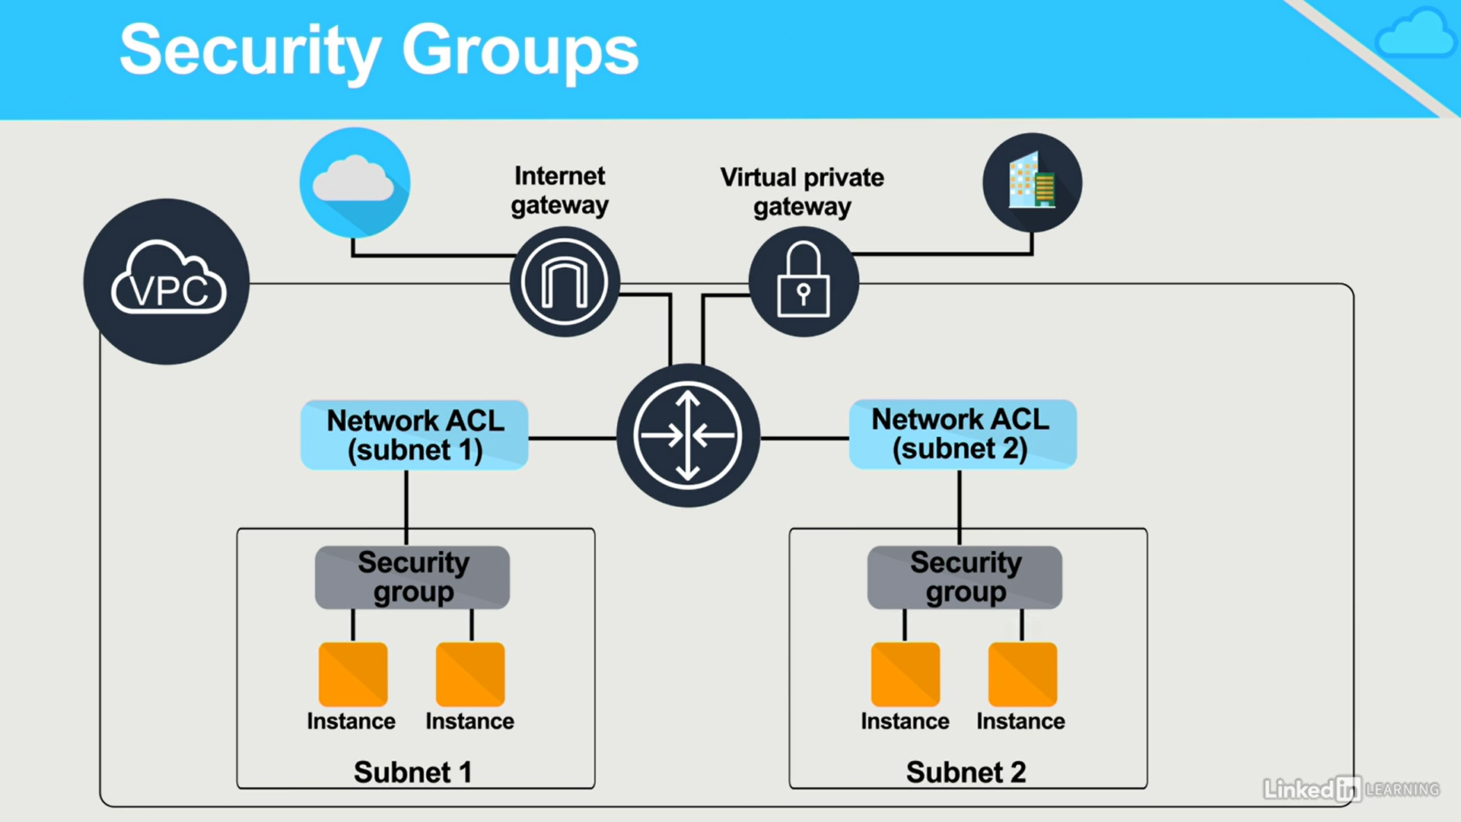

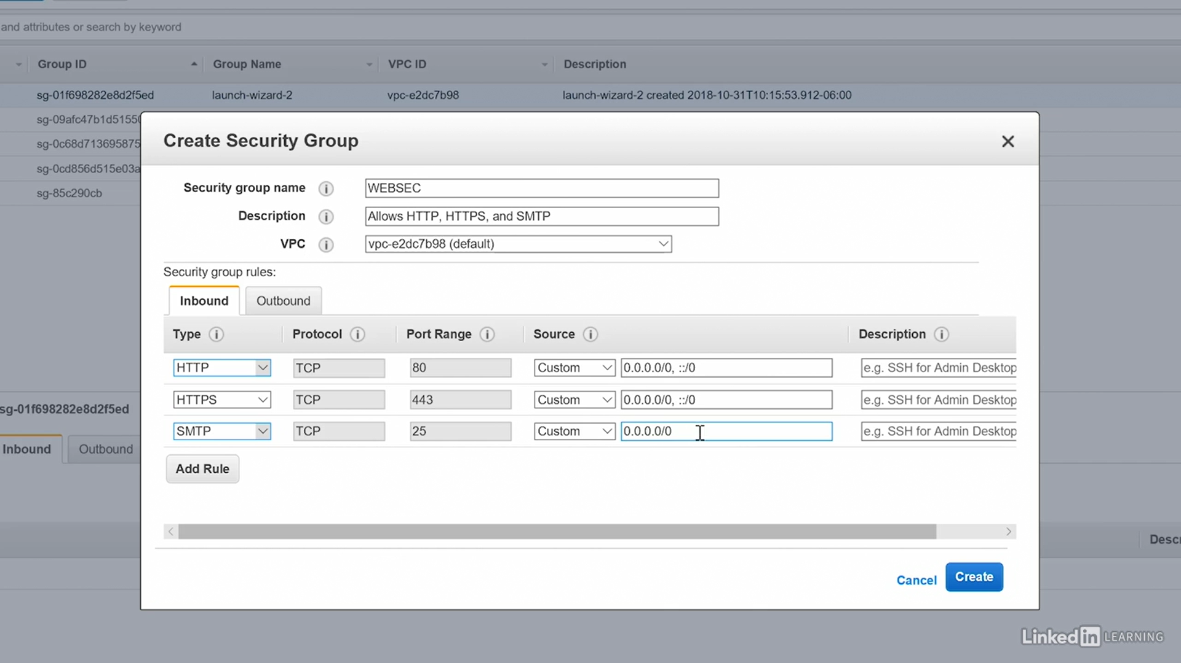

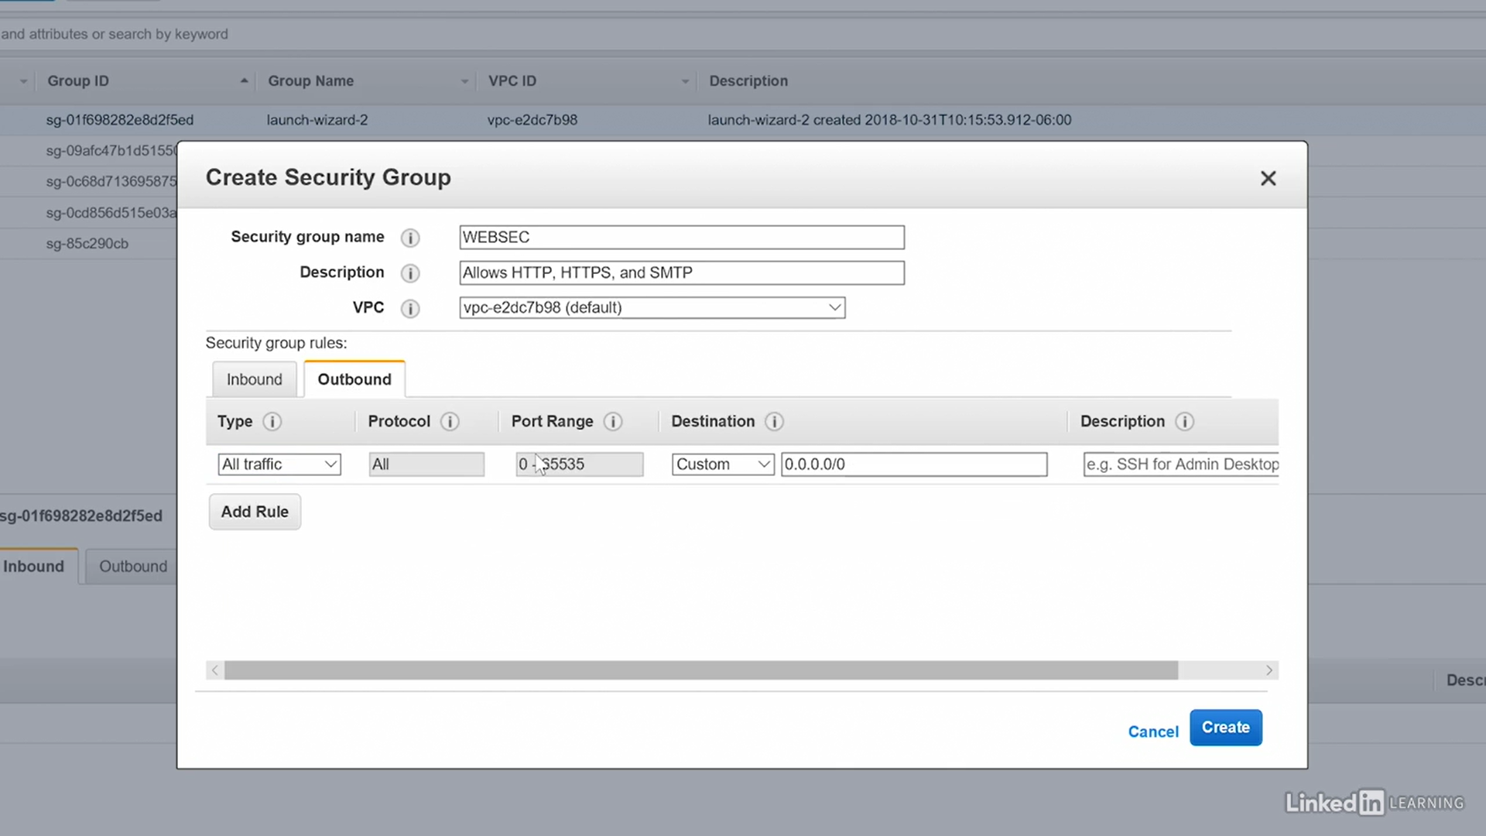

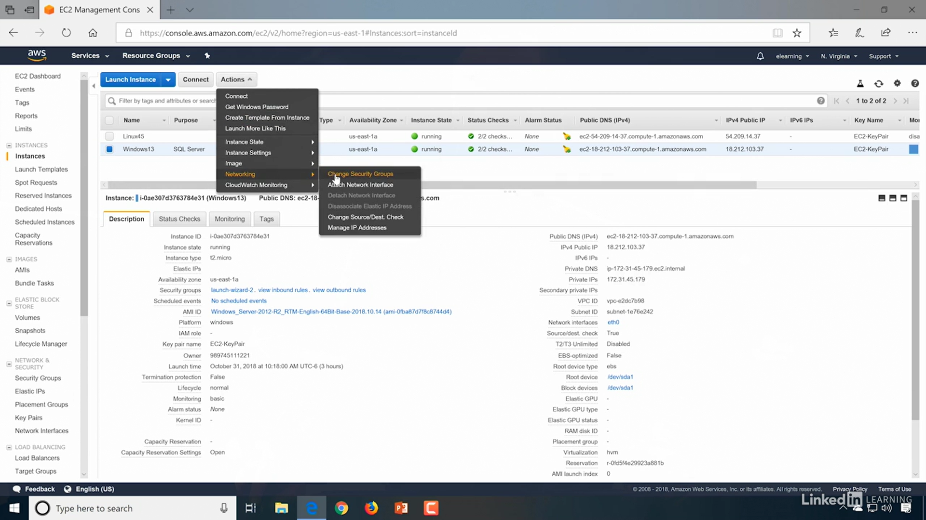

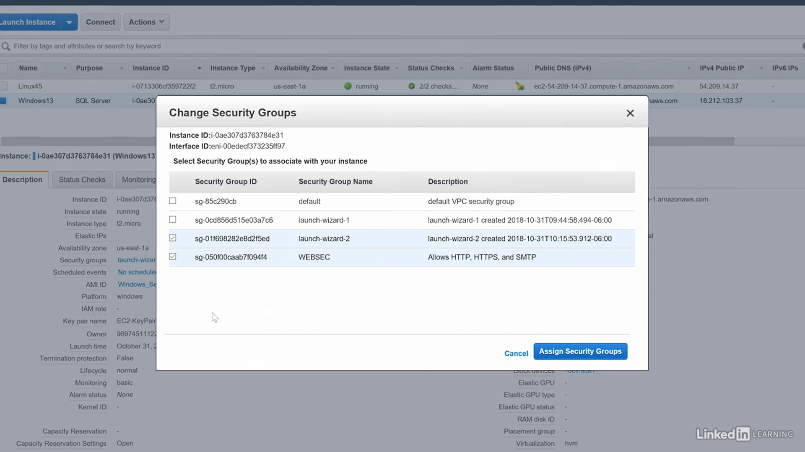

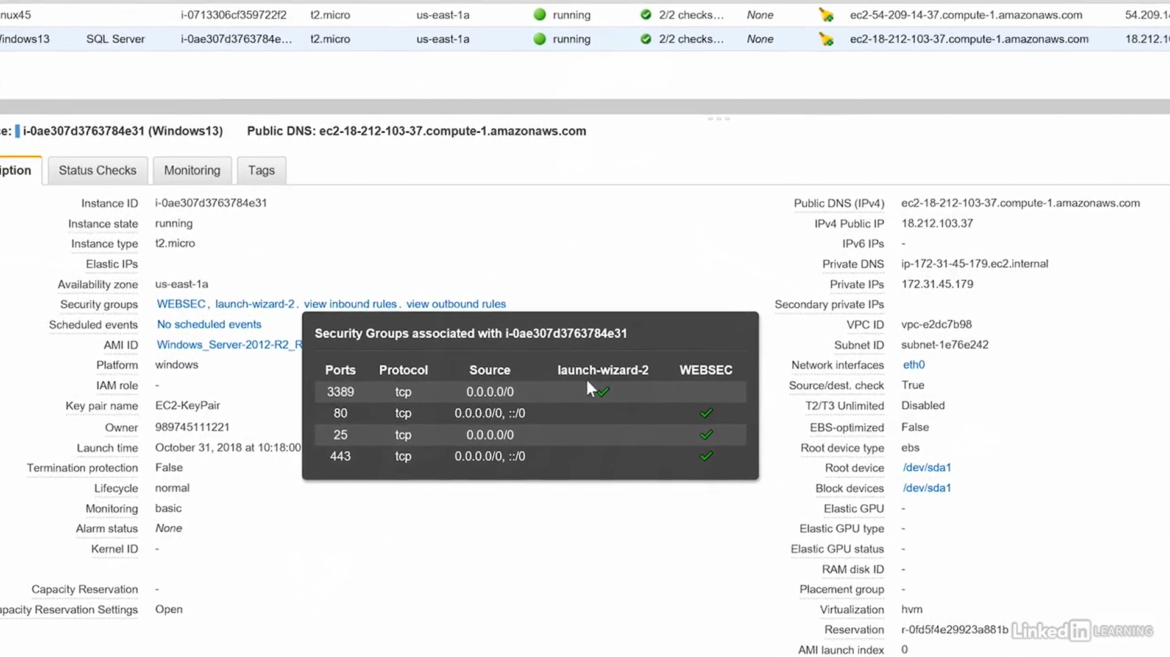

## Elastic Container Service (ECS) – Docker Container

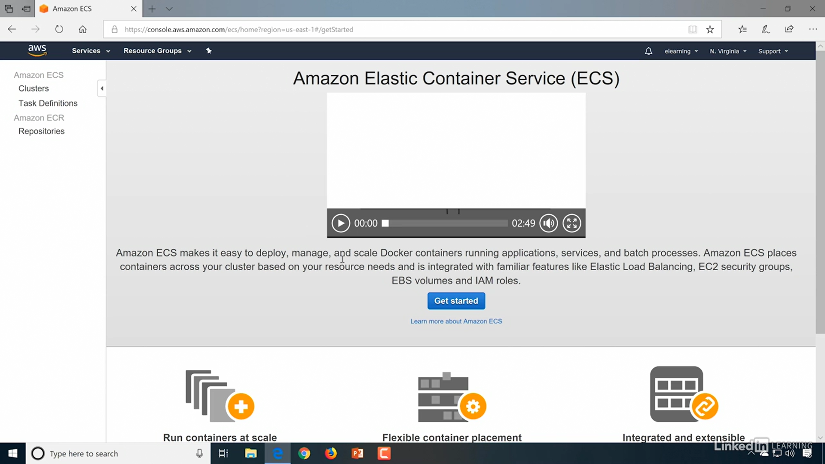

## Elastic Beanstalk environment



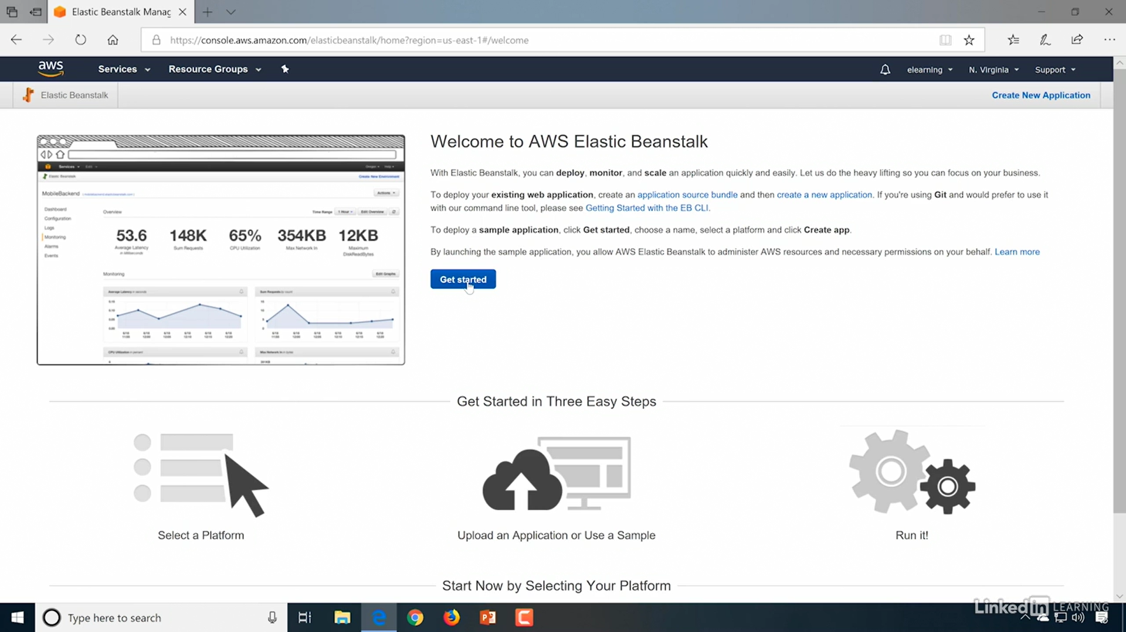

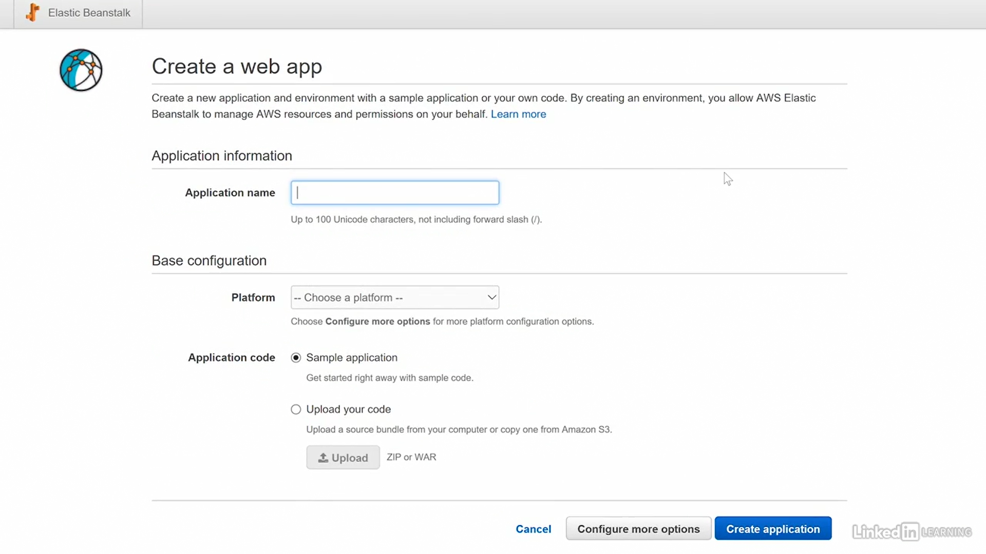

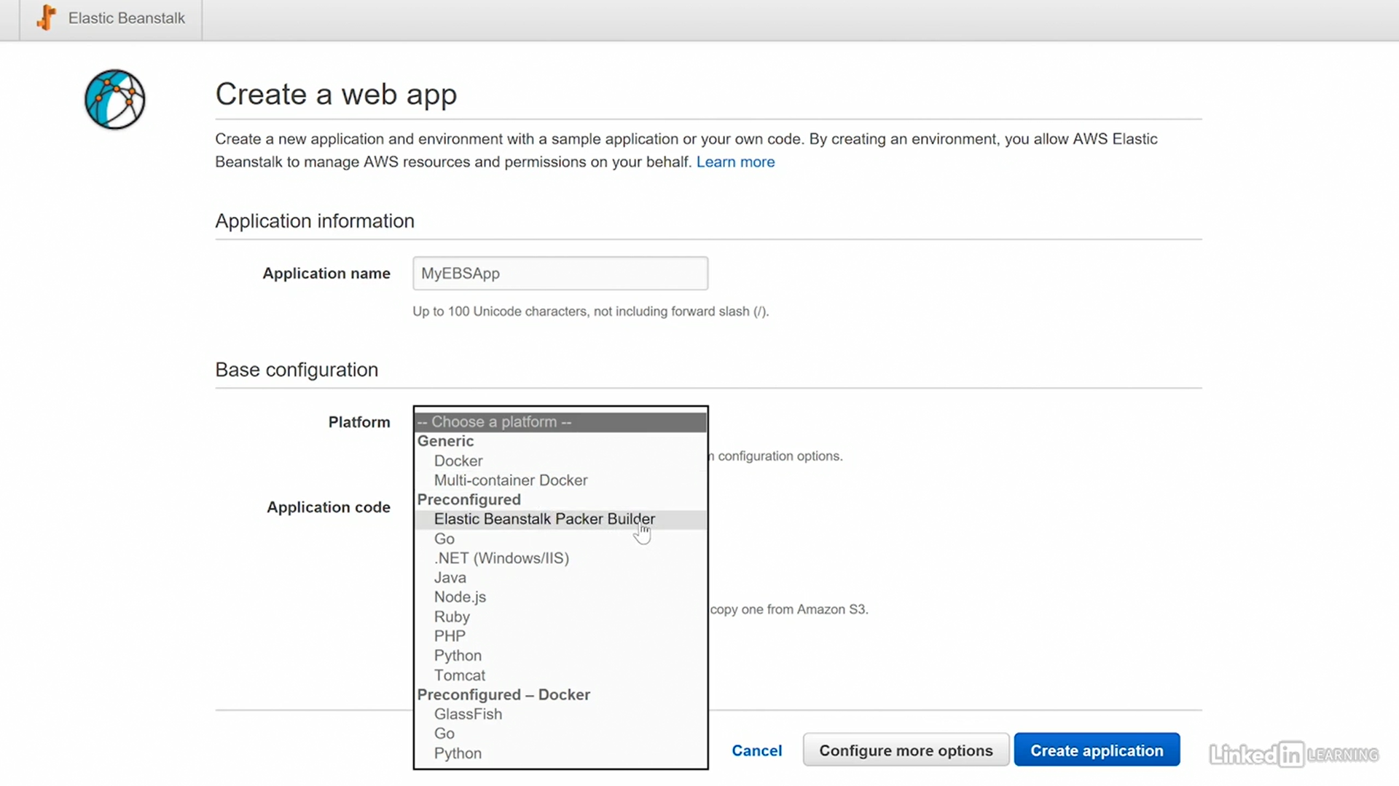

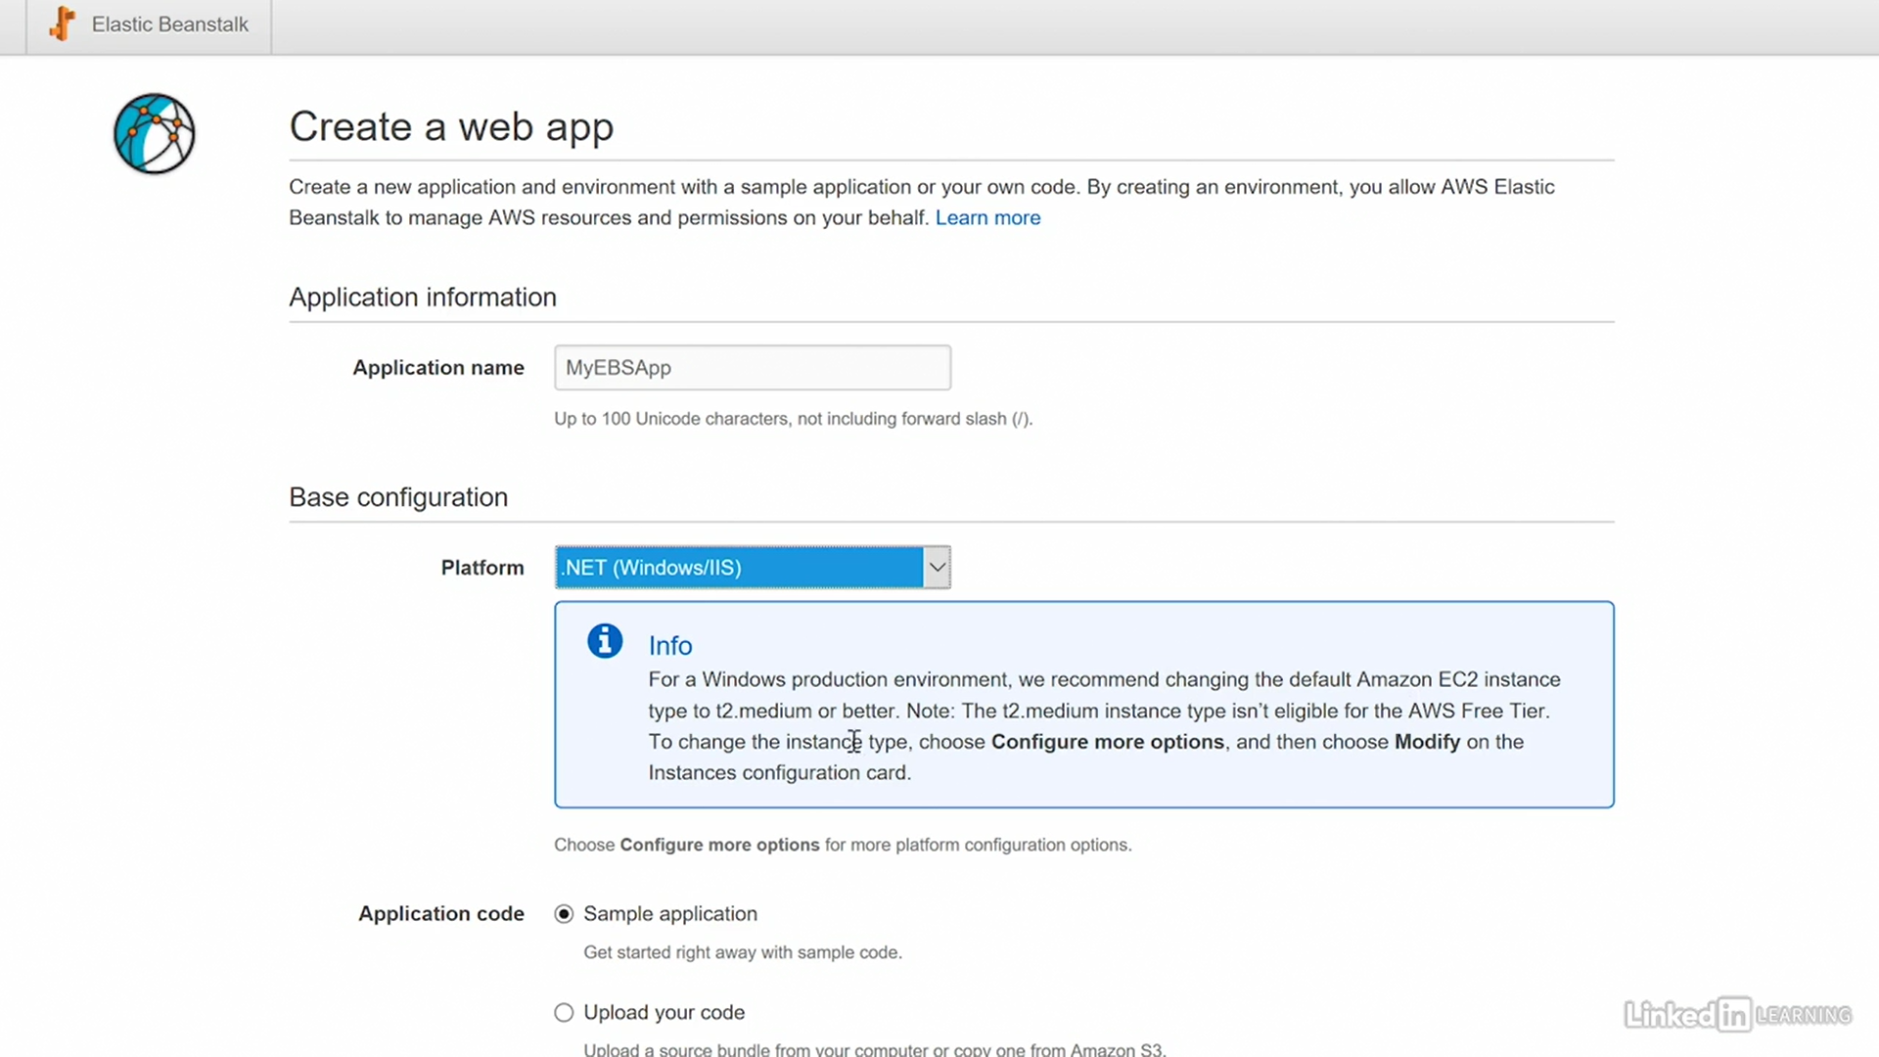

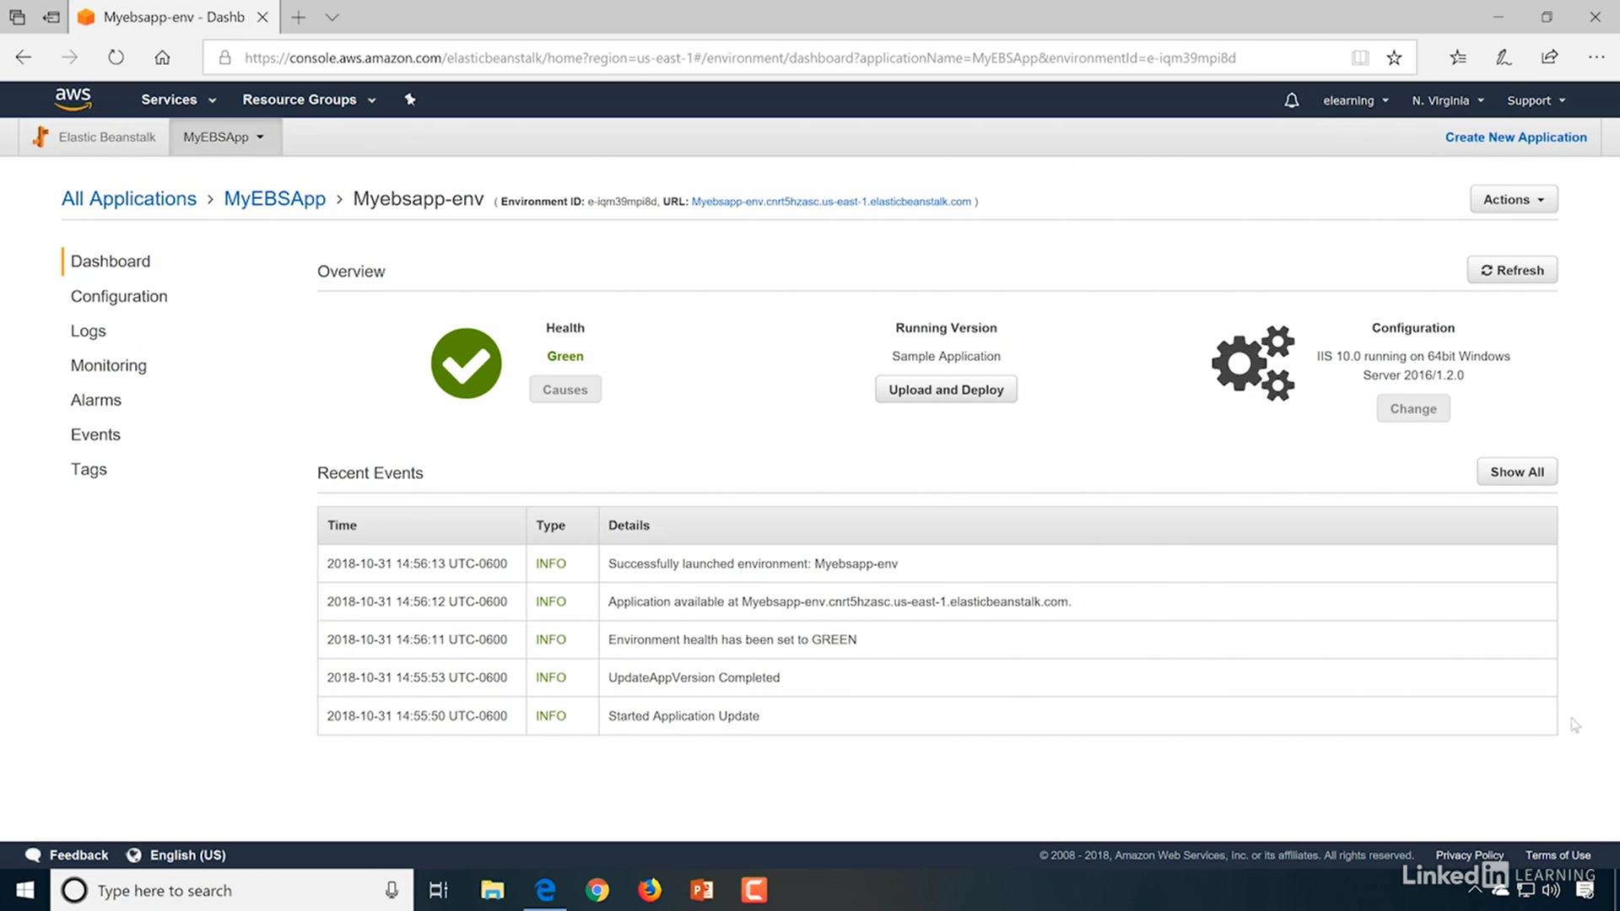

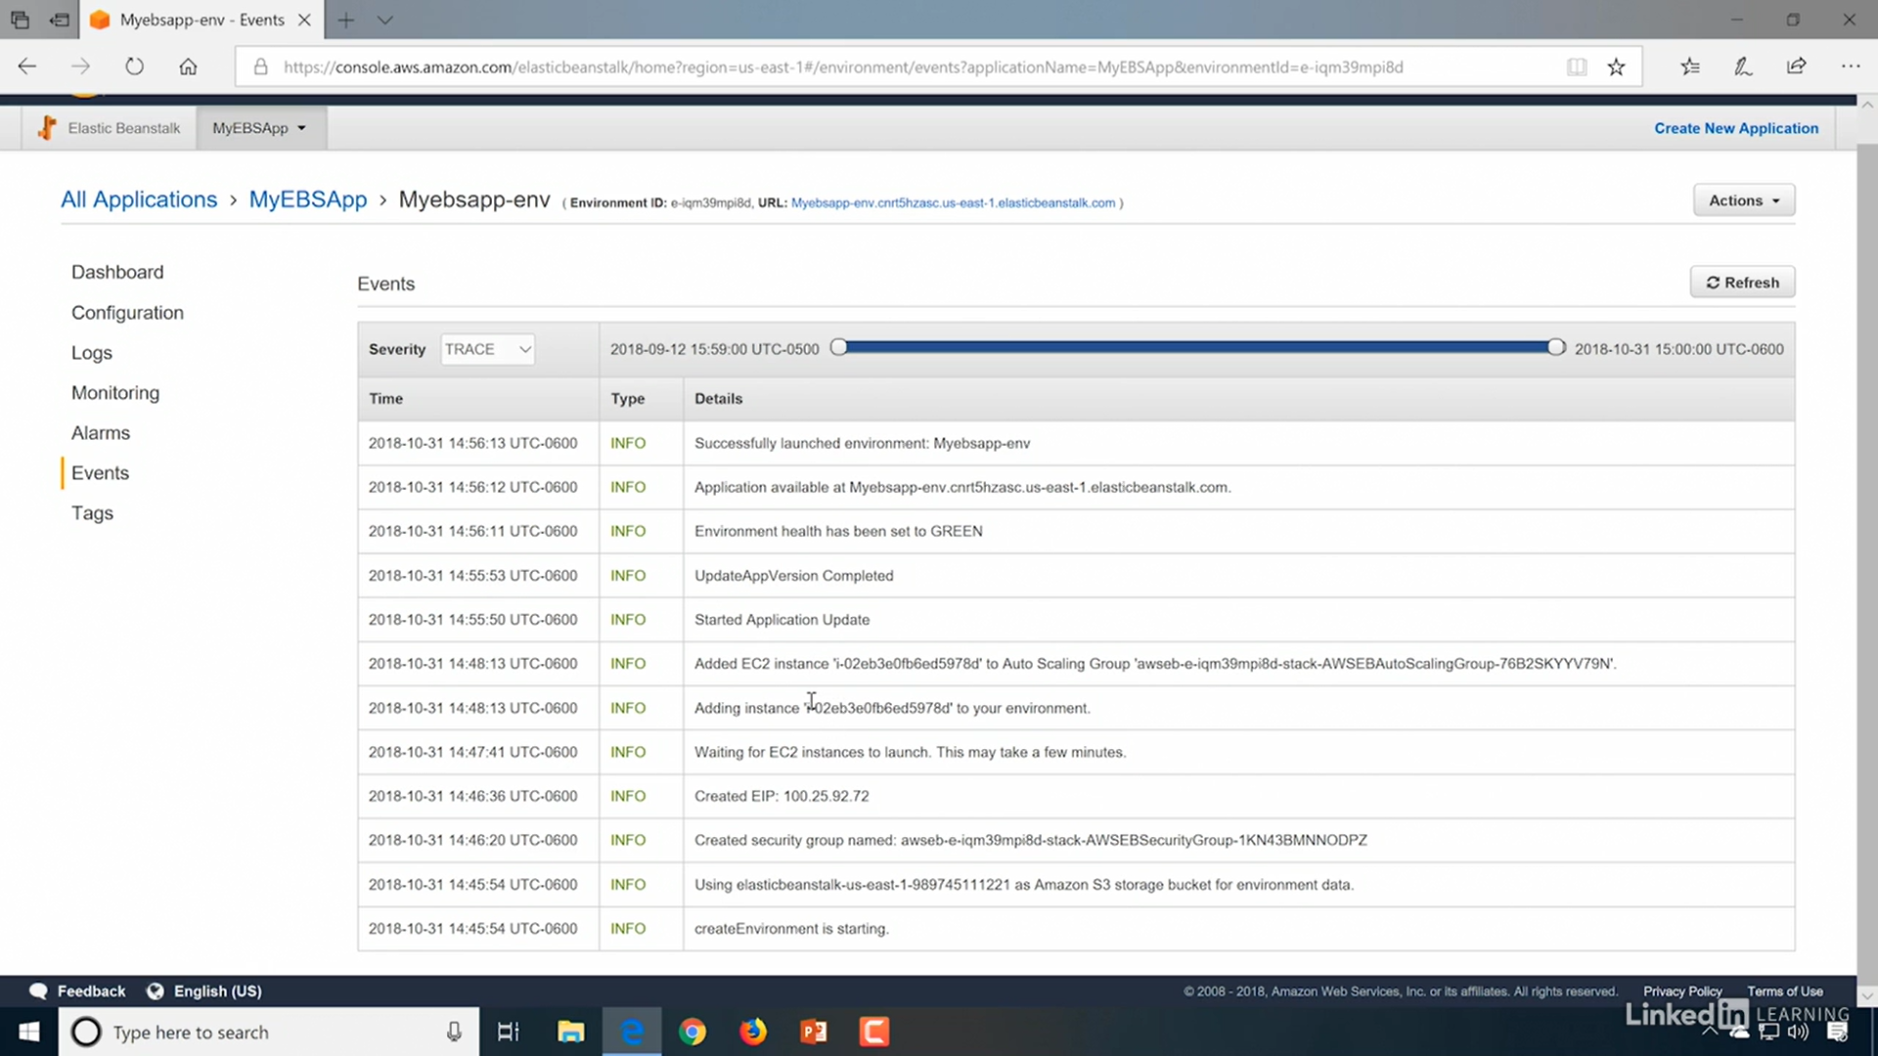

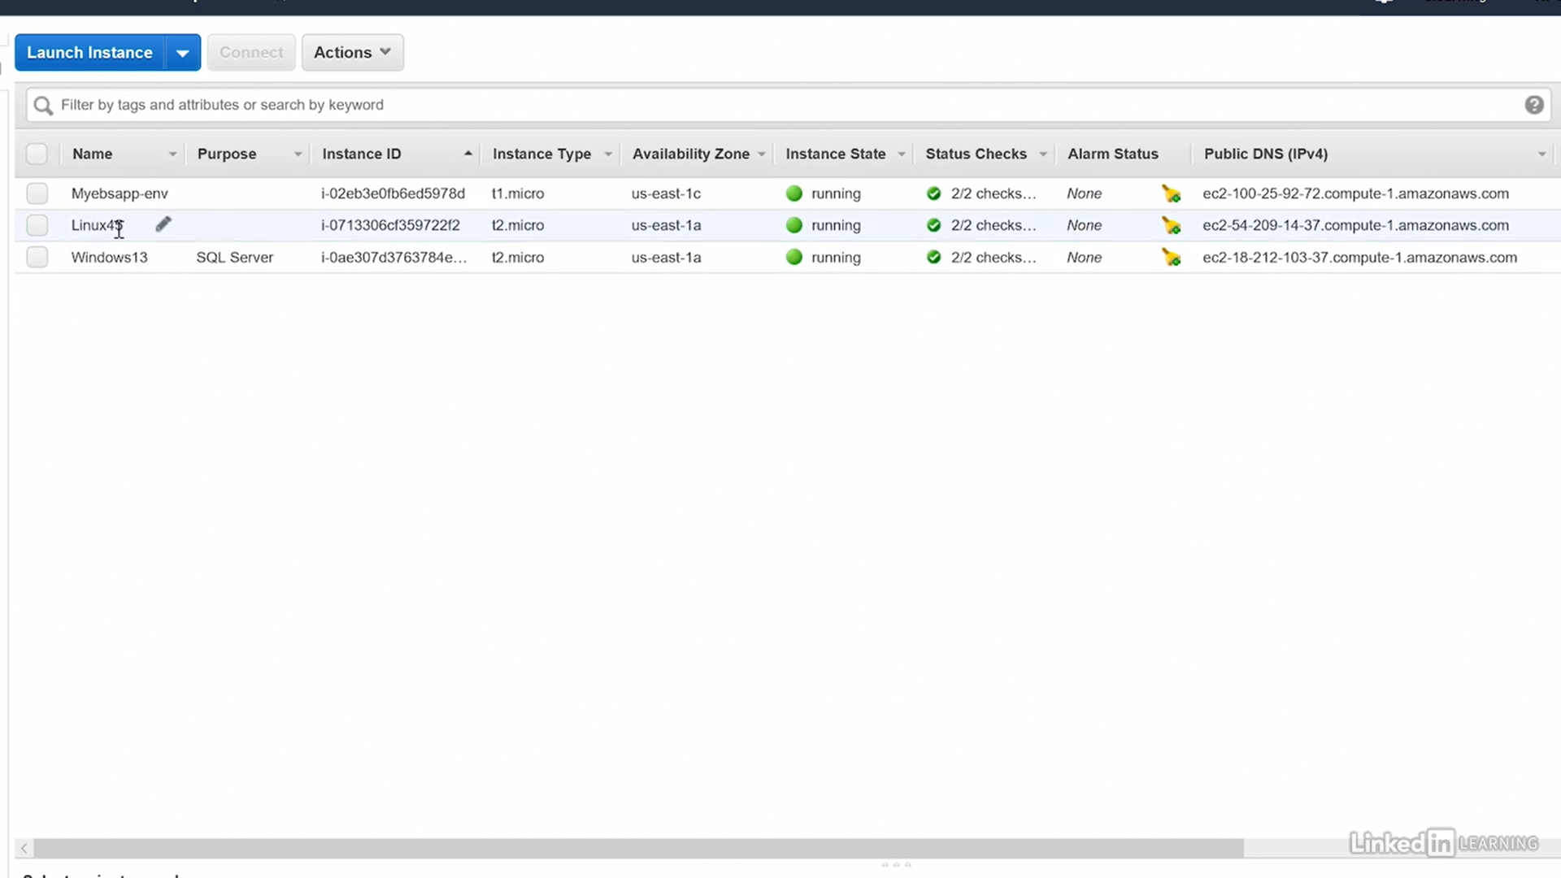

## S3 – Caching Static Files with Amazon CloudFront

<https://www.qwiklabs.com/focuses/295?parent=catalog>

## S3 – Hosting WordPress Using Amazon S3

[Hosting WordPress Using Amazon S3](https://www.qwiklabs.com/focuses/347?parent=catalog)

## S3 – Working with Amazon CloudFront for Dynamic Content Acceleration

[Working with Amazon CloudFront for Dynamic Content Acceleration](https://www.qwiklabs.com/focuses/8553?parent=catalog)

## References

1.<https://www.youtube.com/watch?v=FXvlq89Ph_4>

2.<https://www.youtube.com/watch?v=QNIPh4DhLx0>

<https://www.edureka.co/blog/ec2-aws-tutorial-elastic-compute-cloud/>

<https://www.qwiklabs.com/focuses/8554?parent=catalog>

<https://docs.aws.amazon.com/ec2/index.html?nc2=h_ql_doc_ec2>

<https://www.linkedin.com/learning/aws-certified-solutions-architect-associate-4-compute-services/elastic-compute-cloud-ec2-overview?u=2057244>

**Handson**

<https://aws.amazon.com/getting-started/use-cases/?e=gs&p=gsrc&awsf.getting-started-content-type=content-type%23hands-on&awsf.getting-started-category=category%23compute>

* Cloud Computing with AWS
* Amazon EC2 Overview
* Amazon Machine Images(AMI)
* EC2 Instance Types
* Amazon Elastic Block Store (EBS)
* EC2 Pricing
* Elastic Load Balancing (ELB)
* Auto Scaling
* AWS Services
* Amazon Elastic Container Service
* EC2 Best Practices and Costs
* Practice Assignment: Configure ELB not started
* Demos Included:
  1. Launch and connect to an EC2 Linux instance
  2. Launch and connect to an EC2 Windows instance
  3. Create an AMI
  4. EC2 Instance Types
  5. Attaching EBS Volumes
  6. EBS and Raid 0
  7. EBS Snapshots
  8. EC2 Spot Pricing
  9. Elastic Load Balancing
  10. Auto Scaling
  11. AWS CLI

# 5.Databases

### AWS Relational Database Service (RDS)

* Aurora MySQL
* Aurora PostgreSQL
* Oracle
* SQL Server
* MySQL
* PostgreSQL
* MariaDB
* NoSQL - DynamoDB

All the listed databases are relational SQL databases except DynamoDB. It is called a NoSQL database, but it is better termed a non-relational database.

#### Aurora MySQL

* Relational DB
* Optimized for Online Transaction Processing (OLTP)
* Very fast writes
* MySQL-compatible database system
* Increased performance over MySQL, 5X more speed than MySQL
* Initially 10 GB, scaling in 10 GB increments upto Max 64 TB
* Compute resources - Max 32 CPUs, Max 244 GiBRAM
* 2 DB copies in each AZ, Minimum of 3 AZs

### Types of DBs

#### Flat file databases

* Have one line per record
* Doesn’t contain multiple tables
* Ex: xls

#### Relational databases

* Store portions of the data in designated tables
* Tables are related based on unique identifier

#### NoSQL

* Not based on SQL or relational design theory
* Design supports fast transactions
* DynamoDB is a NoSQL service
* Create
* Query
* Read/write/modify

#### Data Warehouses

* Large, central repository for data
* Data aggregated from one or more sources
* Used for Online Analytical Processing (OLAP), bigdata
* Ex. AWS Redshift

Redshift is a data warehouse database solution. It is optimized for OLAP and is managed by AWS through the RDS service.

### Types DB hosting in AWS

#### EC2 Instance-Based Database Hosting

1.Launch an instance

2.Install the database service

3.Open appropriate ports in security groups

4.Connect to the database

#### AWS Service-Based

With AWS Service-Based databases in the RDS service, you do not need to be concerned with operating system installation and configuration, but you will still need to create the databases, manage security, and perform backup procedures

1.Create the database

2.Connect to the database

### High Availability Solutions

#### Clustering

* Multiple servers (instances)
* One database with replication
* Increases availability
* Automatic failover
* Increased cost

#### Standby Instances

* Multiple servers (instances)
* One database with replication
* Increases recoverability
* No automatic failover
* Reduced costs

#### Multiple AZ Deployment

* Multiple instances
* Multiple AZs
* One region
* Replicated storage
* Increased availability
* Increased performance
* Cost

### Database Security

**RDS databases support Storage encryption**

If someone steals a hard drive for example, they cannot get the data off of that hard drive, because it's encrypted on the hard drive.

Administration access based on IAM.

RDS databases do support encryption; however, it must be enabled during database creation. The only other option is to backup the database and then recover it with encryption. However, database recovery is really the creation of a new database and that is why encryption can be enabled during recovery.

## Labs

### DynamoDB lab

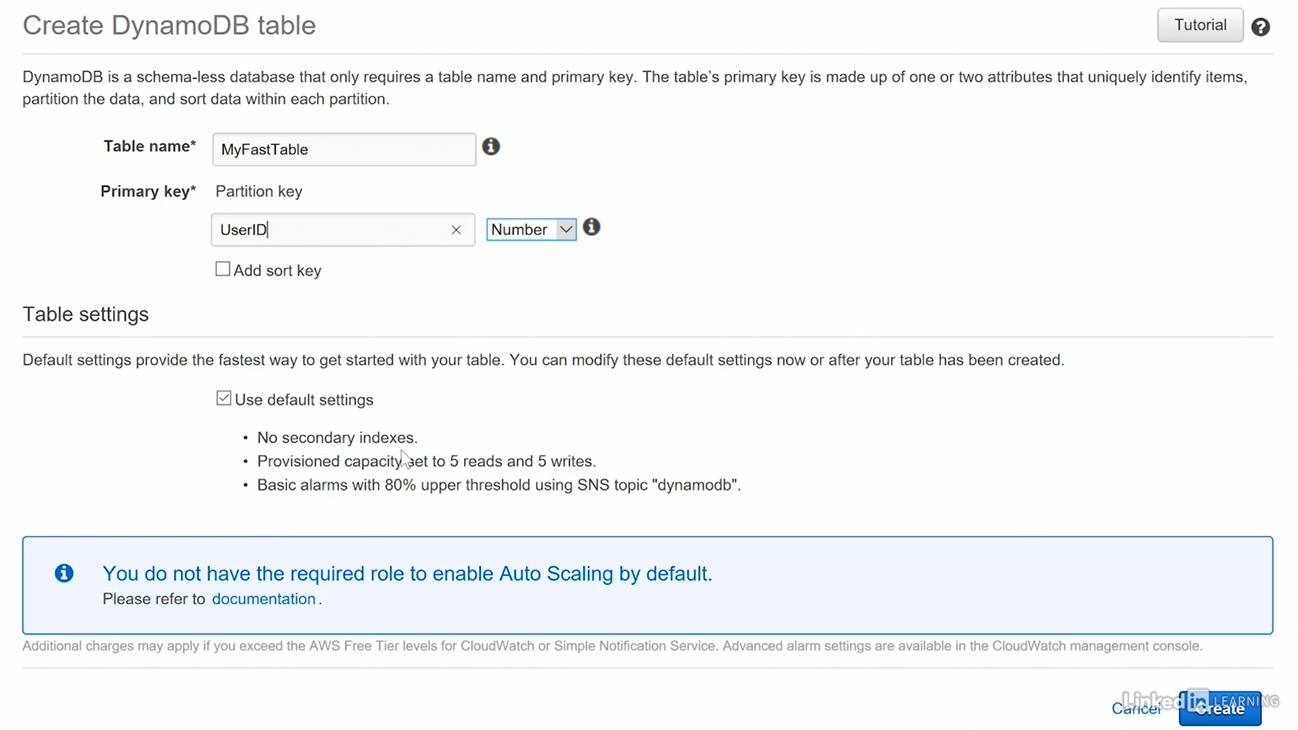

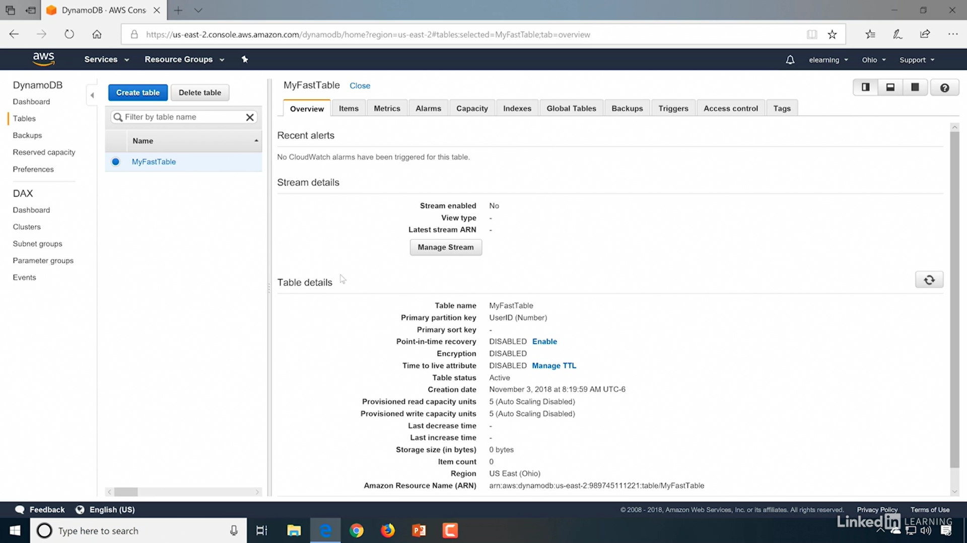

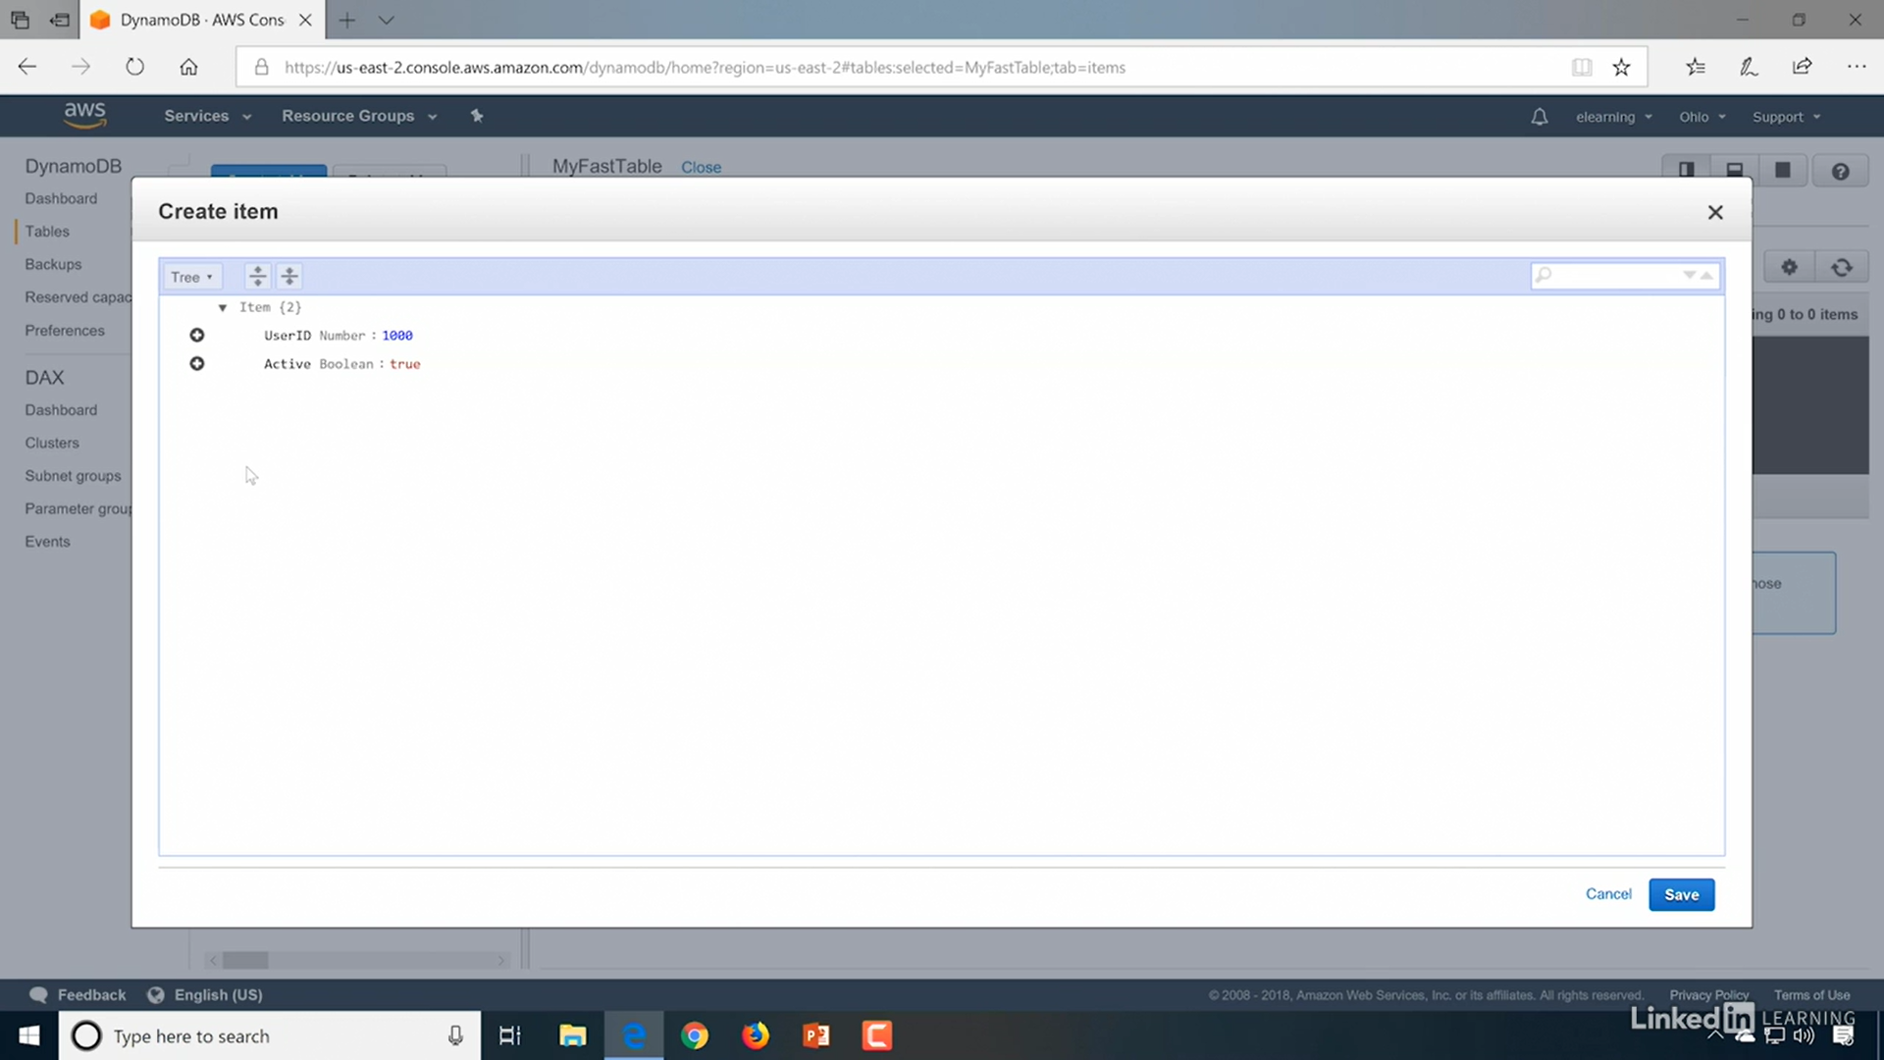

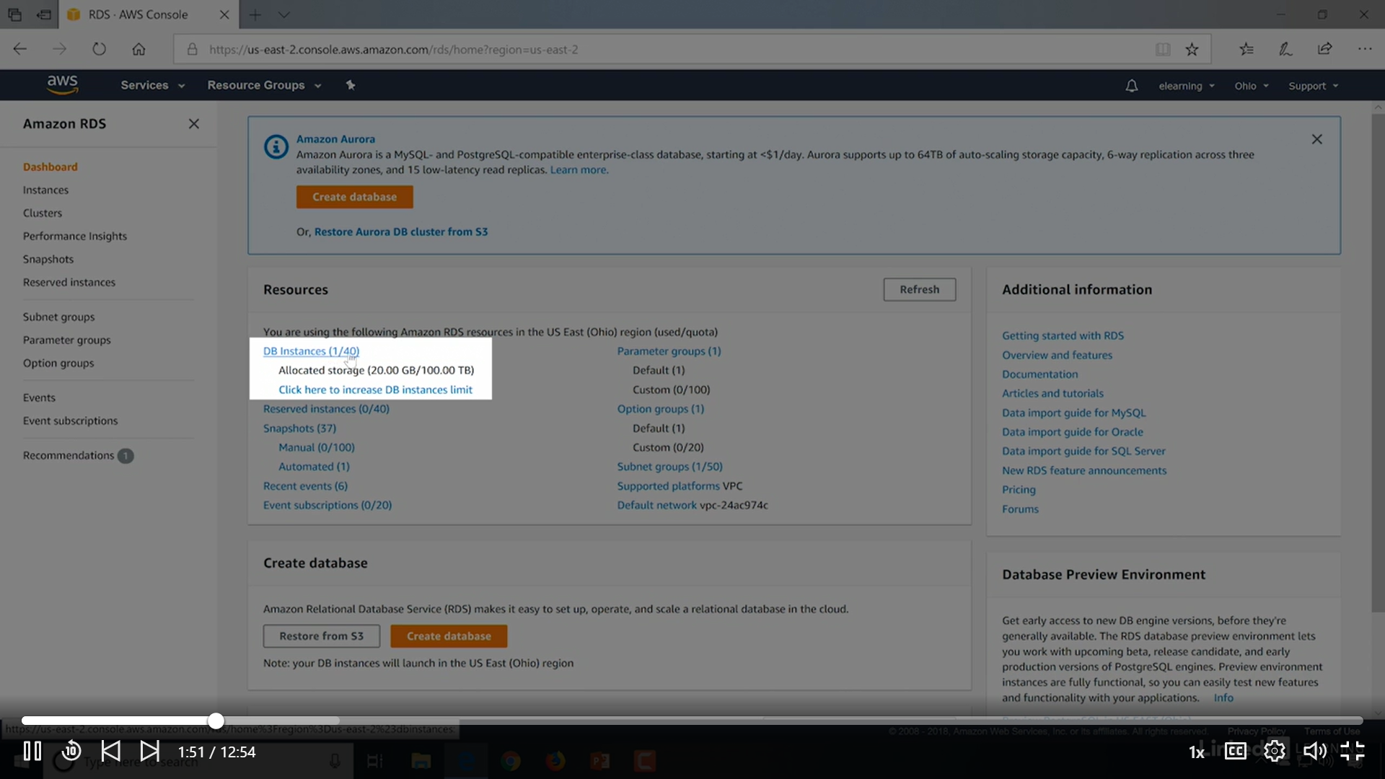

# Auto Scaling and Virtual Network Services

## Auto Scaling

 With a physical server infrastructure, if you want to scale up it means adding more physical servers, scale down means reducing physical servers.

* Monitors applications
* Adjusts capacity
* Manages costs

### Auto Scaling Functionality



* It monitors your applications and then adjusts capacity according to your needs
* Auto Scaling is Free to use, Results of use may cost: adding more services means adding more cost

### Scalable AWS Resources

* EC2 Auto Scaling groups
* DB clusters
* DynamoDB indexes, tables
* Elastic Container Service (ECS) services

### Auto Scaling groups

Auto Scaling groups can be defined as a collection of instances with similar characteristics.

The auto scaling group is going to have the EC2 instances in it that can be scaled out or scaled in as you need them to be scaled.

* Scaling out ‐ adding instances
* Scaling in ‐ removing instances

### Lab

EC2 >Autoscaling >Autoscaling Group

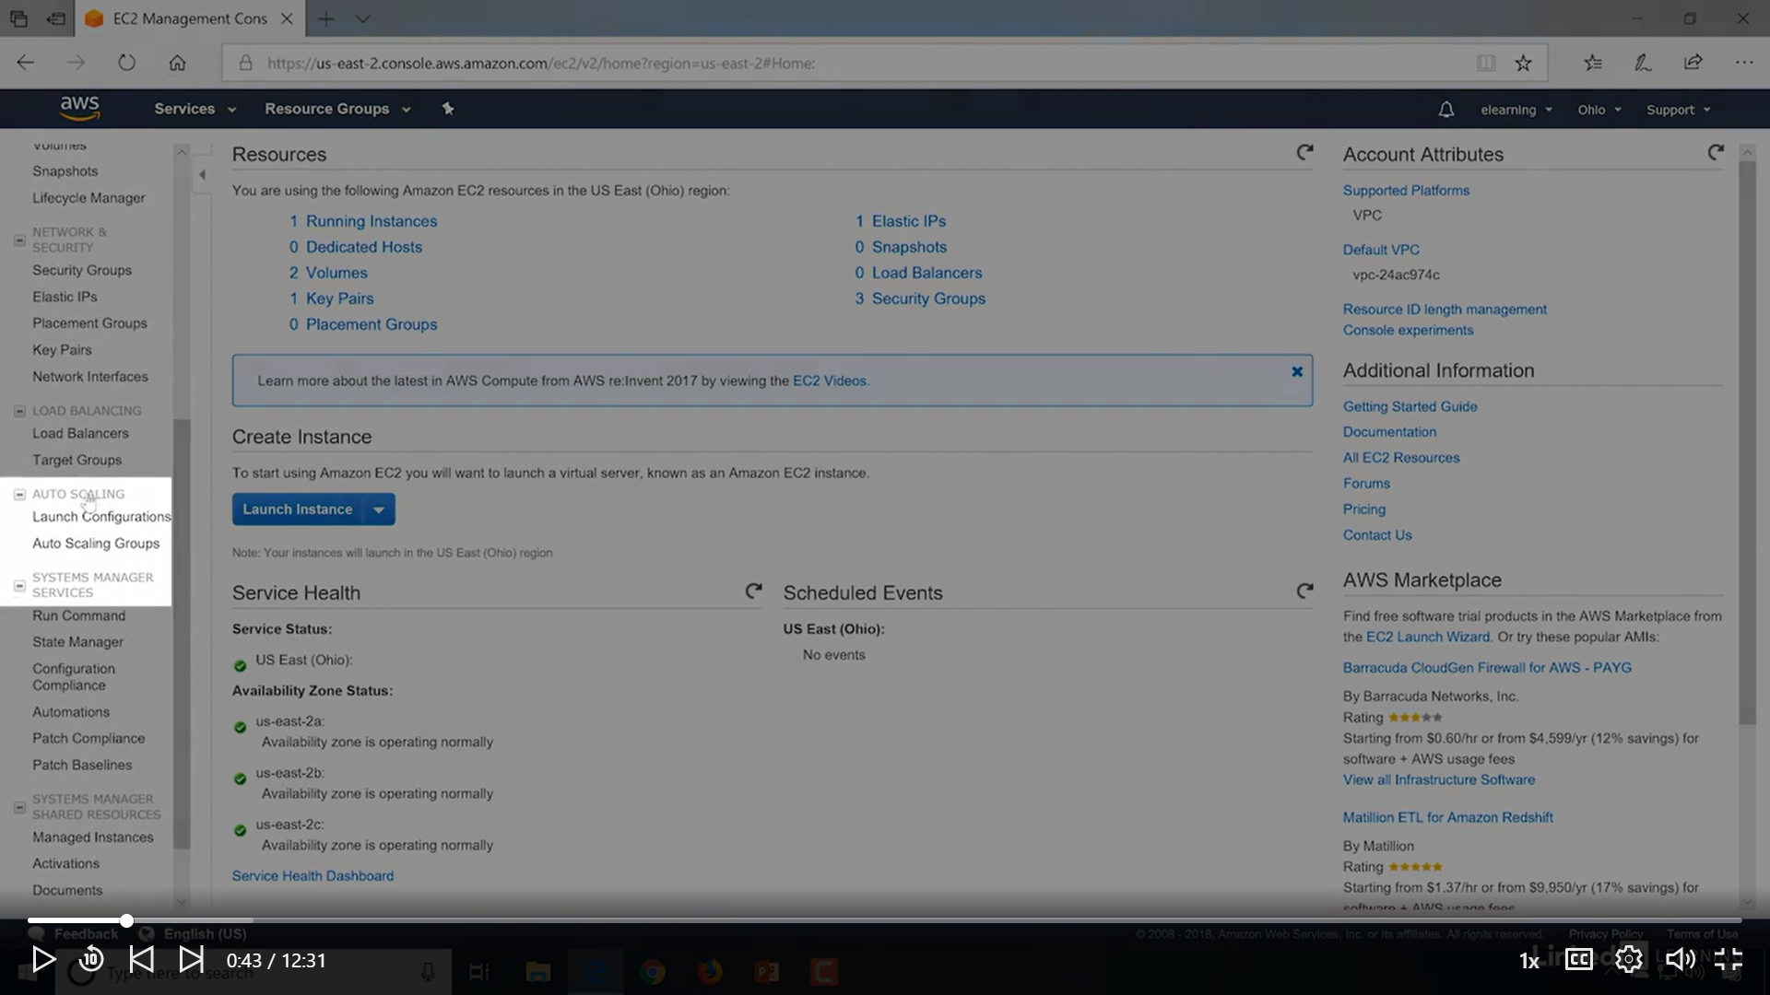

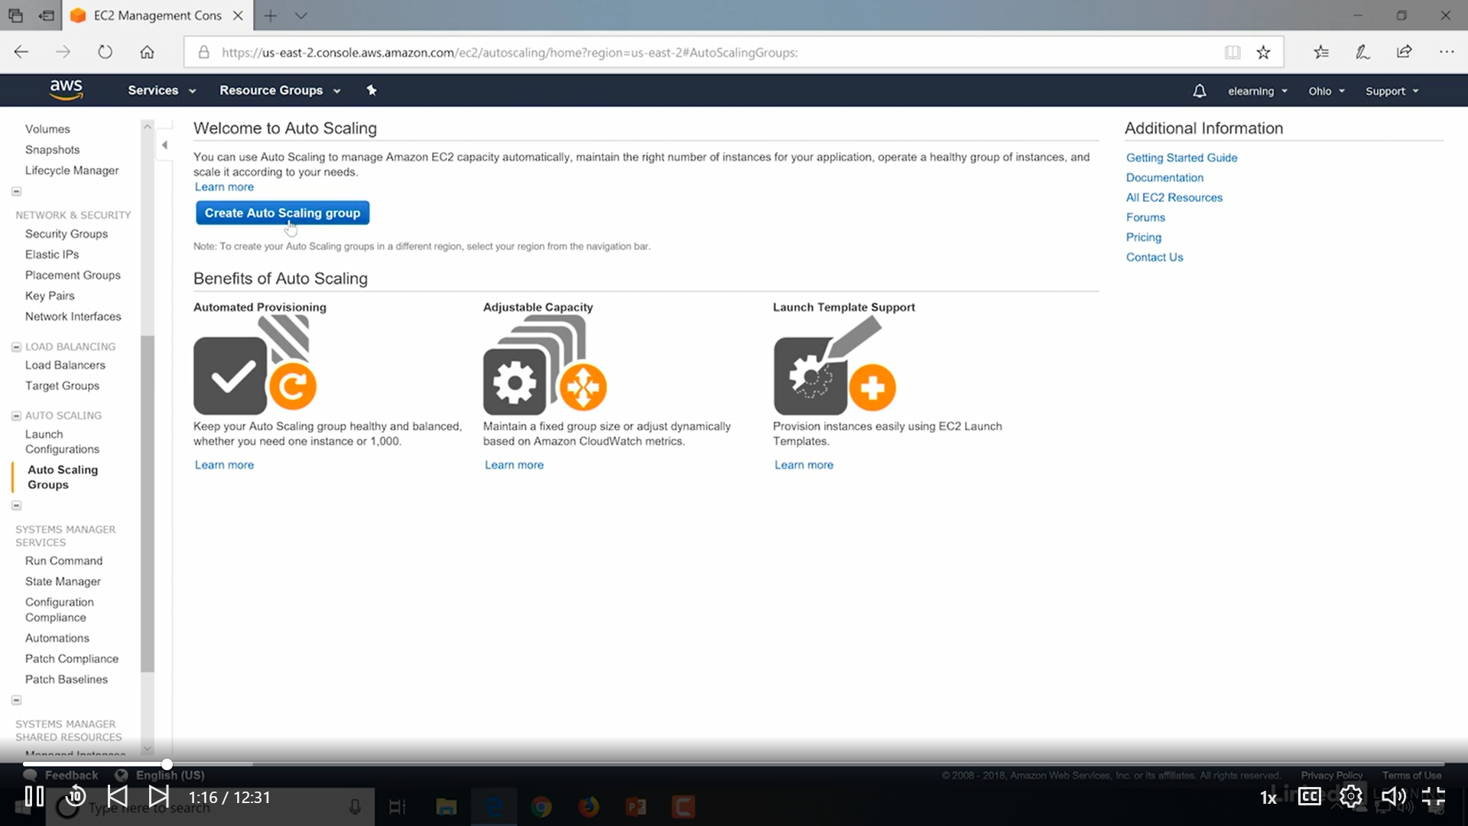

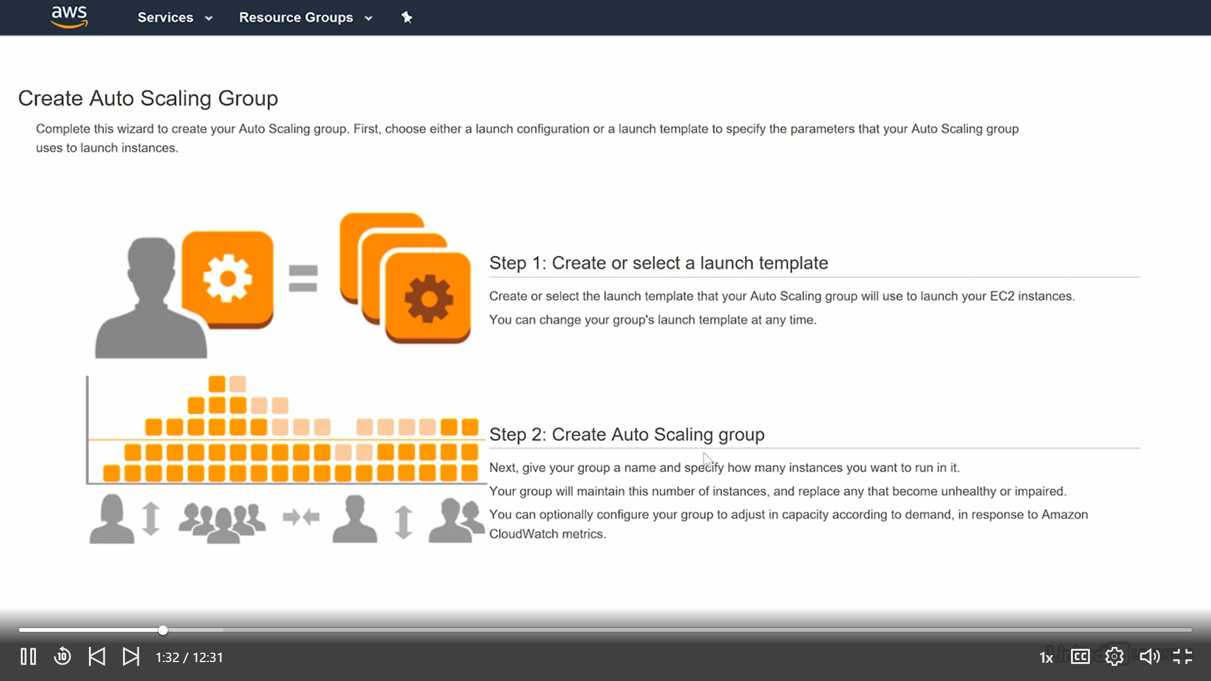

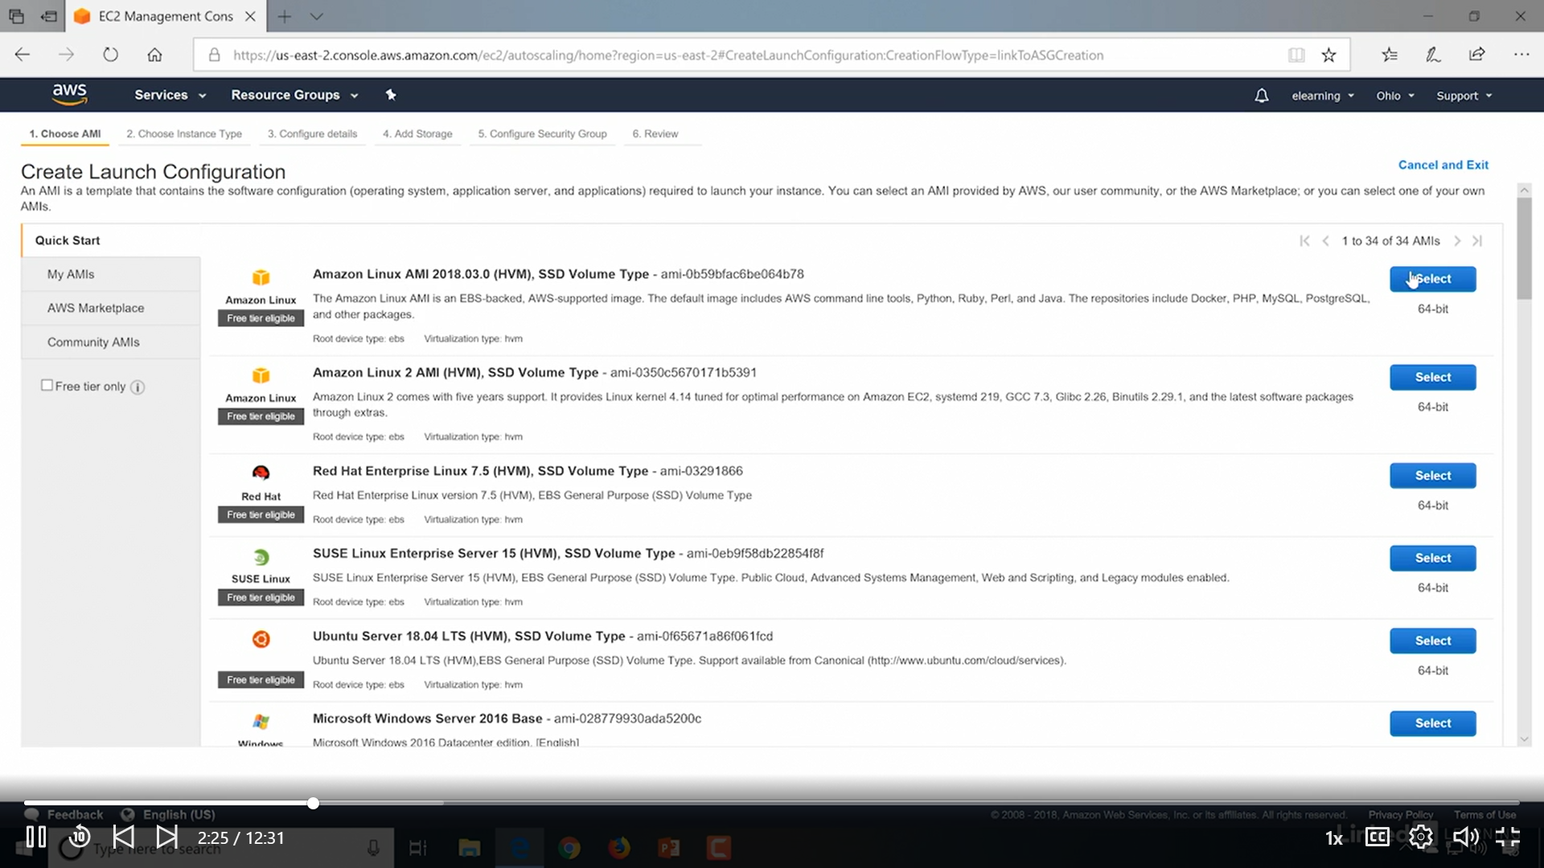

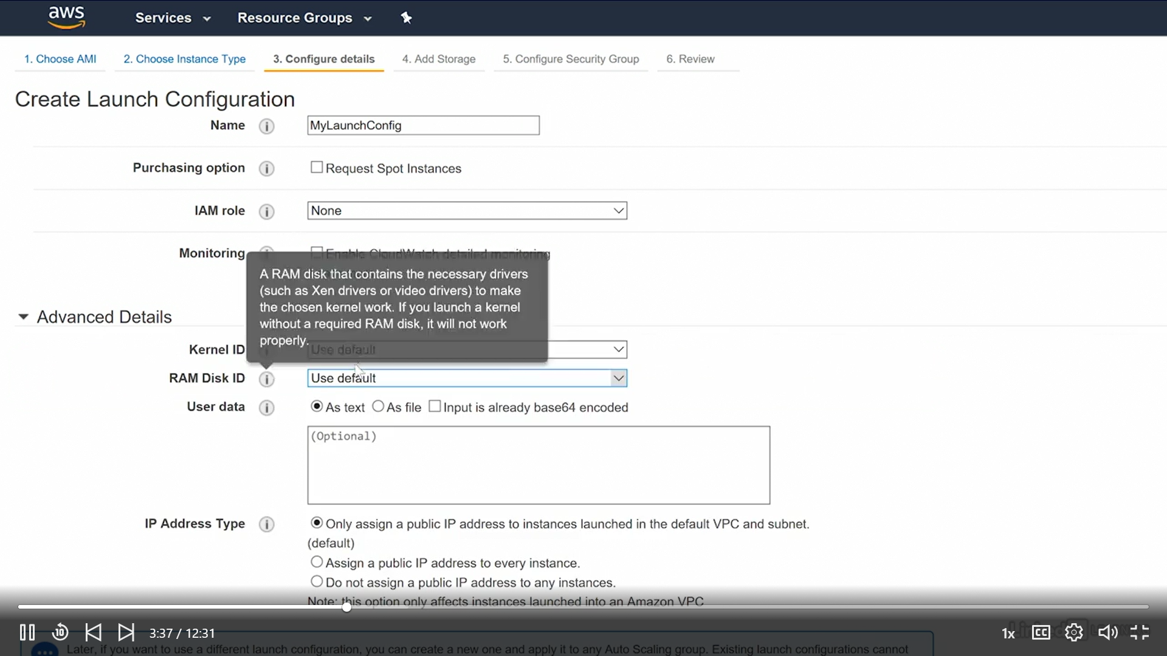

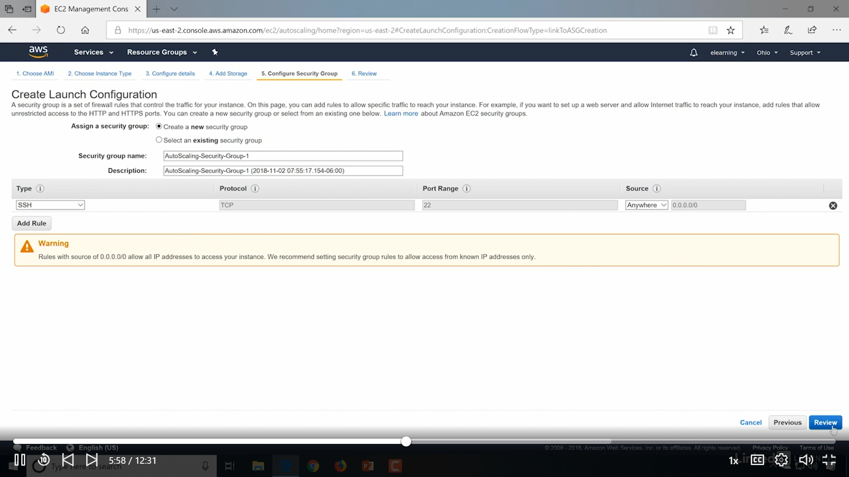

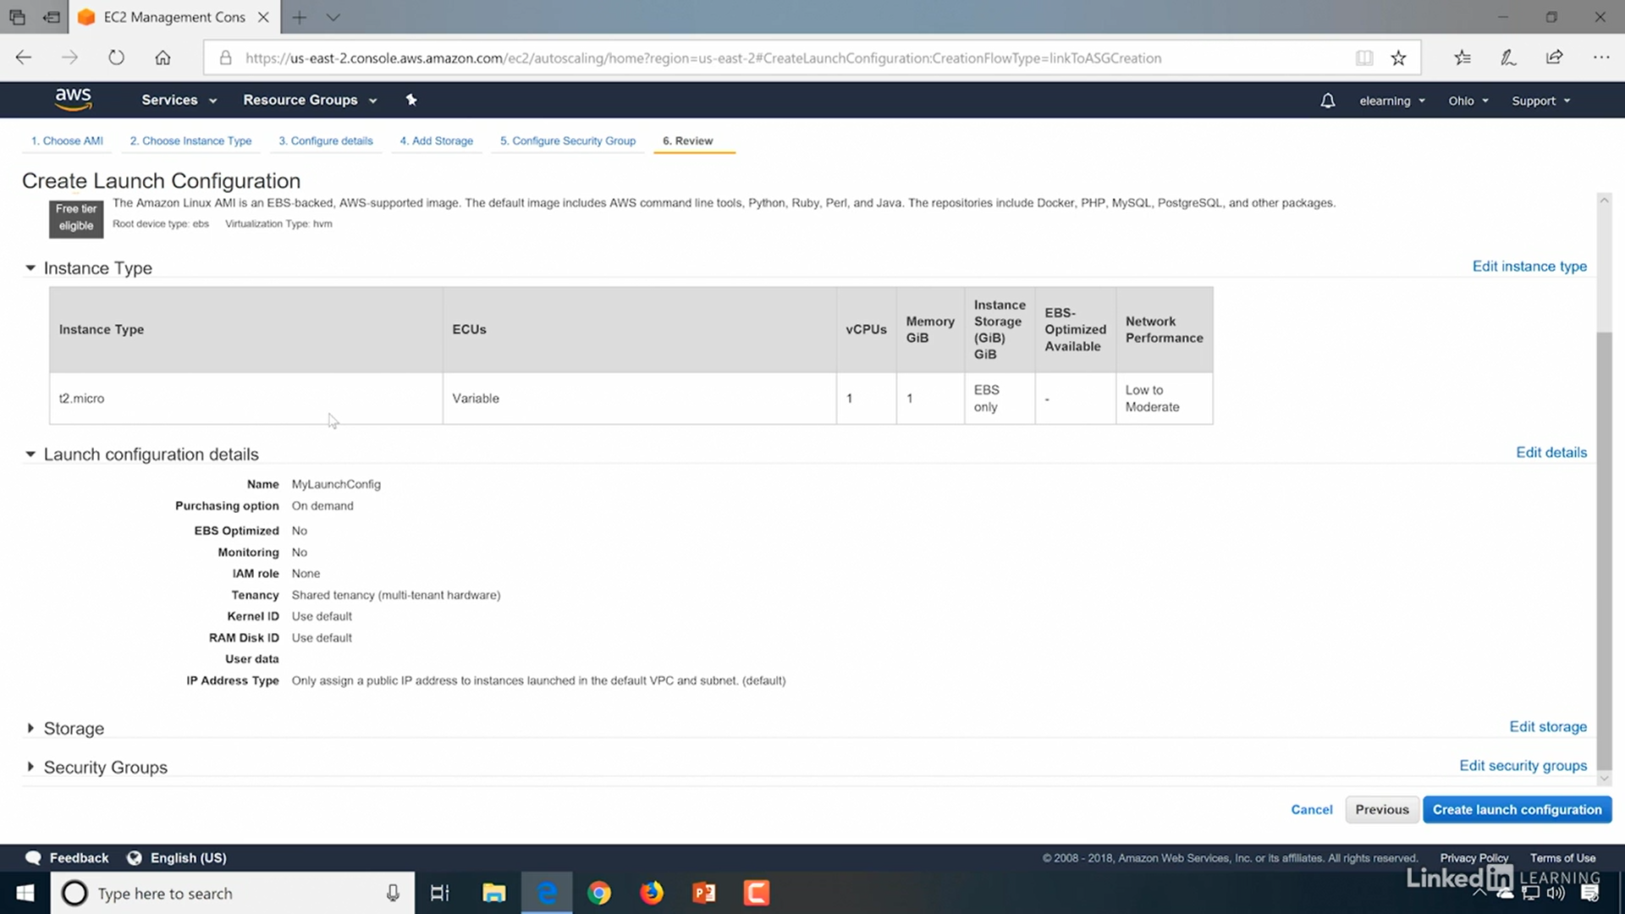

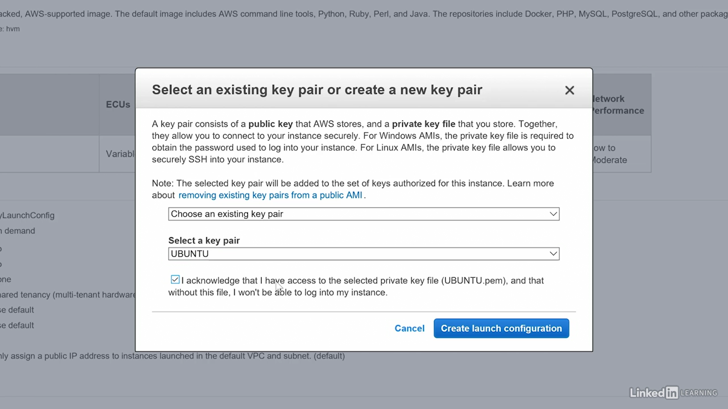

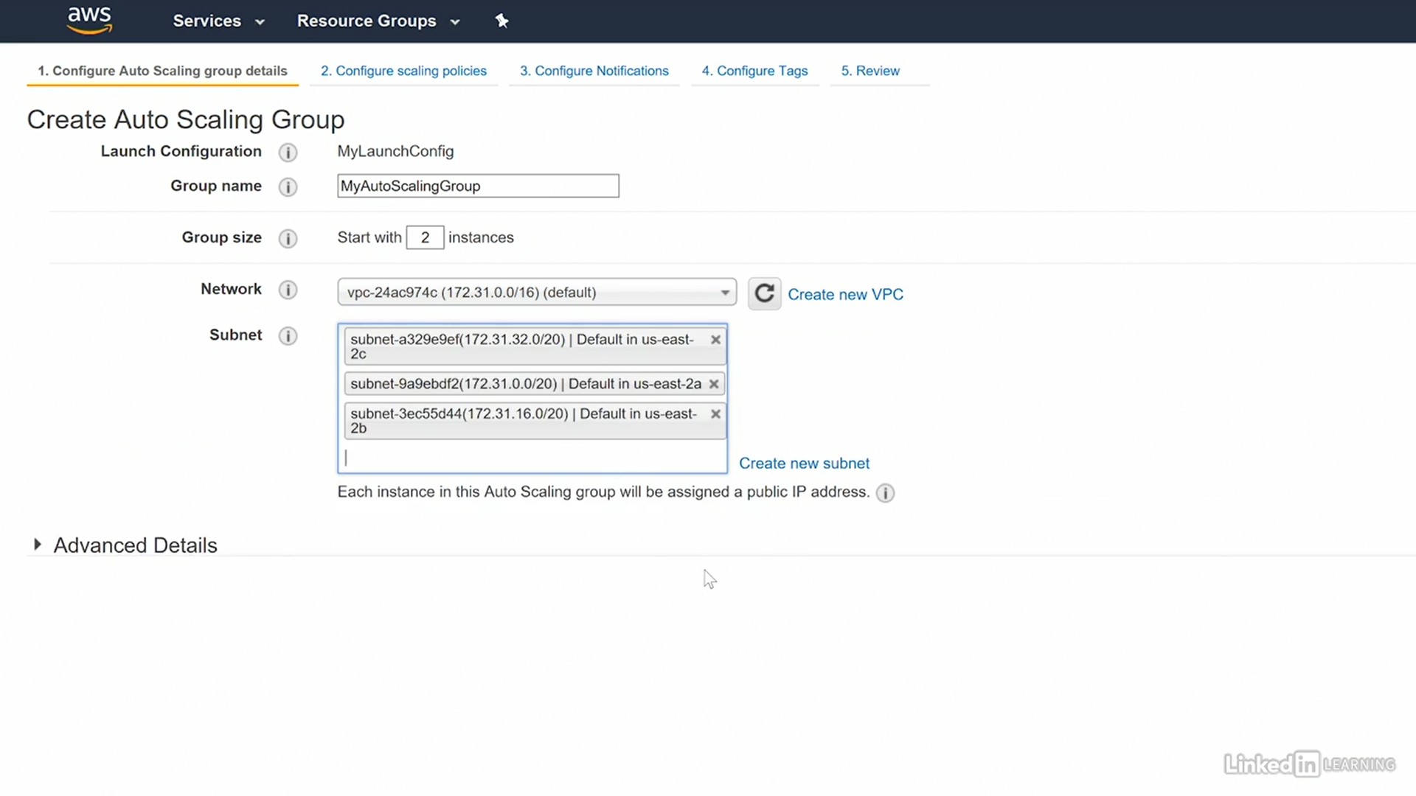 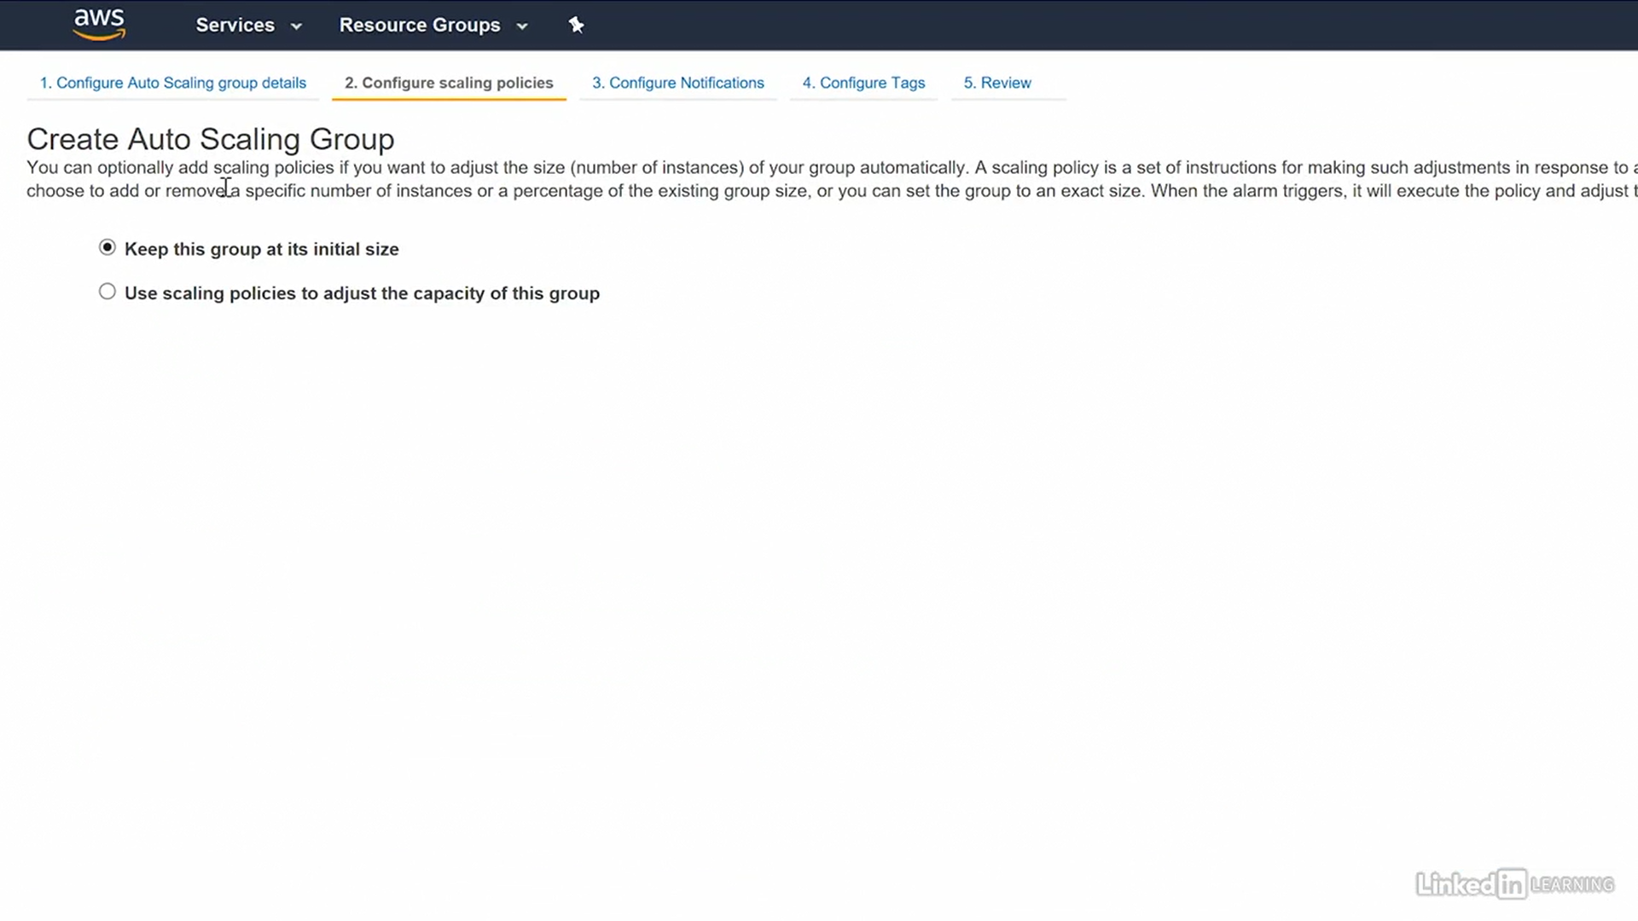 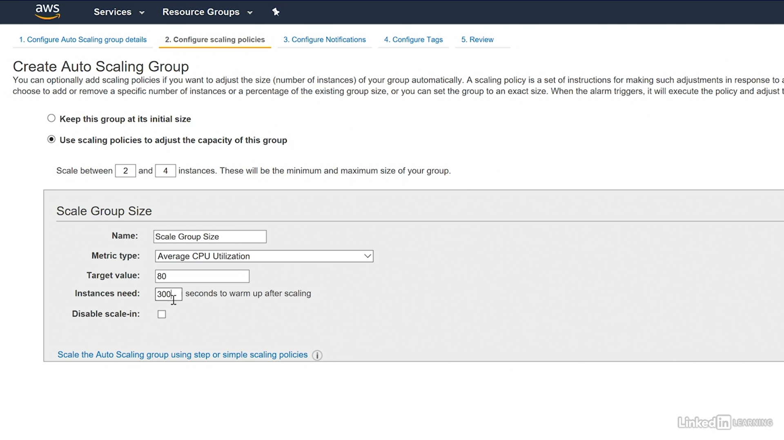

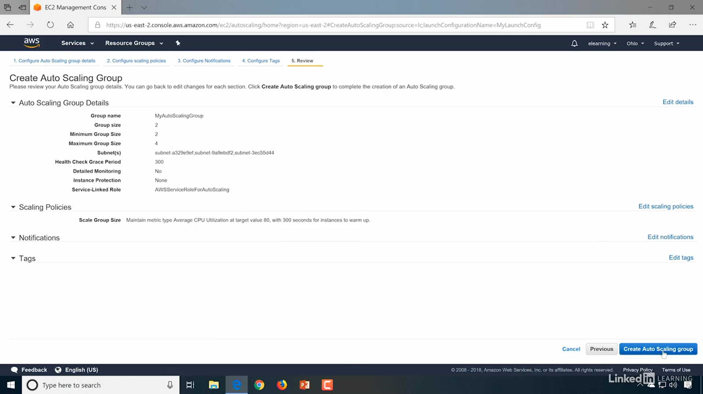

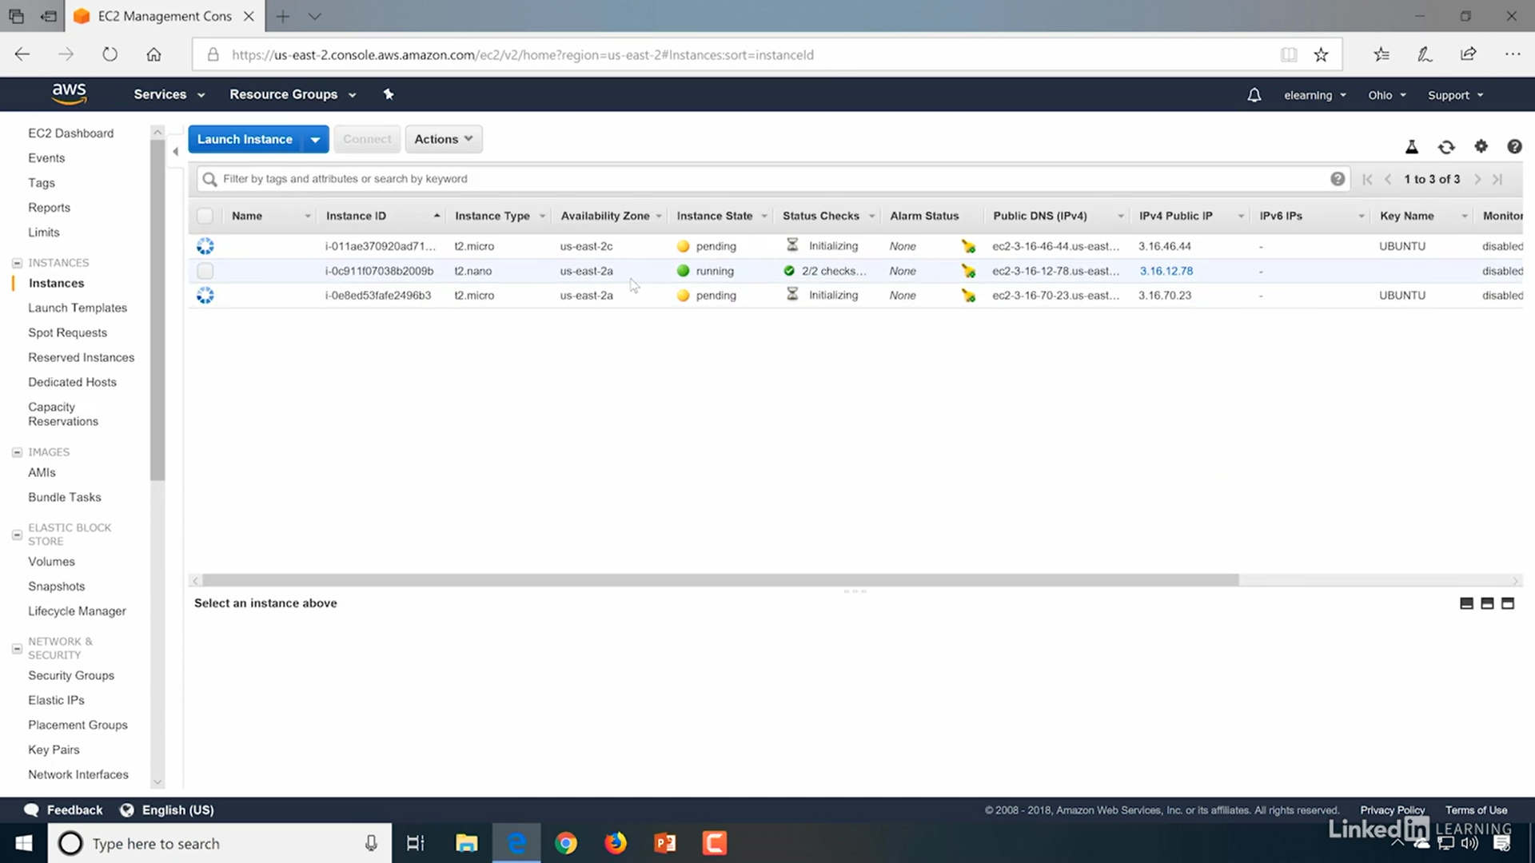

## Elastic Load Balancing (ELB)

Elastic Load Balancing automatically distributes incoming application traffic across multiple targets, such as Amazon EC2 instances, containers, IP addresses

### Load Balancer Basics

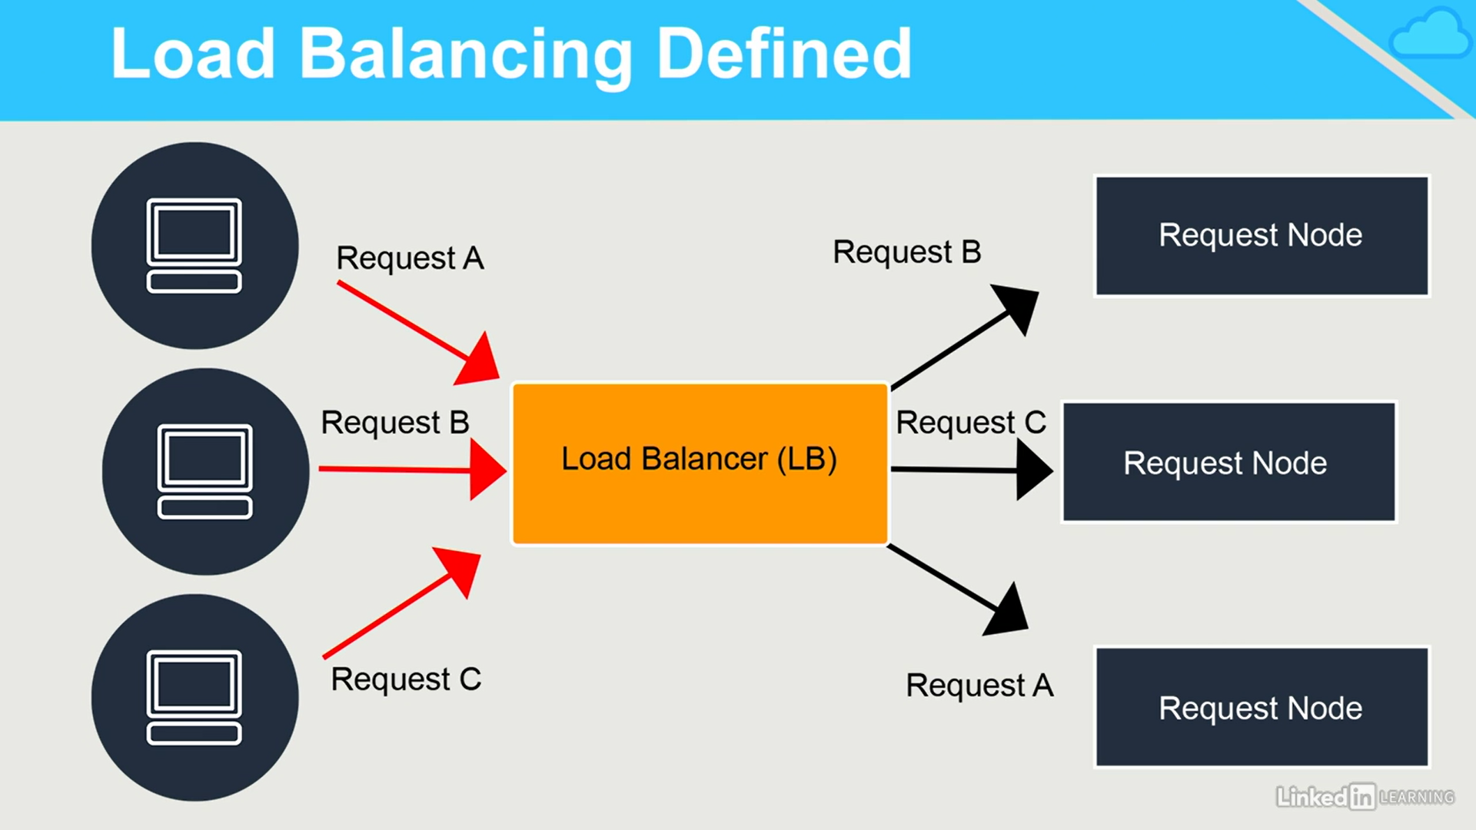

**Sender initiated Load Balancer**

If you're using the type of DNS load balancing , The DNS server responds to a client request by saying here are all the possible IP addresses you can use for that host name you're trying to resolve. . Then the client can decide which one of those IP addresses it to actually wants to use.

**Receiver initiated Load Balancing**

With receiver initiated, it means that the request always goes to one location, and that receiver, what we call the load balancer, selects the best target.

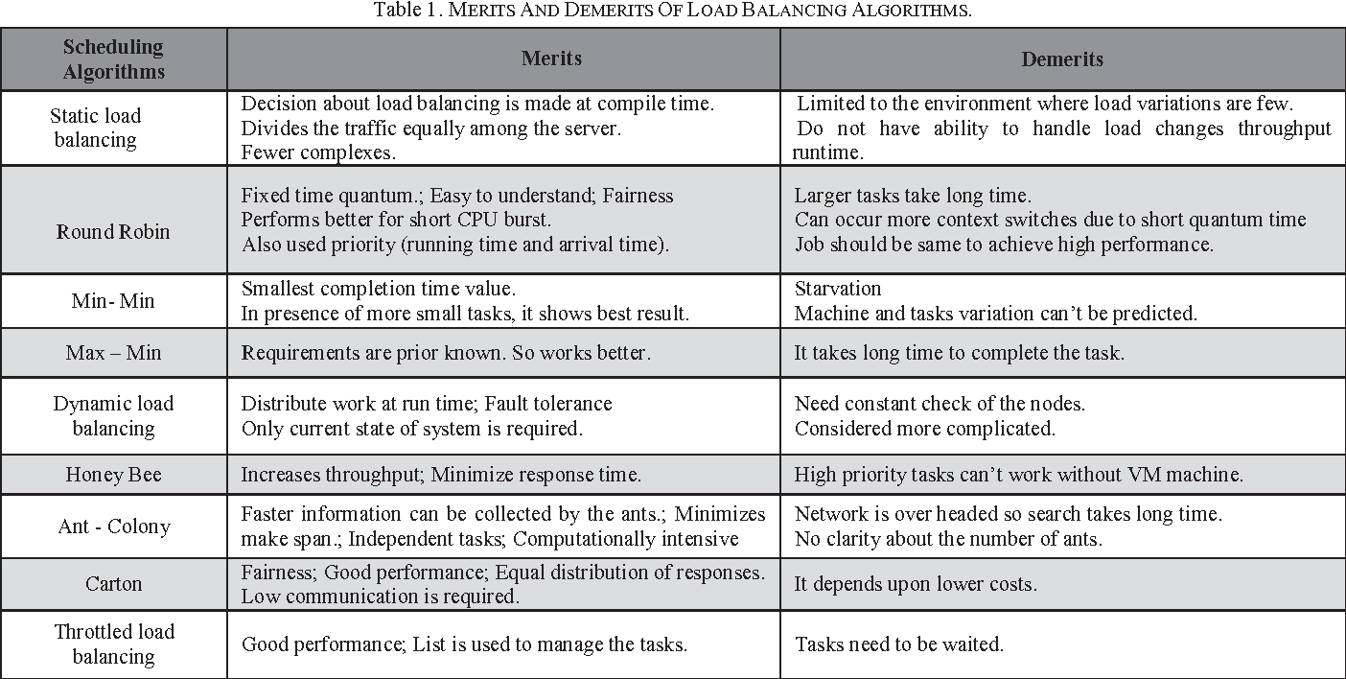

### ELB Types

Elastic Load Balancing offers three types of load balancers that all feature the high availability, automatic scaling, and robust security necessary to make your applications fault tolerant.

* Application load balancer - HTTP/HTTPS , Web Applications
* Network load balancer - TCP load balancing
* Classic load balancer - only for legacy use and not for new deployments

**ELB Supported Services**

* EC2
* ECS
* Auto Scaling
* CloudWatch
* Route 53

# Virtual Network Services

## DNS

* DNS is all about being able to resolve hostnames like www.yourwebsite.com to an IP address.
* we actually communicate with IP addresses not names. The names are there for make it easier to remember
* RFCs 1034 and 1035 are DNS routing specifications

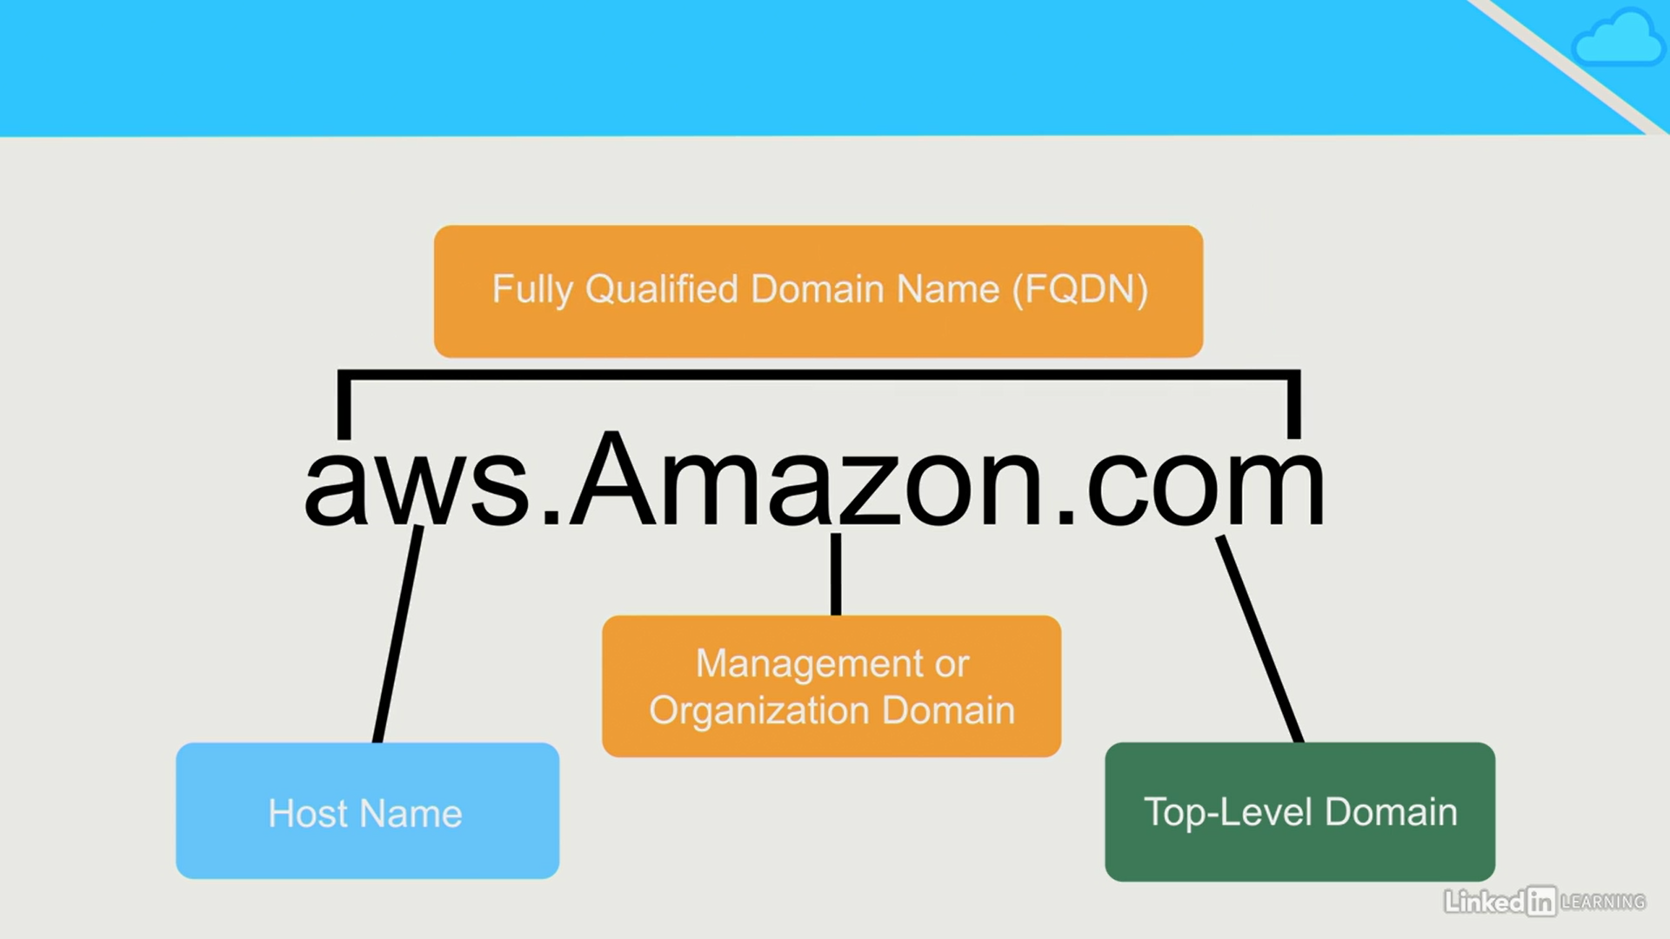

* if we hit www.satyacodes.com, you're actually going to a specific host at the satyacodes.com domain.
* So, you're actually going to the host that's named "www" and that host exists in the "satyacodes.com" domain
* So, you've got to resolve that host name to an IP address

client wants IP for aws.amazon.com

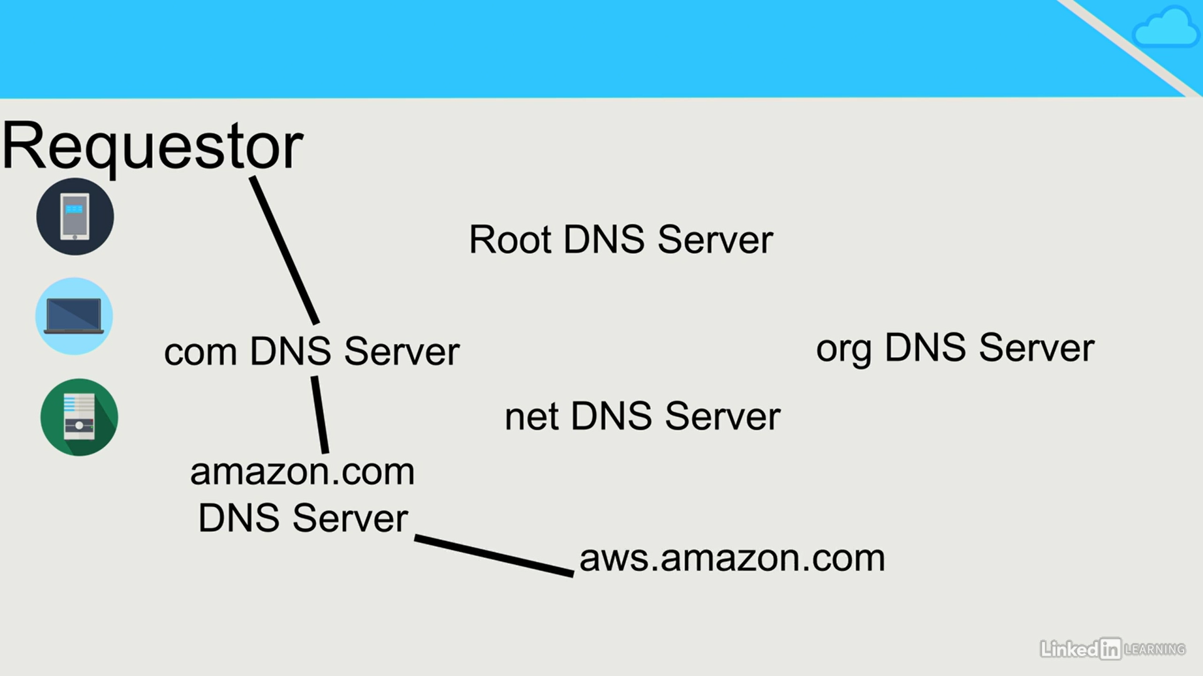

1. Client queries a root server to find com DNS server

2. Client queries com DNS server to get amazon.com DNS server

3. Client queries amazon.com DNS server to get IP address for aws.amazon.com

Read more <https://www.inetdaemon.com/tutorials/internet/dns/operation/resolution/forward/forward.shtml>

### DNS Records

* **A(IPv4) and AAAA(IPv6) -**  Hostname to IPv4 or IPv6
* **NS (Name Server Records) -** Domain to hostname
* **MX - Mail record**
* **CNAME - Alias for the real name (ex.ex.ex..)**

## Route 53

We can use Amazon Route 53 to register new domains, transfer existing domains, route traffic for your domains to your AWS and external resources, and monitor the health of your resources

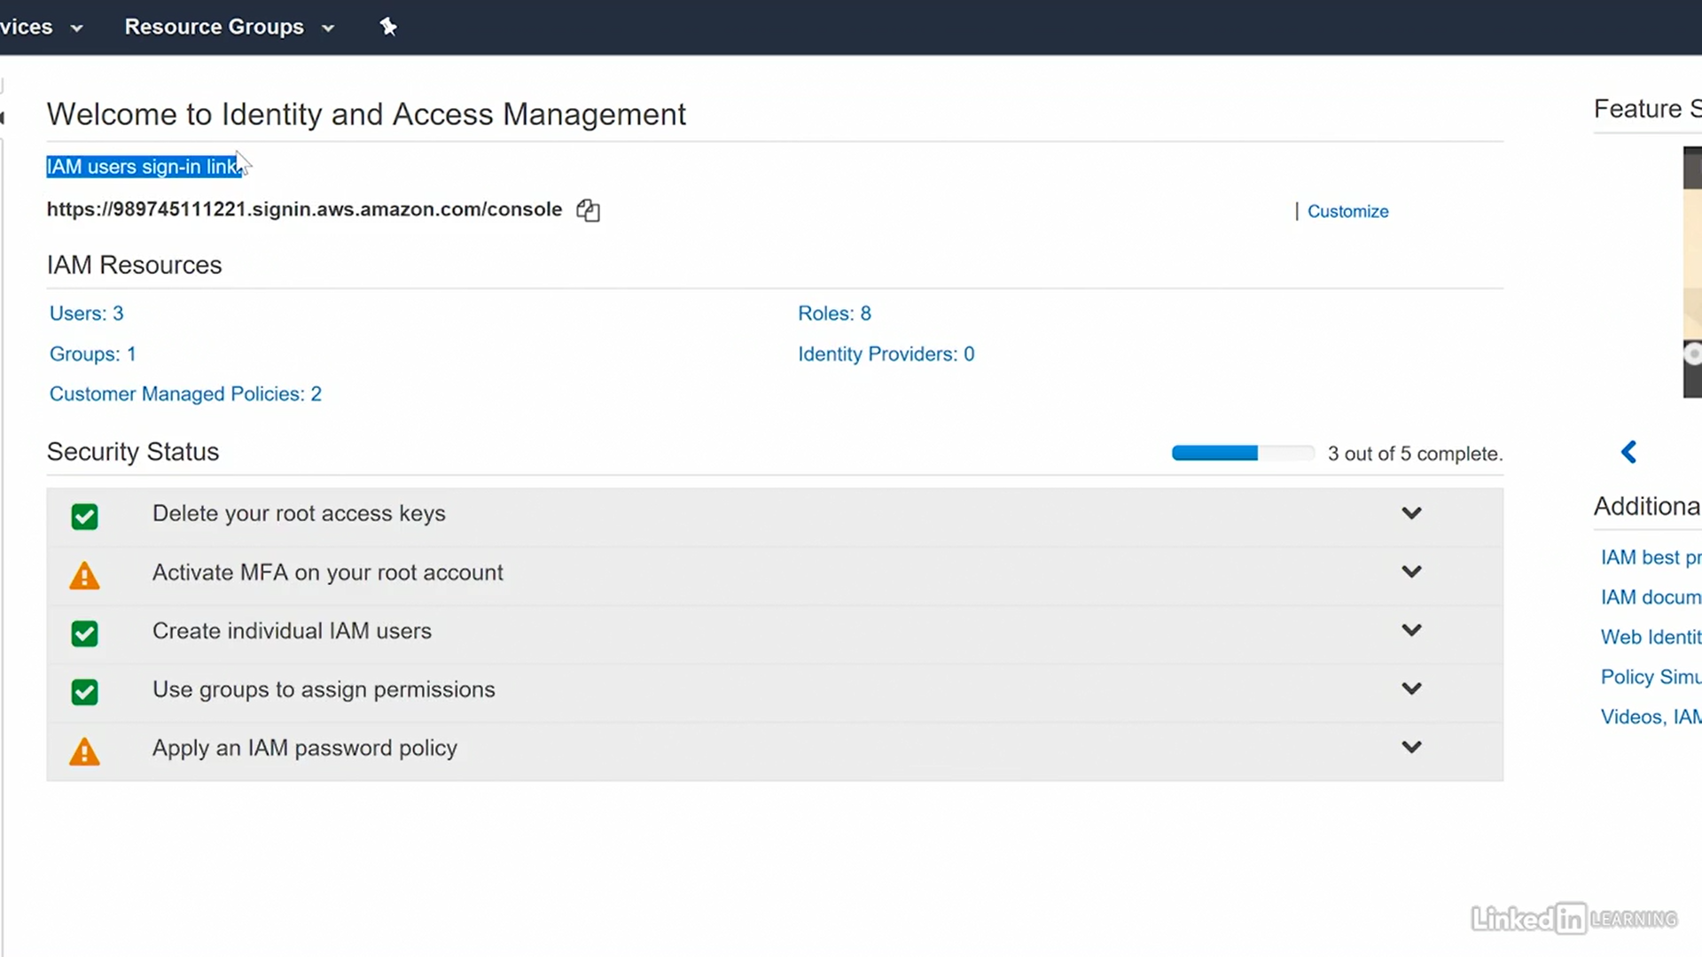

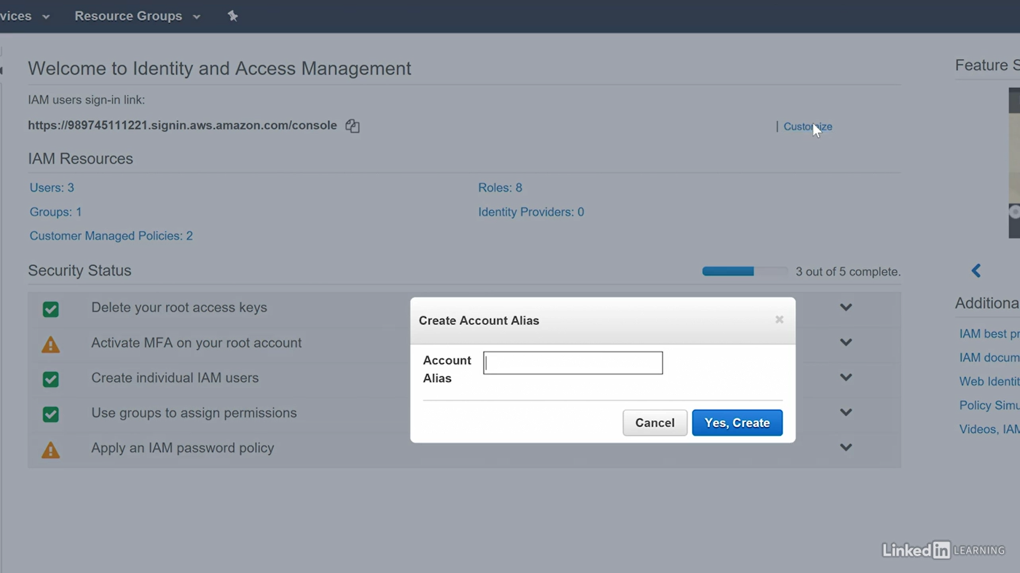

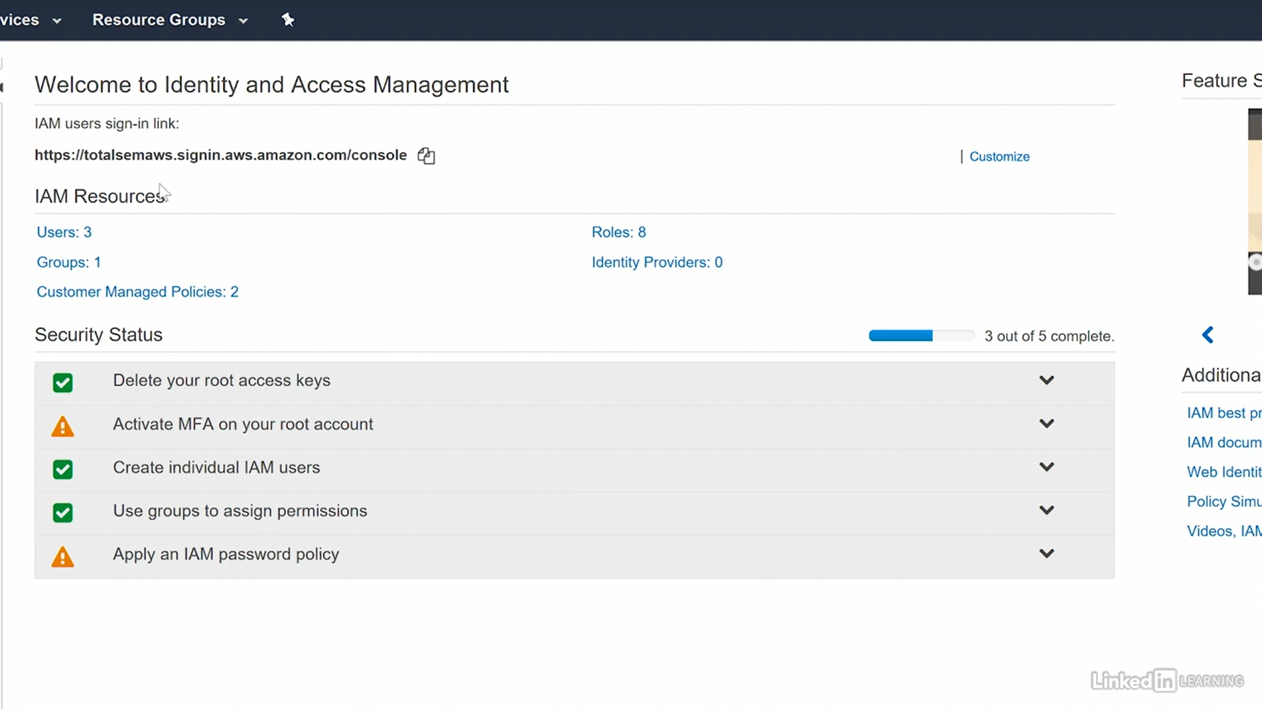

To make more easier – route53

EC2

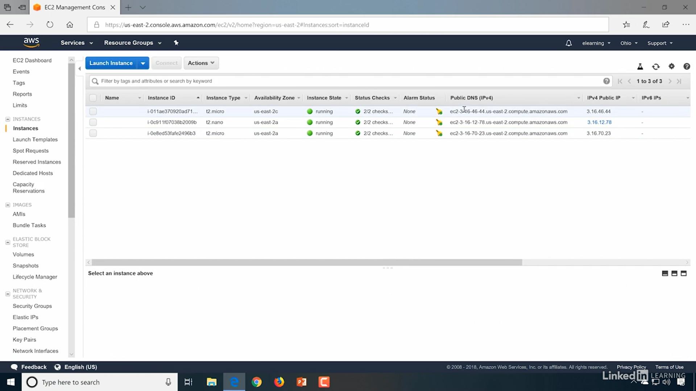

### 53

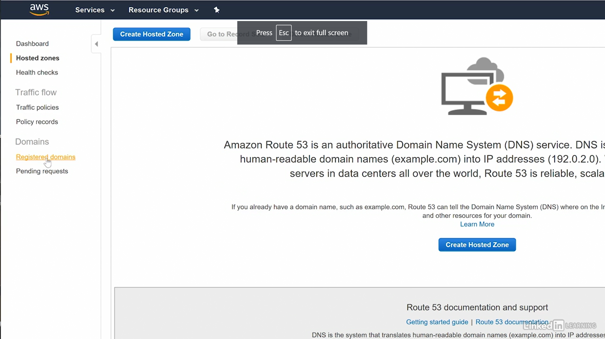

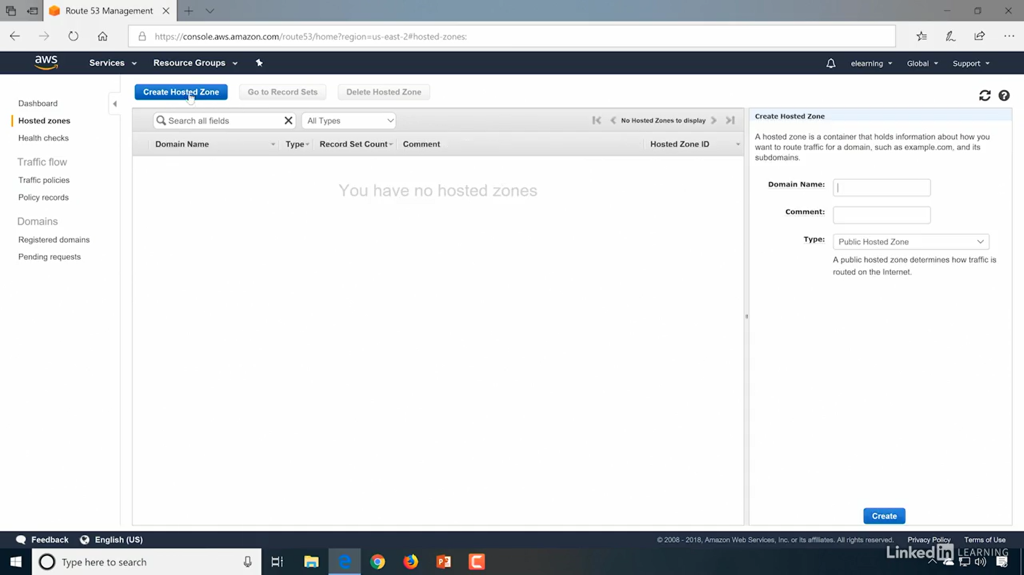

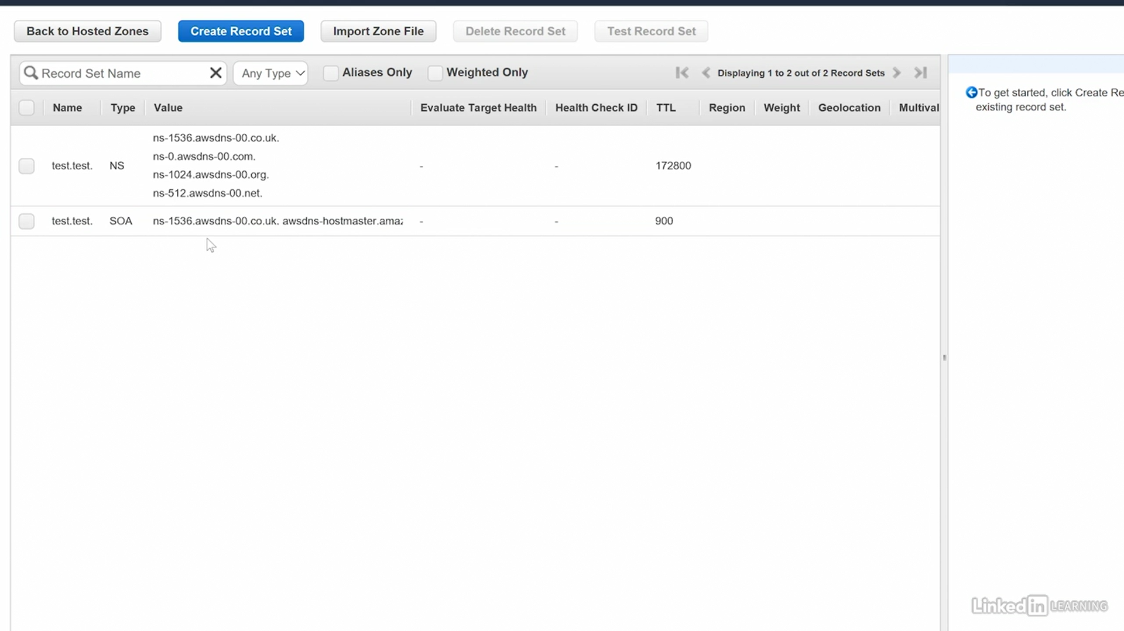

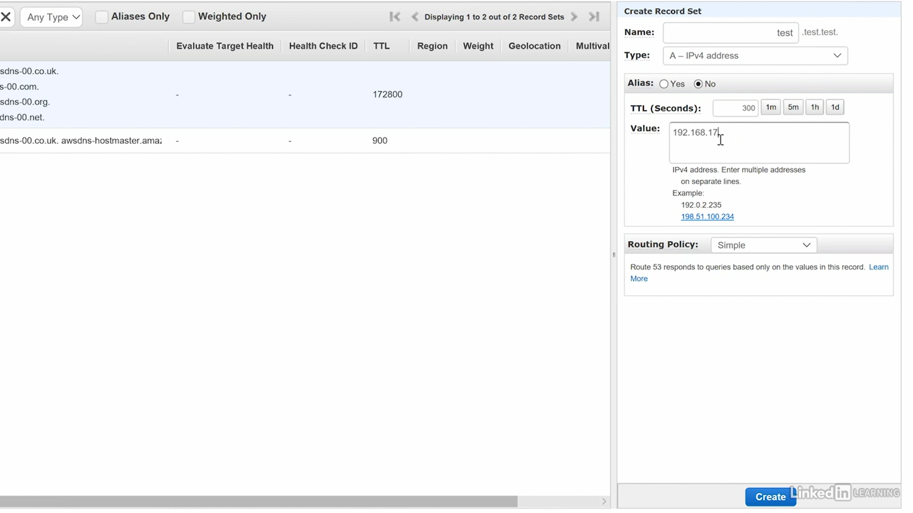

# Application Deployment

## Lambda

Run code without thinking about servers. Pay only for the compute time you consume

With Lambda, you can run code for virtually any type of application or backend service - all with zero administration. Just upload your code and Lambda takes care of everything required to run and scale your code with high availability

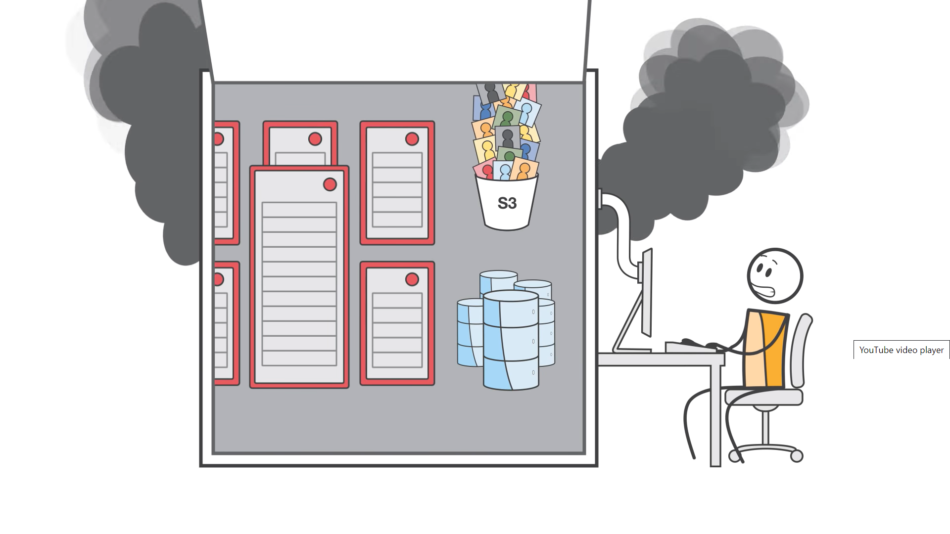

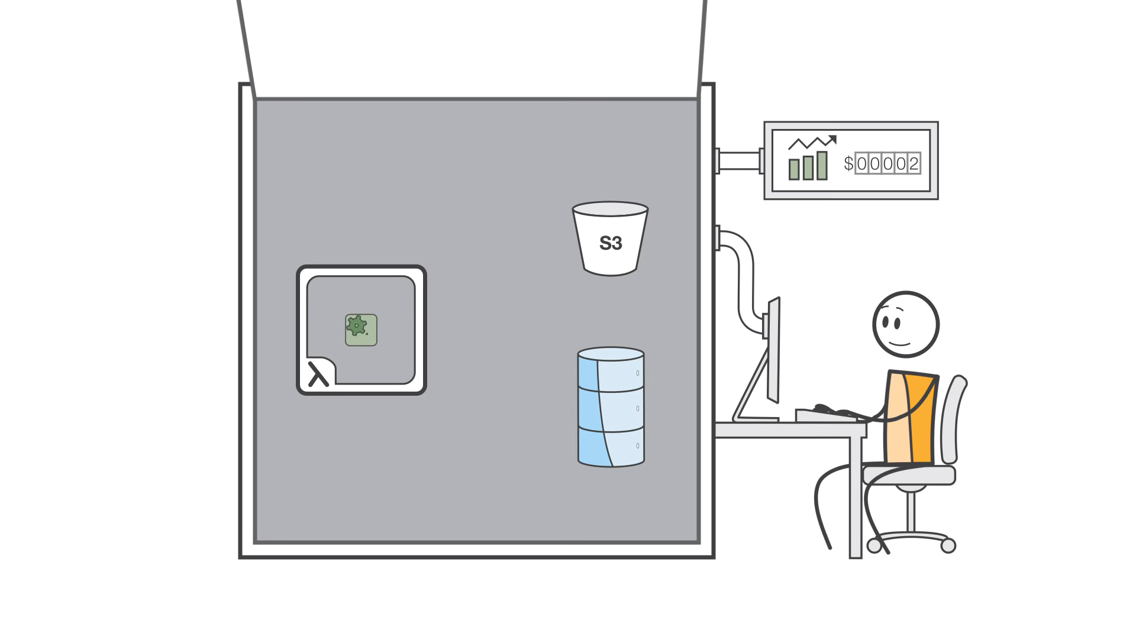



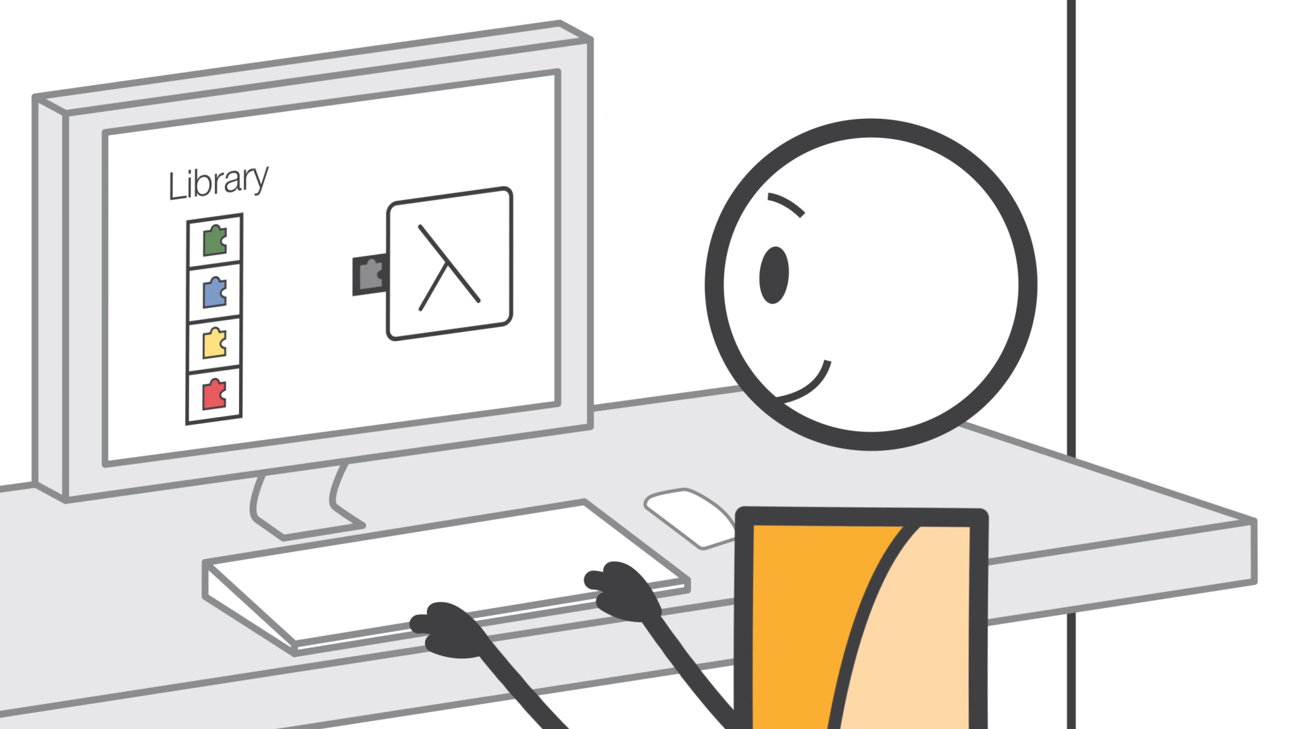

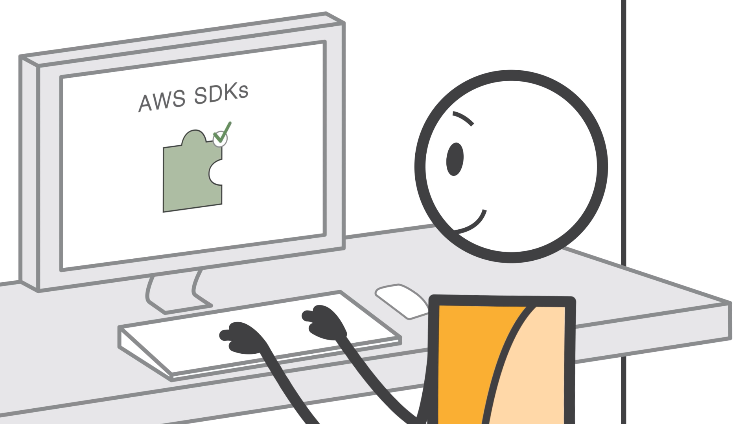

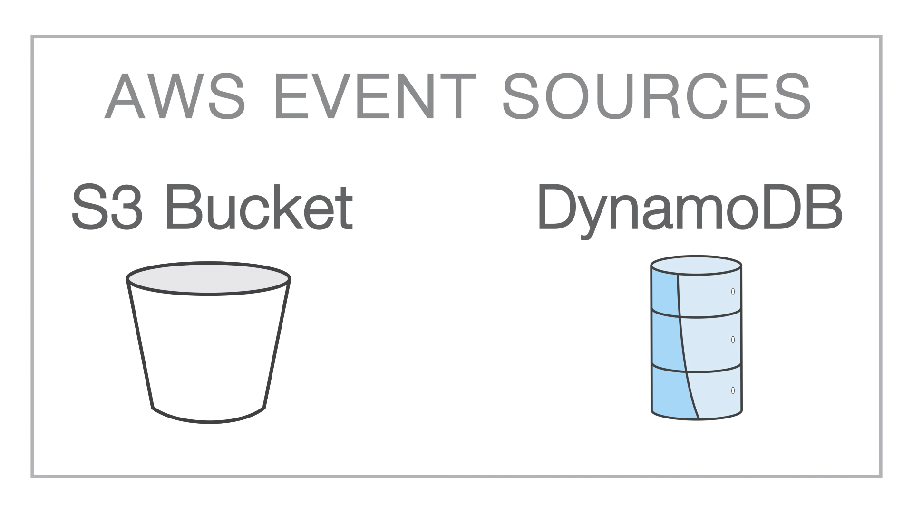

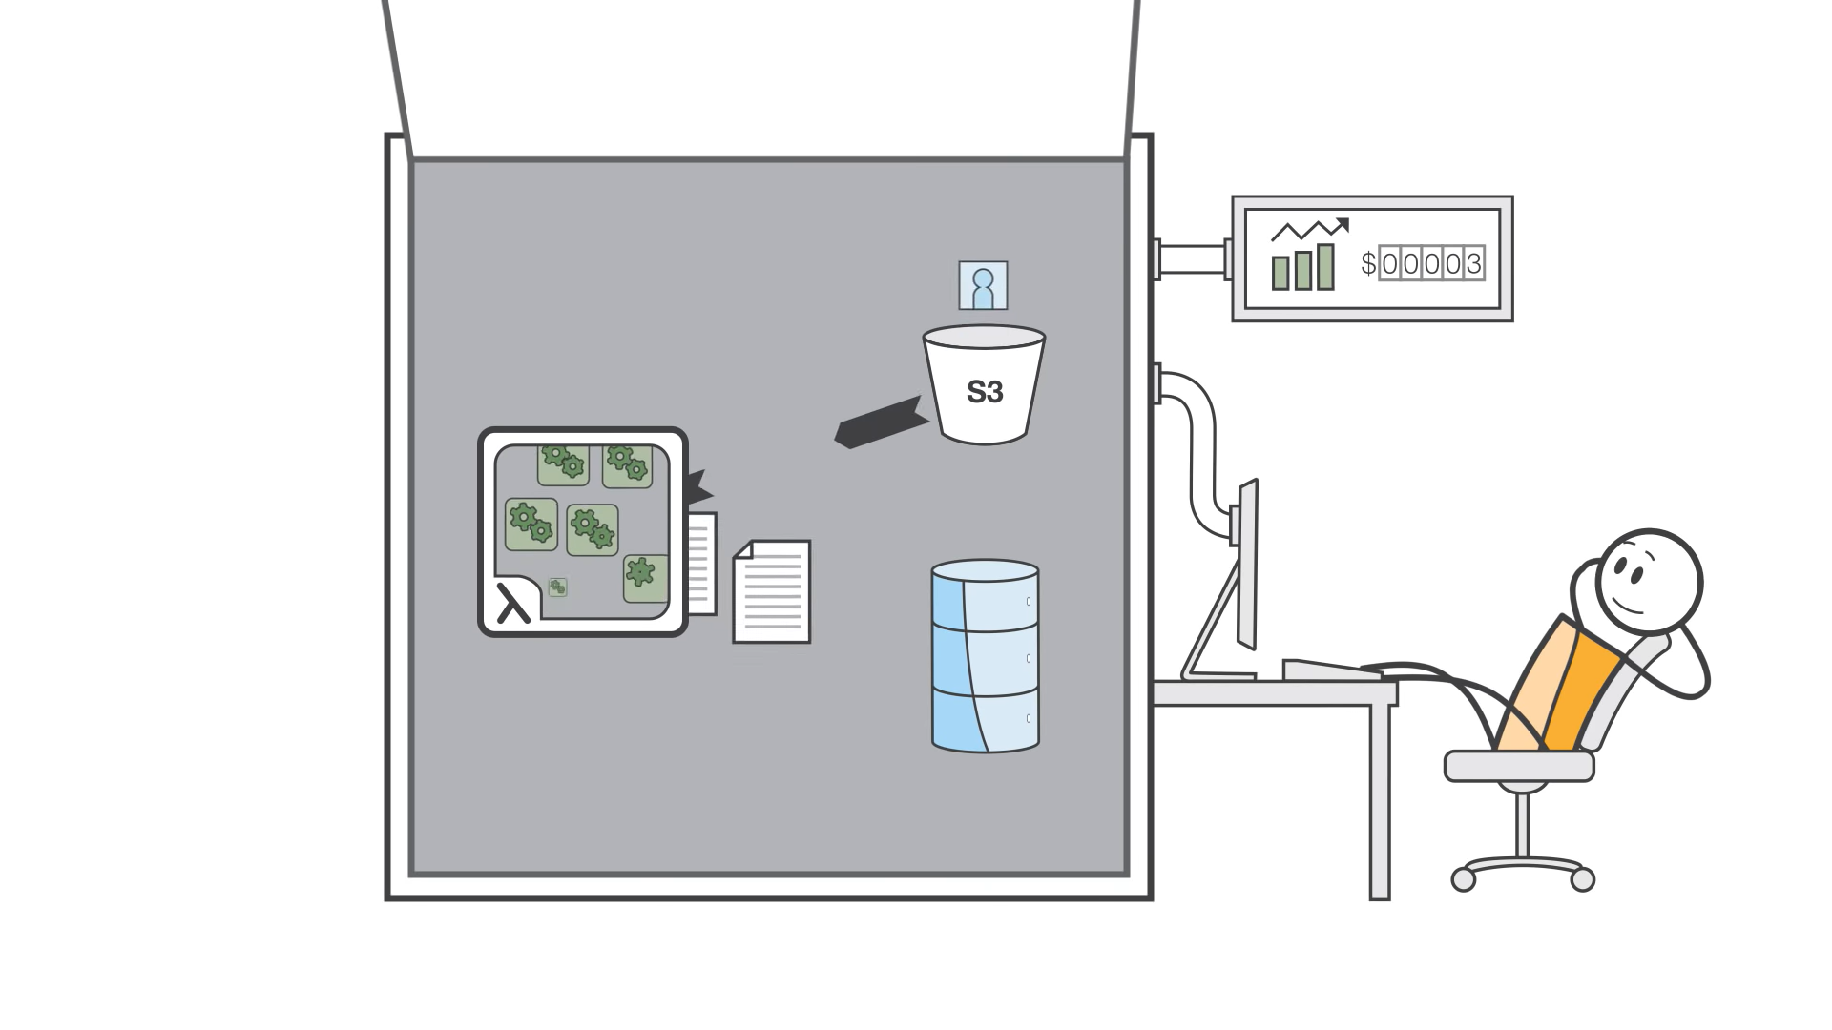

### How it works

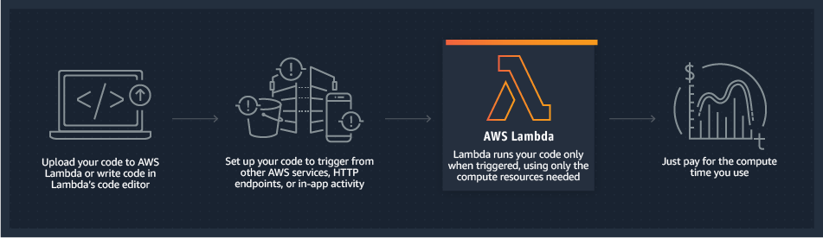

* Customer builds the code
* Customer launches the code as Lambda function
* AWS selects server
* Customer calls Lambda function as needed from applications

Languages Supported

* Node.js
* Java
* C#
* Go
* Python

## API Gateway

Create, maintain, and secure APIs at any scale

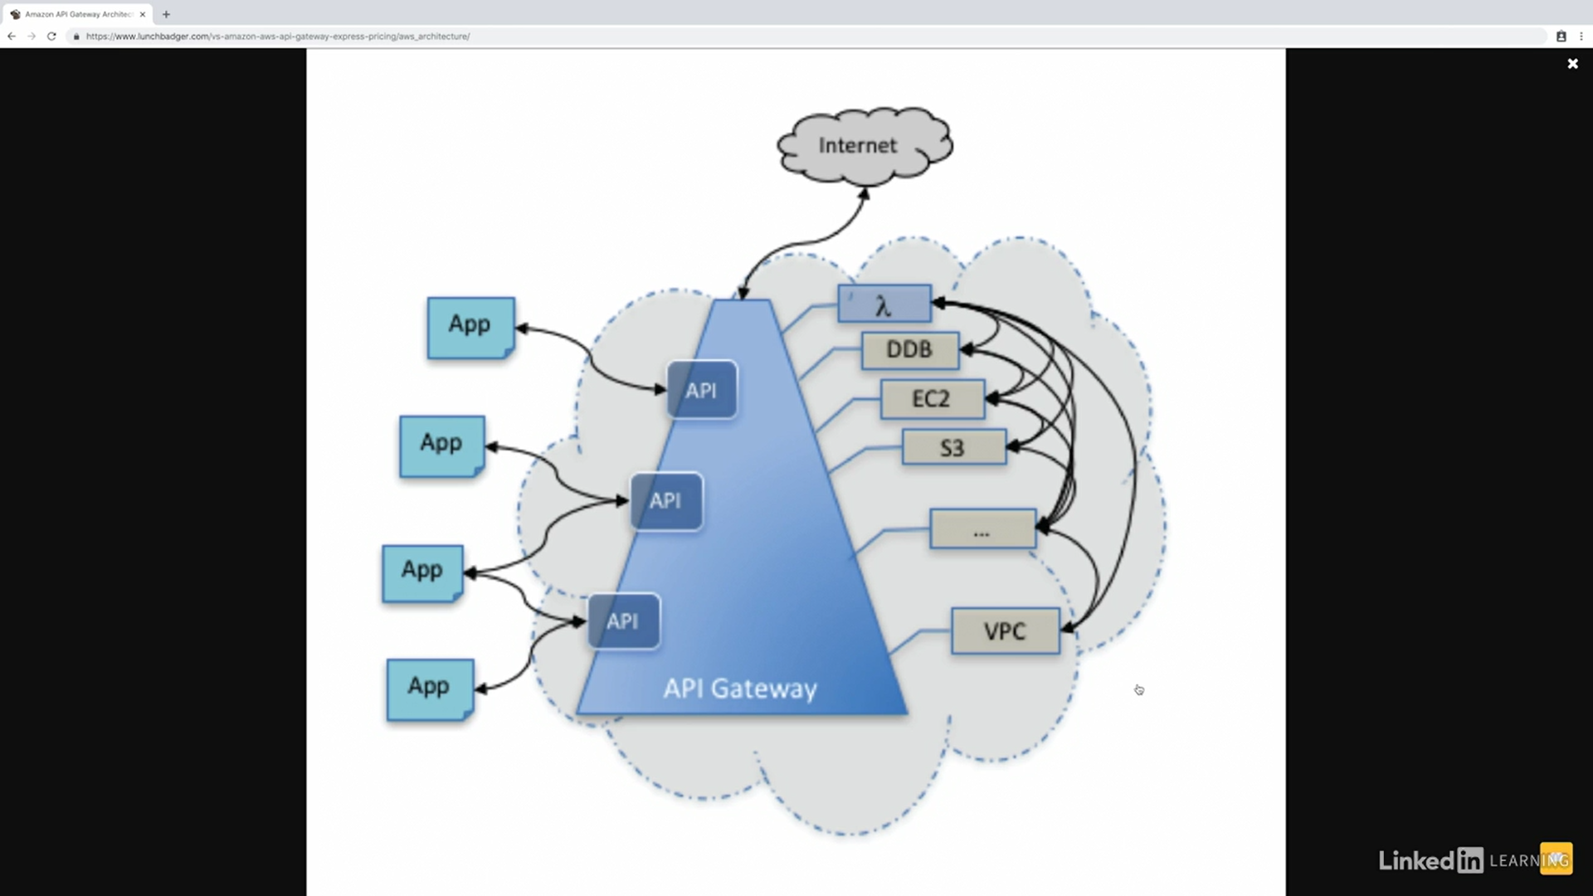

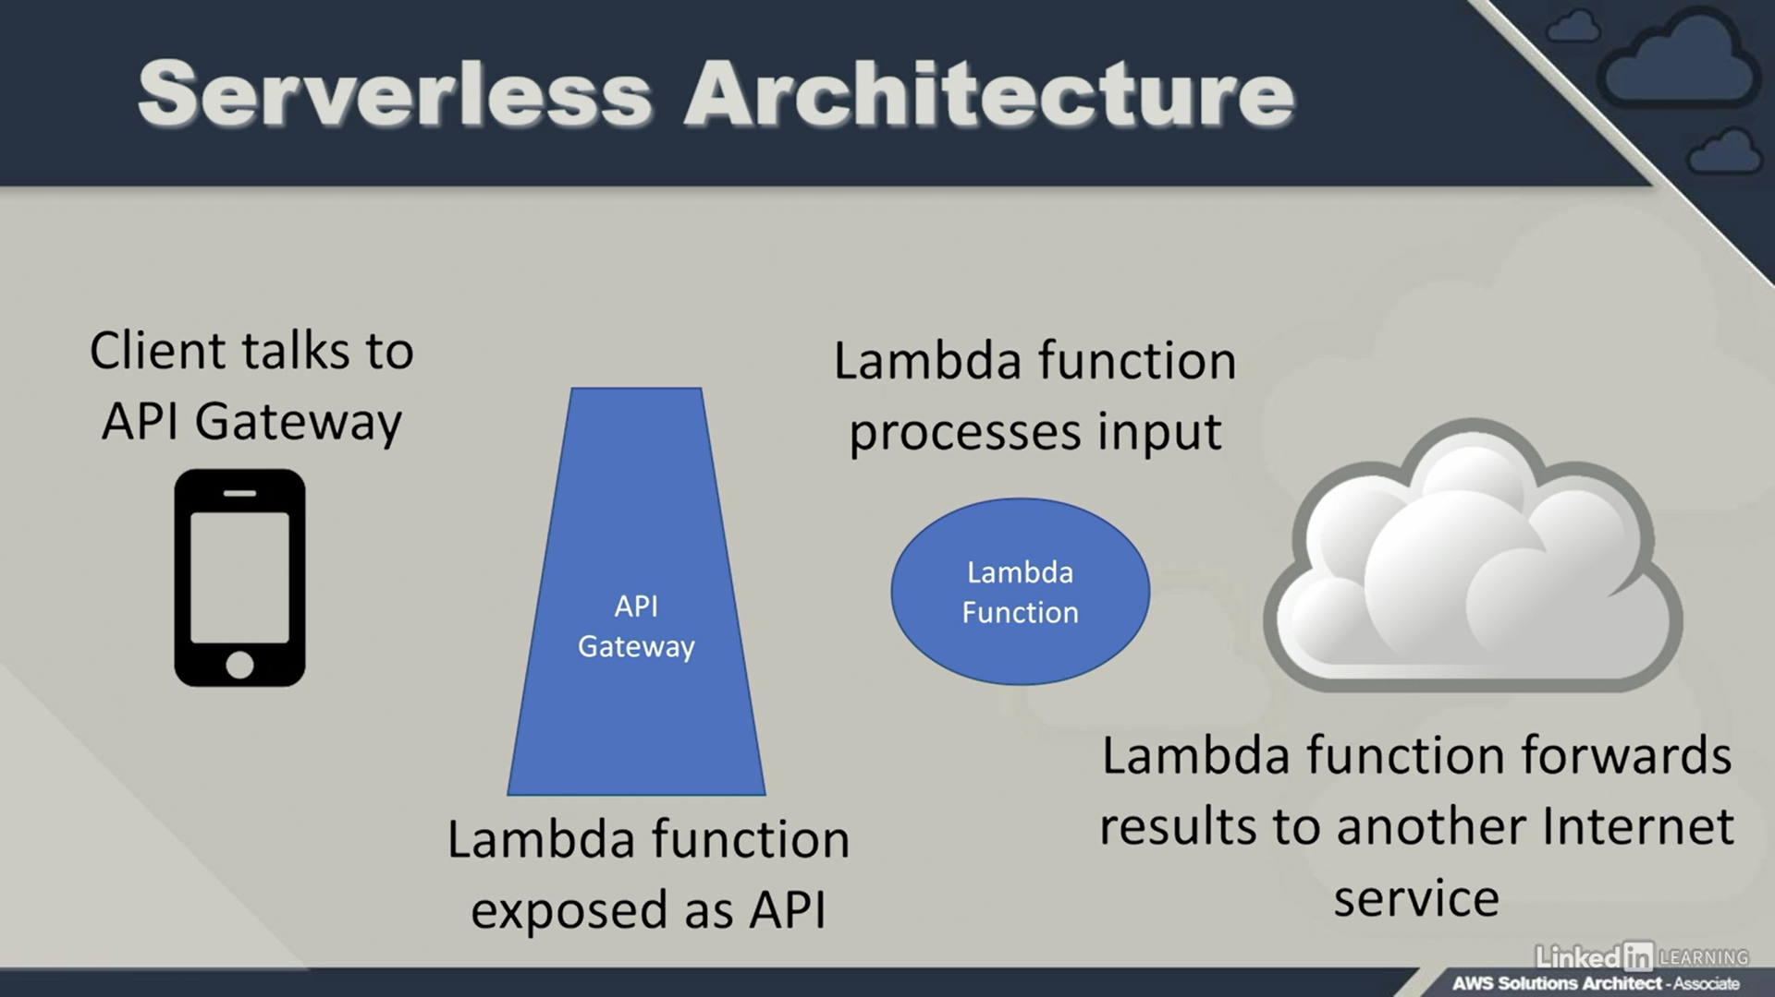

## Kinesis

Easily collect, process, and analyze video and data streams in real time

* Processes streaming data
* Real-time analytics
* Multi-tier enabler
* Very DevOps focused

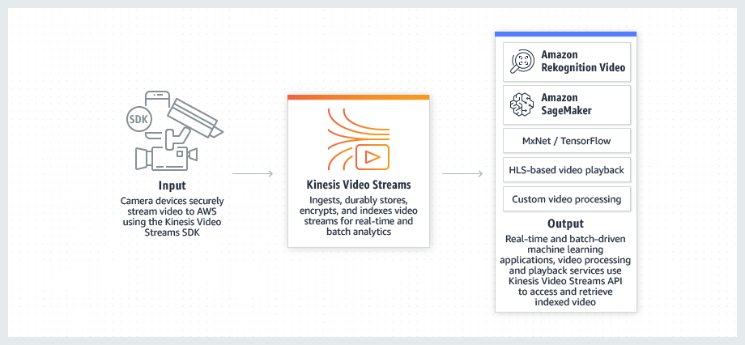

## CloudFront

CDN – content delivery network

Fast, highly secure and programmable content delivery network (CDN).

## OpsWork

AWS OpsWorks is a configuration management service.

OpsWorks lets you use Chef and Puppet to automate how servers are configured, deployed, and managed across your [Amazon EC2](https://aws.amazon.com/ec2/) instances or on-premises compute environments. OpsWorks has three offerings,

* [AWS Opsworks for Chef Automate](https://aws.amazon.com/opsworks/chefautomate/),
* [AWS OpsWorks for Puppet Enterprise](https://aws.amazon.com/opsworks/puppetenterprise/),
* [AWS OpsWorks Stacks](https://aws.amazon.com/opsworks/stacks/).

## AWS Cloud​Formation

Model and provision all your cloud infrastructure resources

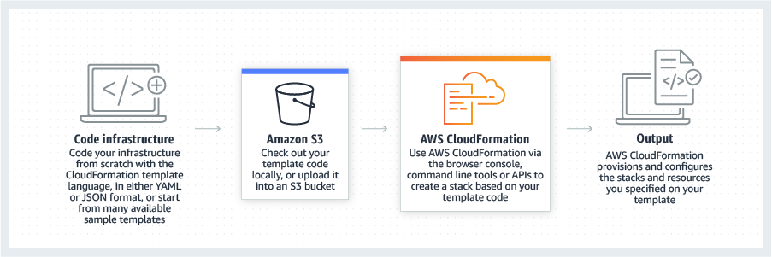

## Cagnito

For SSO- Simple and Secure User Sign-Up, Sign-In, and Access Control

Amazon Cognito lets you add user sign-up, sign-in, and access control to your web and mobile apps quickly and easily. Amazon Cognito scales to millions of users and supports sign-in with social identity providers, such as Facebook, Google, and Amazon, and enterprise identity providers via SAML 2.0.

User identity and data synchronization service

* SSO

Public identity providers

* Google
* Facebook
* Amazon

Private identity providers

* Active Directory with SAML

# References